Genome Editing of WDS with CRISPR-Cas9
Kelly Tarmon
Biol 324
February 11, 2018

Background
Will Die Slowly (Wds) gene is a gene that manages Drosophila development. The sex comb on midleg (scm) gene encodes a transcriptional repressor, manages Drosophila development and is conveyed in malignant brain tumors. Duo and Jin’s research in 2015 realizes a connection between Wds and Scm where Wds stimulates Scm degradation through ubiquitination in Drosophila (Guo et al 2015). To show the function of Wds in humans, Hollmann’s research reveals the presence of Wds RNA throughout development. Its abundance throughout development is left virtually unaltered except in adult females. This is due to a notable increase in RNA levels during oogenesis, as shown by hybridizations to ovary RNA compared to carcass and head RNA. Wds RNA is also present in male testis, but its level is only slightly raised compared to that in the other parts of the body in both sexes (Hollmann et al 2002).
Wds is involved in many biological processes such as: chromatin remodeling, histone acetylation, histone H3-K4 methylation, mitotic G2 damage checkpoint, and more. When involved in chromatin remodeling and histone acetylation, purification of Wds shows peptides from other complexes, marking that this WD40 domain protein is present in many complexes (Suganuma et al 2008). When involved in H3-K4, significant enrichment of Wds is a shared component of all H3K4 methylase complexes (Mohan et al 2011). Wds, along with many other genes is involved in mitotic G2 DNA damage checkpoint along with its homologous human protein, Wdr5 (Konda et al 2011). Wdr5 is required for endochondral bone formation and influences this process by regulating osteoblast differentiation (Zhu et al 2010). This gene could be important as it is another developmental conscious gene.
It is hypothesized that the Wds gene is required for Mitosis because the Wds gene is required for development in Drosophila and most human cells. This research is important to link the effect of Wds on drosophila development to the effect of Wds on human development, specifically to brain tumor development. In order to be able to accept the hypothesis, an experiment will be conducted to show that the cells that do not have the Wds gene will not proceed through mitosis and will stop in G2 of the cell cycle. Cells that have the Wds gene and cells that do not have Wds gene will be grown and the amount of cells in G2 between the two types of cells will be compared.
Methods:

Digest pAc-sgRNA-Cas9 with BspQI

A microcentrifuge tube was labelled with “G4” and “BspQI”. Six microliters of sterile water, ten microliters of the pAC-sgRNA-Cas9, two microliters of the NEB buffer, and two microliters of the BspQI enzyme were added to the microcentrifuge tube. The reaction was mixed by pipetting and finally incubated at 50°C for two hr then changed to -20°C after four hr. Target oligos were designed.

Phosphorylate and anneal oligos to prepare for ligation
To phosphorylate and anneal each pair of oligos, two microliters of oligos 1 and 2 (respectively), two microliters of 10X T4 Ligation Buffer (NEB), one microliters of T4 Polynucleotide kinase, and thirteen microliters of Nuclease-free water. To anneal the oligos, the microcentrifuge tube was placed in a thermocycler at 37ºC for thirty min, 95ºC for five min, and then to 25ºC at 5ºC/min

Dephosphorylate and purify the digested pAc-sgRNA-Cas9

Two microliters of quick calf intestinal alkaline phosphatase (NEB) was added to the tube from the BspQ1 digestion. The tube was then incubated at 37°C for ten min. One hundred and ten microliters of binding buffer were added to the microcentrifuge tube, spun for one min at 13,000 rpm, and the flow through was discarded. The mixture was then added to a spin filter column spun for one min at 13,000 rpm, and the flow through was discarded. Two hundred microliters DNA Wash Buffer was added to the spun filter column and spun for one min at 13,000 rpm. The latter step was repeated. The spin filter column was transferred to a clean tube and re-spun for one min. Twenty microliters of sterile water was added to the center of the white filter and a nanodrop was used to measure the DNA concentration (ng/uL) and 260/280 values.
Ligate the annealed oligos into pAc-sgRNA-Cas9

To dilute the annealed oligos 1:10 in sterile water, a microcentrifuge tube was labeled with G4 and “oligos”. Forty five microliters of sterile water and five microliters of annealed oligos were then added to the tube and mixed by vortexing. One point thirty-nine microliters of the digestion vector, 1 µL of annealed oligos, one microliter of 10X T4 Ligation Buffer, one microliter of the T4 DNA Ligase, and fourteen point sixty-one microliters of nuclease-free water were added to a labeled microcentrifuge tube. This reaction was incubated at room temperature for ten minutes.
Transform ligation reaction into E. coli

Five microliters containing the ligation reaction from was added to the cell mixture, mixed by flicking, placed on ice for thirty min, heated shocked at exactly 42°C for exactly thirty seconds, and placed on ice for five min. Nine hundred fifty microliters of room temperature SOC was then pipetted into the mixture and placed at 37°C for fourty-five minutes and shaken vigorously. Selection plates made of LB containing ampicillin were warmed to 37°C and cells were mixed thoroughly by flicking the tube and inverting. Fifty to one hundred microliters of each dilution was added onto a selection plate and incubated overnight at 37°C.

Colony PCR

Six colonies were identified, circled, and numbered on the agar-side of the plate. For each colony, a culture tube containing LB and ampicillin was used. A strip of PCR tubes was used and kept on ice. Colonies were picked up using a pipette tip and wiped onto the bottom of the PCR tube with the appropriate colony number. The tip was immediately ejected into the culture tube with that colony number. A Eppendorf tube of master mix was kept on ice. The master mix was made by adding six microliters of water, three microliters of primer, one microliters of sgRNA for oligo, then ten microliters of the Q5 reagent. The master mix was vortexed and spun to collect the liquid. Twenty microliters of the master mix were added to each PCR tube. One microliter of the original pAc-sgRNA-Cas9 (negative control, no insert) was added to the tube labeled ‘N’. The PCR tubes were then transferred to a PCR machine and thermocycling was preformed.

Gel electrophoresis

The electrophoresis chamber was filled and the gel was covered with 1X TAE buffer. Five microliters of Quick-Load Purple 100 kb DNA Ladder were loaded onto the gel. Four microliters of 6X loading dye was added to each PCR tube, ten microliters of each sample was loaded into separate wells in the gel chamber, and the lid was carefully placed on the electrophoresis chamber. The electrical leads were connected into the power supply, red to red and black to black. The power was turned on and the gel ran at 120 V for thirty minutes. After the gel was finished, it was visualized under a UV camera.

Plasmid purification and sequencing analysis

A frozen pellet of DH5alpha E. coli that was collected from the liquid cultures was obtained.
For each colony, a spin column and a microcentrifuge tube were used. The pellet was then resuspended in two hundred and fifty microliters of resuspension buffer and vortexed until the pellet was completely resuspended. Two hundred and fifty microliters of lysis buffer and three hundred and fifty microliters of neutralization buffer were added to the microcentrifuge tube and inverted 6 times to mix and then centrifuge the tube for five minutes at maximum speed. The clear supernatent was transferred to the spin column, centrifuged for one minute at maximum speed, and the flow through was disposed of. Five hundred microliters of wash buffer were added to the column, centrifuged for one minute at maximum speed, and the flow through was discarded. The latter step was repeated and spun for another three min. The spin column was then transferred to the microcentrifuge tube. Fifty microliters of sterile water were added to the white silica matrix and incubated for one minute. The column and tube were centrifuged for one minute to collect the flow through. A nanodrop was used to determine the concentration of DNA (ng/uL) and purity (absorbance at 260/280 value). Eight hundred microliters of the purified DNA and six point six microliters of water were added to the tube. Eight hundred nanograms of the purified DNA and two point two micrliters of water were added to the second tube. Two microliters of U6For sequencing primer (5’ – GTTCGACTTGCAGCCTGAAATACG – 3’) was then added.

Transformation, Plasmid Purification, and Transfection

Instructor transformed E. Coli with pAc-sgWDS-cas9. An overnight culture was grown and frozen. A plasmid purification was repeated using the alkyline lysis method. For the transfection, four microliters of DNA, four microliters of Fugene HD, 2004 μL of serum free media were added to to 4x10^6 cells in four microliters media. After twenty-four hours, six micrograms per milliliter of puromycin was added to cells. These cells were collected and frozen after seventy-two hours.

Results:

A target sequence from the gene Will Die Slowly (WDS) was chosen based on the least amount of PAM overlaps and most amount of gene overlap. This information was found in flybase. The sequence that was most successful is the one shown in Table 1. The overlapping genes shown are Frq1, CG10721, TaF13, CG18812, and d1 (Table 1). None of these genes had an overlapping PAM sequence, therefore the sequence “CTGATAAACTAATCAAAATCTGG” was chosen.
A colony PCR and gel electrophoresis were preformed and the results are shown in figure 1. The ladder depicts the base pairs in which the genomic DNA was determined. Lane 1 contains the protein CRIPSR-cas-9 used to identify if the genome sequence was ultimately found in the new coding for the gene Will Die Slowly (WDS). At 500 base pairs the DNA sequence for lanes 2 and 3 could be determined. The DNA sequences were from colonies 4 and 5 in the experiment.
After the plasmid purification was preformed, the product was nanodropped. The results are shown in table 2. For colony 4, the concentrations are shown as 573.3 ng/μL and the 260/280 value is shown as 1.90 (Table 2). For colony 5, the concentration is shown as 137.9 ng/μL and the 260/280 value is shown as 1.86 (Table 2). These values are very pure, meaning are product was very pure.
DNA sequencing was preformed and the following chromatograms for colonies 4 and 5 showed that DNA was present (Figures 2 and 3). Since DNA was present, these colonies can be used to further our research.

Discussion:
As previously stated, it is hypothesized that the Wds gene is required for Mitosis because the Wds gene is required for development in Drosophila and most human cells. Through this research, it is very evident that Wds is required for mitosis and CRISPR is important in genome editing. Williams and Warman’s research in 2011 shows that CRISPR technologies are paving the way we modify DNA and alter gene expression in cells and model organisms (Williams and Warman 2017). They saw obvious applications of CRISPR for treating human disease (Williams and Warman 2017). These applications are important, not only for research purposes but in worldwide research. CRISPR is not the only important method of editing genes. Other more complicated method can be used according to Towers’ research. CRISPR is much easier to use than many other methods and it has been proven to work well in genome editing (Towers 2017). A pitfall found in other CRISPR genome editing trials is sgRNA design. According to Peng’s research in 2016, applications of CRISPR/Cas9 require the design of sgRNAs that is efficient and specific. Peng continues by saying that reasonable sgRNA design is a major challenge because it requires multiple criteria (Peng et al 2016). Through our research, this sgRNA design is something that could have been slightly messed up. We ended up having our DNA, as stated above, therefore our research was a success.
Future Directions:
CRISPR and its applications are important for worldwide research. CRISPR-Cas 9 isn’t only important in medicine, but also in other aspects such as agriculture. According to Gao’s research, CRISPR-Cas 9 can be used as a tool for crop improvement (Gao et al 2018). Gao continues to talk about how CRISPR is already used in crop plants such as wheat, corn, and tomatoes. The gene SDN-1 is being used to provide resistance against mildew fungus (Gao et al 2018). SDN-1 was used to generate mutations in the regulatory regions of tomato yield genes, which increased their genetic variation and boosted yield in a fraction of the time it took to achieve a similar result through conventional breeding approaches (Gao et al 2018). CRISPR will go beyond DSB-based editing to pushing it to target DNA sequences in these different plants (Gao et al 2018).
Although many scientists are attempting to push CRISPR into the agricultural world, it is mainly used for medical reasons such as medical genetics screens and allergic and immunologic diseases. Researches like Xue and Goodman are focused on the medical side of this application. Xue’s research pushes for genetic screens, specifically CRISPR screens. CRISPR screens provide a practical and way for functional genomic studies. Whereas conventional screens conducted with RNAi or cDNA libraries are less versatile, reliable, and specific than CRISPR screens (Xue et al 2015). Goodman’s research explores CRISPR’s impact on allergic and immunologic diseases. Goodman expresses how easy CRISPR is to use, specifically with Mendelian inheritance (Goodman et al 2017). According to Goodman, by simply changing the gRNA sequence, and a donor sequence, almost any locus in the genome can be targeted which allows researchers enormous flexibility in generating disease models of Mendelian diseases (Goodman et al 2017). CRISPR/Cas can also be used to modify SNPs that contribute to allergic disease, initially starting off in experimental systems and then advancing to therapy (Goodman et al 2017). CRISPR again is clearly an important application for us to use as genetic scientists as it is easy to use and extremely straightforward.
Figures:
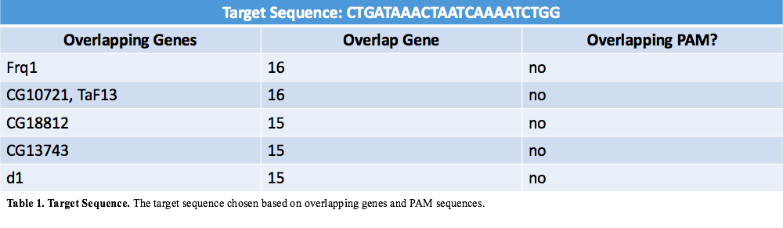
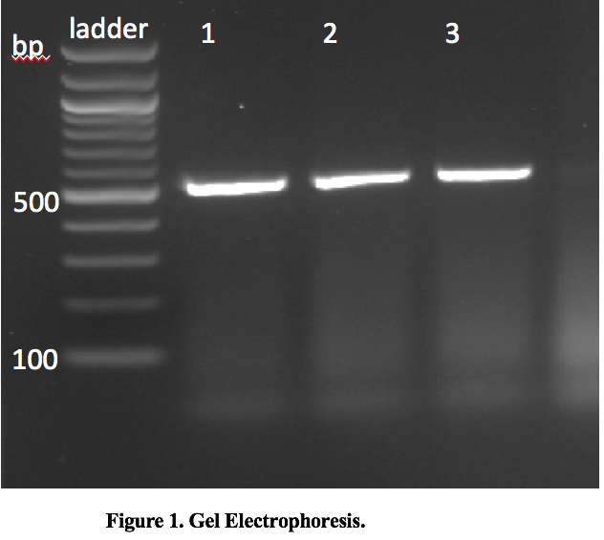

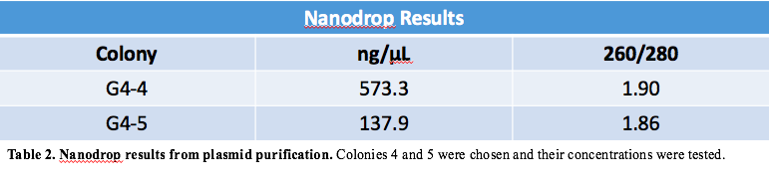
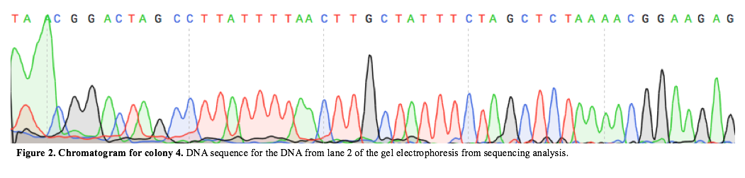
CRISPR/Cas9 technologies are revolutionizing the way we
modify DNA and alter gene expression in cells and in model
organisms.
CRISPR/Cas9 technologies are revolutionizing the way we
modify DNA and alter gene expression in cells and in model
organisms.
CRISPR/Cas9 technologies are revolutionizing the way we
modify DNA and alter gene expression in cells and in model
organisms.
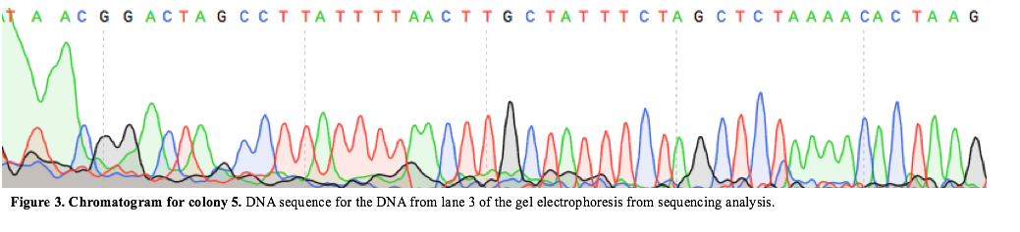

References
Gao, Caixia. “The Future of CRISPR Technologies in Agriculture.” Nature Reviews Molecular Cell Biology, vol. 19, no. 5, 2018, pp. 275–276., doi:10.1038/nrm.2018.2.
Goodman, Michael A. et al. “CRISPR/Cas and the Future of Gene Editing in Allergic and Immunologic Diseases.” Expert review of clinical immunology 13.1 (2017): 5–9. PMC. Web. 23 Apr. 2018.
Peng, R; Lin, G; Li, J. “Potential pitfalls of CRISPR/Cas9-mediated genome editing.” FEBS Journal, Vol. 283, no. 7, pp1218-1231.
Williams, Bart O, and Matthew L Warman. “CRISPR/CAS9 Technologies.” Journal of Bone and Mineral Research, vol. 32, no. 5, 2017, pp. 883–888., doi:10.1002/jbmr.3086.
Towers S. Gene Therapy: What Is It? How Is It Different from CRISPR/Cas9? Why Is CRISPR/Cas9 Getting So Much Media Hype?. AMWA Journal: American Medical Writers Association Journal [serial online]. Winter2017 2017;32(4):172-175. Available from: Academic Search Complete, Ipswich, MA. Accessed March 30, 2018.
Xue, Hui-Ying, et al. “CRISPR-Cas9 for Medical Genetic Screens: Applications and Future Perspectives.” Journal of Medical Genetics, vol. 53, no. 2, 2015, pp. 91–97., doi:10.1136/jmedgenet-2015-103409.

Materials Used
- pAc-sgRNA-Cas9
  - Source: Addgene #49330
  - Reference: Bassett AR, Tibbit C, Ponting CP, Liu JL. Mutagenesis and homologous recombination in Drosophila cell lines using CRISPR/Cas9. Biol Open. 2013 Dec 10. pii: bio.20137120v1. doi: 10.1242/bio.20137120. 10.1242/bio.20137120 PubMed 24326186
  - Cost: $85
- BspQI enzyme
  - Source: New England Biosciences
  - Cost: $69
- Monarch PCR purification kit
  - Source: New Enland Biosciences
  - Cost: $99
- Oligos (single stranded primers and target sequences)
  - Source: Integrated DNA Technologies
  - Cost: ~$4/oligo
- T4 polynucleotide kinase
  - Source: New England Biosciences
  - Cost: $56
- Calf Intestinal Alkaline Phosphatase
  - Source: New England Biosciences
  - Cost: $76
- T4 DNA ligase
  - Source: New England Biosciences
  - Cost $ 64
- NEB 5-alpha competent E. coli
  - Source: New England Biosciences
  - Cost: $151
- Q5® Hot Start High-Fidelity 2X Master Mix
  - Source: New England Biosciences
  - Cost: $204
- GeneJet Plasmid Miniprep Kit
  - Source: ThermoFisher
  - Cost: $80
- Agarose
  - Source: Sigma
  - Cost: $60
- 100 bp DNA ladder
  - Source: New England Biosciences
  - Cost: $57

