The Effect of Bromated Paraben Analogues and their Anti-Microbial Abilities
Kelly Tarmon, Devin Teachey, and Micaela Wade
Department of Chemistry and Physics, Longwood University

Abstract

Para-hydroxybenzoates (parabens) are widely used in both cosmetic and food industries because of their antibiotic properties. There have been recent studies that point out the potential of these parabens to be carcinogenic to humans. It is pointed out that these parabens have the potential to be xenoestrogenic and bind to estrogen receptors, causing an unneeded cellular expression, which can lead to an increased risk of cancer after extended use. This article discusses the effect of assorted bromated paraben analogues and their microbial properties. Once the bromated parabens were synthesized and then isolated, a serial dilution was then preformed using an inoculated bacterial broth containing Streptococcus salivarius to determine the effectiveness of the paraben analogues. In this test, positive and negative controls were used. Penicillin, erythromycin, and other known effective antibiotics such as unbromated parabens, were the positive control and no compound added was the negative control. What was found that this bromated parabens are an effective antibiotic against strains of S. salivarius showing a minimum inhibitory concentration (MIC) of 2 μg/ml. This shows that bromated octyl paraben is an effective antibiotic at the concentrations tested against S. salivarius. As the length of the carbon chains decreased, the weaker the paraben became with methyl paraben and ethyl parabens having derivatives of MIC of >256 μg/ml.

Introduction

Para-hydroxybenzoates (parabens) are widely used in common every-day products throughout our daily lives. They are most commonly used in cosmetics, toiletries, food items, and pharmaceutical products such as preservatives because of their antimicrobial properties, stability in a wide variety of pH ranges, and their solubility in water (Terasaki et al. 2008). This antibiotic activity has been shown to increase with an increase in molecular weight and the length of the carbon side chain (Charnock et al. 2007).
Though these parabens are normally considered to be non-toxic and non-carcinogenic, there has been some increasing evidence that show that parabens play a possible role in increasing the chances of breast cancer in humans (Charnock et al. 2007 and Darbe et al. 2008). These parabens from personal care products have the ability to be absorbed into the skin from application, accumulate in underlying tissues, and are measurable in blood after as little as one hour from the dermal application (Janjua et al. 2007). This is a concern since they have the potential to disrupt normal endocrine function, resulting in potential changes to reproduction and increased chance of cancer over multiple years of use (Byford et al. 2002).
These parabens work by binding into the estrogen receptor-β (ER-β) and estrogen receptor-α (ER-α). This stimulates a cellular response in its DNA that will lead to an unwanted gene to be expressed. Any molecule that stimulates this kind of cellular response that is not estrogen, is part of a diverse group of compounds known as xenoestrogens (Byford et al. 2002). Parabens have been implicated as endocrine disrupting chemicals (EDCs) and may make women more prone to developing oestrogen-positive breast cancer (Narayanan et al. 2016).
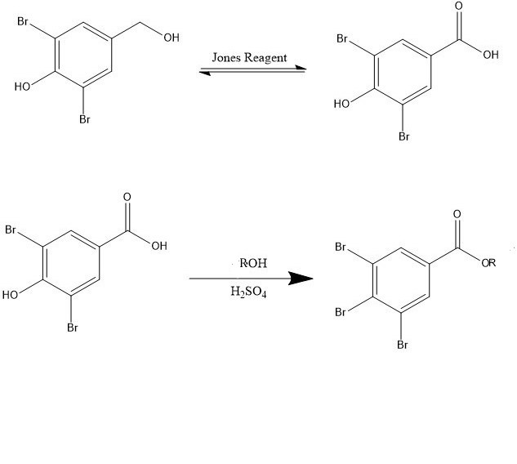
There is limited research available that shows any effective counter to prevent oestrogenic activity in cells and also still retains its antibiotic capabilities. This paper looks to investigate a synthesis of a paraben-like structure that is both non-carcinogenic and an effective antibiotic. It is hypothesized that adding a large atom such as bromine in the ortho positions, relative to the phenol group, will serve as a natural steric inhibitor to prevent the paraben from binding in ER-β and causing a cellular response. The addition of bromine to the ortho positions should also have no effect on the new paraben’s antimicrobial properties compared to the unbromated analogues.
Figure 1: First half of the scheme used to achieve 2,6-dibromo-4-(hydroxymethyl)phenol (product 3).

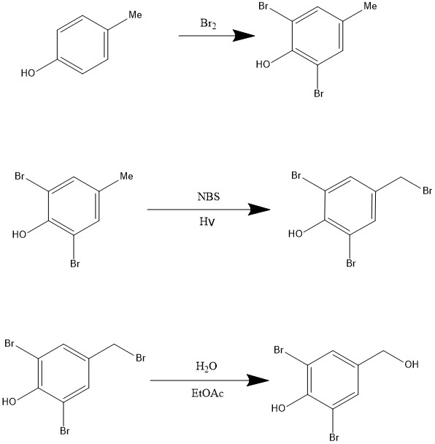
Results
In Figure 1 and Figure 2, are schemes that show the process that was used to achieve the final paraben analouges. Over all, the synthesis went well showing that we did achieve the final bromated paraben products. The ¹HNMR showed that the product was present in the final white powder, but there was also contamination from other sources as well. The solvent used for the elution, 15% EtOAc/Hexanes, was still present in ¹HNMR even after running column chromatography. It appears that the presence of 15%EtOAc did not play a role
Figure 2: Shows the scheme used to get to the final parabens (products 5 a-k).
Positive controls | MIC μg/ml
Methyl paraben | >256
Ethyl paraben | >256
Propyl paraben | 256
Butyl paraben | 128
Enrythromycin | 0.007813
in determining the parabens’ effectiveness though.
R group | Compound | MIC μg/ml
Methyl | 5a | >256
Ethyl | 5b | 256
Propyl | 5c | 256
Butyl | 5d | 128
Pentyl | 5e | 64
Hexyl | 5f | 4
Heptyl | 5g | 4
Octyl | 5h | 2
Isobutyl | 5i | 128
Secbutyl | 5j | N/A
Isopentyl | 5k | 64
After the bacteria were incubated, they were then analyzed for bacterial growth. The Minimum Inhibitory Concentraction (MIC) values were gathered and analyzed. The results show that as the length of the carbon chains and molecular weights on the bromated parabens increased, the more efficient they were at killing S. salivarius. To a point where octyl 3,5-dibromo-4-hydroxybenzoate (5h) had MIC value of 2 μg/ml that were comparable to penicillin with a MIC of 1 μg/ml, a known strong antibiotic. The least successful paraben analogue was methyl paraben (5a) showing a MIC value of >256 μg/ml (Table 1).
Table 2: Shows the reported MIC values from the biological assay of each positive control
Discussion
Based on the data that was found from all the tests, it shows that the longer the carbon chain added onto the paraben analogue, the more effective it is against killing bacteria. The smaller carbon chains such as methyl, ethyl and propyl were found to have considerably larger MIC values that would show that they are not effective antibiotics against S. salivarius. Because of this fact, our hypothesis is inconclusive. While it was proven that the addition of bromines to the ortho is true with the longer carbon chains, it cannot be proven because based on the design of the experiment, we cannot accurately compare the paraben to the synthetic one as both MIC values were greater than 256 μg/ml. This opens the door for future studies that can allow the testing of the paraben’s strength at higher concentrations than 256 μg/ml. Also, more experiments should be done exploring the molecule’s bonding affinities in the ER-β and ER-α and serving as a ligand initiating a cellular response. This will determine if the made paraben analogues still have the potential to be carcinogenic.
Table 1: Shows the reported MIC values from the biological assay for each paraben analogue made
Experimental

Aromatic Bromination of 4-methylphenol

3.008 Grams of 4-methylphenol (1) was weighed out and placed in 2.1 mol equivalent pyridinium tribromide in 15 mL of acetic acid. The reagents were then placed in acetic acid and refluxed for 30 minutes. The reaction was the allowed to cool to room temperature. Then 50 mL of 0.5M HCl was added dropwise. The reaction was then let to cool to allow crystals to form. It was then vacuum filtered to get the product. The Product was a white powder. Mass= 5.953g, 80.6%. Major mass spec peaks at 44, 49, 77, 105, 185, and 266 m/z.

Benzylic Bromination and of 2,6-dibromo-4-methylphenol

3.008 grams 2,6-dibromo-4-methylphenol (2) was weighed out then 1.05 mole equivalents (2.11g) of N-bromosuccinimide (NBS) was added to a flask. To the flask, 50 mL of chloroform was added to dissolve the solid. The solution was the placed under UV light for 7 days. It was then placed in a separatory funnel and first washed with dichloromethane and then washed 3 times with 50mL portions of 1M HCl. Then dried with anhydrous magnesium sulfate (MgSO₄). The dry solution was then placed in a rotary evaporator to remove the dichloromethane solvent. In the round bottom with the 2,6-dibromo-4-bromomethylpheol, the reactant was dissolved with a 2:1 ratio of acetone to 1 M HCl to make a 0.25 M solution. The solution was the left to stir for 7 days. Then the solution was added into a sepratory funnel and 75mL ethyl acetate (EtOAc) was added. Then the solution washed with deionized water in 25mL portions. A TLC was then run in 25% EtOAc. The solution was then dried with MgSO₄ and placed in a rotary evaporator. (1.225g, 68% and RF 0.68). Taking the 2,6-dibromo-4-(hydroxymethyl)phenol (3) made in the previous step, add 3 mL of ethyl acetate (EtOAc) and dissolve the product. A column purification was then done using sillicon dioxide (SiO₂) beads, while increasing the concentrations of EtOAc/hexanes. Starting at 200mL of 20% EtOAc/hexanes then 300mL of 30% EtOAc/hexanes, and last 400mL of 50% EtOAc/hexanes. As the column is running, fractions should be collected in separate test tubes in order to isolate the product. Once finished, a TLC was run using 25% EtOAc to determine where the desired product is within the fractions. An RF of 0.27 was found. Once found the fractions showing the product were collected and combined into one flask. The flask was then placed in a rotary evaporator resulting in product 3. (1.225g; 77%); H¹ NMR (DMSO, 400MHz)δ 9.721 (s, 0H), 7.468 (s, 1H), 4.399-3.900 (m, 1H), 0.011 (s, 3H); [Calculated mass 281.929 amu]

Oxidation of benzylic alcohol by Jones oxidation

In a 500 mL Erlenmeyer flask, 1 g of the purified 3 was dissolved in acetone until it is a 0.1 M solution. With high stirring on, 1.5 equivalent (3.31mL) of 2.0 M Jones reagent dropwise was added and allowed to stir for 1 hour. After 1 hr the product was washed with deionized water three times in a sepratory funnel and then dried with MgSO₄. The solution was then again, placed into a rotary evaporator. Leaving a yellow solid powder. (0.748g; 59%; MP 251.7-271˚c).

Fischer esterification of carboxylic acid into esters

In a 100mL round bottom flask, 300 mg 3,5-dibromo-4-hydroxybenzoic acid (4), 1 mL of methanol, and 2 mL of H2SO4 was added. The solution was then refluxed for an hour to ensure reaction completion. The final paraben was then isolated by column chromatography using 400 mL of 10% EtOAc/hexanes as an elutent. Then 400mL of 15% ethyl acetate/hexanes was used. A TLC test was done using 25% EtOAc. The plates were then dipped in KMnO₄ to test for any a residual alcohol on the plates. The test tubes confirmed to have the product were then taken and combined together. Then the final product was then placed in the rotary evaporator to produce the final product, methyl 3,5-dibromo-4-hydroxybenzoate (5), a white solid powder. (0.852g; RF 0.93; 91.9%); H¹ NMR (DMSO, 400MHz)δ 8.916 (s, 1H), 6.440 (s, 1H), 3.959 (m, 2H), 1.310 (m, 3H), 0.937 (m, 2H); IR (DMSO, 400MHz)δ 3442, 2989, 2925, 1695, 1653, 1589, 1554, 1481, 1469, 1456, 1436, 1419, 1397, 1366, 1300, 1264, 1203, 1150, 1021, 982, 917, 899, 867, 762, 737; [calculated mass C₈H₆O₃Br₂ 309.902 amu]

Determining minimum inhibitory concentrations for parabens

To determine the antibiotic capabilities of the made paraben analogue, a minimum inhibitory concertation (MIC) test was done. We weighed out 5-10 mg into an Eppendorf and dissolve with DMSO to have a final concentration of 16 mg/mL. Using a 96 well plate, labeled with positive and negative controls, as well as the sample, they were inoculated with the bacterial broth containing Streptococcus slaivarius. Once inoculated, the paraben was then pipetted into the wells. The wells then were incubated at 37° C for a minimum of 16 hours. After 16 hours, minimum inhibitory concentration (MIC) values were recorded as the lowest concentration of antibiotic at which no visible growth of bacteria was observed.

Sources
Byford, J., Shaw, L., Drew, M., Pope, G., Sauer, M., & Darbre, P. (2002). Oestrogenic activity of parabens in MCF7 human breast cancer cells. The Journal of Steroid Biochemistry and Molecular Biology, 80(1), 49-60. doi:10.1016/s0960-0760(01)00174-1

Charnock et al. (2007). Combining esters of para-hydroxy benzoic acid (parabens) to achieve increased antimicrobial activity. Journal of Clinical Pharmacy and Therapeutics, 32, 567-572.

Darbre, P. D., & Harvey, P. W. (2008). Paraben esters: review of recent studies of endocrine toxicity, absorption, esterase and human exposure, and discussion of potential human health risks. Journal of Applied Toxicology, 28(5), 561-578. doi:10.1002/jat.1358

Janjua et al. (2007). Systemic Uptake of Diethyl Phthalate, Dibutyl Phthalate, and Butyl Paraben Following Whole-Body Topical Application and Reproductive and Thyroid Hormone Levels in Humans. Environ. Sci. Technol., 41 (15), pp 5564–5570. doi:10.1021/es0628755

Narayanan et al. (2017). Self-preserving personal care products. International Journal of Cosmetic Science, 2017, 39, 301–309. doi: 10.1111/ics.12376

Terasaki et al. (2008). Evaluation of estrogenic activity of parabens and their chlorinated derivatives by using the yeast two-hybrid assay and the enzyme-linked immunosorbent assay. Environmental Toxicology and Chemistry, Vol. 28, No. 1, pp. 204–208, 2009

