Childhood Habits and Their Effects on Oral and Maxillofacial Development of Teenage Adolescents
Biology 488
Senior Capstone
Longwood University
Department of Biological and Environmental Science
October 8, 2019

INTRODUCTION
Dental health is an extremely important factor of overall health many people tend to overlook. It is also important to understand the conditions and effects certain habits have on one’s dental health. Understanding the explanations given by health care professionals can provide insight into a patient’s preventative and restorative options. The patient can become very educated on a condition when the health care professionals provides a clear and concise explanation.
In order to understand the contents of this proposal, one must first review what defines normal occlusion in children (6-12) and teenagers (13-18) and the types of occlusions possible. Occlusion can be defined in two ways. First, it is the way the mandible and maxilla come together when the mouth is closed⁷. Secondly, it is how how the teeth come into contact with each other when the mouth is closed⁷. Normal occlusion is shown in figure 1 below⁷. 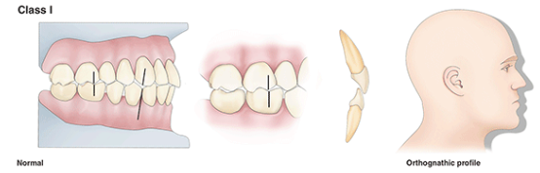
Figure 1. Normal Occlusion Also Known as Class I. Shows the normal occlusion of the mouth as it refers to the teeth and face profile.

Figure 1 describes normal occlusion as the first molars on the mandible and maxilla are aligned and the maxillary canine diagonally fits into the space between the mandibular canine and first premolar. The jaw looks very relaxed in the human model shown in the picture and is described as a orthognathic profile¹⁰. 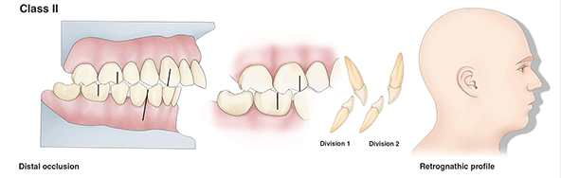
Figure 2. Distal Occlusion Also Known as Class II. Shows the distal occlusion of the mouth as it refers to the teeth and face profile.

The second type of occlusion described by Vickie Foster, RDH is called a distal occlusion and is shown in the figure above⁷. This model provides a good visual on how the distal occlusion effects the line up of the teeth as well as the face profile. In a distal occlusion, the maxillary first molar is in line with the mandibular second premolar and the maxillary canine is aligned with mandibular lateral incisor. This occlusion causes the maxilla to be positioned further out than the mandible, causing a retrognathic profile as shown in the figure⁷.
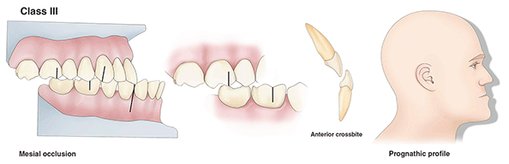
Figure 3. Mesial Occlusion Also Known as Class III. Shows the mesial occlusion of the mouth as it refers to the teeth and face profile.

The third and final type of occlusion is called a mesial occlusion and is shown in the figure above⁷. The mesial occlusion shows the maxillary first molar in line with the mandibular second molar and the maxillary canine aligned with space between the mandibular second premolar and first molar. This occlusion causes the mandible to be positioned further out than the maxilla causing a prognathic profile as shown in the figure⁷.
After reviewing different occlusions, it is necessary to provide information on crossbites as they are mentioned in this proposal. Dr. Romani Banjerjee provides us with the definition of a crossbite as the misalignment of teeth, producing an improper bite between the maxillary and mandibular teeth². There are two different types of crossbites; anterior and posterior². In an anterior crossbite, the maxillary front teeth are positioned behind the mandibular front teeth and is shown below^{2,13}.
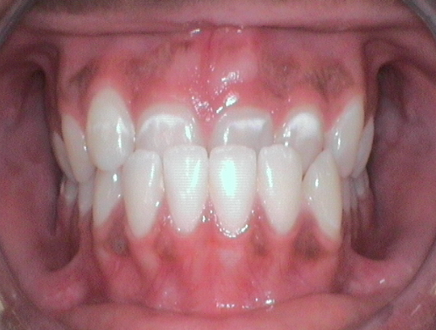
Figure 4. Anterior Crossbite. Shows a frontal view of the condition known as an anterior crossbite.

The second crossbite is known as a posterior crossbite and can be described by the maxillary back teeth being outside of the mandibular back teeth and is shown in the figure below^{2,16}.
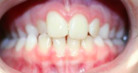
Figure 5. Anterior Crossbite. Shows a frontal view of the condition known as an anterior crossbite.

Habits such as digit and thumb sucking, non-nutritive (pacifier) sucking and nail-biting are common in young children. These habits can be frustrating for parents to help their children overcome. How are these habits effecting children in the long term and what can parents do to successfully help their children overcome them?
After extensive research, it is obvious that these habits are prevalent around the world and start in the early years of a child’s life. Larsson brings a study that shows the effects of these habits in Sweden. He talks about how those who breast-feed longer (~11 months) are less likely to have children who develop habits such as pacifier- and digit-sucking¹⁴. Chen and his colleagues also confirm this fact as he shows that a short duration of breast-feeding is “associated with a posterior crossbite”⁴. Along with this research, Larsson also found that children with a pacifier habit should be evaluated between 2 and 3 years of age due to the occlusion of the teeth prevalent with a pacifier-sucking habit¹⁴. He advises parents to reduce the pacifier-sucking time for children¹⁴. In the early months and years of a child’s development, it is important to wean children off of bottles in a timely manner due to the obvious risks of prolonged bottle use⁸. Not only do these early habits cause crossbites, they can also cause dental caries in childhood. Feldens and his colleagues research this fact and find that “more frequent feeding and daily bottle-use, breastfeeding, and consumption of food and/or drinks at 12 months prove a high risk of dental caries showing up two years later”⁶. These researchers also suggest that the amount of time the child is nursed and fed should be reduced to “less frequent intervals once nutritionally sufficient foods are introduced” into the child’s diet⁶. Lastly, Ling and his team help us understand how these habits are intertwined. These researchers find that breast feeding for more than 6 months leads to daily pacifier use and daily pacifier use leads to daily digit and/or thumb sucking¹⁵. Children showing these habits for more than a year have a higher risk at the development of dental occlusion¹⁵. After looking at these extremely early childhood habits and their effects, it is necessary to look at the specific habits and note what happens if there is prolonged exposure to these habits.
One of the most common childhood habits is pacifier-sucking. This habit starts when children are extremely young and is generally used to calm crying children down. Schmid and her colleagues found that there is some evidence showing that “pacifier use may cause open bites and crossbites”, therefore causing improper development of orofacial structures¹⁷. They also found that pacifiers with a thin neck produce less of an open bite than regular ones¹⁷. To further study these facts, Caruso and his colleagues studied orthodontic pacifiers and their effects on children’s dental occlusion. They found that orthodontic pacifiers do not help improve a pacifier habit³. Although these orthodontic pacifiers do not help with regular pacifier habits, they do help reduce the risk of a digit-sucking habit³. With this being said, most parents seem to prefer their children to have a pacifier habit rather than a digit-sucking habit, but which is really worse? Dogramaci and his colleagues seem to provide an answer for this question. His team found that those with a pacifier habit are less at risk to develop an overjet, but more likely to develop a crossbite⁵. Overall, they found that pacifiers pose a greater risk of malocclusion compared to digit-sucking⁵.
As stated before, we have seen in many different studies that one habit is strongly related to another. Digit-sucking is another major childhood habit that effects the dental occlusion of children. Kolawole and his colleagues found that not only do digit-sucking habits effect the dental occlusion of children, but also increase the risk of cavities¹¹. They conclude that this is not a significant predictor, but it is a prevalent result¹¹.
Digit-sucking clearly influences the dental occlusion of children, but what happens if there is no orthodontic intervention? Huang and his colleagues decided to conduct an experiment to bring an answer to this question. A non-orthodontic intervention (NOI), involves the guidance of tongue position by a small, round gelatin material⁹. Through this experiment, they found that the digit-sucking habit decreased in most of their subjects⁹. They also conclude that those with an anterior bite decreased from this NOI⁹. This NOI could help many children overcome their digit-sucking habit and decrease the amount of orthodontic visits, saving patients money.
The last habit in review is fingernail biting. Fingernail biting can cause gingival injuries in the mouth as stated by two research teams. Charlene Krejci provides a case study on an adolescent male. She describes this patient’s gingiva to show bleeding and inflammation¹². She also finds fingernail fragments embedded in the gingival tissue¹². This case study shows some minor effects of fingernail biting, but patients can also present bacterial contamination, inflammation, recession, attachment loss, bone loss, and even tooth loss¹². In context with bacterial contamination, Baydas brings research that provides information on Enterobacteriaceae. This family of organisms is one of the most pathogenic and frequent in clinical microbioliogy¹. The habits of fingernail biting and digit-sucking are associated with this family of organisms and can easily lead to the spread of infectious diseases¹. Sun and his colleagues provide information on how to improve habit reversal treatment for nail biting as it is ineffective since nailbiting is a stress and nerve related habit¹⁸. They found that auricular acupressure (acupressure on the external ear) can improve the usefulness of habit reversal treatment by reducing anxiety¹⁸.
These habits clearly provide evidence to multiple oral problems such as bacterial contamination, injury, crossbites, occlusions, joint disorders, and tooth wear and tear. It is important for patients and parents to understand how to reverse these habits in easy and effective ways to be healthy and save money. Dentists can easily provide information on these issues in regards to how to reverse them¹⁹. Kerosuo provides evidence that dentists can easily use prevention and early orthodontic prevention to minimalize the effects of the aforementioned habits¹⁰.
AIMS OF THE PROPOSED STUDY
This study aims to research and observe the effects of the previously mentioned habits on teenagers with/without orthodontic interference. There was not much research found on the effects of these habits with/without orthodontic interference, therefore it will be interesting to see what the results of this study. I am very interested in studying teenagers as there was also not research about how their childhood habits effected them. Another reason this study is extremely interesting to me is because I had a large gap in between my front teeth and have had a nail biting habit since my pre-teen years, yet never had to visit the orthodontist. I did not have any other habits as I was not breast fed after 3 months, stopped being bottle fed around 1 year, and never developed a thumb/finger-sucking or pacifier sucking habit. I feel as though this project will also allow me to further pursue my career in the dental field. With this research, I will be able to advise my patients and/or their parents about when and how to overcome or help one overcome these habits. I will also be able to explain to these individuals how these habits effect their oral and maxillofacial development. My hopes for this study are to provide a solid explanation of the effects of childhood habits on oral and maxillofacial development. I hope to advise individuals enough so they can get rid of their habit before orthodontic interference is necessary. I think the work orthodontists do is incredible, but I am afraid patients are sent to the orthodontist too often and spend thousands on dental issues that could have been fixed early on in development. One habit not mentioned I believe should be studied in children and will be studied in teenagers in this study is “sippy” cup use. There is little to no research on this topic, therefore it is important to study, research, and observe this possible damaging habit. As a hopeful dental school applicant, I am interested in further studying these habits and providing more research on them.
METHODS
1000 teenagers both male and female will originally partake in this study. They will first take a survey providing information on their past childhood habits as well denoting whether or not they have pursued orthodontic help for their oral and maxillofacial developmental problems. 600 teenagers will be chosen based on their childhood habits and whether they have pursued orthodontic help. 100 will have denoted that they previously developed a specific habit, placing the teenagers in 6 groups with one group being teenagers who had no habits. The other five groups will be made up of previous thumb and digit-suckers, pacifier suckers, nail biters, prolonged bottle users, and prolonged sippy cup users. These teenagers will then be split into two subgroups based on whether they have received orthodontic interference within their habit group. These subgroup numbers may vary, which I predict to possibly be a pitfall of this experiment. Each teenager will undergo a thorough examination and their dental occlusion will be noted in writing and with pictures. After this, each written and picture note will be compared to the normal occlusion description and picture previously mentioned (Fig. 1).
EXPECTED RESULTS
Based on previous research, all effects of habits are expected to be shown in all patients who have not been seen and treated by an orthodontist. Those who have been treated will show signs of improvement of the occlusion and crossbite of the mouth. The intention of showing these results is to provide evidence that orthodontic interference is helpful, but possibly not the best option. This project serves as a baseline for these teenagers. In order to continue research, the teenagers who have not undergone orthodontic interference will be provided a cheaper alternative to braces/invisalign and observed in an appropriate amount of time.

REFERENCES
- Baydas, B., Uslu, H., Yavuz, I., Ceylan, I., & Dagsuyu, I. M. (2007). Effect of a chronic nail-biting habit on the oral carriage of Enterobacteriaceae. British Dental Journal, 202(11), 679–679. doi: 10.1038/bdj.2007.500
- Banerjee, R. (2019, July 18). What is a Crossbite? Cause, Types, Treatment. Retrieved from https://www.stemjar.com/crossbite/.
- Caruso, S., Nota, A., Darvizeh, A., Severino, M., Gatto, R., & Tecco, S. (2019). Poor oral habits and malocclusions after usage of orthodontic pacifiers: an observational study on 3–5 years old children. BMC Pediatrics, 19(1). doi: 10.1186/s12887-019-1668-3
- Chen, X., Xia, B., & Ge, L. (2015). Effects of breast-feeding duration, bottle-feeding duration and non-nutritive sucking habits on the occlusal characteristics of primary dentition. BMC Pediatrics, 15(1). doi: 10.1186/s12887-015-0364-1
- Dogramaci, E. J., & Rossi-Fedele, G. (2016). Establishing the association between nonnutritive sucking behavior and malocclusions. The Journal of the American Dental Association, 147(12). doi: 10.1016/j.adaj.2016.08.018
- Feldens, C. A., Rodrigues, P. H., Anastácio, G. D., Vítolo, M. R., & Chaffee, B. W. (2017). Feeding frequency in infancy and dental caries in childhood: a prospective cohort study. International Dental Journal, 68(2), 113–121. doi: 10.1111/idj.12333
- Foster, V. P. (n.d.). Occlusion: An Overview of Dental Anatomy: CE Course. Retrieved from https://www.dentalcare.com/en-us/professional-education/ce-courses/ce500/occlusion.
- Gillham, M., Rich, A., Finkelman, M., Loo, C. Y. (2019). Bottle-Weaning Recommendations Among Pediatricians and Pediatric Dentists. Pediatric Dentistry, 41(4), 271-280(10).
- Huang, B., Lejarraga, C., Franco, C. S., Kang, Y., Lee, A., Abbott, J., … Pumtang-On, P. (2015). Influence of non-orthodontic intervention on digit sucking and consequent anterior open bite: a preliminary study. International Dental Journal, 65(5), 235–241. doi: 10.1111/idj.12178
- Kerosuo, H. (2002). The Role of Prevention and Simple Interceptive Measures in Reducing the Need for Orthodontic Treatment. Medical Principles and Practice, 11(1), 16–21. doi: 10.1159/000057774
- Kolawole, K. A., Folayan, M. O., Agbaje, H. O., Oyedele, T. A., Oziegbe, E. O., Onyejaka, N. K., … Oshomoji, O. V. (2016). Digit Sucking Habit and Association with Dental Caries and Oral Hygiene Status of Children Aged 6 Months to 12 Years Resident in Semi-Urban Nigeria. Plos One, 11(2). doi: 10.1371/journal.pone.0148322
- Krejci, C. B. (2000). Self-Inflicted Gingival Injury Due to Habitual Fingernail Biting. Journal of Periodontology, 71(6), 1029–1031. doi: 10.1902/jop.2000.71.6.1029
- Kumar, D. (2017, December 11). Anterior Crossbite. Retrieved from https://www.angelorthodontics.co.uk/anterior-crossbite/.
- Larsson, E. (2001). Sucking, chewing, and feeding habits and the development of crossbite: A longitudal study of girls from birth to 3 years of age. Angle Orthodontist, 71(2), 116-119.
- Ling, H. T. B., Fung Hou Kumoi Mineaki Howard Sum, Zhang, L., Yeung, C. P. W., Li, K. Y., Wong, H. M., & Yang, Y. (2018). The association between nutritive, non-nutritive sucking habits and primary dental occlusion. BMC Oral Health, 18(1). doi: 10.1186/s12903-018-0610-7
- Masuda. (n.d.). Smile Gallery Walnut Creek: Orthodontic Before and After Photos. Retrieved from https://www.masudaortho.com/patient-information/smile-gallery/.
- Schmid, K. M., Kugler, R., Nalabothu, P., Bosch, C., & Verna, C. (2018). The effect of pacifier sucking on orofacial structures: a systematic literature review. Progress in Orthodontics, 19(1). doi: 10.1186/s40510-018-0206-4
- Sun, D., Reziwan, K., Wang, J., Zhang, J., Cao, M., Wang, X., … Liu, Y. (2019). Auricular Acupressure Improves Habit Reversal Treatment for Nail Biting. The Journal of Alternative and Complementary Medicine, 25(1), 79–85. doi: 10.1089/acm.2018.0063
- Vogel, L. D., (1998). When Children Put Their Fingers in Their Mouths. New York State Dental Journal, 64(2), 48-53.

