Investigating Microbial Diversity Between Water and Gravel in Prince Edward County

Introduction
Microbes are mainly composed of bacteria, archaea, algae, protozoa, fungi and small metazoan. These microbes represent the most abundant and diverse group across ecosystems, and play crucial roles in aquatic ecosystem functioning. In river ecosystems, microbial communities are driven by many interacting factors and processes. It has been shown that environmental factors play the most important role in shaping the composition of microbial communities. However, spatiotemporal variation in the distribution and abundance of microbes is an inherent property of ecological systems (Liu 2013). Bacteria and archaea drive many fundamental processes in marine sediment, including oxidation of organic matter, production of methane and other hydrocarbons, and removal of sulfate from the ocean (Kallmeyer 2013). Previous studies of sub-seafloor sediment from ocean margins and the eastern equatorial Pacific Ocean reported high abundances of microbial cells (Kallmeyer 2013). Soil also has very interesting microbes found in it. The high diversity of microorganisms in soil has proven challenging to investigations of community dynamics and persistence. Numerous DNA- and lipid-based investigations of soil microbial communities have suggested high spatial and seasonal variability (Yarwood 2013).
The walking path should show change if the experiment was also performed a week or so later because of the nutrients available to it at the present moment versus a few weeks from now (Shen 2016). Previous studies of sub-seafloor sediment from ocean margins and the eastern equatorial Pacific Ocean reported high abundances of microbial cells (Kallmeyer 2013). For this project, there will be a collection of samples from the top of the water in Buffalo Creek and from the top of the walking path from the EEC to Buffalo Creek. The specific aim is to see how much and what kind of microbes can be found in the samples and compare the samples to each other. It is hypothesized that both samples will show a large and diverse amount of microbes.
Methods
Site Selection, Description, and Sampling
The sites were chosen by the group in Farmville, Virginia near the Environmental Education Center(EEC). One water sample was taken about 500 feet away from the Appomattox River in the middle of Buffalo Creek and the gravel sample was taken about 100 feet away from the water sample on a gravel road closer to the EEC. Both samples were taken by unscrewing the cap of the 50ml conical tubes once the one for the creek sample was under the water and once the tube was over the gravel scooping up the samples.
Dilution of the Samples and Bacterial Colonization
The gravel sample was weighed out to 3g and 10ml of sterile water was put in the tube with the gravel and shaken for 1 minute. For both samples, 100µl was taken out of each sample and put on the respective 100% nutrient agar plate. 20µl of both samples were taken, put into 1:10 microcentrifuge tubes, mixed by vortex, and put on the appropriate 1:10 plate by micropipette. 20µl of each sample was taken from the 1:10 microcentrifuge tube, put into the 1:100 microfuge tube, mixed by vortex, and put onto their respective 1:100 nutrient agar plate using a micropipette. All plated samples were spread using the hockey stick method with L shaped cell spreaders. The nutrient agar plates were then incubated in 23°C for 48 hours, but stopped after 48 hours because of overgrowth on the plates.
Genomic DNA Extraction and Isolation
One bacterial colony was selected from two different nutrient agar plates to perform DNA analysis. The two colonies were a pink colony and an orange colony. 300µl of the microbead solution was added into each centrifuge tube. The selected colony was then collected by gently sliding the tip of a sterile toothpick across the colony. The tip was then placed in the sterile water of the appropriate microcentrifuge tube quickly and carefully and swirled around for 30 seconds. This process was completed with the second colony. All 300µl of cells were transferred into a microbead tube and 50µl of the MD1 solution was added. The microbead tubes were secured horizontally to a vortex and vortexed for 10 minutes. The tubes were then centrifuged at 10,000 x g for 30 seconds at room temperature. The supernatant was then transferred to a clean, labelled 2ml collection tube. 100µl of the MD2 solution was added to the supernatant, vortexed for 5 seconds, and incubated at 4°C for 5 minutes. The tubes were then centrifuged at 10,000 x g for 1 minute at room temperature. Avoiding the pellet, the entire volume of supernatant was transferred to a clean, labeled 2 mL collection tube and shaken to mix MD3 solution. 900µl of MD3 was added to the supernatant and vortexed for 5 seconds. About 700µl of this mixture was put in the spin filter and centrifuged at 10,000 x g for 30 seconds at room temperature. The flowthrough was discarded in a waste beaker. The remaining supernatant was added to the spin filter and centrifuged at 10,000 x g for 30 seconds at room temperature. The flow through was again discarded. 300µl of MD4 solution was added and centrifuged at 10,000 x g for 30 seconds at room temperature. The flow through was discarded again. The tube was centrifuged again for 1 minute at 10,000 x g. Being careful not to splash liquid on the sides of the spin filter, the spin filter was placed in a new 2 mL collection tube. 50µl of MD5 solution was added to the center of the white filter membrane and centrifuged at 10,000 x g for 30 seconds at room temperature. The flow through was discarded once more. The tubes of DNA were labelled with the colony, date, and group initials and stored at -20°C.
PCR-16s DNA Amplification
6μL of the template DNA and 44μL of PCR were added to a tube. The PCR contained 1μL of forward primer, 1μL of reverse primer, 25μL of Taq, and 17μL of water. The tubes were labeled and placed in a PCR machine. Initial Denaturation was at 94°C for 30 seconds and then there were 30 cycles of 94°C for 30 seconds, 55°C for 45 seconds, and 68°C for 60 seconds. The final extension was at 68°C for 5 minutes, and was held at 4°C. The universal primers that were used to amplify the DNA were a forward strand of 5’GAGTTTGATYMTGGCTC-3’ and a reverse strand of 5’NRGYTACCTTGTTACGACTT-3’. The unknowns in this strand (N, R, and Y) could be A or G for R, C or T for Y, and all four bases for N.
PCR Clean-up
100 µl of a reaction product was transferred to a 1.5 microcentrifuge tube and 5 volumes of DF Buffer was added to 1 volume of the sample and mixed by vortex. The DF Column was placed in a 2 ml Collection Tube, the sample mixture was transferred to the DF Column, and centrifuged at full speed for 30 seconds. The flow-through was discarded and the DF Column was placed back in the 2 ml Collection Tube. 600 µl of Wash Buffer with ethanol was added into the center of the DF Column, stood for 1 minute, and was centrifuged at full speed for 30 seconds. The flow-through was discarded, the DF Column was placed back in the 2 ml Collection Tube, and centrifuged again for 3 minutes at full speed to dry the column matrix.
The dried DF Column was transferred to a new 1.5 ml microcentrifuge tube. 25 µl of Elution Buffer was added into the center of the column matrix, stood until the Elution Buffer is completely absorbed by the matrix, and centrifuge for 2 minutes at full speed to elute the purified DNA.
Restriction Enzyme Digestion
The two PCR products and a tube of MspI enzyme premixed with its buffer were set up for 5μl PCR product and 10μl MspI. Samples were mixed by pipetting gently up and down with the micropipette set to 10μL. The samples were incubated for 45 min at 37°C.
Gel Electrophoresis
The gel caster was leveled and 0.6 g of agarose and 40 mL of 1X TAE buffer was mixed in a 125 mL Erlenmeyer flask. The agarose was microwaved for 2 minutes, stopping the microwave every 30 seconds to swirl the flask, making sure it doesn’t boil. The dissolved agarose was poured into the gel tray. The comb was immediately inserted at the top of the gel and the gel was left to solidify for about 45 minutes. After 45 minutes, the comb was carefully removed. 5 μL of 5X loading buffer was added into each tube. The contents were mixed by pipetting slowly up and down with the micropipette. The electrophoresis chamber was filled and the gel was covered with 1X TAE buffer. 10 μL of each sample was loaded into separate wells in the gel chamber. The lid was carefully placed on the electrophoresis chamber. An electrical power supply was run through the gel apparatus being careful to attach red connectors with red ports and black connectors with black ports. The power was turned on and the gel was run at 120 V for 30 minutes. When the electrophoresis run was complete, the power was turned off and the top of the chamber was removed. The gel and tray were carefully removed from the gel box and the gel was slid into a tray. The gel was visualized under a UV camera and placed in the waste bag.
DNA Sequencing
The DNA was sent to a company called EurofinsGenomics for sequencing. To prepare the DNA for sequencing, the “cleaned” PCR product was mixed with the sequencing primer: 5’-GAGTTTGATCCTGGCTCAG-3’. Two sequencing tubes were obtained with each one having a unique barcode on the side. The barcodes were written down along with a label easily recognized. 5µl of the “cleaned” PCR product and 4µl of the sequencing primer was added to both samples. The samples were then sent off for sequencing.
Results
Site Description
The site from which the gravel and water samples was in Prince Edward County near the Environmental Education Center. The water sample was collected from Buffalo Creek, about 100 feet from the Appomattox River (Figure 1). The gravel sample was collected from a gravel trail about a mile away from the water sample (Figure 2).
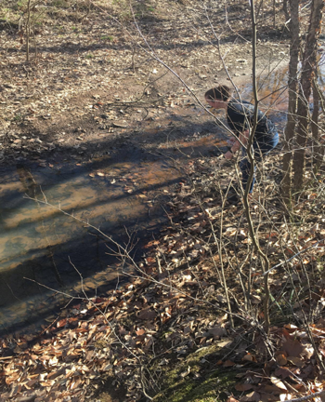
Figure 1. Buffalo Creek sample site.
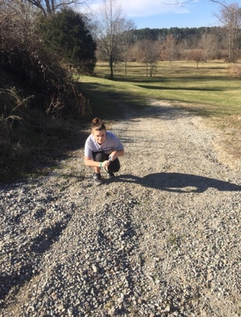
Figure 2. Gravel sample site

Colony Growth and Characteristics
After 24 hours the colony growth was recorded. The 100%(undiluted) gravel grew over 100 colonies, 1:10 diluted gravel grew 15 colonies, and the 1:100 diluted gravel grew 22 colonies. The 100%(undiluted) water grew 5 colonies, 1:10 diluted water grew over 100 colonies, and the 1:100 diluted water grew 4 colonies (Figure 3).
After 48 hours the colony growth was recorded. The 100%(undiluted) gravel grew over 100 colonies, 1:10 diluted gravel grew 50 colonies, and the 1:100 diluted gravel grew 8-10 colonies. The 100%(undiluted) water grew 30 colonies, 1:10 diluted water grew 1-3 colonies, and the 1:100 diluted water grew 1 colony (Figure 3).

Figure 3. The amount of colony growth over a 48-hour time period. Data was collected after 24 hours and after 48 hours.
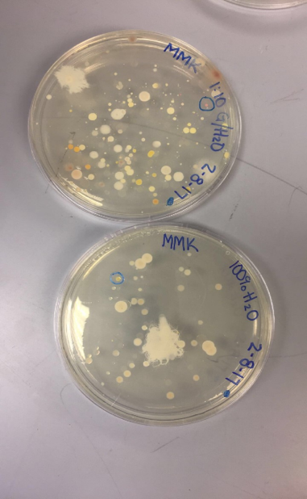
Figure 4. Bacterial plates for DNA sampling. The plate for undiluted creek water sample (left) is shown, as well as the plate for the 1:10 diluted gravel sample (right).

After 48 hours, the different colors of bacteria were observed. For the water, 2 pink colonies, 40 white colonies, 6 yellow colonies, and 2 orange colonies were observed (Figure 5). For the gravel, 0 pink colonies, 30 white colonies, 5 yellow colonies, and 2 orange colonies were observed (Figure 5). 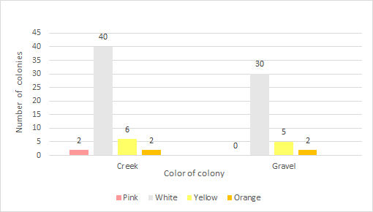
Figure 5. The sum of various colored colonies. Data about the colors of colonies were collected from the gravel sample and creek sample.
The different characteristics of colonies ranged widely. The creek characteristics were overshadowed by the gravel characteristics in almost all characteristics except the x-large, fuzzy texture, and spindle form (Figure 6). 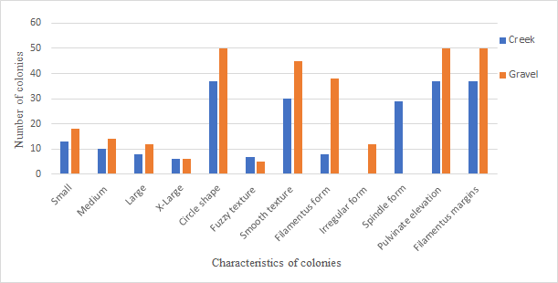
Figure 6. Characteristics of colonies. Colonies were analyzed for sizes, shapes, textures, forms, and margins. Colonies were viewed from a 1:10 gravel sample and 100% creek water sample.
Gel Electrophoresis
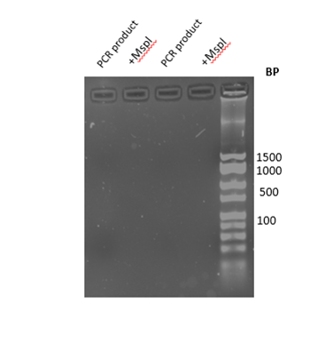
Figure 7. Gel electrophoresis for Mspl and PCR product. There was no visible migration to obtain data from due to the impurity of the DNA run.

DNA sequencing and analysis
Janthinobacterium lividum strain was the strain of bacteria which most aligned to the sequence at 99%. Janthinobacterium svalbardensis strain and Janthinobacterium agaricidamnosum strain were the next in alignment with 98%. Herminiimonas glaciei strain and Herminiimonas saxobsidens strain were the least of the five aligned strain at 97%. Janthinobacterium lividum strain was chosen because it did show the highest identity compared to the others (Table 1).
Bacterial alignment | Percent identity | Number of gaps
Janthinobacterium lividum strain | 99 | 2
Janthinobacterium svalbardensis strain | 98 | 6
Janthinobacterium agaricidamnosum strain | 98 | 11
Herminiimonas glaciei strain | 97 | 12
Herminiimonas saxobsidens strain | 97 | 15
Table 1. Top five alignments for 16s rRNA sequence.

Bacterial Identification

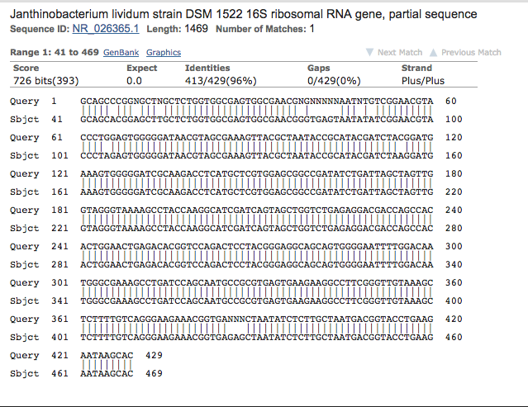
Figure 8. DNA sequence for the creek water sample. The sequenced PCR product generated 469 base reads. The chromatogram of the sequence is available as a pdf. (SKRFC_PREMIX_JF7578_46) NCBI BLAST analysis revealed 96% identity with bases 413/429 of the 16s rRNA gene of Janthinobacterium lividum.

Discussion
The experimental goal of this project was comparing microbes at the top of gravel trail to microbes at the top of Buffalo Creek water, both located near the Environmental Education Center in Prince Edward County. It was hypothesized that each sampled area will have many microbes; however, their classifications would be different. The experiment’s hypothesis cannot be accepted nor rejected due to lack of data. Both site’s DNA could not be sequenced due to a malfunction in the experiment from human error and/or the possibility that the bacteria contained was a yeast or other fungal form. However, a bacterium was received from another group who sampled from the same water site. This bacterium was contained and studied in this experiment.
The bacterium contained is named Janthinobacterium lividum strain DSM 1522 16S Ribosomal. It is a gram-negative bacterium that has antimicrobial and antitumor properties. It is usually found on the skin of amphibians. This bacterium protects against fungal pathogens, which means the bacterium found was prepared to attach to creek amphibians such as frogs, salamanders, and snakes. The bacterium protects amphibians from a fungus called Batrachochytium dendrobatidis. This fungus causes a disease called Chytridiomycosis, which has shown a major decline in amphibians around the world. This bacterium is found in arctic areas as well as in soil on land and/or soil at the bottom of a water source. Janthinobacterium lividum shows capnophilic (when organisms live in high concentrations of carbon dioxide) actions which has not been shown in any of the other members of the bacterium’s genus. The genome sequence of Janthinobacterium lividum strain showed that enzymes with the glyoxylate cycle, may increase the efficiency of gluconeogenesis (Valdes, 2015). Gluconeogenesis is a process where organisms produce glucose for catabolic reactions from non-carbohydrates. This is done by using intermediaries from the TCA cycle. This explains the capnophilic behavior of the Janthinobacterium lividum (Valdes, 2015). This fact is important because it could help enhance growth in places with excessive amounts of O2 and CO2 areas, similar to the skin of amphibians.
Janthinobacterium lividum has shown elevated levels of resistance to B-lactam antibiotics. The two most common forms of Janthinobacterium lividum are red pigmented and purple pigmented. The red pigmented bacteria are mostly found in aquatic environments, whereas the purple pigmented bacteria are found in arctic soils. However, a study found red pigmented Janthinobacterium lividum in a non-permafrost Alaskan soil (Patrick, 2010). It was found that the red pigmented bacteria produced prodigiosin which is a secondary metabolite of Serratia marcescens. It was also found that the purple pigmented bacteria produced violacein, which is a naturally-occurring bis-indole pigment with antibiotic properties. These are both temperature dependent bacteria and both the red and purple pigmented Janthinobacterium lividum can be toxic to other bacteria, viruses, and protozoa. Investigating and exploring the different environments and locations of Janthinobacterium lividum bacteria may help to expand the knowledge of the bacteria, the resistance to different antibiotics, and the biochemical and genetic diversity of this bacteria.
Along with its resistance to B-lactam antibiotics, Janthinobacterium lividum can sometimes cause infections, such as fatal septicemia which is an infection of the blood, and if left untreated can lead to death. It has been found that Janthinobacterium lividum is able to grow in sessile conditions forming extended biofilms that are an important way to colonize environments (Pantanella, 2006). It also has been found that violacein and biofilm production in Janthinobacterium lividum is regulated through the influence of antibiotics, the carbon source, and the phase of growth. Studies show that the violacein production and biofilm development represent a response to environmental stresses and are key factors in survival mechanisms of Janthinobacterium lividum (Pantanella, 2006). The production of violacein and biofilm can be considered a beneficial factor for Janthinobacterium lividum to resist to different environmental stresses. Although this has been found, it is still not clear how the metabolic pathway by which the survival is guaranteed, therefore further studies must be performed (Pantanella, 2006). This shows there is still more to discover about the Janthinobacterium lividum bacteria.
There are many harmful diseases threatening the wildlife population, which is why understanding the diseases and their treatments can lead to better management and better outcomes. For example, many amphibians are experiencing a decline in population due to a skin disease previously mentioned called chytridiomycosis, which is caused by the fungus Batrachochytrium dendrobatidis (Harris, 2009). It has been found in multiple studies that the bacteria Janthinobacterium lividum helps to fight off this disease. A high production of an anti-chytrid metabolite violacein, is found on amphibians where Janthinobacterium lividum was added (Harris, 2009). It was found that altering the amount of Janthinobacterium lividum produced on the skin of an amphibian allows for an increasingly higher chance of protection against chytridiomycosis, ultimately allowing the survival rate of amphibians to be much higher (Harris, 2009).
This study is important because knowing more about Janthinobacterium lividum strain DSM 1522 16S Ribosomal can help the massive decline in amphibians around Prince Edward county and ultimately around the world. For future experiments, a retesting of the gravel sample could be completed in order to compare the microbiomes in the creek water and the microbiomes in the gravel. Another experiment which could be done is to test the top and bottom of each of the sample sites as done in 2006, if these sites are tested, comparison of microbes from each site as well as what was found to what may be known about the top of those specific areas already will be easy to match (Mitchell, 2006). To further study Janthinobacterium lividum, studies could be done to see the interaction of Janthinobacterium lividum with other bacteria, as well as the interaction with the amphibians. Finding this bacterium could help to multiply it, ultimately helping amphibians fight off diseases.

Acknowledgements
Harris, R. N., Brucker, R. M., Walke, J. B., Becker, M. H., Schwantes, C. R., Flaherty, D. C., . . . Minbiole, K P. (2009, March 26). Skin microbes on frogs prevent morbidity and mortality caused by a lethal skin fungus. The ISME Journal 3, 818–824. Available from google scholar. Retrieved April 4, 2017.
Kawakami, R., Sakuraba, H., & Ohshima, T. (2007, May 25). Gene Cloning and Characterization of the Very Large NAD-Dependent L-Glutamate Dehydrogenase from the Psychrophile Janthinobacterium lividum, Isolated from Cold Soil. Journal of bacteriology 189,15. Available from Web of science. Retrieved April 5, 2017.
Pantanella, F., Berlutti, F., Passariello, C., Sarli, S., Morea, C., & Schippa, S. (2006, September 19). Violacein and biofilm production in Janthinobacterium lividum. Applied microbiology, 102,4. Available from google scholar. Retrieved April 02, 2017.
Patrick D. Schloss, Heather K. Allen, Amy K. Klimowicz, Christine Mlot, Jessica A. Gross, Sarah Savengsuksa, Jennifer McEllin, Jon Clardy, Roger W. Ruess, and Jo Handelsman.(2010, July 13). Psychrotrophic Strain of Janthinobacterium lividum from a Cold Alaskan Soil Produces Prodigiosin. DNA and Cell Biology,29,9. Available from google scholar. Retrieved April 02, 2017.
Valdes, N., Soto, P., Cottet, L., Alarcon, P., Gonzalez, A., Castillo, A., . . . Tello, M. (2015, November 24). Draft genome sequence of Janthinobacterium lividum strain MTR reveals its mechanism of capnophilic behavior. Standards in Genomic Sciences, 10, 110. Available from Web of science. Retrieved April 02, 2017.
Kallmeyer, J., Pockalny, R., Adhikari, R. R., Smith, D. C., & D’Hondt, S. (2012). Global distribution of microbial abundance and biomass in subseafloor sediment. Proceedings of the National Academy of Sciences of the United States of America, 109(40), 16213–16216.
Liu, Lemian, Jun Yang, Xiaoqing Yu, Guangjie Chen, and Zheng Yu. 2013. "Patterns in the Composition of Microbial Communities from a Subtropical River: Effects of Environmental, Spatial and Temporal Factors." PLoS One 8 (11).
Mitchell L. Sogin, Hilary G. Morrison, Julie A. Huber, David Mark Welch, Susan M. Huse, Phillip R. Neal, Jesus M. Arrieta, and Gerhard J. Herndl. July 31, 2006. “Microbial diversity in the deep sea and the underexplored “rare biosphere”. PNAS 2006 103 (32)
Shen, Y., Chen, Y., & Li, S. (2016). Microbial functional diversity, biomass and activity as affected by soil surface mulching in a semiarid farmland. PLoS One, 11(7)
Yarwood, S., Brewer, E., Yarwood, R., Lajtha, K., & Myrold, D. (2013). Soil Microbe Active Community Composition and Capability of Responding to Litter Addition after 12 Years of No Inputs. Applied and Environmental Microbiology, 79(4), 1385–1392.

