Fluoride: Friend or Foe? The Effects of Fluoride on the Human Body

Introduction
This review explores the positive and negative effects of fluoride on the body as well as suggests safer alternatives to fluoride. Recently, I had the opportunity to intern at a pediatric dental office close to home. Through that experience an application I heard about every day was “fluoride”. This brought me to think about the effectiveness of fluoride and how safe if truly is.
As an element, Fluorine is the most electronegative and one of the most reactive elements (Adair et al 1990). “Fluorine forms many inorganic salts and is present in many organic compounds, taking place of hydrogen” (Adair et al 1990). Since fluoride is a highly toxic substance, the FDA now requires a poison warning on all fluoride toothpastes (fluoridealert). Fluoride has been used in rodenticides and pesticides to kill pests like rats and insects (fluoridealert). Because of these pest-killing chemicals, consumption of fluoridated dental products can cause serious poisoning incidents, including death (fluoridealert). Fluoride is also commonly used in restorative dental applications such as glass ionomer cements, fissure sealants, dental amalgam, and etc. (Burke et al 2006).
Fluoride can be used in multiple ways; by varnish, through drinking water, in toothpaste, in mouthwashes, etc. (Adair et al 2007). With all of these uses, fluoride ingestion is clearly a concern (Adair et al 2007). Excessive fluoride use can cause health issues such as arthritis, brain effects, cancer, cardiovascular disease, diabetes, kidney disease, thyroid disease, and much more (fluoridealert). A common health issue caused by excessive fluoride intake is fluorosis, where the appearance of enamel is changed to look mottled.
Fluoride is used on individuals of all ages, but it is often endorsed in pediatric oral health more than adult oral health because of how much children end up getting cavities due to excessive juice intake, candy, and other sticky foods. It was shown in a study by E.D Tabari that children who did not have fluoridated water were at lower risk of developing fluorosis than those who consumed fluoridated water on a daily basis (Tabari et al 2000). Although fluoride is endorsed in pediatric settings, fluorosis is commonly developed in children as their primary teeth are forming but have not appeared in the mouth yet.
The focus of this paper is based on the question: Do the negative effects of fluoride outweigh the positive effects?
Positive Effects of Fluoride
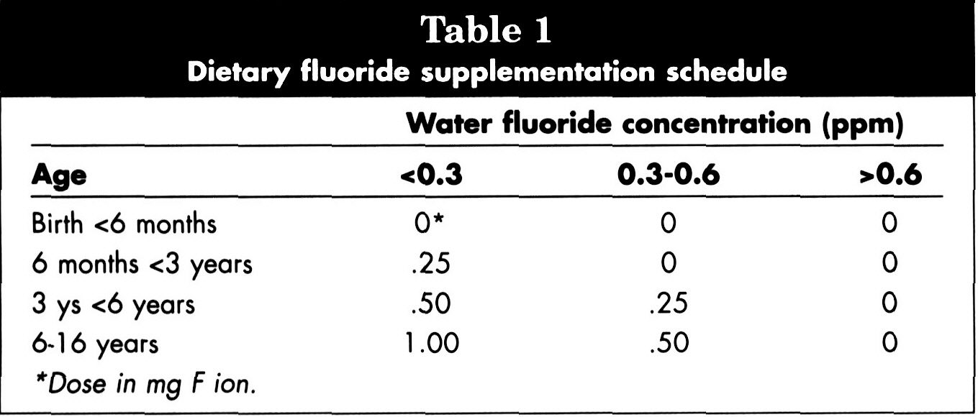
Fluoride is an important and effective means of reducing cavities in children (Adair et al 2007). Dental professionals have discovered that naturally occurring fluoride in the water supply led to decreased rates of cavities in the populations that consume them (Adair et al 2007). As stated previously, fluoride use is heavily endorsed in pediatric dentistry while primary teeth are forming. Adair’s review in 2007 shows how effective fluoride really is in preventing caries. Trials with various fluoride compounds between 1949 and the 1970s show that caries reductions of 26% to 80% were reported for decayed and filled primary surfaces. Of course with every experiment there are errors (Adair et al 2007). Between the 20-25 years of studies, there was poor or no randomization, lack of consistent controls, and differing levels of baseline dental care among study groups (Adair et al 1990). As the 20th century came to an end, researchers looked to reduce dental fluorosis risk as well as cavities risk management (Adair et al 1990). Through their studies, researches decided that dental professionals should inquire if children receive fluoride through their water. If children do not receive fluoride through their water, these dental professionals should recommend fluoride supplements (Table 1) (Adair et al 1990).

Table 1. Dietary Fluoride Supplementation Schedule.
Supplementation trials for children from birth to 16 years of age testing different concentrations of fluoride (Adair et al 1990).

In the first part of the 21st century, rather than ingesting fluoride through supplements, it was made known that a varnish should be applied (Adair et al 1990). Along with varnishes comes a review from Rasines in 2010. Rasines reviews the effectiveness of fluoride toothpastes of different concentrations in preventing cavities in children and adolescents (Rasines 2010). The review shows that fluoride concentrations of 1000 ppm and above provide preventative effects of fluoride toothpastes on dental cavities (Rasines 2010). With every discovery comes a risk: the risk of fluorosis. Acoording to Rasines, “The decision of what fluoride levels to use for children under 6 years of age should be balanced with this risk” (Rasines 2010).
Although fluoride use is endorsed in children and adolescents, they are not the only ones susceptible to cavities. Adults pose the same amount of risk as children to obtaining cavities. According to Griffin’s review, “Cavities are becoming more important health issues among adults, especially older adults, because they are more likely to retain their natural teeth than in previous generations” (Griffin et al 2007). Through this review it is also shown that the “mean number of missing teeth among adults aged 40+ has decreased by 22%” (Griffin et al 2007). Individuals are also living longer, therefore there are more “at-risk” teeth.
Negative Effects of Fluoride
There are multiple negative effects of excessive fluoride use. Excessive fluoride use weakens skeletal health, causes arthritis, is toxic to the thyroid, cause early puberty in females, is harmful to the cardiovascular system, and causes dental fluorosis.
Fluoride can weaken skeletal health because the liver is unable to process it (Kaminsky et al 1990). Since the liver is unable to process fluoride, the fluoride passes through the bloodstream where it combines with calcium that has been taken from the skeletal system (Kaminsky et al 1990). Because of this, affected individuals are left with weak bones known as skeletal fluorosis (Kaminsky et al 1990). Linked to skeletal fluorosis is arthritis as fluoride causes calcification of cartilage (dredwardgroup 2015).
Fluoride is toxic to the thyroid, as it was previously used in patients with hyperthyroidism (fluoridealert). Fluorine is in the same family as iodine where both are halogens (dredwardgroup 2015). Iodine is beneficial to the thyroid, but fluorine is not; since iodine and fluorine are extremely similar, the thyroid can absorb fluorine rather than iodine, inhibiting the function oft the thyroid and causing cell death (dredwardgroup 2015).
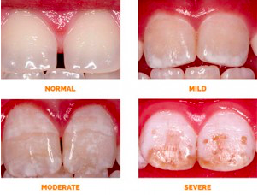
The pineal gland has the highest level of fluoride in the body (fluoridealert). On the website flouridealert the authors state that, “Fluoride exposure has been found to cause a decrease in the amount of circulating melatonin and leads to early puberty in females” (fluoridealert). On Dr Axe’s website it is stated that, “This early puberty may possibly lead to issues such as short stature and an increased chance of breast cancer” (draxe). It has been shown that higher fluoride exposure is linked to reduced testosterone and decreased fertility in humans (fluoridealert). Drinking water levels of 3ppm contribute to lower fertility as they have higher fluoride levels in them (dredwardgroup 2015). Excessive fluoride is also harmful to the cardiovascular system as it causes cardiovascular inflammation as well as atherosclerosis (dredwardgroup 2015). Another health issue caused by excessive fluoride intake is fluorosis, where the appearance of enamel is changed to look mottled (Figure 1).

Figure 1. Dental Fluorosis on Enamel. Normal enamel compared to mild, moderate, and severe fluorosis impacted
enamel (American Academy of Pediatrics).

Alternatives to Fluoride
Many alternatives to the harsh substance of fluoride have been discovered and studied, but one stands out over most: Chlorhexidine. Chlorhexidine, when used as a mouth rinse is considered the “gold standard” antiplaque agent (Claydon et al 2002). The use of chlorhexidine has been talked about in several reviews, but Claydon’s review in 2002 stands out the most. In this review, Claydon talks about how chlorhexidine varnishes are the most effective at reducing “mutans streptococci” (Claydon et al 2002). Research and studies by Autio-Gold about “using different chlorhexidine modes/chlorhexidine-fluoride combinations for cavities prevention is incomplete” (Autio-Gold 2006). The only chlorhexidine containing products in the US today are mouth rinses containing .12% chlorhexidine, but these rinses are not highly effective in preventing cavities (Autio-Gold 2006). Since chlorhexidine needs to be studied more, it is better that “evidence-based methods” (fluoride applications, diet modifications, and good oral hygiene) be used (Claydon et al 2002). Also recently found by Autio-Gold, when “reducing the levels of mutans streptococci/plaque reduction may not always correlate with cavities reduction” (Autio-Gold 2006).
A great diet modification that is effective in preventing cavities is Vitamin D. Vitamin D is a hormone produced by the skin that plays a part in bone health and can be a determining factor in developing many diseases because of its role in inflammation (vitaminD). Vitamin D’s involvement in calcium and phosphorus uptake and absorption also make vitamin D a major component of nervous system functioning (vitaminD). Vitamin D not only protects your teeth against cavities, but also helps keep your gums healthy (delitedental). Vitamin D is so effective, that children living in sunnier areas have fewer cavities than those living in rainy and foggy areas (delitedental). There are multiple sources of Vitamin D, that can be accessed through foods consumed such as, mushrooms, green leafy vegetables, salmon, tuna and catfish (delitedental). These foods create a powerful antimicrobial protein that attacks the oral bacteria known to cause cavities (delitedental).
The use of oils such as coconut oil, olive oil and oregano oil as a toothpaste have antibacterial properties also (delitedental). Mouthwash containing Neem is another alternative to fluoride and Myrrh is an ingredient in fluoride free toothpaste which kills the bacteria that causes bad breath (delitedental). Other foods that prevent decay in your mouth are yogurt, cheese, almonds, apples and pears (delitedental). Xylitol containing sugar free gums and mints prevent the bacteria that causes decay (delitedental). As for liquids; green tea, black tea, and red wine have benefits that provide a healthy balance in the mouth (delitedental).

Conclusion
In conclusion, this review has shown that although fluoride is commonly used and very effective, excessive fluoride use can cause chronic effects. These effects are extremely worrying. In order to eliminate the intense effects of fluoride, one should use safer and healthier alternatives. Healthier alternatives should be introduced and endorsed in and out of the dental office. Vitamin D can be accessed in many different foods as well as through vitamins. Other natural remedies and healthy foods should also be endorsed. As previously stated, the use of oils as a toothpaste have antibacterial properties (delitedental). Mouthwash containing Neem-which derives from a plant-is another alternative to fluoride and Myrrh is an ingredient in fluoride free toothpaste which kills the bacteria that causes bad breath (delitedental). Other foods that prevent decay in your mouth are yogurt, cheese, almonds, apples and pears (delitedental). Xylitol containing sugar free gums and mints prevent the bacteria that causes decay (delitedental). Xylitol is something I saw endorsed in a pediatric dental setting as we put Xylitol lollipops into the gifts bags. Along with these healthier alternatives, drinking plenty of water, avoiding sports drinks, juice, and sticky foods, including gummy vitamins can all prevent cavities in addition to routine dental care (delitedental).
Future Directions
Over-fluoridation should be tested to show how much fluoride is too much fluoride. Since city water contains fluoride, this type (mainly) would need to be tested. Once this test has been conducted, water should be filtered before entering homes, restaurants, and other places if possible.
Another important issue of fluoride is that those with low incomes as well as the elderly may have little or no access to restorative or preventive clinical care. At present, approximately 15% of state Medicaid programs provide no adult dental benefits at all, and approximately 45% cover only tooth extraction and emergency services (Oral Health America, 2003). Medicare actually does not cover routine dental care (Griffin et al 2007).
As previously stated, healthier alternatives should be introduced into the dental office, in the school system, and in the home, but it seems all that is healthy is expensive. In the bigger picture, if we can reduce the price of healthy foods, oils, vitamins, and other things, we would not have a national crisis of obesitby on our hands.

Works Cited
Adair, S. M. (2007). Evidence-Based use of Fluoride in Contemporary Pediatric Dental Practice. Oral Health,97(1), 44-60.
Autio-Gold, J. (2008). The Role of Chlorhexidine in Caries Prevention. Operative Dentistry,33(6), 710-716. doi:10.2341/08-3
Burke, F. M., Ray, N. J., & McConnell, R. J. (2006). Fluoride Containing Restorative Materials. International Dental Journal,56, 33-43.
Claydon, N., Smith, S., Stiller, S., Newcombe, R. G., & Addy, M. (2002). A comparison of the plaque-inhibitory properties of stannous fluoride and low-concentration chlorhexidine mouthrinses. Journal of Clinical Periodontology,29(12), 1072-1077. doi:10.1034/j.1600-051x.2002.291204.x
delitedental (2016, October 10). Are There Alternatives to Fluoride to Prevent Cavities?? Retrieved from https://delitedental.net/alternatives-fluoride-prevent-cavities/
dredwardfroup (2015, November 16). 9 Shocking Dangers of Fluoride Exposure. Retrieved from https://www.globalhealingcenter.com/natural-health/9-shocking-dangers-of-fluoride/
Fluoride Action Network | Health Effects. (n.d.). Retrieved March 1, 2018, from http://flouridealert.org/issues/health/
Fluoride in Water | What You Need to Know About Fluoride. (n.d.). Retrieved from https://draxe.com/is-fluoride-bad-for-you/
Griffin, S. O., Regnier, E., Griffin, P. M., & Huntley, V. (2007). Effectiveness of Fluoride in Preventing Caries in Adults. Journal of Dental Research; Houston,86(5), 410-415.
Kaminsky, L. S., Mahoney, M. C., Leach, J., Melius, J., & Miller, M. J. (1990). Fluoride: Benefits and Risks of Exposure. Critical Reviews in Oral Biology & Medicine,1(4), 261-281.
Oral Health America (2003). Keep America smiling: 2003 oral health report card. Chicago: Oral Health America. http://www.oralhealthamerica.org/pdf/2003ReportCard.pdf
Rasines, G. (2010). Fluoride toothpaste prevents caries in children and adolescents at fluoride concentrations of 1000 ppm and above. Evidence-Based Dentistry,11(1), 6-7. doi:10.1038/sj.ebd.6400698
Tabari, E., Ellwood, R., Rugg-Gunn, A., Evans, D., & Davies, R. (2000). Dental fluorosis in permanent incisor teeth in relation to water fluoridation, social deprivation and toothpaste use in infancy. British Dental Journal,189(4), 216-220. doi:10.1038/sj.bdj.4800726a
“Vitamin D.” Focus for Health, 22 June 2016, www.focusforhealth.org/vitamin-d-deficiency/.
“What Is Fluorosis.” Campaign for Dental Health, American Academy of Pediatrics, ilikemyteeth.org/what-is-fluorosis/.

