Running Head: Species Richness of Plankton

Species richness and composition of plankton in a pond in Farmville, Virginia

Megan Barnard¹, Brianna LaFratta², Catherine Swinsky³ and Kelly Tarmon⁴

Department of Biological and Environmental Sciences
Longwood University
201 High Street Farmville, Virginia 23909¹²³⁴

Abstract
Plankton are known to become more abundant in warmer water temperatures. In this study, species richness and composition of plankton samples from sunlit and shaded areas were compared. It was hypothesized that the sunlit samples would have more species richness than the samples taken in the shade, and that more phytoplankton would also be found in the sunlit samples. The samples were collected with plankton tow nets and then the data was collected by observing samples under dissecting and high powered microscopes. The data was then analyzed in JMP-Statistical Analysis Software. Species richness of plankton in general, and specifically phytoplankton, was not found to be significantly different between the sunlit and shaded samples. The hypothesis was somewhat supported by the data, due to small sample sizes and not enough repetition. From the data, it is possible to infer that phytoplankton can reduce the greenhouse effect by becoming more abundant in warmer temperatures, and take in carbon dioxide from the atmosphere through photosynthesis.
Key words
Plankton, Phytoplankton, Zooplankton, Species Richness, Composition, Fall Turnover, Sunlight, Shade, Photosynthesis.
Introduction
Plankton play an important role in aquatic ecosystems as primary producers. Also, phytoplankton contribute greatly to ecosystem carbon cycles because they go through photosynthesis. It has been found that the increase of temperatures globally has increased the species richness and abundance of small plankton species in small aquatic ecosystems. Also, the mean cell size of phytoplankton tend to decrease with increasing temperature (Daufresne et. al. 2009). It is also known that if plankton are put a warmer water conditions, smaller species will become significantly more abundant. Population growths have also been found to peak during the warmest times of the year (Rasconi et. al. 2015).
In Farmville, Virginia, species richness and composition of plankton were measured and compared with samples from sunlit and shaded areas of a local pond. It was hypothesized that the sunlit plankton samples would have more species richness than the samples from the shaded areas. It was also hypothesized that the sunlit areas would have more phytoplankton than the shaded areas due to phytoplankton relying on sunlight for photosynthesis and survival.
Methods
Plankton samples were collected from the pond at Lancer Park in Farmville, Virginia. Samples were collected on three separate days in the fall, each a week apart starting on September 26th. All the samples were collected between 9:30am and 10:00am. Sunny and Shaded samples were collected from each sample site. Sunny samples were collected towards the center of the pond where light was more prominent. The shaded samples were taken around the edges of the pond underneath the trees. The first sample (Site 1) was taken on northeast side of the pond at 37.3060, -78.4041. The second sample (Site 2) was taken on the southwest side of the pond at 37.3060, -78.4046. The third and final sample (Site 3) was taken on the southeast side of the pond at 37.3057, -78.4044. Samples were taken from different sides of the pond to create representative data for the entire pond.
Plankton tow nets were used to collect the samples. Approximately equal amounts of water was filtered through the plankton net for each trial by repeating collection more in smaller areas of water and less repetition for larger amounts of water. Two separate plankton nets were used, one for sunny and one for shaded, to keep from cross contamination. After collection, the samples were then transferred into specimen containers for analysis. This was repeated each week at the different locations. Dissolved oxygen and temperature was only collected during the first week of data collection due to unavailable resources the preceding weeks.
To examine and identify the samples, a micropipette was used to transfer 50μL of the samples to a grid tray. These samples were then observed under a dissecting microscope. To count and observe the data more accurately, a representative samples from the gridded plate were transferred to slides and observed under a compound light microscope. Most organisms were identified at the genus level of classification. Due to the evident ceratium differences between the sunny and shaded samples, detailed counts of ceratium were taken for each sample. The pH levels were also tested for each sample. Phosphorus levels were tested for the samples from the last week of data collection. The data that was collected was then analyzed in JMP-Statistical Analysis Software.
Results
Plankton found in the sunny areas were different species of protozoans, planaria, diatoms, green algae, and desmids. In the shaded areas, protozoans, green algae, desmids, planaria, rotifers, and crustaceans were found. Although many different kinds of plankton were found (Table 1), species richness was not significantly different between the sunlit and shaded plankton samples. Species richness of phytoplankton specifically was also not significantly different between the sunlit and shaded samples.
The plankton most commonly found was ceratium in both sunny and shaded areas, but the sunny areas showed more abundant numbers of ceratium (Fig. 1). The first week of data for the sunny area showed 3,500-4,000 ceratium while the shaded area showed almost 500 ceratium. The second week of data for the sunny area showed 500-1000 ceratium while the shaded area showed about 100 ceratium. The third week of data for the sunny area showed a little over 500 ceratium while the shaded area showed about 500 ceratium.
The phosphorous level from the last week’s water sample showed to be 4 ppm (parts per million). The temperature and dissolved oxygen were virtually the same (Sunny: 7.09; 22.4℃ Shaded: 7.26; 22℃). pH levels were analyzed and recorded each week after data collection. Based on these pH levels, there was no significant different between weeks 2 and 3 (Fig. 2). However, there was a significant difference between week 1 and the other 2 weeks.
Discussion
The hypothesis was somewhat supported by the research done. Although there were more plankton in the sunlight than the shade, due to the small sample sizes, the difference was not statistically significant. The numbers suggest for a trend that phytoplankton survive better in the sunlight.
The apparent difference in richness and numbers of ceratium between week one compared to weeks two and three are concluded to be a result of fall turnover, which happened at the time that the experiment was conducted. Fall turnover is the seasonal movement in bodies of water where the top surface layer and bottom layer “turn over.” Week one of the experiment showed the highest temperatures outdoors for the duration of the experiment. Weeks two and three dropped ten degrees lower than week one’s high temperature. The diversity difference between these weeks correlated with temperature. Changes in temperature and recurring temperature fluctuations entail an important diversity loss among the planktonic community. (Rasconi et. al. 2017) Since week one had a large count of Ceratium found in the sunlight and the diversity of plankton varied greatly, the tendency was for the phytoplankton and plankton to be more abundant while the temperatures were higher. As the temperatures began to fluctuate, the diversity declined in the sunlight and shade.
Many different species were found in both the sunlit and shaded areas of the pond that had unique tendencies. Many rotifers, copepods, and cladocera are known to be found near littoral zones of bodies of water (Utete et. al. 2017), this could be why we found a plethora of these plankton species. This could also be a confounding factor for our lack of depth placement of the plankton net used.
Bias also could have been a factor in our results since, under the microscope, ceratium were very abundant and so the experiment focused its attention more on the richest counterpart. Another bias could be that the phosphorous test kit used was a lower level phosphorous test kit, therefore results could have been a little bit higher, but was not detected by our test kit. Phosphorus and nitrogen are the primary nutrients that in excessive amounts, pollute our lakes, streams, and wetlands. It was determined that there was not much pollution in this pond as the phosphorous levels were lower.
If more trials were taken, the plankton and phytoplankton would be observed equally throughout different seasons to analyze the diversity through colder and warmer times of the year. Also, in the future, a long-term mesocosm experiment would be beneficial to see the effects that temperature has on the plankton when the temperature and fluctuation are able to be manipulated.
Once ideal temperatures can be reached for these phytoplankton to strive, positive implications for climate change can play a role. Climate change may increase the abundance of phytoplankton. Extra carbon dioxide trapped in the atmosphere and added to the greenhouse effect is helped by phytoplankton taking in carbon dioxide from the atmosphere by conducting photosynthesis. Since phytoplankton strive in the sunlight and in warmer temperatures, as the climate warms, there will theoretically be more abundance of phytoplankton to help decrease carbon dioxide in the atmosphere so the greenhouse effect will be reduced which, in turn, could help to slow down climate change.
Aknowledgements
Thank you Dr. Lehman for helping identify the types of plankton, and for counting the ceratium slides every week. Thank you to our parents for supporting our education and research.
Literature Cited
Daufresne, M., K. Lengfellner, and U. Sommer. 2009. Global warming benefits the small in aquatic ecosystems. 106:12788-12793.
Rasconi, S., A. Gall, K. Winter, and M. J. Kainz. 2015. Increasing water temperature triggers dominance of small freshwater plankton. PLoS One 10:1-17.
Rasconi, S., K. Winter, and M. J. Kainz. 2017. Temperature increase and fluctuation induce phytoplankton biodiversity loss. John Wiley and Sons, Ltd. 7: 2936-2946.
Utete, B., S. Zenda, W.A. Mbauya, J. Tsamba. Plankton and macroinvertebrate community composition in the pelagic and non-vegetated littoral drawdown zones of a shallow reservoir. 2017. Applied Ecology and Environmental Research. 15: 743-766.

Table 1. Plankton Species composition of sunny versus shaded locations . In each column are the species of aquatic plankton as well as which week they were found and observed. Ceratium were the most consistently observed plankton throughout each week.

Sunny | Shaded
Ceratium (Dinoflagellate)wk 1,2,3 | Ceratium (Protozoan) wk 1,2,3
Stylonychia (Protozoan) wk 1 | Eudorina (Protozoan) wk 1
Zoothamnium (Protozoan) wk 2 | Scenedesmus (Green Algae) wk 1
Nematode worm (miscellaneous invertebrate) wk 2 | Ankistrodesmus (Green Algae) wk 1
Flatworm (Planaria) wk 2 | Netrium (Desmid) wk 1
Diatom (Diatom) wk 2 | Flatworm (Planaria) wk 1
Ulothrix (Green Algae) wk 2 | Polyarthra (Rotifer) wk 2
Synedra (Diatom) wk 2 | Keratella (Rotifer) wk 2
Closterium (Green Algae) wk 2,3 | Unknown Protozoan (unknown-completely round) wk 2
Synura (Protozoan) wk 3 | Zygnema (Green Algae) wk 2
 | Bosmina (Crustacean) wk 3
 | Epiphanes (Rotifer) wk 3
 | Stentor (Protozoan) wk 3

Figure 1. Comparison of Sunlight and Shade. For three consecutive weeks the ceratium number was collected at both conditions of the pond. The “Sunny 1, Shaded 1” corresponds with week one, the “Sunny 2, Shaded 2” corresponds with week two, and “Sunny 3, Shaded 3” corresponds with week three.
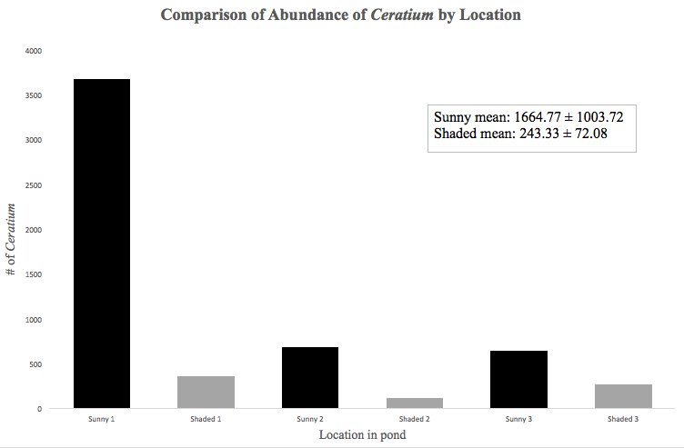

Figure 2. Comparison of pH levels and the Week of Data Collection. Plankton samples were taken each week at different locations of a pond in Lancer Park in Farmville, Virginia. At each site, plankton samples were taken in the sun and in the shade. The sunny area pH levels of the collected water was recorded for both the sunlight and shade conditions. Different letters represent statistically significant differences at p< 0.05.
