Name: Kayla Lehman
Bi-Weekly Report Dates: March 22-28 and March 29-April 4
Week 7 Total: 70,159 steps High Day (March 24): 14,053 steps Low Day (March 28): 8,428 steps
Week 8 Total: 71,197 steps High Day (April 1): 13,132 steps Low Day (March 31): 6,034 steps
Week 7 Reflection and Graphs:
During my seventh week of activity monitoring, I had a lot going on so I just barely reached the step goal with 70,159 steps. I had a lot of computer work to do between class projects and presentations so most days I didn’t reach or just barely exceeded the 10,000-step daily recommendation. On my high day, March 24th, I went for a walk on High Bridge, which I usually try to do once a week to get a good step total just in case other days get too busy, like they were this week. On my low day, March 28th, I had a lot of work to do on the computer so I didn’t have much time to accomplish any physical activity that day.
Week 7 graph:
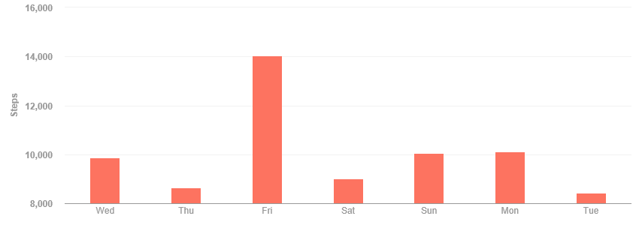
Low Day:
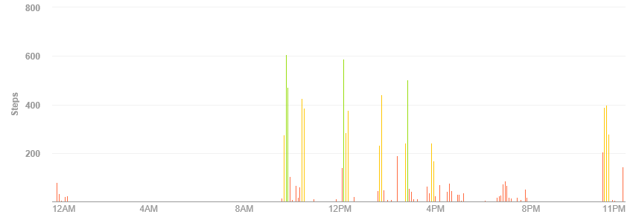
High Day:
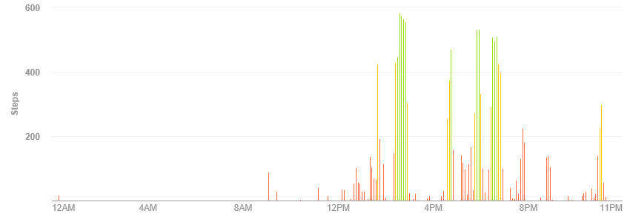
Week 8 Reflection and Graph:
I was pretty active for the latter half of week eight, so getting my steps wasn’t very difficult. I did a lot of walking at parks and around campus on various days this week to increase my total step count. On my high day, April 1st, I did a lot of outdoor activities and went for a walk on High Bridge Trail with my mom, which increased my step count for the day. On my low day, March 31st, I woke up really late which took away from the amount of time I had for activity and I also went home that night, so I didn’t walk around campus or have to walk to dinner, which always decreases my daily step total.
Week 8 graph:
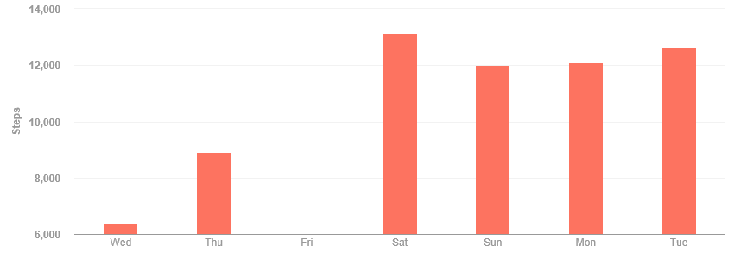
Low Day:
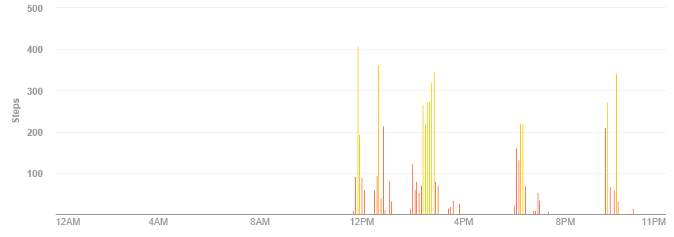

High Day:
