Karyn Keane

Report Dates: Feb. 21 – March 1 and March 2 – 12 (Added a few extra days)

Week 3 Total: 114,413 in total; high day was 19,603 steps, low day was 6,637 steps

Week 4 Total: 62,607 in total; high day was 20,399 steps; low day was 0 (forgot to wear it this day and for others that followed)

**Week 3 Reflection and Graphs**

Reflection: I started going to the gym five days per week, even if it means getting up early, and that’s helped a lot. I’m finding that I feel more energized and better about myself as a whole. On my high day, I did an intense cardio workout, ran to classes all day, took a walk, and had commitments on campus that I had to walk to. On my low day, I went to the gym but biked instead of walking.

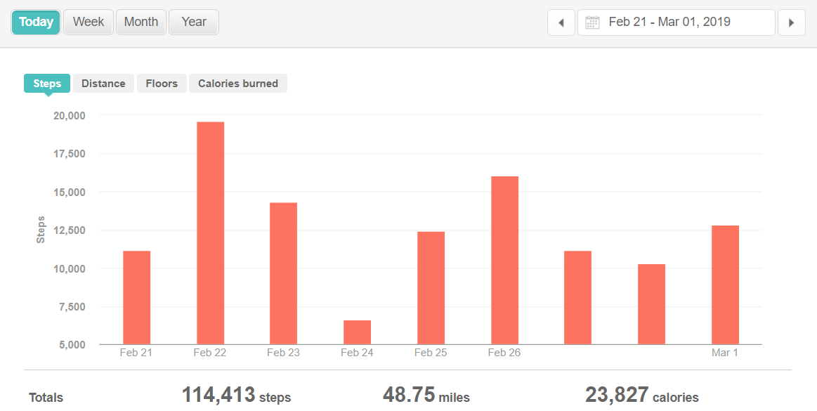

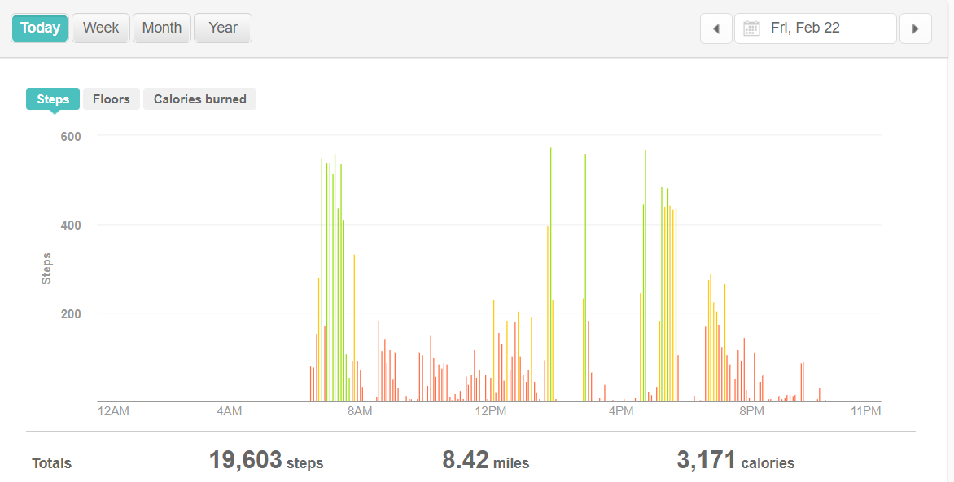

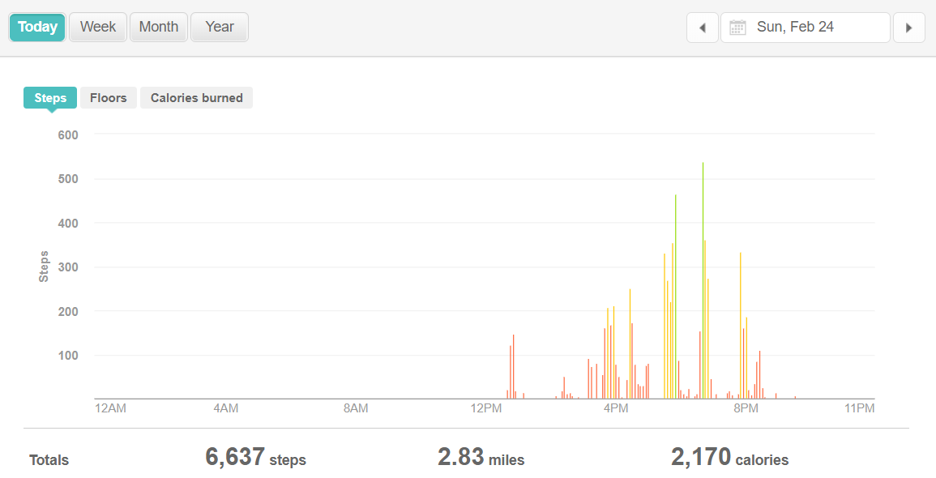

**Week 4 Reflection and Graphs**

Reflection: I am a fool! I went to Disney World and thought I forgot my Fitbit at home, only to find it in my backpack on the last day. I added some extra days in to show that I started wearing it again as soon as I got back. Disney World kept me active because those parks are huge, so I wish I had worn it for data collection purposes.

