Karyn Keane

Dr. Magill

HONS 495

3 May 2018

Legacies of *Frankenstein*: Mary Shelley’s Work Adapted in Alan Moore’s *Watchmen*, Stephen King’s *Misery*, and Chris Columbus’s *Mrs. Doubtfire*

Literary critics often credit Mary Shelley’s *Frankenstein* with starting the science fiction genre. The 1818 classic novel’s themes remain present in contemporary film, literature, and culture with Shelley’s classic monster persisting as an icon of horror. Although some modern legacies of *Frankenstein* pay obvious tribute to the original work (such as the 2013 novel *Frankenstein in Baghdad* or the 1935 film *Bride of Frankenstein*), others respond to Shelley’s themes in more discreet ways. Three such works—Alan Moore’s comic series *Watchmen*, Stephen King’s horror novel *Misery*, and Chris Columbus’s comedy film *Mrs. Doubtfire*—all draw upon themes present in Shelley’s novel but examine them from different perspectives. By adapting the tropes created in *Frankenstein* for contemporary audiences, *Watchmen*, *Misery*, and *Mrs. Doubtfire* all perpetuate Shelley’s message and ensure its continued relevance.

Perhaps the most obvious trope adapted by all three works is the destruction of the creators by their creations. In Shelley’s original *Frankenstein*, Victor’s monster marks the beginning of a tumultuous period which encompasses the deaths of loved ones, strained relationships, and general personal turmoil. Regarding one interpretation of the novel, Brian Stableford writes:

A closely-related interpretation regards Victor Frankenstein as an archetypal example of a man destroyed by his own creation; in this view the story becomes a central myth of the kind of technophobia which argues that modern man is indeed doomed to be destroyed by his own artefacts (and that such a fate, however tragic, is not undeserved). (46)

This technophobia is crucial to the plot of the original novel; however, its unique translations in modern works further Shelley’s message and provide audiences with new lenses through which to consider the same issues. Each adaptation witnesses a new “creation” result in the downfall of characters. In *Watchmen*, Jon Osterman’s painful and traumatic transformation into Dr. Manhattan occurs when he carelessly enters his creation: a time-locked radiation testing vault at the laboratory where he works (see Figure 1). His inability to anticipate the consequences of this research is similar to that of Victor Frankenstein, who never expected his creation to become a force of murder. Similarly, in *Misery*, Paul Sheldon kills his captor Annie with help from the typewriter upon which she forced him to write his novel: “He brought his arms forward and down, letting the typewriter fly out of his hands. It struck her squarely in the center of her wide solid back” (King 316). Here, Annie’s “creation” is Paul’s creative process and draft, which she never considered a lethal weapon. *Mrs. Doubtfire* shows the creator destroyed by his creation when Daniel inadvertently reveals that Mrs. Doubtfire was a fake persona while at dinner with his family. After a halfhearted apology to his ex-wife for masquerading as an old woman for months, he feels humiliated when other guests in the restaurant stare at him after the scene, lamenting, “What are you looking at? Show’s over” (Columbus). Although Daniel created Mrs. Doubtfire to bring him closer to his children—just as Victor created his monster to achieve glory—his reveal as a fraud creates serious problems. In each case, these works apply Shelley’s reluctance about creation to other predicaments, ensuring the idea’s relevance to a wider contemporary audience.

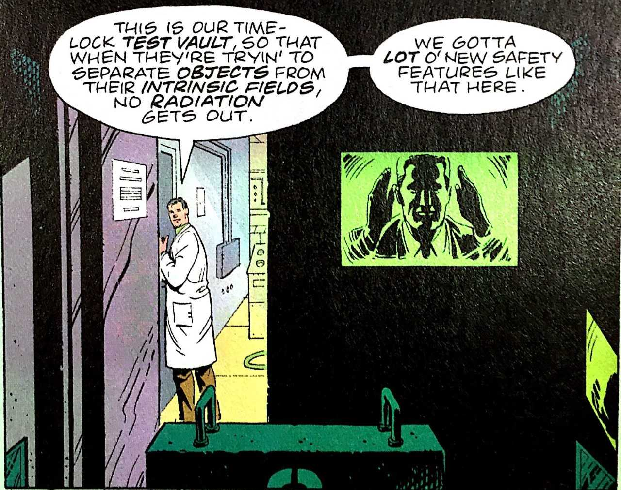

Figure 1: *Safety Features*

The implications of *Frankenstein*’s alternate title, *The Modern Prometheus*, also persist in all three works. Arthur Paul Patterson defines “Prometheanism” as “a tendency to be impatient with limitations and to defy conventional traditions and authority to get one’s way” (90). Victor exhibited this quality in creating his monster and it appears differently across the three legacies; however, each features a Promethean character who rebels to meet their own needs. *Watchmen* sees this personality in Adrian Veidt, who sets a giant monster on New York City in an effort to unite world powers and end the Cold War (see Figure 2). Like Victor, Adrian’s ambition resulted in unforeseen destruction and adversely affected the lives of many. In *Misery*, Annie embodies the Promethean character: her captivity and intense torture of Paul disregards authority figures as she demands an alternate ending to Paul’s book series. She also defies Paul’s authority as a writer by insisting that she knows what is best for his series, stating, “I *do* know good when I see it—*you* are good, Paul. All you need is a little help” (King 43). Lastly, in *Mrs. Doubtfire*, Daniel behaves in a Promethean manner by ignoring court-imposed limits regarding custody of his children. Rather than seeking traditional methods of negotiation, he approaches his cosmetically-inclined brother and pleads, “Could you make me a woman?” thus marking the beginning of Mrs. Doubtfire’s turbulent reign (Columbus). Like Victor, Daniel’s self-centeredness and stubborn demeanor prove detrimental. Throughout these works, Adrian, Annie, and Daniel warn audiences about the dangers of Promethean attitudes and spread their own version of Shelley’s original message.

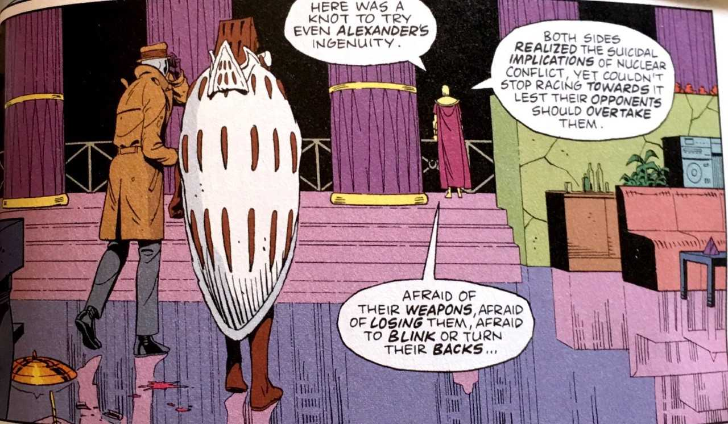

Figure 2: *Implications*

These works’ use of Gothic elements also constructs their image as legacies of *Frankenstein*. Heidi Strengell writes that “the Gothic novel is characterized by a focus on terrifying, archaic settings, an indefinite past, the use of the supernatural, the presence of stereotypical characters, and the attempt to deploy and develop techniques of literary suspense” (28). Use of the supernatural is a crucial part of *Watchmen* when Adrian’s monster destroys New York City (see Figure 3). *Misery* utilizes each of these techniques; however, the text focuses most prominently on literary suspense as readers accompany Paul on his ventures into Annie’s house. The narrator recounts one particularly anxiety-provoking scene:

He [Paul] backed carefully away from the phone, and when he gained the room’s one reasonably clear area, he began the laborious job of turning the wheelchair around, careful not to bump the occasional table as he did so.

He had nearly finished the turn when he heard an approaching car, and knew, simply *knew* it was her, returning from town. (King 90)

This tense moment produces effects similar to those of *Frankenstein*, in which readers seldom know what to expect from the monster. *Mrs. Doubtfire* also continues the Gothic tradition in emphasizing the suspense of Daniel maintaining his disguise. In one scene, Daniel dashes in and out of a public restroom and repeatedly changes outfits so he can enjoy a dinner with his family as Mrs. Doubtfire while simultaneously attending a business dinner as himself (Columbus). The constant anxiety in this hectic scene resembles Victor’s efforts to maintain a positive outward appearance while inwardly tormented by his knowledge of the monster’s crimes. The three works all perpetuate Shelley’s Gothic themes and argue for their significance in contemporary culture.

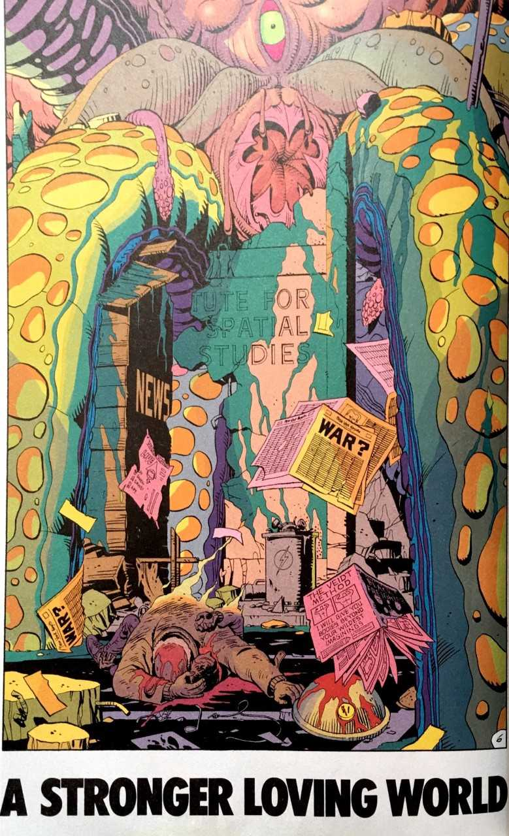

Figure 3: *A Stronger Loving World*