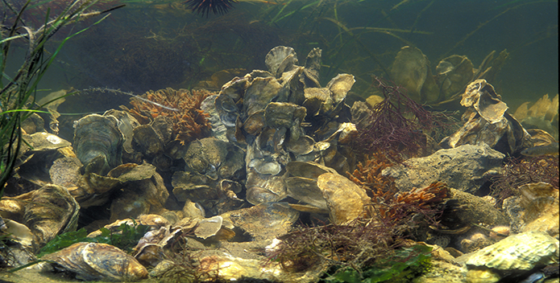

A World Without Oysters

A continuation of Mark Kurlansky’s *World Without Fish*

Karyn J. Keane

Dr. Alix Fink

GNED 261

November 17, 2016

“He was a bold man who first ate an oyster.”

-Jonathan Swift

Throughout history, certain aquatic creatures have consistently served as the objects of adoration and fascination for humans. It’s no surprise why interesting animals like dolphins, sharks, clownfish, and sea turtles continue to intrigue and amaze people all over the world.

When we try to think of more creatures along these lines, oysters certainly do not come to mind.

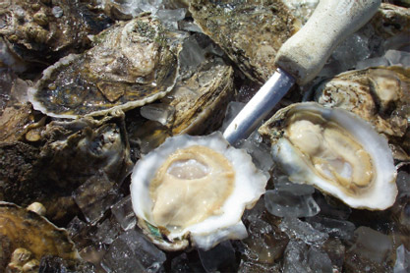

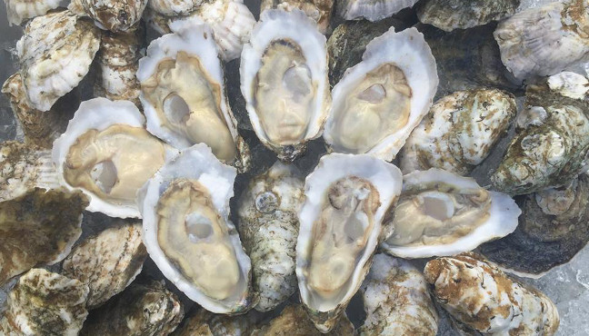

The rough, grimy, dull exterior of the oyster makes a lackluster first impression upon those who see it. When compared to other beautiful, more brightly-colored shells, it seems like a relatively boring addition to underwater ecosystems.

Furthermore, their interior does not prove to be much better. The oyster’s thick, phlegmy consistency continues to disturb many to this day. While some refuse to eat oysters entirely, others will only eat them after they have been cooked. (And certain brave souls will eat them completely raw.)

Despite the poor first impression that they tend to make, oysters serve as one of the most important species in the Chesapeake Bay and the areas that surround it.

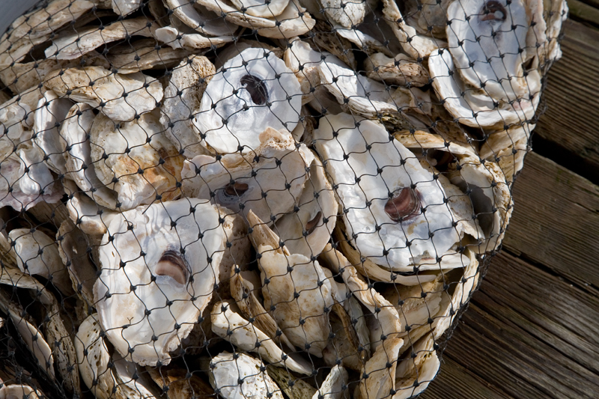

The oysters of the Chesapeake Bay have shaped the architecture of their surrounding environment and culture for centuries. Over time, they have come to symbolize opportunities for survival, prosperity, environmental harmony, and innovation within the region.

Since the beginning of time, oysters have served as a staple in the diet of Chesapeake residents. This practice started with the Chesapeake Paleo-Indians, who consumed the creatures in massive quantities. While doing so, they left middens—ancient trash pits of discarded shells—in the ground, permanently altering the landscape of the region and leaving behind their mark on history. They also used oysters as inexpensive construction materials that could be replenished easily through harvests.

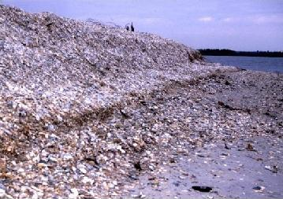

During the cold winter months, the Native Americans living near the Chesapeake Bay traveled to winter camps situated near the massive oyster reefs. These oyster habitats sustained them when they lacked other sources of food.

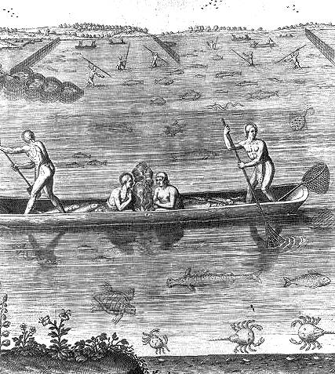

Upon arriving in North America, the British colonists were astonished by the oysters’ widespread abundance. They relied on them as a major source of food, developing a variety of tasty recipes as they settled into more established communities.

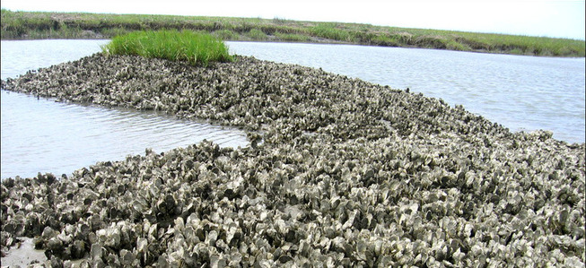

Particularly, oysters proved vital to the success of the Jamestown colony.

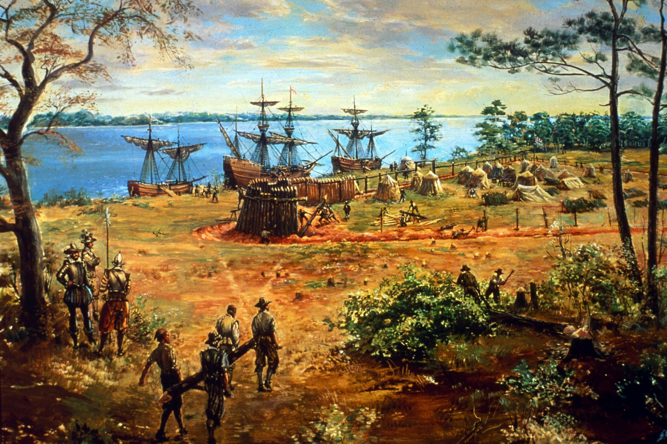

Numerous cities developed throughout New England as a result of the oyster industry. For residents in these areas, oysters served as an easily accessible, nutritious source of protein. Unfortunately, their penchant for the creatures led to depletion of the oyster reefs along these coasts. This soon led to regulations and restrictions within each state. These included restricting harvests to only local residents, limiting the tools that could be used, and enforcing size requirements, among many others.

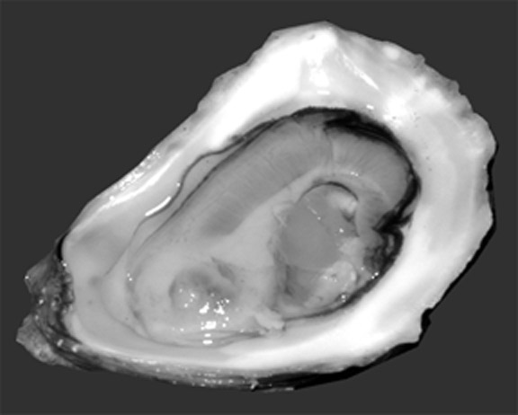

As time progressed and early Americans’ dependence on oysters increased, they accordingly developed oyster-specific technologies to assist in the capturing and harvesting of these creatures. One such technology was the dredge.

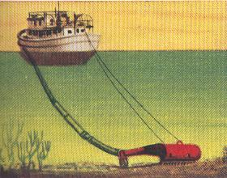

Dredges consisted of triangular iron frames with rake-like teeth along one edge and a rope across the back. Dredges were lowered overboard and pulled along behind boats. Underneath the water, they would scrape across the massive oyster beds and gather up massive quantities of the mollusks.

The primary benefit of using dredges for oyster harvests was their extreme efficiency. Just one boat equipped with a dredge could accomplish the same amount of work as five oyster tongers in one day.

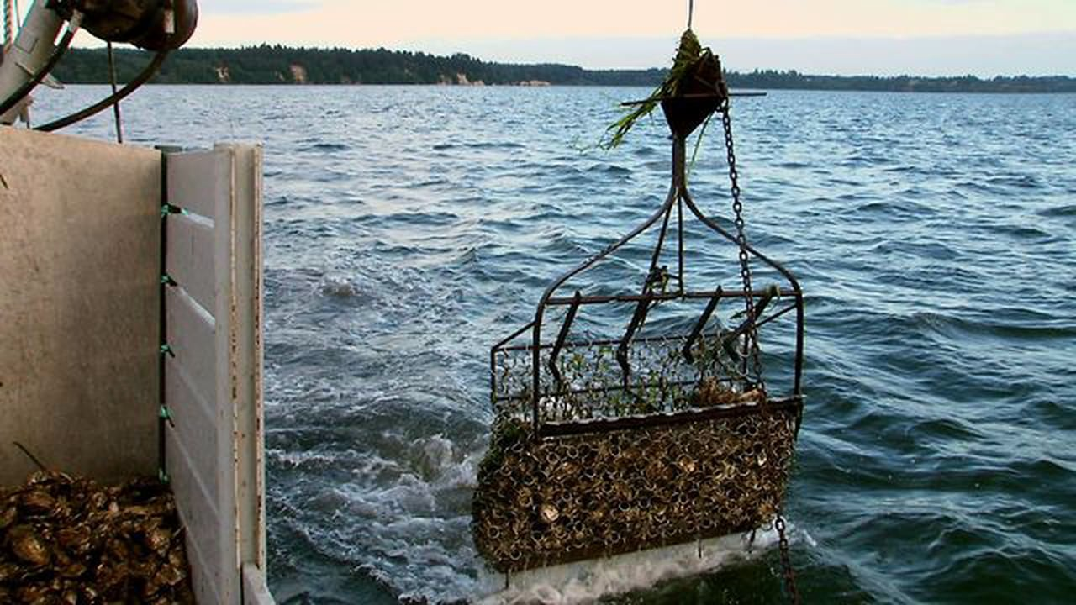

Unfortunately, this innovation came with its fair share of disadvantages.

Because of the dredges’ efficiency, oyster beds were stripped of all life much more quickly than before. This change often occurred in just one or two seasons. Oystermen were not perturbed by this threat due to the massive increase in profits as a result of this technology.

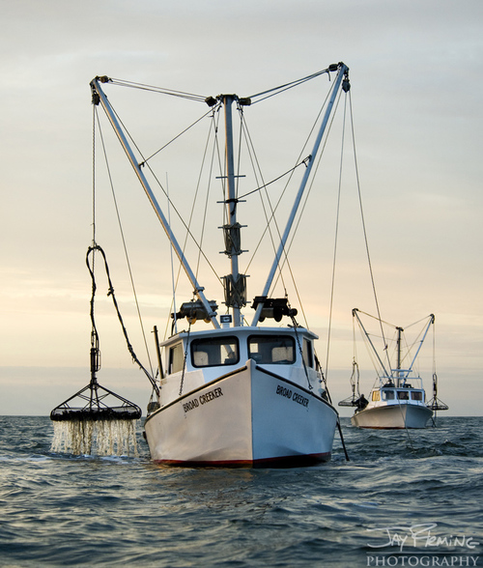

During the nineteenth century, oysters became even more crucial to life in the Chesapeake Bay area. The rapid technological innovations of the Industrial Era helped improve the efficiency of the oyster harvest. These included the steam engine, dredging, and canning/preserving foods.

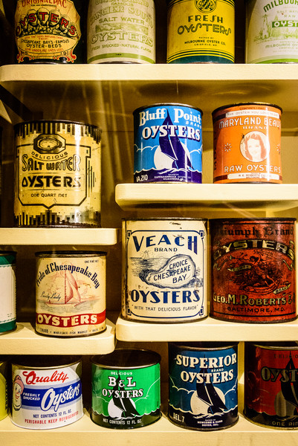

Additionally, oysters have some inherent natural benefits. They serve as natural filter feeders for the Chesapeake Bay. To do this, they cycle water through their gills, catching food particles as well as nutrients, suspended sediments, and chemical contaminants. This process helps keep the water of the Bay clean for other aquatic animals and plant life.

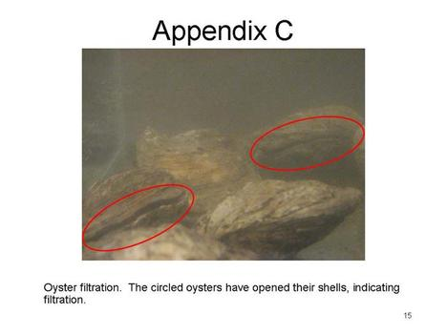

Oysters also provide natural habitats for a myriad of other aquatic animals. As larvae, oysters settle on top of mature adult oysters, forming “walls” composed of layers that spread upward and outward. Hundreds of animals swim into these rocks in search of shelter and/or food.

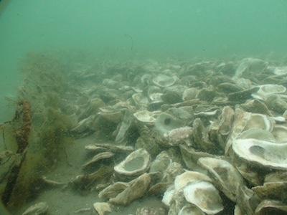

So…if the oysters are so important, why is the overall size of their population declining? Why aren’t people taking more measures to conserve and protect such a critical species?

Read on for the causes of this decline…

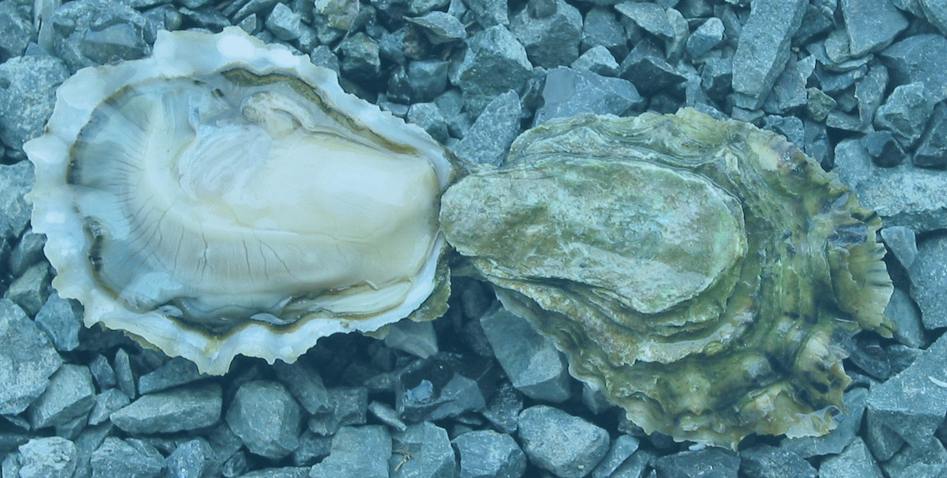

As alluded to earlier in this chapter, oysters have historically suffered from overharvesting.

The invention of dredges led to an exponential increase in the annual size of the oyster harvest. This process removed too many oysters from the Bay and destroyed the Bay’s formerly healthy oyster reefs. Currently, oyster beds are limited to flat layers of dead shells and live oysters on the bottom of the Chesapeake Bay. These changes have led to a decrease in available surface area for other animals and the destruction of new beds (as these can now easily be buried by sediment at the bottom of the water).

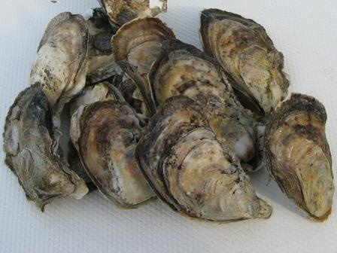

The spread of harmful diseases has also contributed to this decline in the oyster population.

In the 1940s and 50s, parasites known as Dermo (or Perkinsus marinus) and MSX (or Haplosporidium nelson) were discovered in the Chesapeake Bay. Dermo frequently infects oysters during their second year of life, leading to slower growth rates and deaths. MSX also causes death among oysters but can affect them at any age.

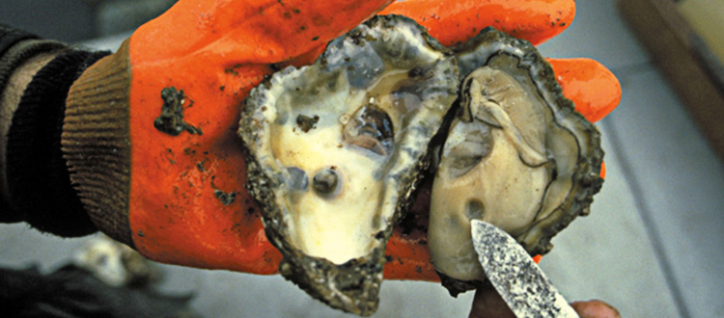

The final enemy of the healthy oyster population is habitat loss.

As forested lands have been replaced for urban and agricultural uses, the amount of nutrients and sediments entering the Chesapeake Bay has increased. This influx leads to poor water quality that can adversely affect aquatic life. One such negative effect is the creation of low-oxygen “dead zones” that hinder the development of oyster larvae and suffocate aquatic life.

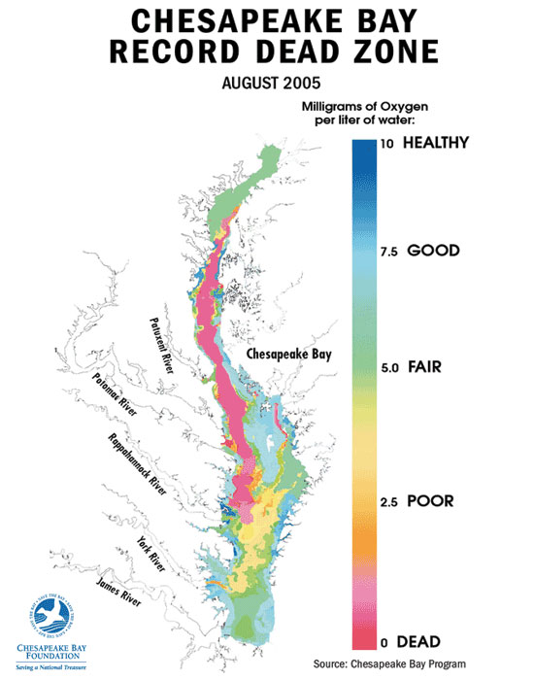

This information leads us to the question…what is being done to save the oyster population?

**1: Management of Oyster Harvests**

By managing the oyster harvest, Bay officials can ensure that the oyster industry in the area remains sustainable. To achieve this, they must estimate the number of oysters that can be taken out of the Bay without negatively affecting conservation efforts or population size.

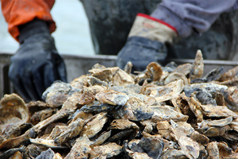

**2: Establishment of Oyster Sanctuaries**

**Oyster sanctuaries are underwater reefs where shellfish harvesting is completely prohibited. To create an effective sanctuary, scientists clean designated reefs of excess sediment and/or add shells or other materials for spat to settle on. This job is undertaken in hopes of increasing oyster populations.**

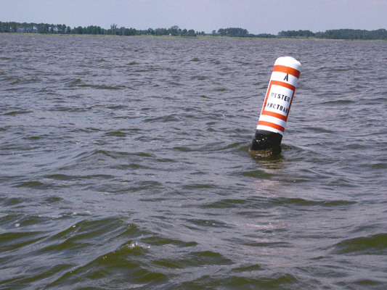

**3: Defeating diseases harmful to oyster populations**

**Different states in the Bay’s estuary face different challenges with infectious oyster diseases. For example, oysters in Maryland waters are only affected with the prevalence of certain weather patterns; however, oysters in Virginia’s waters must cope with constant threats of disease. A report from the Virginia Institute of Marine Science has stated that oysters have begun to develop resistance to these diseases and that efforts are underway to breed greater resistance in native oyster strains.**

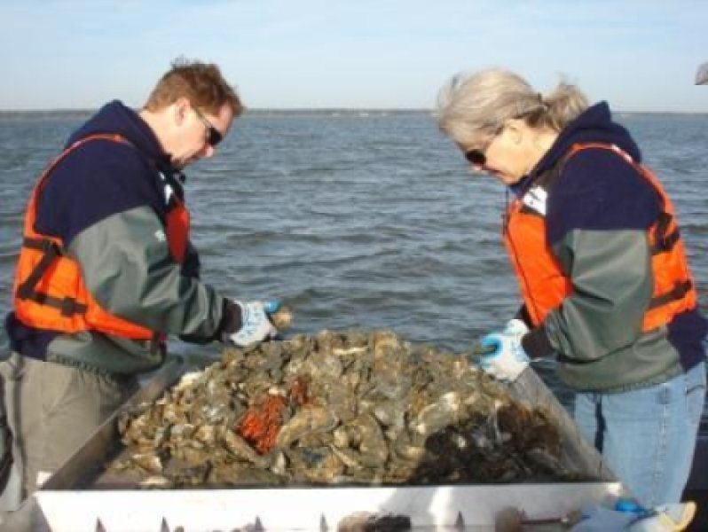

What can regular, every day people like me do to help the oysters?

1. Recycle oyster shells.

Recycled shells can be used in the construction of new reefs.

2. If your home has access to a pier or a dock, consider raising your own oyster larvae at home.

Maryland’s Smart, Green, and Growing office and the Chesapeake Bay Foundation both offer assistance through oyster gardening programs. The oysters you grow at home will help filter local waters and restock oyster reefs.

Works Cited

American Museum of Natural History. *Oyster filtration.* 2016, photograph, American Museum

of Natural History.

Chesapeake Bay Oysters. *Oysters in the shell.* 2016, photography, Chesapeake Bay News.

Chesapeake Bay Oyster Company. *Parrot Island Oysters.* 2015, photograph, Chesapeake

Oyster Company.

Chesapeake Bay Program. *Wild oysters.* 2015, photograph, Yale University.

Crockett, Rita. *Aberdeen Rock.* 2011, photography, Science Daily.

Conoco Oil. *Vacuum Dredge.* 1951, painting, Rowe Oyster Co.

Dead Zones. *Chesapeake Bay record dead zone.* 2016, diagram, the Chesapeake Bay

Foundation.

DuCap, Doug. *Oysters.* 2012, photograph, Biomimicry Institute.

Epes, Chuck. *Oysters*. 2012, photograph, *The Bay Daily.*

Fleming, Jay. *Chesapeake Bay oyster boats.* 2016, photograph, Jay Fleming Photography.

Harp, Dave. *Diversity of Life.* 2014, photograph, Chesapeake Bay Foundation.

Hulton Archive. *Jamestown Colony.* 2013, illustration, *The Daily Beast.*

Institute of Marine Science at the University of North Carolina. *Oyster reefs.* 2016,

photography, UNC.

Integration & Application Network. *Oyster sanctuary marker.* 2016, photography, UMCES.

Little Wicomico Oyster Company, LLC. *Our Oysters.* 2016, photograph, Little Wicomico Oyster Company.

Livie, Kate. *Chesapeake Oysters: The Bay’s Foundation and Future.* American Palate, 2015.

Maryland Sea Grant. *Crassotrea virginica.* 2014, photography, NCCOS.

National Oceanic and Atmospheric Administration (NOAA). *Oyster midden, now exposed and*

*eroding.* 2016, photograph, [www.virginiaplaces.org](http://www.virginiaplaces.org).

Nemazie, David. *Oysters*. 2011, photograph, University of Maryland Center for Environmental

Science.

Oyster Aficionado. *New England Oyster.* 2016, photograph, [www.freewebs.com/oyster](http://www.freewebs.com/oyster)

aficionado/.

Oyster Sentinel. *Oysters.* 2013, photography, Oyster Sentinel.

“Oysters.” *Chesapeake Bay Program,* 2015, <http://www.chesapeakebay.net/issues/issue/oysters>.

Stony Point Pictures. *Oyster dredging (underwater).* 2011, video, <https://vimeo.com>.

White, John. *Native Americans.* 2016, illustration, Library of Congress.