Morgan Karnes
Bio 120-04 Lab Project 1 Results
Dr. Znosko
10-13-201

Analysis of bacteria growth of two different brands of hand sanitizer samples after incubation showed that one hand sanitizer brand killed more bacteria than the other. Likewise, using either brand of hand sanitizer cut down on bacteria growth far more than unwashed and unsanitized hands (Figure 1).
The samples of Bath And Body Works hand sanitizer had an average of one bacteria colony. Whereas the CVS brand samples had an average of two colonies of bacteria. However, the samples of the unwashed and unsanitized hands had an average of about twelve colonies of bacteria (Figure 1).
The average of bacteria growth on all four plates in section A was 4%, in section B 0.25%, and section C 22%. The averaged bacteria growth took up a combined 15% of section A, 1% of section B, and 84% of section C.
The average number of white colonies that appeared in all sections of the agar plates was an average of about twenty-three colonies of bacteria. The average number of yellow colonies that appeared on all the plates was two colonies of bacteria. The average number of brown colonies on all the plates was >1 colonies of bacteria (Figure 2).

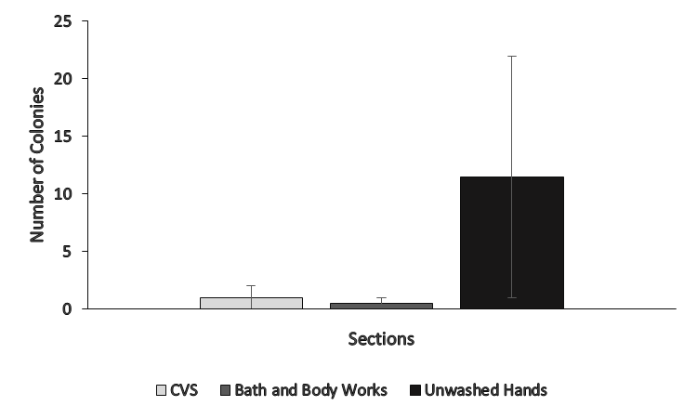
Figure 1. Number of bacteria colonies on samples of unwashed and sanitized hands. Bacteria growth results are shown for samples of CVS hand sanitizer, Bath and Body Works hand sanitizer, and unwashed hands samples. All of the agar plates showed some signs of bacteria growth, however, unwashed hands had the most growth on each plate followed by CVS and Bath and Body Works, which both had little to no growth. Error bars are graphed to show the high and low of the amount of colonies out of all four plates.
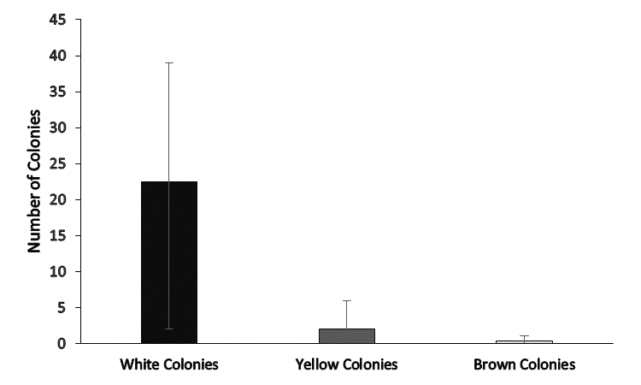
Figure 2. Number of white, yellow, and brown bacteria colony growth on samples of unwashed and sanitized hands. Data are shown for CVS hand sanitizer, Bath and Body Works hand sanitizer, and unwashed hand samples. In all cases, white bacteria colony growth was seen, however, only for the unwashed hand samples were yellow and brown colonies seen. Error bars are graphed to show the high and low of the amount of different color colonies out of all four plates.

