Morgan Karnes
Bio 120-04 Lab Project 2 Results
Dr. Znosko
11/17/2016
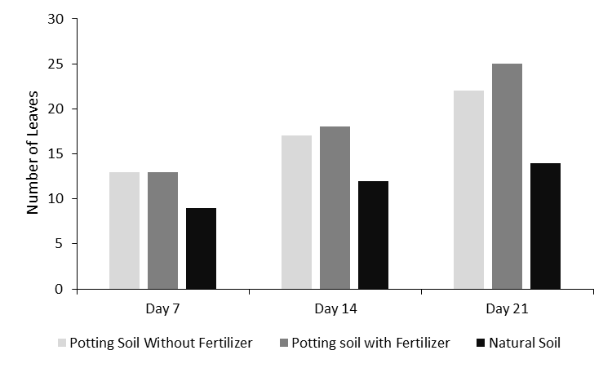
Figure 1. The total number of leaves on the Brassica rapa plants that appeared in each Styrofoam planter. Plant leaf quantities for plants potted in potting soil without fertilizer, potting soil with fertilizer and natural soil are shown for day 7, 14, and 21. Each planter contained four Brassica rapa plants, the number of leaves that were present on each day of data recording were counted and recorded for each planter. The planters were counted and recorded as a whole, rather than each individual plant, due to this no error bars were graphed.
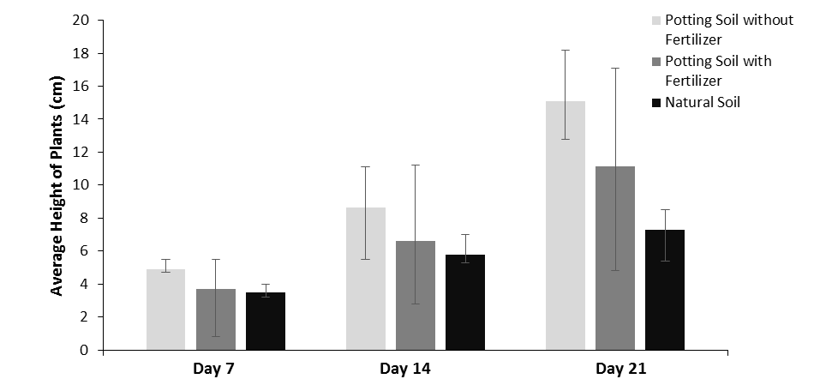
Figure 2. The average height in centimeter of all four plants in each Styrofoam planter. Height averages for plants potted in potting soil with fertilizer, potting soil without fertilizer, and natural soil are shown for day 7, 14, and 21. The height of each Brassica rapa was measured from the soil to the highest point of the plant. The heights were recorded for each separate plant and the heights were averaged for each planter. Error bars are graphed to represent the tallest and shortest plants that were measured in that planter.
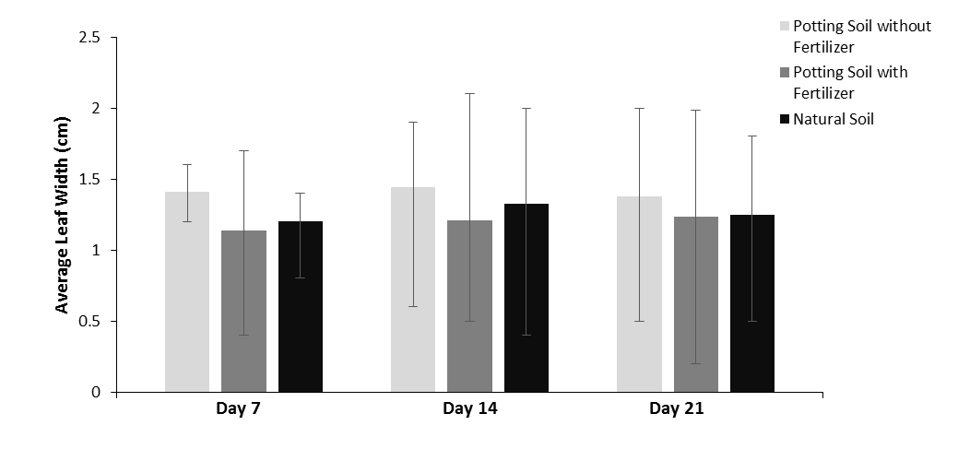
Figure 3. The average width of leaves that appeared on the plants in each Styrofoam planter. Leaf width averages for plants potted in potting soil without fertilizer, potting soil with fertilizer, and natural soil are shown for day 7, 14, and 21. The width of each measurable leaf was recorded, the leaf widths were averaged for each planter. Error bars are graphed to represent the widest leaf and the smallest leaf measured in the planter.

Analysis of plants grown in three different types of potting soils showed that plant growth varies depending on the type of soil being used. Potting soil with fertilizer helped more leaves grow while it was not as successful for height and leaf width growth. Likewise, potting soil without fertilizer helped height and leaf width growth and was not as successful in number of leaves; however, this soil helped the plants grow better overall (Figure 1, Figure 2, and Figure 3).
The average number of leaves that appeared in the planters for day 7 was thirteen leaves for potting soil without fertilizer, thirteen leaves for potting soil with fertilizer, and nine leaves for the natural soil. The average number of leaves for day 14 was seventeen leaves for potting soil without fertilizer, eighteen leaves for potting soil with fertilizer, and twelve leaves for natural soil. The average number of leaves for day 21 was twenty-two leaves for potting soil without fertilizer, twenty-five leaves for potting soil with fertilizer and fourteen leaves for natural soil (Figure 1).
The average height for the plants in the planters on day 7 was 4.925cm for potting soil without fertilizer, 3.7cm for potting soil with fertilizer, and 3.525cm for natural soil. The average heights for day 14 was 8.65cm for potting soil without fertilizer, 6.625cm for potting soil with fertilizer, and 5.775cm for natural soil. The average heights for day 21 was 15.075cm for potting soil without fertilizer, 11.125cm for potting soil with fertilizer, and 7.3cm for natural soil (Figure 2).
The average leaf width for the plants in each planter on day 7 was 1.4125cm for potting soil without fertilizer, 1.1375cm for potting soil with fertilizer, and 1.2cm for natural soil. The average leaf width for day 14 was 1.44cm for potting soil without fertilizer, 1.206cm for potting soil with fertilizer, and 1.325cm for natural soil. The average leaf width for day 21 was 1.3788cm for potting soil without fertilizer, 1.236cm for potting soil with fertilizer, and 1.246cm for natural soil (Figure 3).

