The Effects of Parking Lot Pollution on Soil Microbes in Prince Edward County, VA
Morgan Karnes
Bio 250 spring 2017

Introduction:
Since microbes play an important role in the environmental health, such as breaking down of soil contaminants and aiding in the carbon and nitrogen cycles, they have been the focal point in many scientific experiments (Bardgett et al., 2008). These scientific experiments have led to the discovery of an abundance of different types of microbes, such as the Acetobacterium, A. pastevriuanus, A. punctate, Bacteroides, B. Coagulans, and B. bivius (Mcgowan et al 1980). In Prince Edward County, VA, the microbial community has never been studied.
Prince Edward County is a largely populated area, and is home to two fairly large colleges. As a result, Prince Edward County is heavily trafficked and due to the terrain of Prince Edward County, storm drains are a necessity. Storm drains are designed to prevent the buildup of rain water in places such as parking lots. These drains usually dump the water into a designated area, such as a retention pond, where the runoff will be absorbed into the soil. The water that is drained from these parking lots usually contain a higher percentage of pollutants due to car run off (Grace et al 2011). Previous studies have found a very high concentration of heavy metals, such as Zn, Cu, and Cd in rain water that runs off of parking lots (Olson and Zhang 2012; Grace et al., 2011; Abed and Al Kindi 2017).
Some studies, have found that prolonged exposure to these heavy metals leads to the microbes forming a resistance to the metals absorbed in the soil. One studied measured the resistance of bacteria to metals by incubating the Bacillus thuringiensis and Escherichia coli K12 with several different types of heavy metals. The study found that microbes formed a high tolerance to heavy metals, especially copper, a heavy metal that is prominent in car runoff (Boudabous et al 1998). In another study, the authors measured the attachment of bacteria to the soil after the exposure to heavy metals. In this experiment, soil containing Escherichia coli was exposed to synthetically made parking lot runoff under a controlled environment. The study found that the heavy metals caused a change in structure of the exposed bacteria. The molecules that were attached to the cell surface of the bacteria usually are responsible for the intake of heavy metals, but these molecules were chemically altered by the heavy metals. This caused the bacteria to no long take in the heavy metals. When this change occurred, the bacteria were able adhere to the soil better than the bacteria that did not under go this change (Olson and Zhang 2012).
Since the microbial community in Prince Edward County has never been studied before, the microbial abundance and diversity is unknown. Several teams of students have conducted experiments using different variables to test the microbial community in the county, in an attempt to try and understand what the microbial community is like in Prince Edward County. In this experiment, the soil in a flowing creek was compared to the soil in a runoff basin that is constantly exposed to heavy metals, in an attempt to see how the proposed metals and other pollutants affected the abundance and diversity of microbes in the soil. Based on the previous research, it was hypothesized that the soil cultures from the runoff basin would yield a higher abundance and diversity of microbes.
Methods:
Collecting and Plating the Samples
The moisture content at the runoff basin and Buffalo Creek were examined. Samples were collected and placed into separate vials. For each sample, 0.5 grams of soil was weighed out. The 0.5 grams of each soil was then added to separate tubes that contained twenty-five milliliters of sterile water. The tubes were shaken for thirty seconds. Ten microliters of each soil and sterile water solution was pipetted into minicentrifuges, along with ninety microliters of LB solution. The minicentrifuges were vortexed for five seconds each. Ten microliters of the solutions were then pipetted into different minicentrifuge tubes, along with ninety microliters of LB solution. The minicentrifuges were then vortexed for five seconds. Six agar plates were gathered and one hundred microliters of the Buffalo Creek soil and sterile water solution was pipetted on to the first agar plate. On the second agar plate, one hundred microliters of the runoff basin soil and sterile water solution was pipetted. Ninety microliters of Buffalo Creek 1:10 solution and runoff basin 1:10 solution were pipetted on to the third and fourth agar plates, and one hundred microliters of Buffalo Creek 1:100 solution and runoff basin 1:100 solution were pipetted on to the fifth and sixth agar plates. Two sterile sticks were then used to spread the solutions on the Buffalo creek agar plates and the runoff basin site agar plates. The six plates were left to incubate at 30 degrees Celsius for five days and were checked on days two and five of incubation. After incubation, colonies were counted on each plate and shape, size, texture, and color were noted for each colony on the plates.
Extracting the DNA from Samples
DNA extraction was performed to retrieve the DNA from the bacteria colonies on the agar plates in order to sequence the 16s rRNA which helps to identify the bacteria species. The genomic kit used in this experiment included solutions MD1, MD2, MD3, MD4, and MD5. One colony was chosen from each direct count sample plate. Half of each colony was plated on a different agar plates for further examination. The other half of the colony was mixed with three hundred microliters of microbead solution and pipetted into a microbead tubes. Fifty microliters of solution MD1 was added into the tubes, this solution contains sodium dodecyl sulfate (SDS), an anionic detergent that helps breaks down the fatty acids and lipids of the cell membrane. This tube was then placed in a heat block at 65 degrees Celsius for ten minutes. The microbead tubes were then secured to a vortex and vortexed at maximum speed for ten minutes. The tubes were then centrifuged at 10,000 × g for thirty seconds and the supernatant was pipetted into two milliliter collection tubes. One hundred microliters of solution MD2, which contains a chemical that precipitates non-DNA molecules was added to the tube, in order to remove any organic and inorganic matter that may reduce the purity of the DNA. The tubes were vortexed for five seconds and incubated at 4 degrees Celsius for five minutes. The tubes were centrifuge for one minute and the solution was transferred into two milliliter collection tubes. Nine hundred microliters of solution MD3, which contains a highly concentrated salt solution was added to help bind the DNA to the spin filter membrane. The tubes and vortexed for five seconds and seven hundred microliters of the solution in the collection tubes were then pipetted into spin filters and centrifuged for thirty seconds. Flow through was discarded and the remaining solution in the collection tubes were added to the spin filters and centrifuged again for thirty seconds. Flow through was discarded again and three hundred microliters of solution MD4, which contains an ethanol-based solution, was added to the spin filters. This helped remove any residual salts or contaminants and allowed the DNA to remain bound to the spin filter membrane. The spin filters were centrifuged for thirty seconds, and were then centrifuged again for one minute. The spin filters were placed in new collection tubes and fifty microliters of solution MD5 was pipetted into the center of the spin filters. DNA is soluble in MD5 solution, which allowed for the separation of the DNA from the spin filter membrane. The spin filters were centrifuged for thirty seconds and the filters were then discarded and the collection tubes were stored at 20 degrees Celsius.

PCR (Polymerase Chain Reaction)
PCR was performed to amplify the sequences of the 16s rDNA obtained during extraction in order to sequence the DNA to be able to identify the bacteria species. Two primer sequences, which help detect the 16s rDNA sequence were used, the forward- 5’GAGTTTGATYMTGGCTC-3’ and the reverse- 5’-URGYTACCTTGTTACGACTT-3’. These sequences contain degenerate bases, which are less sequence specific, thus allow for more flexibility during DNA amplification. Two point five microliters of primer mix, twenty five microliters of one Tag 2× master mix, and fifteen microliters of nuclease-free water were mixed together in PCR tubes. Seven point five microliters of the genomic DNA solutions were pipetted into the PCR tubes. The PCR tubes were placed in a PCR machine. The solution was initial denatured at ninety four degrees Celsius for four minutes. The solution was heated to ninety eight degrees Celsius for ten seconds, then cooled to fifty degrees Celsius for fifteen seconds and reheated to seventy two degrees Celsius; these three steps repeated thirty times. The solution was finally extended at seventy two degrees Celsius for five minutes and held at four degrees Celsius.
Purification of the PCR Samples
PCR purification was performed in order to remove the enzyme, dNTPs, genomic DNA, and other components of the PCR reaction from the DNA. Two hundred and fifty microliters of binding buffer was mixed with the PCR samples and added to one point five milliliter tubes. The solutions were pipetted into spin filters and spun at 13,000 rpm for one minute. Flow through was discarded and two hundred microliters of DNA wash buffer was pipetted into the spin filters and spun for one minute. Another two hundred microliters of DNA wash buffer was pipetted into the spin filters and spun again for one minute. The spin filters were transferred into new one point five milliliter tubes and thirty microliters of sterile water was pipetted into the center of each spin filter. The spin filters were spun for one minute and a DNA concentration was measured using the nanodrop.
Restriction Enzyme Digestion of PCR Samples and Running Gel Electrophoresis
MspI digestion was performed to help identify the unique rRNA gene sequence of the bacteria. Five microliters of PCR product was mixed with ten microliters of MspI mix, an enzyme that cuts DNA at any CCGG sequence. The tubes were incubated at thirty seven degrees Celsius for forty five minutes.
Five microliters of 6× loading buffer was mixed with the tubes containing the PCR and MspI mix. The electrophoresis chambers were filled and the gel was covered with 1× TAE buffer. The wells were loaded with ten microliters of sample. The lid was placed on the chamber and the gel was ran at one hundred and twenty volts for thirty minutes. After run was complete the gel was removed and visualized under a UV camera.
Sequencing the DNA
Eight microliters of PCR product was mixed with four microliters of sequencing primer 5’-GAGTTTGATCCTGGCTCAG-3’. The mixture was then sent to EurofinsGenomics to be sequenced.
Blast (Basic Local Alignment Search Tool)
The sequences acquired were analyzed by the use of snap gene. Snap gene was used to observe high quality DNA base pairs. High quality DNA base pairs were classified as base pairs that were able to be identified as A, T, G, or C. The number of sequential high quality DNA base pairs were noted for each PCR product. In order to be identified a large amount of sequential high quality DNA base pairs were needed. The PCR sequences that contained large amounts of sequential high quality DNA base pairs were copied and placed in an online database called BLAST, which contained sequences of bacteria that were found and recorded in previous studies. BLAST matched the sequences with several other bacteria sequences. The top five matches were recorded and further analysis of compatibility with performed.
Results:
Buffalo Creek and Runoff Basin Plate Comparison
The runoff basin plates and the Buffalo creek plates helped further the investigation of how heavy metasl affect microbial diversity in the soil. The runoff basin formed more overall bacteria colonies than the Buffalo creek plates (Figure 2). The only colony shapes that were observed were filamentous, circular, irregular, and punctiform (Figure 3A, 3B, 3C). These shapes were present on all plates except for the absence of filamentous colonies on the runoff basin 1:100. The runoff basin plates that yielded filamentous grew fewer than those of Buffalo creek plates (Figure 3A). Circular colonies were the most abundant colony shape observed on all the plates, yet runoff basin plates yielded more than the Buffalo creek plates. The runoff basin grew more circular colonies than all the Buffalo creek plates (Figure 3A, 3B, 3C). The Buffalo creek and Runoff basin 1:100 plates yield the same amount of irregular colonies (Figure 3A). Conversely, on the 1:10 and the direct count plates, the runoff basin plates yield more irregular colonies than the Buffalo creek plates (Figure 3B, 3C). The runoff basin 1:100 plate yielded more punctiform than the Buffalo creek 1:100, while the 1:10 plates yielded the same amount of punticform (Figure 3A, 3B). However, the Buffalo creek direct counted yielded more puntiform colonies than the runoff basin direct count (Figure 3C).
Identification of the runoff basin bacteria
After DNA extraction, the DNA concentration for both runoff basin and Buffalo creek was negative, with low 260/280 readings. After DNA was amplified and PCR product was purified, Buffalo creek had a high concentration reading, while the runoff basin had a low concentration reading; however; the runoff basin had a higher 260/280 than the Buffalo creek 260/280 value. The gel electrophoresis of runoff basin PCR product digested with MspI enzyme was run and band formations were observed at around 600 base pairs, 400 base pairs, 200 base pairs, and 150 base pairs (Figure 4B). The runoff basin produced 655 high quality base pairs (Figure 4C). The PCR was 99% compatible to the complete sequence of the Bacillus toyonensis BCT-7112, with a match in sequences from base pair 1-511 (Figure 4D). The computational MspI digest of the Bacillus toyonensis BCT-7112 sequence showed fragment lengths of 606 base pairs, 390 base pairs, 211 base pairs, and 162 base pairs (Figure 4D).After further analysis of compatibility of the two sequence and the MspI cleavages, it was concluded the bacteria was the Bacillus toyonensis BCT-7112 (Figure 4D, Table 1).
Identification of Buffalo Creek bacteria
The gel electrophoresis of Buffalo creek PCR product digested with MspI enzyme was run and band formations were observed at around 600 base pairs, 400 base pairs, 200 base pairs, and 150 base pairs (Figure 5A). However, the sequenced PCR product for Buffalo creek did not yield enough high quality base pair sequence, and was unable to be run in BLAST. Due to this it was unable to be identified (Figure 5C).
Discussion:
In this study it was hypothesized that the runoff basin would have a bigger abundance and diversity of microbes than Buffalo creek. This proved to be true, the runoff basin samples formed more bacteria colonies, whereas the Buffalo creek had far less bacteria colonies form (Figure 3A, 3B, 3C). These results are believed to be due to the site of collection of soil samples. The site in which the runoff basin sample was collected is exposed to more pollutants than that of the site of the Buffalo creek sample. The pollutants in the soil at the runoff basin site come from the runoff from a nearby parking lot. The soil in this study was not test for what types of pollutants were present, but many studies have found that parking lot runoff is high in heavy metal concentration (Grace et al 2011). This high concentration of heavy metals is a result of cars leaking fuel, oil, and gas in parking lots. The cars leak the heavy metals and the metals get trapped in the pores of the pavement until they are washed away when it rains (Al-Abed et al 1996). The rain then gets washed to a drain that dumps the polluted water into a runoff basin. When these heavy metals come into contact with the soil, the soil minerals, as well as the microbes in the soil are chemically altered. The heavy metals cause a change in the functional groups that are located on the membrane of the microbes which causes them to easily attach to the soil (Olson and Zhang 2012).
After the sequencing of the Buffalo creek and the runoff basin PCR, it was found that the Buffalo creek did not have enough high quality DNA to be sequence in BLAST, so it was unable to be identified (Figure 5C). However, the runoff basin produced a large amount of high quality DNA (Figure 4C). After being run in BLAST, the top five matches were recorded, but once further observation of strain compatibility and MspI reaction sites it was concluded the bacteria from the runoff basin was Bacillus toyonensis BCT-7112 (Table 1, Figure 4D). The Bacillus toyonensis BCT-7112 has been found to be a PHA producer. PHA or polyhydroxyalkanoates is a plastic polymer chain produced by bacteria, essentially, the chain forms a membrane around the bacteria. Bacteria that produce PHA have previously been found to be bacteria that are exposed to high oil contaminants, such as the one found in parking lot runoff, which ties in with the previous study by Oslon and Zhang performed in 2012 (Ardakani et al 2014).
Since the soil was not test it cannot be concluded that the data received in this study is a result of heavy metal alterations. However, the data received may help in validating other studies that find similar results as the ones in this study. Since microbial diversity has never been examined in Prince Edward County, VA prior to this study, there is no comparable data to help confirm the results of this study are accurate. As a result, it is necessary more studies be performed to help backup data and further conclude the findings. Performing more studies will help to create a foundation in discoveries of what microbial diversity is like in Prince Edward County, VA.

Figures and Tables:
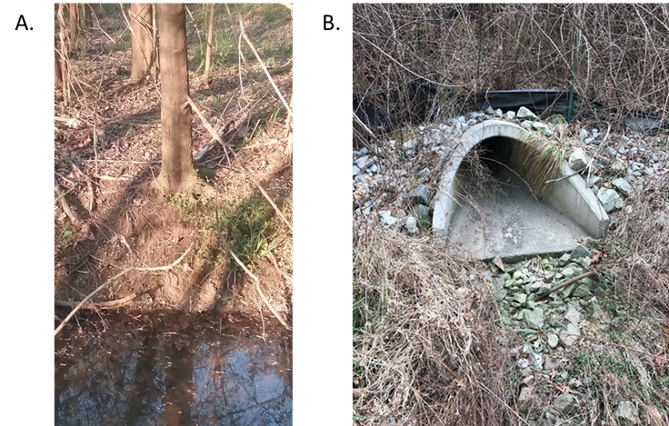
Figure 1. Sites of sample collection. (A) The site of Buffalo creek soil and (B) runoff basin soil sample collections are pictured above. The soil moisture content was analyzed prior to collection. Soils of similar moisture content were obtained from each site. The samples were then diluted and plated.

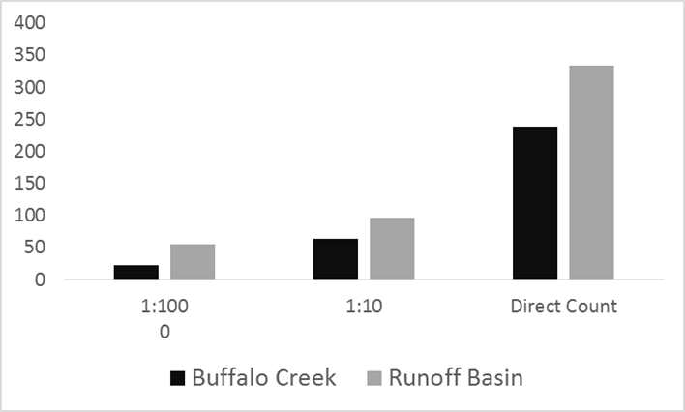

Figure 2. The abundance of bacteria colony formation on Buffalo creek and runoff basin plates. The total number of bacteria colonies that formed on each plate were counted. The runoff basin consistently had more bacteria colonies than the buffalo creek plates. The number of colonies for plates are shown above.
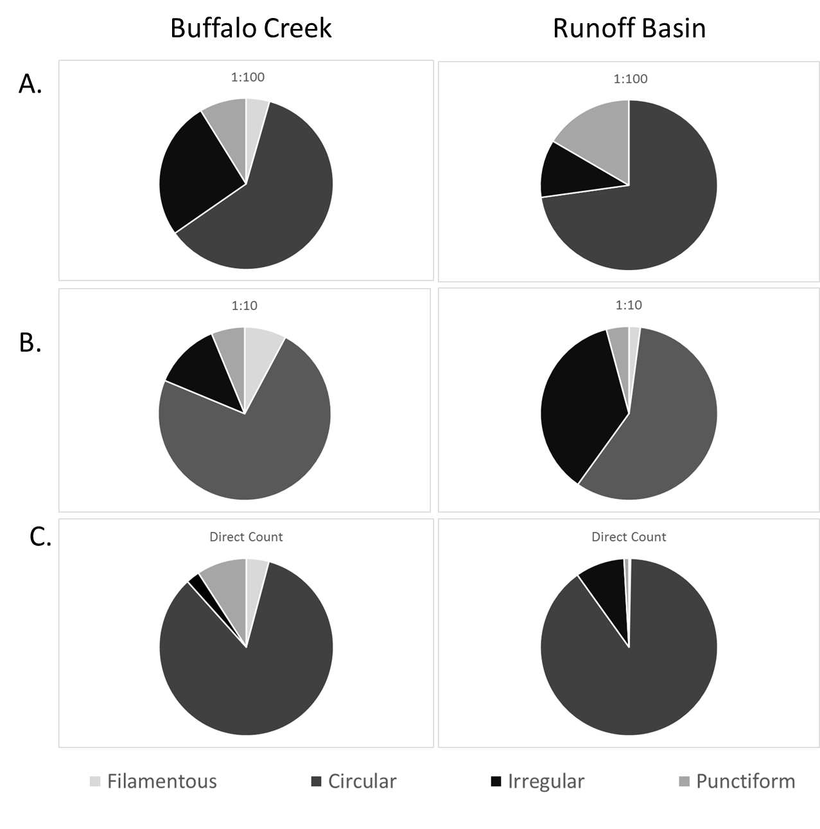
Figure 3. The diversity of Filamentous, Circular, Irregular, and Punctiform colonies grown on the Buffalo creek and runoff basin plates. (A) The number of colonies for each identified shape for Buffalo creek and the runoff basin 1:100 solution (B) 1:10 solution and (C) direct count are shown above. Each plate was observed to identify the types of colony shapes formed. All plates grew circular, filamentous, irregular, and puntiform shaped colonies. Circular colonies were the most abundant on all the plates, while filamentous, irregular, and punctiform varied from plate to plate. The amount of colonies that grew for each shape are graphed above.

Match Number | Genus | Species | Strain
1 | Bacillus | toyonensis | BCT-7112
2 | Bacillus | thuringiensis | ATCC 10792
3 | Bacillus | thuringiensis | IAM 12077
4 | Bacillus | thuringiensis | NBRC 101235
5 | Bacillus | cereus | ATCC 14579

Table 1. The Genus, species, and strain of the top five bacteria matches for the runoff basin PCR product.

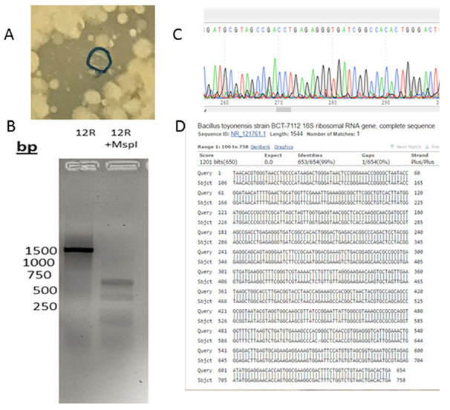
Figure 4. The bacteria colony for 12R, the gel electrophoresis, chromatogram, and the sequence of the identified bacteria. (A) A single colony was chosen from the runoff basin direct count plate in shown in the picture above. This colony was used for DNA extraction, PCR, and PCR purification. The PCR Product was then sequenced. (B) MspI enzymes were added into the for the runoff basin PCR product. Clean PCR product, along with the PCR product with MspI was loaded in agar gel and electrophoresis was ran. The picture above was taken with a UV camera after the gel electrophoresis was complete. (C) A picture of the chromatogram for Runoff basin is sown. The chromatogram showed a large number of high quality DNA in SnapGene (D) The sequence of the Bacillus toyonensis BCT-7112 is shown above. The high quality sequence from the PCR product was used in BLAST to identify the bacteria species. The sequence showed a 99% complete sequence match with the Bacillus toyonensis BCT-7112.

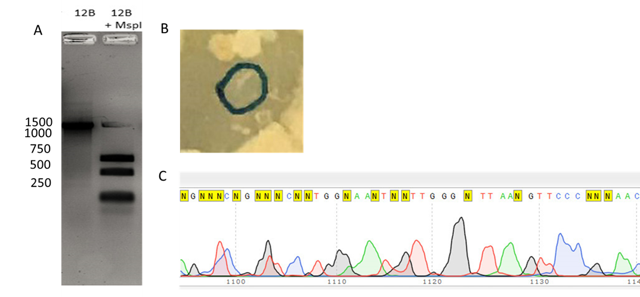
Figure. 5. The 12B colony, gel electrophoresis, and chromatogram. (A) MspI enzymes were added into the for the Buffalo creek PCR product. Clean PCR product, along with the PCR product with MspI was loaded in agar gel and electrophoresis was ran. The picture above was taken with a UV camera after the gel electrophoresis was complete. (B) A single colony was chosen from the Buffalo creek direct count plate in shown in the picture above. This colony was used for DNA extraction, PCR, and PCR purification. The PCR Product was then sequenced. (C) A picture of the chromatogram for Buffalo creek is shown above. The chromatogram showed little high quality DNA in SnapGene and was unable to be ran in BLAST.

Supplementary Figures:

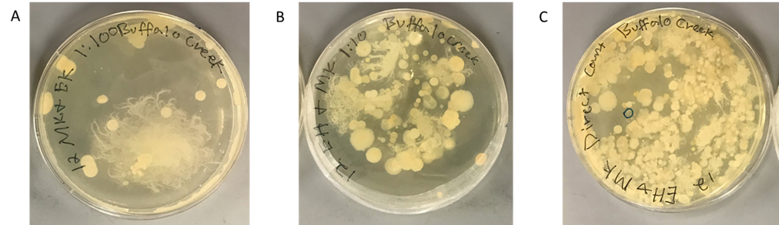
Figure 6. The Pictures of Buffalo Creek Agar Plates are shown. (A) The 1:100 Buffalo Creek solution, (B) the 1:10 Buffalo Creek solution, and (C) the direct count Buffalo Creek solution were plated and smeared with a sterile swab. The plates were incubated for four days and then refrigerated to stop any additional growth. The pictures shown above were taken after refrigeration. 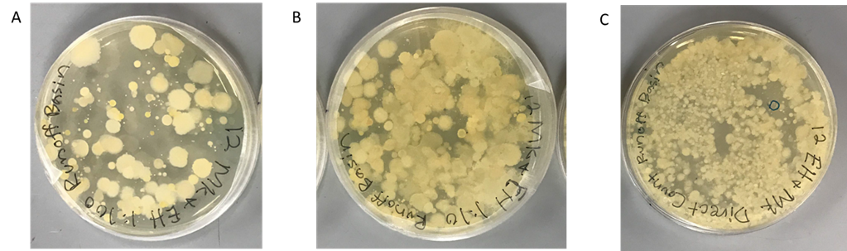
Figure 7. The Pictures of Runoff Basin Agar Plates are shown. (A) The 1:100 Runoff Basin solution, (B) the 1:10 Runoff Basin solution, and (C) the direct count Runoff Basin solution were plated and smeared with a sterile swab. The plates were incubated for four days and then refrigerated to stop any additional growth. The pictures shown above were taken after refrigeration.
Literature Cited:
Abed RM, Al-Kindi S. Effect of disturbance by oil pollution on the diversity and activity of bacterial communities in biological soil crusts from the Sultanate of Oman. Applied Soil Ecology. 2017;110:88–96.
Abo-Amer AE, Mohamed RM. Isolation and characterization of heavy-metal resistant microbes from roadside soil and phylloplane. Journal of Basic Microbiology. 2011;52(1):53–65.
Al-Abed SR, Buchberger SG, Sansalone JJ. Fractionation of heavy metals in pavement runoff. Science of the Total Environment. 1996:189-190:371-387
Ardakani, MR, Mayeli, N, Motamedi, H. Isolation and screening of native polyhydroxyalkanoate producing bacteria from oil contaminated soils of Abadan refinery. Biological Journal of Microorganism. 2015: 3(12):93-103.
Bardgett RD, Freeman C, Ostle NJ. Microbial contributions to climate change through carbon cycle feedbacks. The ISME Journal. 2008;2(8):805–814.
Beman JM, Francis CA, Kuypers MMM. New processes and players in the nitrogen cycle: the microbial ecology of anaerobic and archaeal ammonia oxidation. The ISME Journal. 2007;1(1):19–27.
Boudabous A, Cherif M, Hassen A, Saidi N. Resistance of environmental bacteria to heavy metals. Bioresource Technology. 1998;64(1):7–15.
Brenner E, Endres M, Hilliges R, Marks T, Tiffert A. Characterization of road runoff with regard to seasonal variations, particle size distribution and the correlation of fine particles and pollutants. Water Science & Technology. 2017:75(5):1169-1176
Cebon J, Field MA, Fitzgerald A, Hayward NK, Jakrot V, Johansson PA, Kakavand H, Mann GJ, Paoli-Iseppi RD, Pupo GM, Scolyer RA, Shackleton M, Shang P, Tembe V, Thompson JF, Vilain RE, Wilmott JS. Tumour procurement, DNA extraction, coverage analysis and optimisation of mutation-detection algorithms for human melanoma genomes. Molecular Pathology. 2015:47(7):683-693
Grace MR, Perryman SE, Rees GN, Walsh CJ. Urban Stormwater Runoff Drives Denitrifying Community Composition Through Changes in Sediment Texture and Carbon Content. Microbial Ecology. 2011;61(4):932–940.
Mcgowan V, Skerman VBD, Sneath PHA. Approved Lists of Bacterial Names. International Journal of Systematic and Evolutionary Microbiology. 1980;30(1):225–420.
Olson MS, Zhang H. Effect of Heavy Metals on Bacterial Attachment in Soils. Journal of Environmental Engineering. 2012;138(11):1106–1113.

