Nutrient and Phenolic Acids Stress on Cucumis sativus Plants
Morgan Karnes, Longwood University
Abstract:
The discovery of plant secondary metabolites led to curiosity and extensive research into their main functions. Although a lot of answers have been uncovered over the years, there are still many questions that remain about plant secondary metabolites. In this study, nutrient and phenolic acid stress was applied to Cucumis sativus plants over a period of two weeks. After each week the leaf area and root length were measured. One-way ANOVAs and post hoc analyses were performed on data which showed the application of most phenolic acids did not have a very profound effect on the plants. However, cinnamic acid did have some significant differences for leaf area, shoot dry weight, and total dry weight, which could be a result of its inhibitory effects that cause phytotoxicity.
Introduction:
Plant metabolites are chemicals whose functions deal with the metabolic reactions within the plant system. There is a broad variety of these chemicals, which overtime have been split into two groups: primary metabolites and secondary metabolites. Primary metabolites are chemicals whose functions are necessary in order to perform metabolic rates and functions of the plant, while secondary metabolites are not necessarily necessary for a plant to perform metabolic reactions but help the plant in other situations, such as allelopathy (Bidlack and Jansky 2017, 185). Secondary metabolite chemicals were once thought to be waste products, but in the 1800s scientists realized that these chemicals had actual functions that were important to the plant (Hartmann 2007). Since then thousands of secondary metabolites have been discovered with functions ranging from defense to growth regulation. Although there has been much research on secondary metabolites, many functions and even structures are still unknown (Bidlack and Janksy 2017, 185).
Today there are three major classes of plant secondary metabolites which are separated based on the structure of the chemical. The first group is alkaloids which are ring structures that contain nitrogen. This group contains about ten-thousand described chemicals. The second group is terpenoids, which are chemicals whose structure is composed of isoprene units. This group contains about forty-thousand described chemicals. The last group is the phenolics, which includes chemicals whose structures are composed of aromatic rings. Within this group there are many sub groups, one being phenolic acids (Bidlack and Jansky 2017, 187). With thousands of metabolites discovered and many that are still being discovered and described. This allows for a wide-range of experiments and research.
Phenolic acids are produced by many plants. There are several phenolic acids that occur naturally and some that are synthetically made (Croft 2006). Many studies on phenolic acids and how they effect plants have been performed. A few examples include studies performed by Glass (1972) and Dunlap (1974), in which they performed a series of experiments involving phenolic acid testing the effects that they have on plants. Some of these studies on phenolic acid effects included phosphate uptake and depolarization of membrane potentials. In these experiments, they applied different levels of concentration of various phenolic acids on the roots of barely and found that the increase in phenolic acid concentrations led the concentration of phosphate to decrease, while the increase in concentrations led the depolarization level to increase. Another example is a study performed by Blum (1996) in which he used various pH levels and various number of phenolic acid treatments on the plants to test the effects they had on plant growth. He found that the plants with the higher concentrated treatments of phenolic acids had lower growth rates than the other plants.
In our experiment, we are going to apply phenolic acid stress, as well as nutrient stress on Cucumis sativus to test the effect they have on the growth of the plants leaves, roots, and dry weights. Using the other experiments as a foundation for our study, we hypothesized that if Cucumis sativus plants were exposed to phenolic acid stress in addition to nutrient stress over a period of two weeks, we would see a more negative effect in the growth rate of plants under both the nutrient and phenolic acid stress compared to those under only nutrient stress.
Methods:
In this experiment, we had a total of five chosen phenolic acids: ferulic, vanillic, cinnamic, p-coumaric, and benzoic. We had seven plants, which included two controls and five replicates, for each phenolic acid treatment.
The Cucumis sativus plants used in this experiment were first grown from seeds in vermiculite and covered with foil before being incubated at thirty degrees Celsius for two days. After two days of incubation, the plants were placed under light for three additional days. At day five, the plant roots were cleaned off and the plants were transplanted into jars. The controls both received 110 mL of full-strength Hoagland’s solution, while the five other plants received 110 mL of a nutrient and phenolic acid solution mix.
After week one, the root length and length and width of the leaves were measured for each plant. The jars were then refilled. This time, the first control received 110 mL of full-strength Hoagland’s solution, while all other plants received 110 milliliters of 1/32-strength nutrient solution. During these two weeks, the solutions were not reapplied, but deionized water was added as needed to bring solutions back up to volume. After the second week, the root lengths and length and width for the leaves were measured for each plant.
After all measurements were complete, the plants were cut at the region in which the roots and shoots connected. The roots and shoots were dried and later weighed. The recorded averages were compiled into a datasheet and analyzed using JMP programming.
Results:
ANOVA Test | Overall p-value
Change in leaf area by treatment | <0.0001
Change in root length by treatment | 0.1095
Shoot dry weight by treatment | <0.0001
Root dry weight by treatment | 0.0004
Total dry weight by treatment | <0.0001
Table 1. The overall p-value for each ANOVA performed in JMP.

*Note red implies significance.
Table 2. Letters report for change in leaf area by treatment.
Treatment | Corresponding Letter
Full-strength control | A
p-Coumaric | B
Vanillic | BC
Diluted Control | BC
Ferulic | BC
Benzoic | BC
Cinnamic | C

Table 3. Letters report for shoot and total dry weight by treatment.
Treatment | Corresponding Letter
Full-strength control | A
Vanillic | B
Diluted Control | B
Ferulic | B
Benzoic | B
p-Coumaric | BC
Cinnamic | C
*Note shoot and total dry weight had the same letter reports, to avoid repetition one table was made for both reports.
Table 4. Letters report for root dry weight by treatment.
Treatment | Corresponding Letter
Full-strength control | A
Vanillic | A
Diluted Control | AB
Ferulic | B
Benzoic | B
p-Coumaric | B
Cinnamic | B

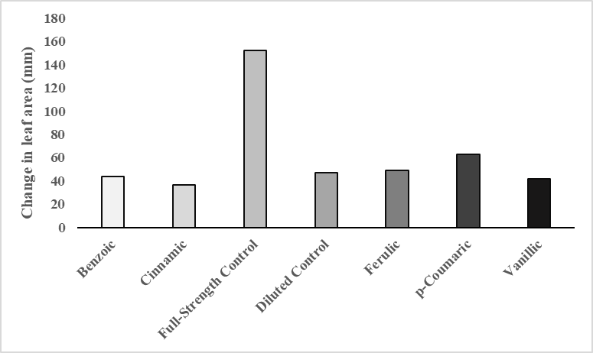
B
A
Figure 1. A graph of change in leaf area by treatments. (A) The bar graph above shows the means for the change
in leaf area in millimeters for each treatment in the experiment. Cucumis sativus plants were placed under phenolic stress at day five of growth and nutrient stress at day twelve. The length and width of Cucumis sativus plant leaves were measured at day twelve and again at day nineteen. The average for the two weeks were calculated and then compiled into a graph. (B) The results from the Tukey-Kramer post hoc test which show the statistical difference between the full-strength control, p-coumaric, cinnamic acid and all other treatments.

A
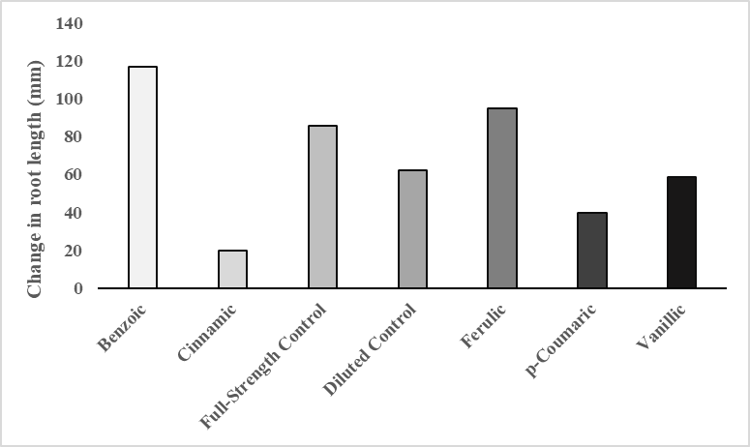
Figure 2. A graph of change in root length by treatments. (A) The bar graph above shows the means for the change in root length in millimeters for each treatment in the experiment Cucumis sativus plants were placed under phenolic stress at day five of growth and nutrient stress at day twelve. The length of Cucumis sativus plant roots were measured at day twelve and again at day nineteen. The average for the two weeks were calculated and then compiled into a graph. There was not significance in the results, so no further tests were run.
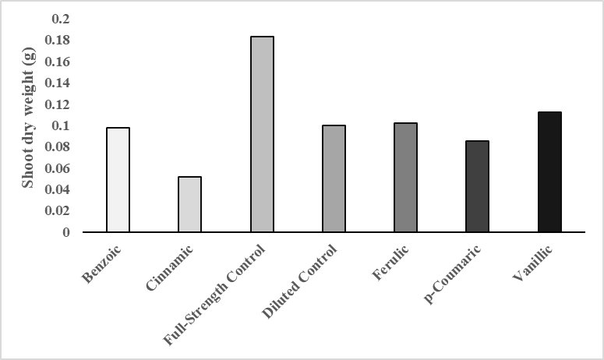
B
A
Figure 3. A graph of shoot dry weight by treatments. (A) The bar graph above shows the means for the shoot dry weight in grams for each treatment in the experiment. Cucumis sativus plants were placed under phenolic stress at day five of growth and nutrient stress at day twelve. After two weeks of growth under stress the plants were cut at the area that the shoot and root meet. The roots were dried out and then weighed. The means for the shoot weights were then graphed. (B) The results from the Tukey-Kramer post hoc test which show the statistical difference between the full-strength control, cinnamic acid and all other treatments.

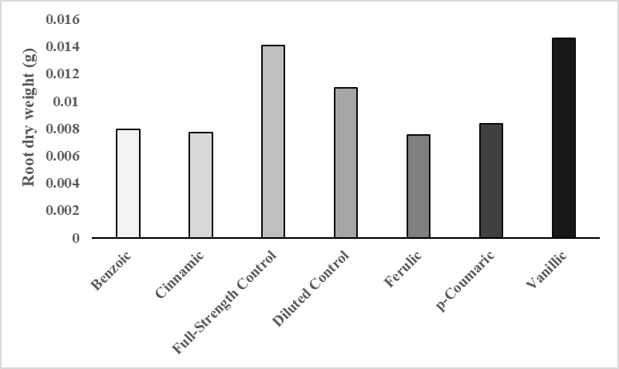
B
A
Figure 4. A graph of root dry weight by treatments. (A) The bar graph above shows the means for the root dry weight in grams for each treatment in the experiment. Cucumis sativus plants were placed under phenolic stress at day five of growth and nutrient stress at day twelve. After two weeks of growth under stress the plants were cut at the area that the shoot and root meet. The shoots were dried out and then weighed. The means for the root weights were then graphed. (B) The results from the Tukey-Kramer post hoc test which show the statistical difference between the full-strength control, vanillic and all other treatments.

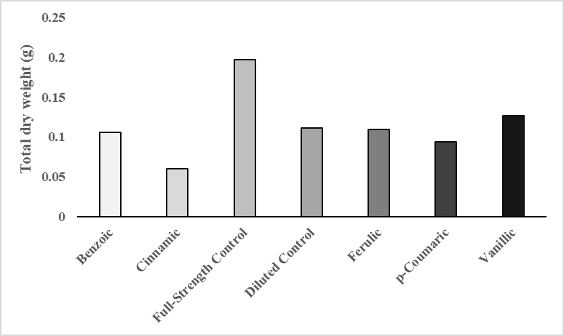
B
A
Figure 5. A graph of total dry weight by treatments. (A) The bar graph above shows the means for the total dry weight in grams for each treatment in the experiment. Cucumis sativus plants were placed under phenolic stress at day five of growth and nutrient stress at day twelve. After two weeks of growth under stress the plants were cut at the area that the shoot and root meet. The shoot and roots were dried out and then weighed. The means for the total weights were then graphed. (B) The results from the Tukey-Kramer post hoc test which show the statistical difference between the full-strength control, cinnamic acid and all other treatments.

All plants that received the nutrient stress, as well as phenolic acid stress appeared to be much yellower in color than the plants that received the full-strength Hoagland solution throughout the whole experiment.
For compiled data, JMP was used to compare the results of each treatment. All treatments were analyzed by change in leaf area, change in root length, shoot dry weight, root dry weight, and total dry weight. A one-way ANOVA was performed on each comparison. We received significant p-values for change in leaf area (<0.0001), shoot dry weight (<0.0001), root dry weight (0.0004), and total dry weight (<0.0001) (Table 1). However, for change in root length we received a p-value of 0.1095 (Table 1), the graphed means values for this comparison can been seen in figure 2. We decided to perform Tukey-Kramer post hoc analyses on comparisons that we received significant p-values for, in order to see which treatment was statistically different than the others.
For change in leaf area by treatments, we found that full strength control, p-courmic, and cinnamic were all statistically different, while benzoic, vanillic, ferulic, and the diluted control were all variable and were not able to be concluded as statistically different from either p-coumaric or cinnamic acid (Table 2). In figure 1 we can see that the full-strength control mean was much higher than all other treatments, while p-coumaric was slightly higher than cinnamic acid.
For root dry weight by treatments, we saw that full-strength control and vanillic acid were similar while benzoic, ferulic, cinnamic, p-coumaric were all similar and the diluted control was too variable to conclude whether it was statistically different than full-strength control and vanillic and all other treatments (Table 4). From figure 4 we can see the full-strength control and vanillic acid were higher than all other treatments.
For both shoot weight and total weight comparisons, full-strength control and cinnamic acid were both statistically different than the other treatments. However, p-coumaric was unable to be concluded as statistically different than cinnamic acid and benzoic, ferulic, and the diluted control (Table 3). From figures 3 and 5 you can see that full-strength control was higher than other treatments, while cinnamic acid was slightly lower than the other treatments.
Discussion:
After observing all data, we noted that the diluted control had very similar results to most phenolic acid treatments. Despite our hypothesis, we concluded that the application of phenolic acid stress to Cucumis sativus plants that also receive nutrient stress does not really have a significant difference on the growth rate of plants.
Overall, we saw that the full-strength control was significantly higher for all comparisons, except for vanillic acid in the root dry weight comparison, in which the means were statistically similar. Cinnamic acid however, had significantly lower means than most treatments for the change in leaf area, shoot dry weight, and total dry weight comparisons.
Phenolic acids have been known to cause allelopathy as well as phytotoxicity in plants. Phytotoxicity is plant damages, such as yellowing or browning of the plants, plant tissue damage, or decreased growth rates, that are caused by the application of chemicals to plants (Harnett et al. 1989). The phenolic acids ferulic and p-coumaric are byproducts of cinnamic acid, while vanillic acid is a byproduct of benzoic acid (Blum 1996). These five phenolic acids and their byproducts have all been found to result in future damages and decreased growth in plants, which is caused by the inhibition to move liquids throughout the plant. This leads to a decrease in water and nutrient absorption in plants (Blum 1996, Glass 1972, Glass and Dunlap 1974).
Since the full-strength control was not under any stress, it was able to absorb all necessary nutrients to successfully grow. As a result, the plants did not experience any phytotoxicity.
Although vanillic acid has been known to cause allelopathic and phytotoxic effects in plants. In a study by Wu and Zhou (2018) they found that the application of vanillic acid to cucumber plants caused an increase in the bacteria of the plant roots. Some of these bacteria they found were known to help breakdown phenolic acids within plants (Wu and Zhou 2018). One conclusion that could account for the higher root length growth in our experiment, could be that the pre-treatment of the vanillic acid lead to an increase in bacteria that breakdown phenolic acids. The breaking down of vanillic acid may have caused a less inhibitory growth effect in the roots of the plants than other treatments.
Since the other plants were under nutrient stress, they did not have enough nutrients to successfully grow and negative growth effects were observed. This could have been the cause of the yellowing of the leaves and the lower growth rates. However, another cause for this could have been the inhibitory effects of the phenolic acids that caused the yellowing and negative growth effects. Moreover, the main reason that we may have seen even lower growth rates in the cinnamic acid is because cinnamic acid is much more inhibitory than other byproducts and acids (Blum 1996).
Throughout this study, there were many people who participated in the experiment. This is one component that could have lead to error in the experiment. There could have been some error in filling of jars, weighing of plants, and measurement of both the leaves and the roots. Also, the roots were very brittle, so there could have been breakage in the primary root that could have led to loss in root length.
Although there have been many studies following the discovery of phenolic acid functions, there are still many questions that remain unanswered. This study helps to establish the effects that phenolic acids can cause plants and add to data that can be used as foundations in future studies.
Acknowledgements:
Thanks to Dr. Lehman for helping run the experiment and keep everything in order. Also thank you to all spring 2018 biology 309 students for taking part in the experiment and showing up to scheduled assignments outside of class.

Literature Cited
Bidlack, J. E, S. H. Jansky. (2017). Stern’s Introductory Plant Biology. McGraw-Hill, New York, New York, USA.
Blum U. 1996. Allelopathic Interactions Involving Phenolic Acids. Journal of Nematology. 28(3):259-267
Croft K. D. 2006. The Chemistry and Biological Effects of Flavonoids and Phenolic Acids. Annals of the New York Academy of Sciences. 854:435-442.
Glass A. 1972. Influence of Phenolic Acids on Ion Uptake. I. Inhibition of Phosphate Uptake. Plant Physiol. 51:1037-1041.
Glass ADM, and Dunlap J. 1974. Influence of Phenolic Acids on Ion Uptake. IV. Depolarization of Membrane Potentials. Plant Physiol. 54:855–858.
Hartmann T. 2007. From waste products to ecochemicals: fifty years research of plant secondary metabolism. Phytochemistry 68:2831–2846.
Hartnett D. C., Romeo J. T., and Weidenhamer J. D. 1989. Density-Dependent Phytotoxicity: Distinguishing Resource Competition and Allelopathic Interference in Plants. Journal of Applied Ecology. 26:613-624
Wu F., Zhou X. 2018.Vanillic acid changed cucumber (Cucumis sativus L.) seedling rhizosphere total bacterial, Pseudomonas and Bacillus spp. Communities. Scientific Reports 8: 4929

