Margin of Error
ppm Concentration | Mean (mm) | Mean±SE
0 | 54.15 | 3.57
1 | 58.32 | 2.51
10 | 50.26 | 2.22
100 | 26.60 | 2.77
Letters Report
ppm Concentration | Letter
0 | A
1 | A
10 | A
100 | B
Significant Comparison Result for Tukey-Kramer Test
ppm Comparison | Difference | p-value
0 100 | 27.55 | <0.0001
1 100 | 31.72 | <0.0001
10 100 | 23.66 | 0.0003
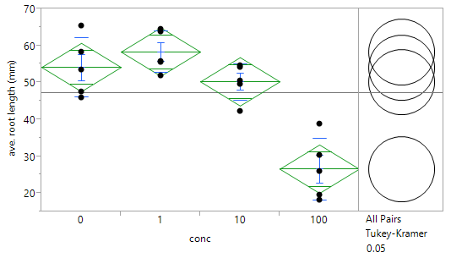
D
B
C
A
FIG. 1. ANOVA results for Salicylic acid. (A) This graph shows the plotted averages of the root length for all four concentrations. The green lines are the results of the ANOVA test that was performed and the circles to the right are the results of the Tukey-Kramer post-hoc test that was performed. (B) These tables are further results of the ANOVA test the first table shows the letters given to each concentration based on the plotted data. (C) The second table shows the margin of error for each concentration, which shows how far calculated error is from the mean for each concentration. (D) The final table shows only the significant comparison results from the Tukey-Kramer post-hoc test that was performed.
Letters Report
ppm Concentration | Letter
0 | A
1 | AB
10 | A
100 | B
Margin of Error
ppm Concentration | Mean (mm) | Mean±SE
0 | 52.44 | 4.93
1 | 47.76 | 4.06
10 | 53.06 | 2.90
100 | 36.66 | 1.21
Significant Comparison Result for Tukey-Kramer Test
ppm Comparison | Difference | p-value
0 100 | 16.40 | 0.0230
10 100 | 15.78 | 0.0294
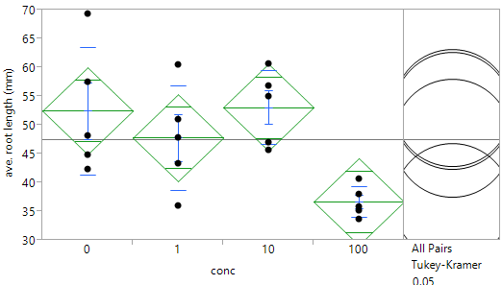
A
C
D
B

FIG. 2. ANOVA results for Gibberellic acid. (A) This graph shows the plotted averages of the root length for all four concentrations. The green lines are the results of the ANOVA test that was performed and the circles to the right are the results of the Tukey-Kramer post-hoc test that was performed. (B) These tables are further results of the ANOVA test the first table shows the letters given to each concentration based on the plotted data. (C) The second table shows the margin of error for each concentration, which shows how far calculated error is from the mean for each concentration. (D) The final table shows only the significant comparison results from the Tukey-Kramer post-hoc test that was performed.
Letters Report
ppm Concentration | Letter
0 | A
1 | B
10 | C
100 | C
Significant Comparison Result for Tukey-Kramer Test
ppm Comparison | Difference | p-value
0 100 | 55.32 | <0.0001
0 10 | 54.20 | <0.0001
0 100 | 36.38 | <0.0001
1 100 | 18.64 | <0.0001
1 10 | 17.82 | <0.0001
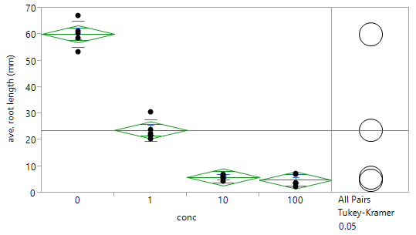
D
B
C
A
Margin of Error
ppm Concentration | Mean (mm) | Mean±SE
0 | 60.14 | 2.18
1 | 23.76 | 1.83
10 | 5.94 | 0.45
100 | 4.82 | 1.00

FIG. 3. ANOVA results for Indoleacetic acid. (A) This graph shows the plotted averages of the root length for all four concentrations. The green lines are the results of the ANOVA test that was performed and the circles to the right are the results of the Tukey-Kramer post-hoc test that was performed. (B) These tables are further results of the ANOVA test the first table shows the letters given to each concentration based on the plotted data. (C) The second table shows the margin of error for each concentration, which shows how far calculated error is from the mean for each concentration. (D) The final table shows only the significant comparison results from the Tukey-Kramer post-hoc test that was performed.

Background:
For our experiment, we were testing the effects of different concentrations of three plant growth regulators on the length of cucumber plant roots. In order to test this, salicylic acid, gibberellic acid, and indoleacetic acid were diluted to make 0 parts per million (ppm), 1-ppm, 10-ppm, 100-ppm solutions. Five replicates containing ten cucumber seeds were used for each concentration solution. After the seeds were incubated and given time to grow, the roots were measured in millimeters for each plant. The root length for each replicate was averaged and average root length measurements were compiled into datasheets according to plant growth regulator. All data was then entered into JMP and used to perform ANOVA testing.

Results:
All cucumber plant roots had root hairs projecting from the main root and all roots of plants located in higher concentration solutions seemed to be more fragile and brittle than those of plants located in lower concentrations.
When an ANOVA test was performed on the salicylic acid average root length data, we observed an overall p-value of <0.0001, this expressed significance in the data, which meant that at least one of the average root length concentrations for salicylic acid plants was statistically different than the others averages (Fig 1A). In order to figure out which concentration(s) average was different, we decided to perform a post hoc analysis on our data. We chose to perform a Tukey-Kramer test, which analyzed each concentration individually to one another. After analyzing the results from the Tukey-Kramer test, we saw that there were three significant results (Fig D). We noted which concentrations were being compared for the ones with significant results and saw that each significant number was a result of the 100-ppm being compared to the other concentrations. This lead us to conclude the root length averages for the 100-ppm concentration were different than those of 0-ppm, 1-ppm, and 10-ppm. This conclusion is supported by the letter report which showed 0-ppm, 1-ppm, and 10-ppm all received a letter A, meaning that the root averages were statistically the same, while 100-ppm received a letter B, implying that the averages for 100-ppm were different than those of the other concentrations (Fig 1B). We also noted the R-squared value was 0.79, telling us that 79% of the variability that we saw was accounted for by the data and that the other 21% of the variability in the data was due to outside sources. Since 100-ppm was significantly different, we analyzed the mean for the root length, which was 26.60mm with a mean ± SE of 2.77 (Fig 1C). All other means were in the 50mm range with mean ± SE of 3 (Fig 1C). From this we can conclude that the average root lengths of the 100-ppm concentration Were significantly lower than the other concentrations (Fig 1).
When the data for gibberellic acid was tested using an ANOVA test, we received an overall p-value of 0.0174 (Fig 2A). This value is statistically significant, which displayed to us that at least one of the means was different and that further tests needed to be run on the data. We decided to run a Tukey-Kramer test for further comparison. When analyzing the Tukey-Kramer test results, we observed two significant values (Fig 2D). The significant values resulted from the comparisons between 100-ppm to 10-ppm and 100-ppm to 0-ppm. From these findings, we concluded that 100-ppm concentration was significantly different than both 10-ppm and 0-ppm, however, the 1-ppm concentration was not significantly different from 100-ppm or 10-ppm and 0-ppm. This meant that due to variability in 1-ppm root length averages, the 1-ppm concentration was not statistically significant from either 100-ppm, 10-ppm, or 0-ppm. These conclusions are supported in the letters report in which 0-ppm and 10-ppm received a letter A, 100-ppm received a letter B, and 1-ppm received both an A and a B (Fig 2B). We also noted the R-squared value, which was 0.46, telling us that 46% of the variability that we saw was accounted for by the data and that the other 54% of the variability in the data was due to outside sources. Since 100-ppm was significantly different, we analyzed the mean for the root length, which was 36.66mm with a mean ± SE of 1.2. However, 1-ppm had a mean of 47.76mm with a large mean ± SE, which showed the root length averages were highly variable and that some averages were similar to both 100-ppm concentration and 10-ppm and 0-ppm. All other means were around 52mm with mean ± SE of 2 (10-ppm) and 5 (0-ppm) (Fig 2C). From this we can conclude that the average root lengths of the 100-ppm concentration were significantly lower than the 10-ppm and 0-ppm concentrations, while 1-ppm was highly variable in root length averages.
When indoleacetic acid data was run using an ANOVA test, we received a p-value of <0.0001, which is significant (Fig 3A). We decided to perform a Tukey-Kramer test to compare each concentration individually. After performing this test, we received significant values for all comparisons except for 10-ppm to 100-ppm (Fig 3D). This implied that all root lengths except for 10-ppm and 100-ppm are significantly different. This was supported because 0-ppm received a letter A, 1-ppm received a letter B, and 10-ppm and 100-ppm both received a letter C. We also noted the R-squared value, which was 0.98, telling us that 98% of the variability that we saw was accounted for by the data and that the other 2% of the variability in the data was due to outside sources. Since 1-ppm and 0-ppm and 100-ppm, 10-ppm we all significantly different, we analyzed the means for the root lengths. The mean root length for 0-ppm was 60.14mm with a mean ± SE of 2.18, 1-ppm had a mean of 23.76mm with a mean ± SE of 1.83, and 100-ppm and 10-ppm both had mean root lengths of about 5mm with mean ± SE of 1 (100-ppm) and 0.45 (10-ppm) (Fig 3C). From this we can conclude that the average root lengths of 0-ppm were significantly high than all other concentrations, and that 1-ppm were significantly lower than 0-ppm but were significantly higher than 100-ppm and 10-ppm, while 100-ppm and 10-ppm were statistically similar.
Discussion:
The root length averages for salicylic acid increased from 0-ppm to 1-ppm concentration but averages slightly decreased as concentration was increased to 10-ppm. However, for seeds located in 100-ppm concertation, the root length averages greatly decreased in size. For gibberellic acid, 0-ppm and 10-ppm concentration root lengths were statistically similar, this is due to the fact that the root length decreased from 0-ppm to 1-ppm, but increased from 1 ppm and 10-ppm, before drastically decreasing from 10-ppm to 100-ppm. For indoleacetic acid there was a slight decline in root length averages in 0-ppm to 1-ppm and 10-ppm to 100-ppm, while there was a drastic decline in root length averages from 1-ppm to 10-ppm.
The application of salicylic acid to cucumber seeds lead to high root length averages for 0-ppm, 1-ppm, and 10-ppm. These results match the ones found in a previous study by Gutiérrez-Coronado and colleagues. In this experiment, they found that the application of salicylic acid to soybean seeds promoted to initiation and growth of the roots in plants (Gutiérrez-Coronado, Trejo-López, and Larqué-Saavedra, 1998).
During normal germination, many seed experience a period known as dormancy before germination, this period occurs to help the seed to become viable and able to with stand the environment around it (Bidlack and Jansky, 2017 pg. 141). Plants usually wait to germinate when temperatures around them start to rise and some can only germinate when they are exposed to cold periods right before germination. Gibberellins act to break this dormancy and promote the germination of the seed. The gibberellins also allow the seeds to be able to germinate without cold periods and allows the seeds to germinate at temperatures lower than that of normal germination temperatures (Bidlack and Jansky, 2017 pg. 197). Although gibberellins act to promote germination, another role that they play is stem elongation. This effect has been known to negatively affect the growth of the roots (Marth, Audia, and Mitchell, 1956). These effects were seen in our experiment, the seeds were given a short growth period, and we saw that almost all seeds in the gibberellic acid replicates germinated. However, while the lower concentrations of gibberellic acid had large root average lengths, those averages were not as large as those of the 0-ppm seeds. This could imply that the lower concentration of gibberellic acid helped promote the germination of the cucumber seeds, but due to the effect of stem elongation, the roots are negatively affected, leading to shorter roots.
Other research on plants and indoleacetic acid has found that auxins actually help to initiate the growth of roots, however in our experiments, we found that the indoleacetic acid lead to shorter roots as concentrations increased. Much like gibberellins, indoleacetic acid, which is a type of auxins, plays many roles in regulation, one being stem growth. This effect could have led to stunted root growth in the cucumber plants. However, it also could have been that the cucumber seeds experienced an “overdose” of the plant growth regulator. This theory can be supported by looking at the graph in figure 1A. As the concentration increases, the root length averages decrease. This is also seen in the 100-ppm concentrations for both salicylic acid and gibberellic acid. The seeds in the higher concentrations received an excess amount of the plant growth regulators which lead to stunted root growth (Bidlack and Jansky, 2017 pg. 194).
For this experiment, we hypothesized that the application of indoleacetic acid and gibberellic acid would promote the initiation of the roots, which would lead to large root length averages, while salicylic acid would cause shorter root length averages. After analyzing our result, we saw that our prior hypothesis was incorrect and that the reverse effect occurred. We saw that salicylic acid had the larger root length averages, while indoleacetic acid negatively affected root growth and had decreasing root length averages as concentration increased.
Since there were many different people who measured the roots during the experiment, we need to take in possibility of error. Some examples of these errors are incorrect start point for root length measurements and incorrect unit measurement and conversion. Another possible source of error could be the handling of the roots. The roots of the cucumber seeds were very fragile and if not handled with care, could cause breakage in the roots, which could lead to lower root length averages. These possibilities of error shows that there need to be more experiments with more replicates for further conclusion. We could also think about having a select person to measure the roots in order to lower the chances of an error in data.
This experiment was just a little look into how different plant growth regulators and different concentrations affect the growth of plants. This experiment helps to show how important balance of substances are to growth and how such little concentrations can have huge effects on plants.

Bibliography
Bidlack, J. E, S. H. Jansky. (2017). Stern’s Introductory Plant Biology. McGraw-Hill, New York, New York, USA.
Gutiérrez-Coronado, M. A., C. Trejo-López, and A. Larqué-Saavedra. 1998. Effects of salicylic acid on the growth of roots and shoots in soybean. Plant Physiology and Biochemistry 36:563–565.
Marth, P. C., W. V. Audia, and J. W. Mitchell. 1956. Effects of Gibberellic Acid on Growth and Development of Plants of Various Genera and Species. Botanical Gazette 118:106–111.

