Week 7 and 8 Physical Activity Monitoring Report
Joshua Walker
Total Steps for week of October 15th-21st: 116,065 High: 33,473 on October 15th Low: 4,387 on October 17th
Total Steps for week of October 22nd-28th: 72,628 High: 19,540 on October 27th Low: 6,551 on October 23rd
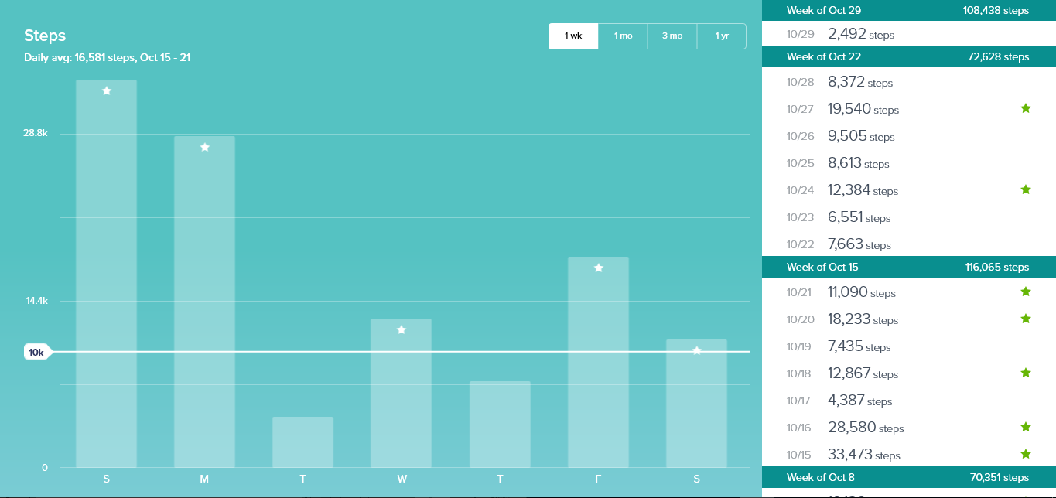
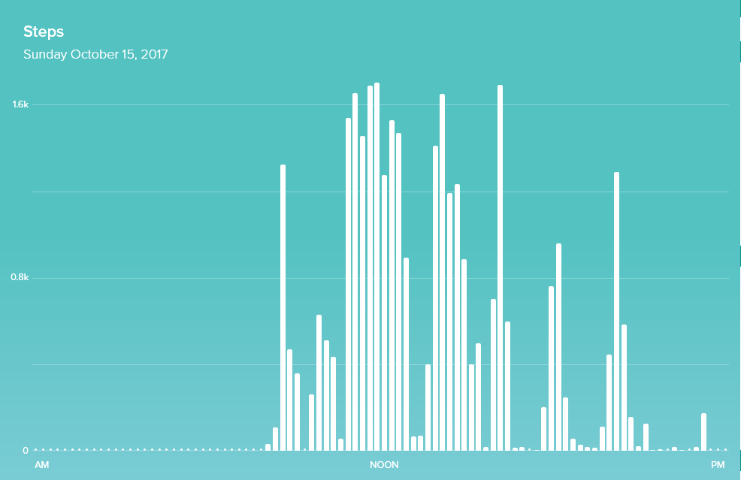
My high was on Sunday, October 15th with 33,473 steps. I got so many steps that day because I was in Atlanta for one of my classes during fall break. Our task was to explore the city and we were assigned different neighborhoods to walk around in, so I got a lot of walking done that day. It was constant walking from the morning until night.
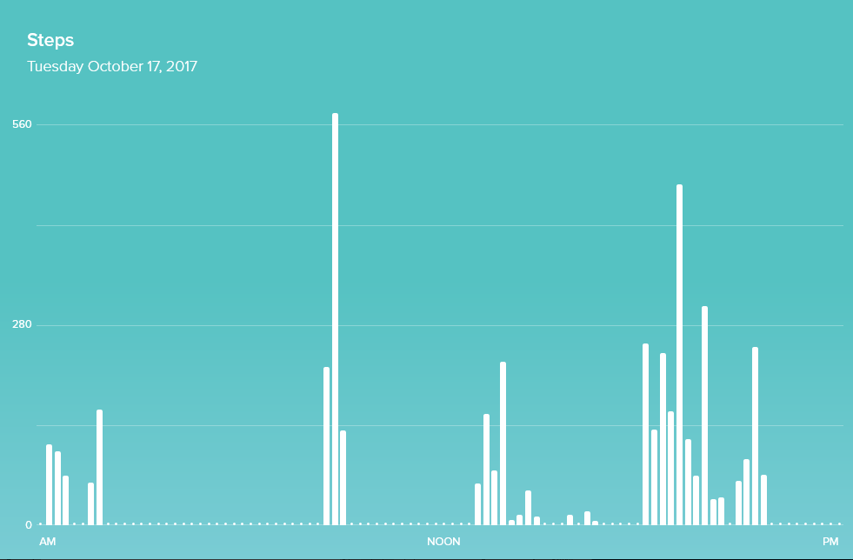
My low of the week was 4,387 steps on Tuesday, October 17th. This day my class drove back to Longwood from Atlanta so that took about 8 hours. I was pretty drained from walking the whole weekend, so I didn’t want to walk and that’s why I didn’t get a lot of steps that day.
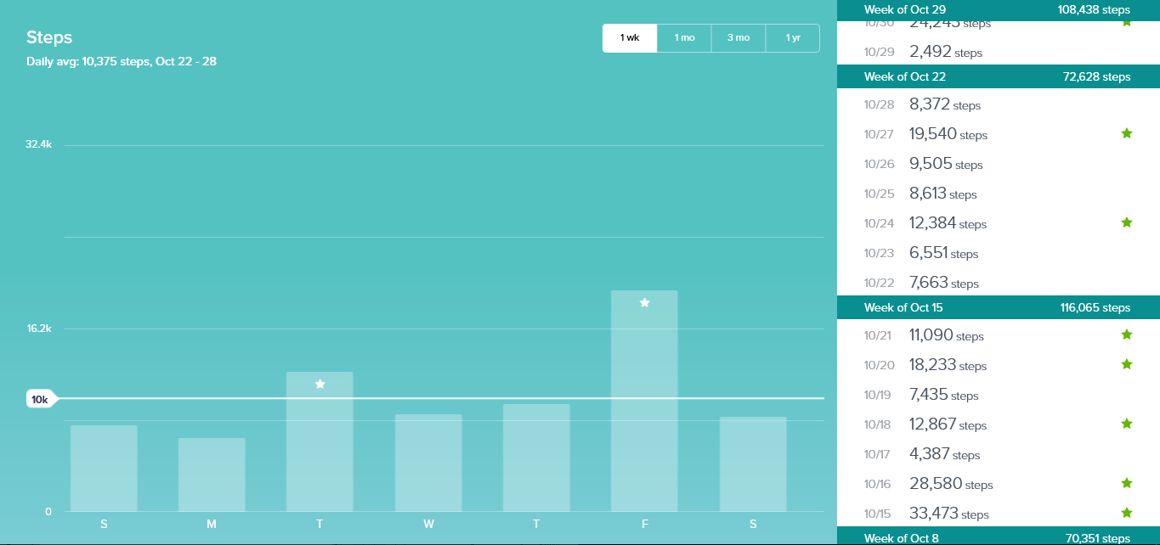
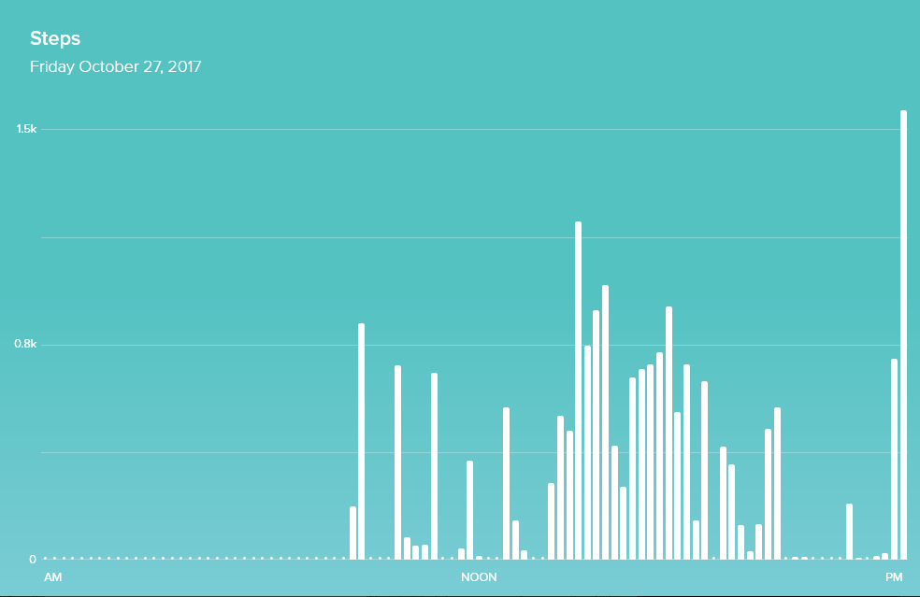
I got the high of 19,540 on October 27th, which was a Friday. I got most of my steps during work because I walk around the whole time. I also went and walked around campus with my friends late at night for the weekend of Halloween fun.
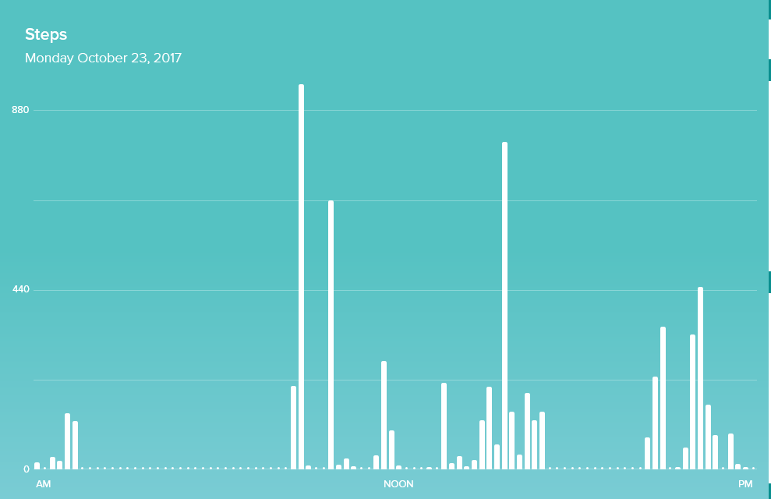
My low was on Monday October 23rd and I got 6,551 steps. I have 7 hours of straight classes on Mondays, so I do not get to walk around much and by the time I’m done with them I’m pretty tired. I have my fraternity chapter at night so I have to walk on campus and get some steps that way.

