The Polymerase Chain Reaction and DNA Samples
Sara Jones
BIO-101-05
11.20.19

Introduction
A study was conducted using different samples of DNA and the Polymerase Chain Reaction (PCR) to find how DNA is amplified. In this study, the main topic is to discover which group of DNA is the best when using PCR. This topic is very important in many different ways. A source entitled Utility of Pcr in Diagnosis of Invasive Fungal Infections: Real-Life Data from a Multicenter Study explained how PCR can be used to diagnose infections in your body, specifically fungal infections. In order to find these infections, the scientists used samples that tested negative to routine microscopy (Lass-Florl C, et al., 2013). The samples were thought to have been tested negative because the DNA sample was too small, which was where PCR came in to amplify the DNA and get more accurate results. This source is significant to my study because it explains how PCR can be used to benefit the medical world. PCR does not only help find infections, but major diseases as well. Another source entitled Apoe Genotyping and Response to Galanthamine in Alzheimer's Disease--A Real Life Retrospective Study, explained a study of diagnosing patients with Alzheimer’s disease. The PCR procedure helps to determine the genotypes to make the diagnosis after a six month treatment. This source is significant to my study because it gives an example of how PCR is used in the real world. Aside from the real world, PCR can also be found on TV shows such as CSI. In this show, PCR is used at crime scenes to amplify DNA and turn it into forensic evidence that can identify anyone involved in the crime. This source is significant to my topic because it explains other ways PCR can be used in real life. There are now new advancements of PCR technology being created and advanced. A news article on PCR explains the recent advancements and positives of digital PCR such as how it is more precise than regular PCR (Chi, 2011). In order to understand the hypothesis of the study, it is important to understand the terms PCR, DNA, amplification, and Variable Number Tandem Repeats. The goal of this study was to test the hypothesis that cheek swabs are the best DNA sample to use in PCR. To test this hypothesis, different samples of DNA were taken and amplified using PCR.
Methods

In this experiment, there were six different samples. Every group used their own DNA as the sample, each in a different way. Some examples of the different samples of DNA include nail clippings, saliva, hair, and cheek swabs. In order to extract the DNA samples from the tube we used a micropipet, which is used to measure small amounts of liquid. In this case the liquid being measured is the DNA samples. After extracting the DNA with the micropipet, the DNA samples are added to the PCR reactions. Each reaction will then contain everything needed for PCR, including DNA polymerase, nucleotides, primers, and the DNA sample. The PCR reaction runs at different temperatures in each stage. There are three stages that are repeated thirty five times. The first stage is run at 94 degrees Celsius for 30 seconds, this stage denatures the two strands of DNA. The second stage runs at 67 degrees Celsius for 30 seconds, this stage is when primers attach to the DNA molecule. The third and final stage is run at 72 degrees Celsius for 60 seconds, this stage is when the DNA polymerase builds new DNA. Once again, these three steps are repeated 35 times before the process is complete. After four cycles of this, there will be sixteen copies of the DNA fragment. Following the completion of the PCR reactions, a DNA gel is run. This gel helps to separate the DNA fragments based on size. It also allows the biological sample that produced the best result to be seen. The DNA gel occurs in an electrophoresis chamber run by a power supply. The gel is made from 0.8% agarose in 0.5 TAE buffer. The DNA gel runs at 300 volts for 10 minutes. During the DNA gel Ethidium Bromide binds to the DNA, this will allow the DNA to glow in UV light. Once DNA gel is complete, the sample is taken out and placed in a foto/phoresis machine. After being placed in the machine, the lights are turned off to make the DNA visible.
Results
The data of this experiment did not support the hypothesis that cheek swabs are the best DNA sample to use in PCR. The cheek swab sample of DNA was not the most unclear sample of DNA however, it appeared to be smeared (See Figure 2). The DNA sample that appeared to work the best for PCR was the nail clippings. By observing the darkness of each DNA band, it can be determined which DNA sample was the strongest. DNA bands in the saliva and hair DNA samples could be made out, however they were not as strong as the sample of nail clippings. This experiment provided adequate information for the hypothesis being tested however, we can not rely on the results as we don’t know if all DNA samples were properly extracted. One possible limitation of this experiment would be that DNA polymerase is prone to error which in turn could cause mutations in the PCR fragments that are generated. Another possible limitation of this experiment is the DNA could be exposed to outside microbes that could cause error in the tests.

References
Babić, T., Mahović, L., Sertić, J., Petrovecki, M., & Stavljenić-Rukavina, A. (2004). Apoe
genotyping and response to galanthamine in alzheimer's disease--a real life
retrospective study. Collegium Antropologicum, 28(1), 199-204.

Chi, K. R. (2011, December 1). Prime Time for Digital PCR. Retrieved November 19, 2019,
from https://www.the-scientist.com/lab-tools/prime-time-for-digital-pcr-41650.

Fan zui xian chang: Csi: Maimi = mai a mi = Crime scene investigation: Maimi. (n.d.).
Journal:

Lass-Florl, C., Mutschlechner, W., Aigner, M., Grif, K., Marth, C., Girschikofsky, M., . . . Nachbaur, D. (2013). Utility of pcr in diagnosis of invasive fungal infections: Real-life data from a multicenter study. Journal of Clinical Microbiology, 51(3), 863-868. doi:10.1128/JCM.02965-12

Figures and Tables
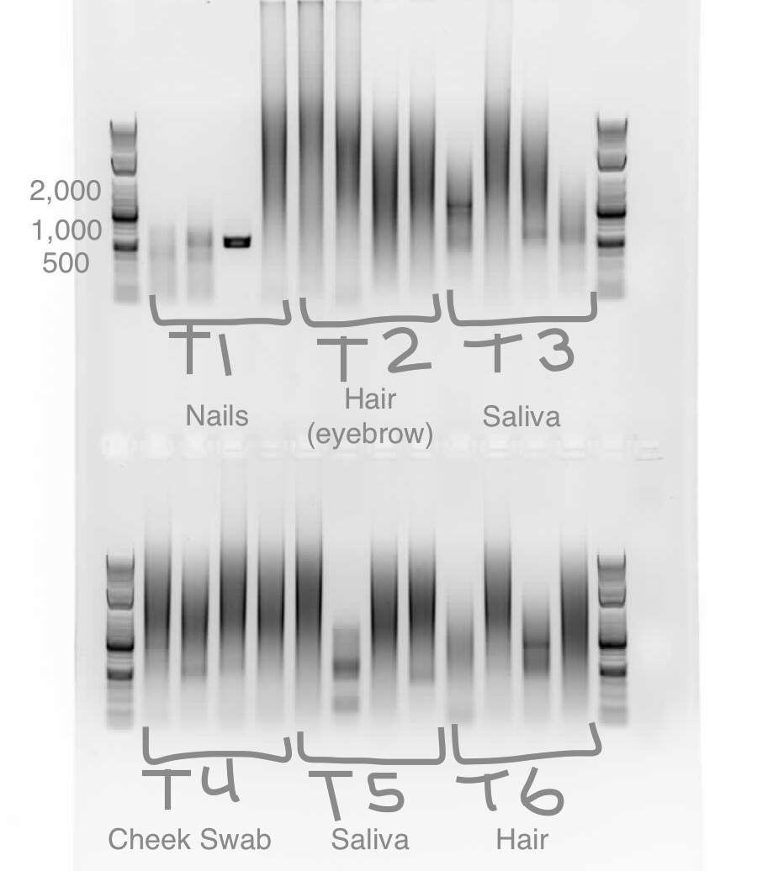
Figure 1: This figure shows the PCR results of each type of DNA sample. Along with our DNA samples, it also has an image of a clear DNA sample to compare each sample to.

