Abstract:

Human evolution is important because it brings about why we do things we do. It can explain why we eat what we eat, discuss what our intellectual capabilities are and how we got them, and most importantly, it can describe how the process will change for mankind in the future. Over recent years, scientist have learned more and more about human evolution. Interesting topics that have been studied are the rate of change in our genomes, closer relatives than chimpanzees, and how our brain evolved. Scientist have concluded that our genomes have slowly changed through the years and have slowly diverged from that of the chimpanzees and our closer relative known as the bonobo. Humans, like all creatures, are supposed to fill in a niche in the ecosystem. One of the adaptations that humans have over other species is that we have a very large brain. The niche that this is supposed to fill involves having the ability to quickly adapt in changing environments. This is the reason why humans are so successful.

Introduction:

Newly found discoveries about our ancestries can lead to a tremendous amount of knowledge. They help piece together the missing pieces of the puzzle the we rely on to understand our evolutionary past. The biggest common misconception among the general public about human ancestry is that we are derived from chimpanzees. Researchers have known for decades that this is a misrepresentation. Rather, the human and chimpanzee lineages diverged over 6MYA (Pruefer el. al. 2012). Recently, new fossil discoveries and genetic analyses have provided new insight into the evolution that took place after that ancient divergence. Researchers look into areas such as the changing rates of our genomes, the evolution of our brains, and other species that are even closer relatives than chimpanzees. All of these areas of research help explain how the human evolution process came to be. From there we can look at how we will evolve for the future since the environments are constantly changing.

Rate of change in our genomes

Scientist speculate that the human genomes change rapidly rather than gradually (Bird 1995). Our traits came to be much more refined as the different species of humans split off. There are two major instances where entire genomes have changed rapidly within the evolution of humans. One was approximately 1.4 billion years ago which is the time when eukaryotes rose from prokaryotes. Prokaryotes have about five thousand genes (Brown 2002). Eukaryotes genomes became more complicated and then a total of ten thousand genes were implemented into their DNA. The other instance occurred at the end of the Cambrian period and the vertebrates were developed. This is important because these vertebrates had roughly thirty thousand genes, which is three times more than those of the first eukaryotes.

There are two ways that newly developed genes can be added to a genome. One of which is duplication of the genes that are already present, and the other way is that they can develop them from other species (Brown 2002).

Gene duplication can occur by either duplicating the entire genome or by duplicating individual or groups of genes. It may be obvious that if the entire genome was replicated that there would be a considerable number of genes in the DNA. This abnormality is caused by an error in meiosis. These gametes were initially supposed to by synthesized into haploid but instead changed to diploid (Figure 1) (Brown 2002).

The other possible cause of the mass evolution of DNA is the duplication of individual/groups of genes (Henikoff et. al. 1997). The possible ways that this phenomenon can occur are by: Unequal crossing-over (occur by similar nucleotide sequences not properly aligned in the correct position of the genome), Unequal sister chromatid exchange (this is when chromatids on a chromosome are to aligned to their designated position), DNA amplification (caused by the unequal recombination of daughter DNA molecules), and Replication slippage (this can occur if the genetic sequence it far too short).

These particular modifications are brought up by duplications. These duplications however involve a deletion mutation which most of the time causes the gene to lose the ability to be expressed (Wagner 2001). Those that don’t lose this ability can result in the expression of a completely new gene. A specific example of this can be traced back to 800 million years ago with the globin gene. The globin gene was responsible for the production of a substance called myoglobin which allows oxygen to bind to blood (Doolittle, 1987). Another example of this can be quite literally from our guts. A common ancestor gave rise to trypsin and chymotrypsin genes about some 1500 million years ago (Barker and Dayhoff, 1980). Both of these genes provide enzymes that assist in human digestion.

By looking at the ways how the genomes change, it can be expected that ours will change in the same fashion in the future. This is an interesting topic because it shows how different species can be from each other all depending on what their DNA possess. An interesting testament to this could be the investigation of the bonobos and chimpanzees. Both of these apes are relatives to humans and their evolution between each other could provide insight to our future.

Humans Vs. Bonobos and chimpanzees:

Recent research studied the muscular system of both bonobos and chimpanzees. They then traced back the lineage of all three species and determined that bonobo muscles have changed the least since they diverged from the lineage of humans and chimpanzees eight and two million years ago respectively (Pruefer el. al. 2012). Closer looks at their anatomy reveal that they are more physically human like than the chimpanzees. Researchers studied seven specimens that died at the Antwerp zoo (Hare, et. al. 2007).

It must also be understood how bonobos and chimpanzees differ as well. Although they are fairly similar in some respects, they are different in many social and sexual behaviors (Pruefer el. al. 2012). Some of these traits do cross over into the humans’ realm. Chimpanzees are native to equatorial Africa and Bonobos are localized in the Democratic Republic of Congo. Their differences in behavior include Bonobos being more playful and immature throughout their adult lives, show intense sexual behavior and do not heavily compete for their territory or females (Pruefer et al. 2012). Chimpanzees on the other hand only use aggression to acquire their home range and to acquire a mate.

This has been investigated in the use of tools and cognitive testing (Hermann 2010). It should be noted that in their natural settings, chimpanzees show their use of tools to get insects while bonobos rely very little on them (McGrew 1992). This is a valuable piece of information to know because using tools means that a species must know the requirements of their surround environment. When researched Bonobos are socially cooperative, reluctant to try new activities, and show a greater tolerance of others around food, unlike the chimpanzees (Hare, et. al. 2007).

A current study was made to compare cognitive functions between juvenile and adult bonobos and chimps. They used a series of sixteen task on both social and physical aspects (see figure 3) (Hermann et. al. 2010). Things like geometric gaze-following, gestural communication, quantitative discrimination, liquid conservation, tool properties, and motoric inhibitory control were measured. Bonobos are hypothesized to be somewhat like small children due to their shy behavior. They were expected to be better at mind task and social skills, while chimps were expected to do well on exercises involving tools. The results are shown in Figure 3. Significant values were found in the task that dealt with Tools and Casualty and Theory of Mind. Chimps as expected did much better with the activities that dealt with tools and casualty, this could be because of their experience in the wild with tools. Bonobos were thought of to be pretty intelligent and also did well in the Theory of Mind test.

It is generally accepted that reasoning and tool usage seems to increase as the apes continue to age (Call 2006) and this test shows no exception. Researchers were fairly concerned as to why there was a decrease in performance on the theory of mind. This could be the result of a lack of episodic memory. Episodic memory involves remembering a unique memory from a specific event. The things that were involved in the test may have not been significant enough for the apes to want to learn (Martin-Ordas et. al. 2010).

Scientist have sequenced the genome of the less common bonobo and have compared it to that of human and chimpanzees. It was found that genome structure many bases aligned those of the human genome. Bonobo DNA favored roughly 98.7% of Human DNA and 99.6% to the chimpanzee’s DNA (Pruefer et. al. 2012).

Now that we see the differences between the bonobo and the chimpanzee are pretty substantial, many speculate that our behavior may change in the future as well (Caldwell and Millen 2008). Most of them however, will be retained due to culture. This degree of retention is uknown though, but on-going research in still being done on this.

Evolution of the Human Brain:

For years people have wondered why humans have so much greater intellectual and cognitive abilities than other animals and what changed in our DNA to develop this remarkable trait. Understanding how we evolved in the past could lead to what might be expected for the future. Humans’ remarkable intellectual abilities can be attributed to the one hundred billion neurons that are in the brain. The storage capacity of all of these neurons together are equal to 1.25x10^12 bytes (Hofman 2012). The evolutionary reasoning behind a large brain is that it can respond to changes in the environment much faster and respond to such changes appropriately (Hofman 2014).

How did humans evolve to develop such a large brain? In smaller species there is a methodical correlation between cortical to subcortical areas of the brain. As the cerebral cortex cortical increase in size, the rate of growth and development for nervous tissue is higher in the cerebral cortex than for subcortical areas (Charvet and Finlay 2012). As the human brain got bigger and bigger, cortical folding took place because the brain reached such an such a large size. This is typical of most mammals to develop folds in the brain as the increase in size. This change in mammalian brains brought out the implementations of further growth in areas of conception rather than motor processing and perception (Glasser et al., 2013).

Researchers compared the size differences between human and chimpanzees and they found that human brain is significantly larger to that of the chimpanzee. It takes humans roughly 14.5 years for their brain to mature and 9.3 years for chimpanzees. Humans have evolved by maturing much later in life and as a result, our brains are nearly four times larger than the chimpanzees (see figure 2) (Robson and Wood 2008) There are clearly many benefits to have a large brain, However, there are some costs. One of those being the exceptionally slow and protracted childhood growth.

Slow childhood growth has been studied quite vigorously and scientist have found that we require a very high basal metabolic rate in our youth lives to allow our brains to develop efficiently (Kuzwaa et. al. 2014). Scientist believe that the reason why our brains are slow develop are due to the necessity of learning complex foraging skills (Kaplan el. al. 2000), this allows the offspring to help forage on their own and keep overall family energy expenditure to a minimum (Kramer and Ellison 2010). This action also helps alleviate the burden that is placed on the mother if she has to help feed all of her offspring (Gurven and Walker 2006).

Scientist took data from a series of pet scans to measure the brain glucose uptake from around birth to adulthood (Chugani et. al. 1987). They found that the most glucose uptake was not found during birth but instead during middle childhood. Glucose uptake by the brain comprises of roughly 66% of the resting metabolic rate during childhood (Holliday 1986). As time goes on it was agreed that the resting metabolic rate slowly decreased as people have aged and gained weight. This leads to an overall decrease of glucose uptake in the later years of peoples’ lives.

How humans are expected to evolve:

Developing scenarios about how humans can evolve is a fairly challenging task. researchers and philosophers alike reason by investigating what humans need and don’t need to develop a possible conclusion. These can develop into specific scenarios/views that people can agree and disagree on. To name a view, there are the Panglossian view, dystopian scenario, and behaviors.

The Panglossian view studies how we developed over a massive amount of time. It considers how we all developed from a primitive behavior and a basic human anatomy. This view also takes into account our evolution over the past few hundred years. It is defined as the change from primitive life to the development of sophisticated and advanced organisms through the process of biological evolution (Bostrom 2004) We have sped up our own evolution because of cultural and technological development. As a result of this, humans have seen increased life span, improve labor productivity and social, and scientific knowledge (Wright 1999). Because of these improvements, this view supports that evolution will only be more favorable towards humans. There are ,however, some objections to this view. The main objections focus on our inability to prepare for a sudden mass extinction. These are things that we cannot possibly stop, things like pandemics, impacts from meteors, or super volcano eruptions. Another objection can include things that can prove evolutionary changes that don’t help humans at all based on our current state (Bostrom 2002).

The dystopian scenario focuses on technology and the unfavorable evolution that it may cause to humans. This scenario discusses the implication of technology that we use to help the weak survive. Overall, this could lead to a lack of consciousness of what we really are and stall our evolution. The human brain is an excellent example of this. Some practices that cause the destroying of a module in the human brain may seem to be beneficial may hinder evolutionary success (Sandberg and Bostrom 2008). For example, this could be one that includes the cause of epilepsy and cause the other parts to function better. These conditions will never go away because the people that have them will still breed and carry on the gene. Technology could cause a regression of human evolution.

Another aspect that is closely being studied is our behavior. Humans rely on flamboyant displays to represent wealth, fitness, qualities, and aggression (Kansa 2003). This can be achieved by social media, the way people dress, and could even be things like dancing and reading. All of the activities are useless and new ways to display such things may be developed or may disappear altogether. New techniques could be the displaying of ownership certificates and bank documents rather than expensive jewelry and clothes

Discussion:

We rank ourselves as the most intelligent species on the planet and have the capabilities to adapt to almost everything. We found out what our role was in the ecosystem by looking at close relatives. Our behaviors are pretty much a mix of both the chimpanzee and bonobo. We take after the bonobo in that we are willing to learn, fairly social, and even have close physiology. Our similarities with the chimpanzees lie with our usage of tools. This mix of characteristics and our exceptionally large brain allowed us to move to the top of the food chain.

Our massive brains have evolved to help newborns and young children to understand the necessities of foraging first. This takes off any unnecessary strain on our mothers. As middle childhood arises, a greater emphasis on learning is put forth leading to a higher level of intelligence.

The rate of change in our genomes is exponentially high at this time due to advancements in technology. Vaccines have ended many of the diseases that have threatened human existence (Church). Our evolutionary growth, however, may be endangered by our intelligence as well. Technology is assisting the weak to stay with us and may cause a retention issue with certain undesirable traits. There are some models that suggest that evolution may actually end up being in our favor but only time can tell.

Figures:

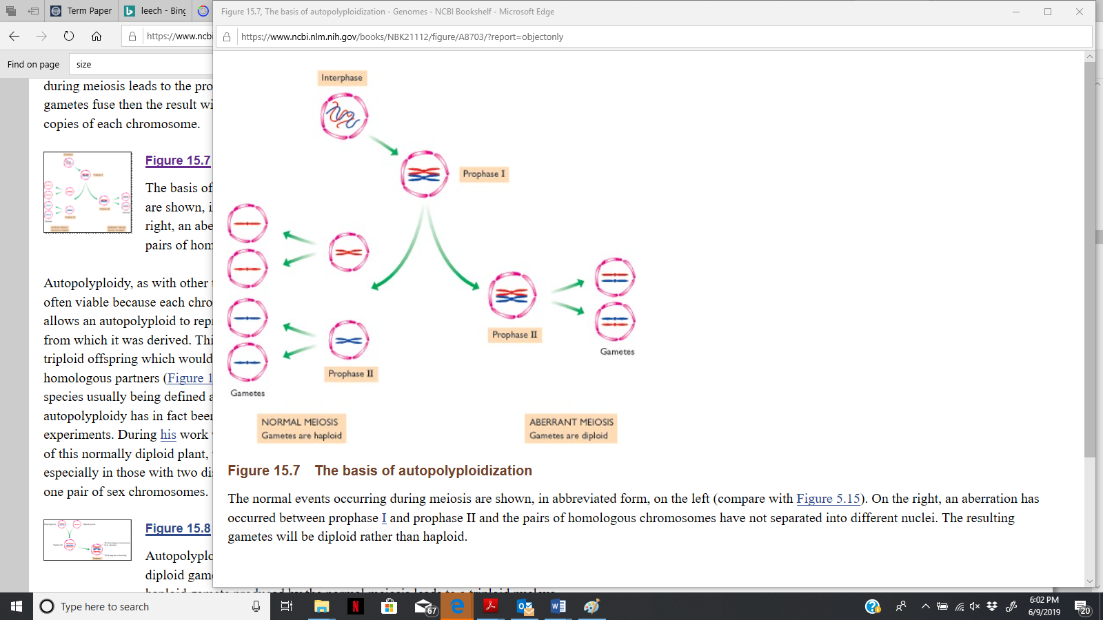

Figure 1 represents the process of meiosis in which the result is two diploid gametes are produced rather than the normal haploid. This is caused by a complete duplication of an entire genome which is a rather rare abnormality but can start an evolutionary phenomenon for a species rather quickly if it is passed on. (Brown 2002)

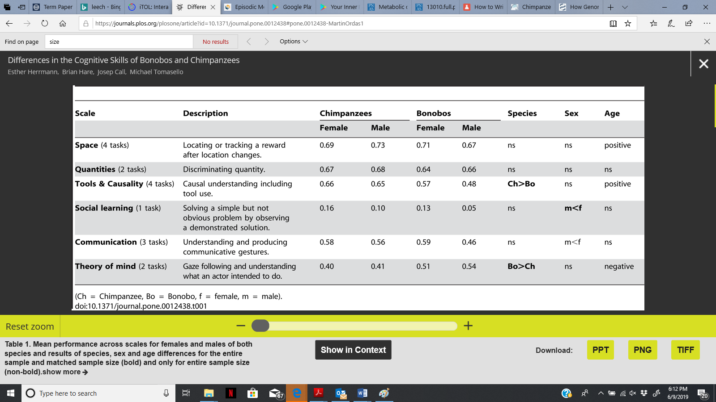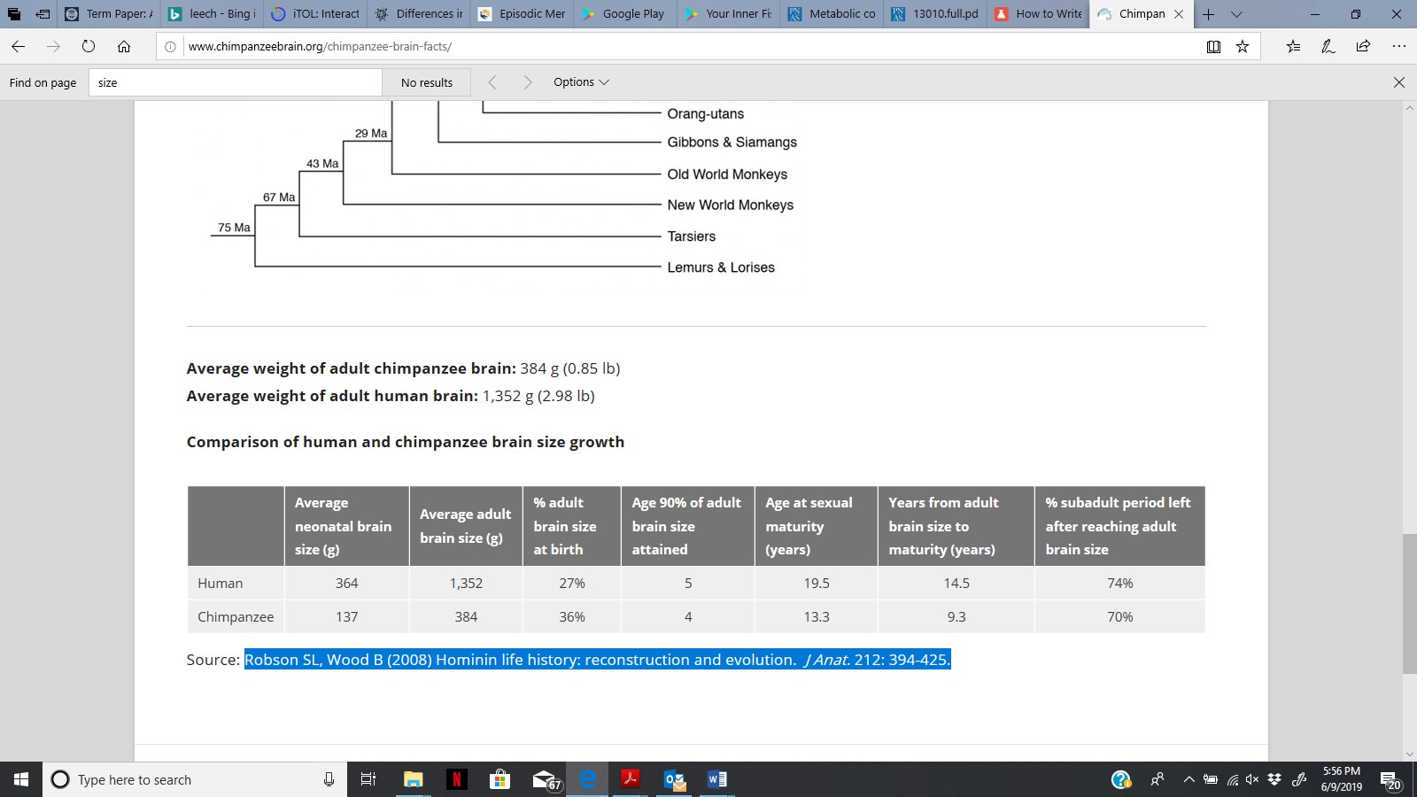Fig. 2 represents a size comparison of the brains between humans and chimpanzees at both maturity and neonatal. It can be seen that the brain of humans are significantly larger than that of the chimpanzees across the board. Other notable differences can be the difference between both sexual and brain maturity. (Robson and Wood 2008)

Figure 3: represents the results of the test that were done on the chimpanzees and Bonobos. Significant value were found for the tools and causality, social learning, and theory of mind task. It was found that chimpanzees and a better score as expected in the tools and causality task, while the bonobos excelled in the theory of mind. Females tended to the best in the social learning class. (Herrmann et. al. 2010)

References:

Barker C, Dayhoff M, (1980) Evolutionary and functional relationships of homologous physiological mechanisms. BioScience 30:593–600

Bird AP (1995). Gene number, noise reduction and biological complexity. Trends Genet 11:94–100.

Bostrom, N. (2002), Existential Risks: Analyzing Human Extinction Scenarios and Related Hazards. Journal of Evolution and Technology 9

Bostrom, N. (2004), THE FUTURE OF HUMAN EVOLUTION. Death and Anti‐Death: Two Hundr ed Years After Kant, Fifty Years After Turing,  339‐371

Brown, T. (2002) Genomes, 2nd edition.

Caldwell C. and Millen E. (2008). Studying cumulative cultural evolution in the laboratory. Philos T R Soc B 2008, 363: 3529-39.

Call J (2006) Inferences by exclusion in the great apes: the effect of age and species. Animal Cognition 9: 393–403.

Chugani T. Phelp, M. Mazziotta J. (1987) Positron emission tomography study of human brain functional development. Ann Neurol 22(4):487–497.

Doolittle RF (1987) The evolution of the vertebrate plasma proteins. Biol. Bull 172:269–283.

Gurven M, Walker R (2006) Energetic demand of multiple dependents and the evolution of slow human growth. Proc Biol Sci (1588):835–841.

Hare B, Melis A, Woods V, Hastings S, Wrangham R (2007) Tolerance allows bonobos to outperform chimpanzees in a cooperative task. Current Biology 17: 619–623.

Henikoff S, Greene EA, Pietrokovski S, Bork P, Attwood TK, Hood L (1997) Gene families: the taxonomy of protein paralogs and chimeras. Science 278: 609–614.

Herrmann E, Hare B, Call J, Tomasello M (2010) Differences in the Cognitive Skills of Bonobos and Chimpanzees https://doi.org/10.1371/journal.pone.0012438

Hofman M. A. (2012). Design principles of the human brain: an evolutionary perspective. Prog. Brain Res. 195, 373–390

Hofman M. A. (2014). Evolution of the human brain and intelligence: from matter to mind, in Handbook of Intelligence: Evolutionary Theory, Historical Perspective and Current Concepts

Holliday MA (1986) Body composition and energy needs during growth. Human Growth: A Comprehensive Treatise: 117–139.

Kaplan H, Hill K, Lancaster J, Hurtado AM (2000) A theory of human life history evolution: Diet, intelligence and longevity. Evolution Anthropology 9(4):156–185

Kramer KL, Ellison PT (2010) Pooled energy budgets: Resituating human energy allocation trade-offs. Evolution Anthropology 19(4):136–147.

Kuzawaa C, Chugani H, Grossman L, Lipoviche L, Muzikd O, Hofg P, Wildman D, Sherwood C, Leonarda W, Langek N (2014) Metabolic costs and evolutionary implications of human brain development. PNAS 111: 13010–13015

Martin-Ordas G, Haun D, Colmenares F, Call J (2010) Keeping track of time: evidence for episodic-like memory in great apes. Animal Cognition 13: 331–340.

McGrew WC (1992) Chimpanzee material culture: Implications for human evolution. Cambridge: Cambridge University Press.

Pruefer K, Munch K, Hellmann I, Akagi k, (2012) The bonobo genome compared with the chimpanzee and human genomes. Nature 486: 527-531

Robson L, Wood B (2008) [Hominin life history: reconstruction and evolution.](http://www.ncbi.nlm.nih.gov/pubmed/18380863)  J Anat. 212: 394-425.

Sandberg, A. and Bostrom, N.  (2008) *Anti-Death: Two Hundred Years After Kant, Fifty Years After Turing:* 339-371

Wagner A. (2001) Birth and death of duplicated genes in completely sequenced eukaryotes. Trends Genet. 17:237–239.

Wright, R.  (1999), Nonzero: The Logic of Human Destiny.  New York: Pantheon Books