Temperature Affected Bacterial Growth and Diversity And Possible Pathogenicity To Fish

By Matthew Jones

Abstract

This research project focused on testing the hypothesis that more bacteria will exhibit a greater presence in areas where more sunlight is available. Abundance was the primary focus but identity was important as well. The species was determined using 16S rRNA gene sequencing. Samples were retrieved from a retention pond at Lancer Park (fig. 1), the locations of all of the samples were recorded, noting whether or not the two areas were in shaded and sunny conditions. Bacteria were cultured to determine the abundance and diversity from these sites. Once cultured, three colonies were selected for identification. The colonies were tested for their gene sequencing using 16S rRNA gene and were compared to the software called BLAST (fig. 9). Contrary to the hypothesis, shaded areas ended up being slightly preferred by bacterium. The genera found were *Bacillus, Pseudomonas, and Pseudo*. These results could be indicative of the similarity of the optimal growing conditions for each bacteria .More samples could have been more helpful and an assurance to the tests performed.

A photic zone is known as the uppermost surface layer of water that typically has intense levels of sunlight on it or is exposed to sunlight regularly. The temperatures of these shady zones can vary quite considerably This is because most bacteria thrive where temperatures are highest. Microorganism prove to be a necessity amongst many fishes and crustaceans and are vital for the wellbeing of an ecosystem (Lemke and Bowen 1998). Research suggest that minnows fed *artemia* (brine shrimp) and detrital aggregate had a significant increase in growth. Detrital aggregate is defined as the mixture of microorganisms and plant debris. This is important because further research could be used to enhance the populations of the fish and could provide a quality ecosystem. Bacteria have been known to harbor in areas of water that is warmer than that of shaded areas. As demonstrated in an experiment at a coastal zone near Stockholm, Sweden, it was found that the frequency of dividing cell for bacteria has a direct correlation to growth rate and was therefore used to measure growth. These values were measured by extracting samples from various depths of water. The highest amount of bacterial growth was found in areas of higher temperature or those sample from the top of the column. (HAGSTROM, et al. 1979). It was found that bacteria preferred the top layer of water all the way down to 15 meters of water. Very little growth was recorded below 15 meters. Surprisingly, bacteria had a very high growth rate in the months of August, September, October, March and May. July, August, and September were the hottest months with the average temperature to be around 13-19 degrees Celsius with 15 meters being the 13 degree Celsius and the surface temperature to 19 degrees Celsius. The optimal conditions for enteric bacterial to growth is best around 30 degree Celsius but growth is hindered at 20 and 5 degree Celsius. The study that supports this investigated a type of bacteria can survive and grow in starving conditions by having a food source of mostly carbon. River water was collected at 3 sites. Then the bacteria were cultured in various temps. Bacteria grew very well in water near sewage, which suggested that conditions were much more favorable (Hendricks 1972). Abundance is not the only important aspect of bacterial growth. This growth also ties into species richness. Is there a difference between microbial bacteria populations and adaptations in areas of water that contain shade and sunlight? More bacteria should be present in areas where more sunlight is present.

Another study found that there was intra- and interannual change in pelagic bacterial community composition over a certain amount of time (Shade, et al. 2007). Supporting information included that previous research of regular phenology was repeated over time, this implied that freshwater bacterial communities are more predictable. Methods included collecting Lake water over the deepest part of the pelagic zone every two weeks. Bacteria was retrieved using polyethersulfone filters. Then the Filters were frozen at 280 degrees Celsius and stored before the deoxyribonucleic acid was extracted and bacteria were identified. These scientists also found that water column mixing and trends in water temperature were strongly correlated to bacterial variation. They found that May and June BCC was not as dispersed and consisted of the communities that took place throughout the late summer and fall months. With the exception of July, each following month had a less expected bacterial community than the previous. Other experiments sought to find if there was a latitudinal gradient between different bacteria biodiversity and if it is caused by temperature, productivity, or historical factors (Furhman et. al 2008). There is a gradient between plant and animals, so they wanted to see if there was one with bacteria. Their hypothesis was that bacteria wouldn’t show much of a latitudinal gradient because of how its so small and very abundant. They found that bacteria actually do show geographic patterns. Their methods consisted of finding 100 samples in 57 locations. Data analysis consisted of a using a rapid and high-resolution whole assemblage genetic fingerprinting to identify bacterial diversity. Extremely high species richness was observed at temperatures 15, 20, and 30 degrees Celsius with a gap at 25.

Sample collection

Label two fifty mL conical tubes noting what site they came from. All of the locations of the samples were recorded from the area of which they came from. Collect the water samples into the sterile 50mL tubes. Plate 100 microliter of water into the first agar plate, then a 1:10 and a 1:100dilution of the 2nd and 3rd agar plates was performed. Pipette the 100 microliters of into the three samples to middle of appropriate plates. Spread the sample using the sterile “hockey sticks.” After application, incubate the plates at twenty-five degrees Celsius for eighteen to twenty-four hours. Next, record the data noting the number of colonies and different colonies in each category of color, form, shape, size, and elevation. Parafilm each plate and place into the fridge.

DNA Extraction

To begin with DNA extraction, scrape cells out of all tubes and transfer them (300μl) to microbeal tube. Be sure to label the tubes. Add fifty μl MDI to each microbial tube. Vortex it for 10min and cetrufuge it at 13,000 Rpm for 30 seconds. Collect 300 μl of the supernalent top liquid. Then add 100 μl of ND2 and vortex for 5 seconds. Place the tube into a fridge with a temp of 4 degrees Celsius for five minutes. To separate the DNA, centrifuge at 13,000 rpm for one minute. Move the supernalent liquid to a clean tube. Add 900 μl of MD3 and vortex it for 5 seconds. Next is to load 700 μl onto the spin column. Centrifuge it for thirty seconds and dispose of the flow through. Using a collection tube, put the liquid into the spin column. Add 300 μl of MD4 to column centrifuge for thirty seconds. Then place the column in a newly labeled tube and add fifty μl of MDS. Next is to centrifuge it for thirty seconds. This new liquid in the spin column is DNA.

PCR

PCR is done to differentiate one gene from another. Label the PCR tube indicating which colony it came from. Set up one reaction tube for each colony. Keep all the tubes on ice to avoid destruction and denaturing of DNA. Add these components to the PCR tube: Nuclease (17.5 μl), one tag hot start quick load 2x master mix (25 μl), and primer mix (ten μl of both forward and reverse) respectively. The bacteria were then primed to replicate the 16s rRNA. Then add three μl of the DNA that was extracted and transfer the PCR tubes to a PCR machine and begin the thermocycling process. The thermocycling conditions are as follows, initial denaturation at 95 degrees Celsius for three minutes, thirty cycles at temps 95 (30 min), 50 (30 min), 72 (60 min). after that it will go through the final extension at 72 degrees Celsius (7 min.) and hold at 4 degrees Celsius.

PCR purification and restriction enzyme digestion

50 uL of binding buffer was added to the tube for each PCR reaction,. Instead of vertexing, it was mixed by pipetting up and down. A 100 uL of this mixture was added to the spin filter column and centrifuged for 1 min at 13,000 rpm. The flow through was then discarded. 700 uL Wash Buffer was then added to the spin filter column and centrifuge for 1 min at 13,000 rpm. Again, the flow through was dumped and it was centrifuged again for 1 min. the spin filter column was then transferred to a clean 1.5 ml. Sterile water (20 uL) was added to the center of the white filter and once again centrifuged for 1 minute. A nanodrop was then used to measure the DNA concentration and 260/280 values of 2 uL of product (flow through).

Gel Electrophoresis

Gel electrophoresis is used to determine the amount of base pairs that are in a PCR. The electrophoresis chamber was filled and cover the gel with 1X TAE buffer (275 mL ). 10 μL of each sample was inserted into the separate wells in the gel chamber. The machine was ran at 120 V for 30 minutes. A ladder image was used to determine the size (in base pairs) of the purified PCR.

Results

A grand total of 23 colonies were discovered in the samples collected from the sites that contained sunlight and another total of 30 from the shady areas. A gel electrophoresis test was performed for each sample to find the number of base pairs that it has (fig. 5). Then the DNA was put into a software system and the base pairs were identified. The specific gene amplified was 16s rRNA. This information was used to help identify the bacterium’s using a government funded software called BLAST (basic local alignment search tool). BLAST is a program that was used to identify the bacteria’s identity based off its sequence of base pairs (example on fig. 9). The possible suspects of bacteria are represented in Fig. 6, 7, and 8 with the percentage of the likelihood of its identity. Figure 6 shows that the bacteria identified is likely *Pseudomonas helmanticensis*. To help confirm the identity of the bacteria they were, the growth temperatures and their cell shapes were compared. For example, for this bacteria, *Pseudomonas helmanticensis, their*  aerobic rod-shaped cells with a growth temperature of around 5-31 degrees Celsius. This is likely what was identified as the cells that were viewed were indeed rod shaped (Ramirez-Bahena et. al. 2014). The close contender *Pseudomonas baetica* could also be a possibility as to what was identified. If this is the case, this bacterium is a known pathogen to a variety of fish. Ideal growth temperature of this bacteria falls around 4–30 degrees Celsius(Lopez et. al. 2012). Figure 7 had a three-way tie between the bacteria *Bacillus wiedmanni**, Bacillus proteolyticus* (37-50 degrees Celsius), and *Bacillus cereus*. (fish pathogen/ puts cells in state of lysis (Bhaskar et. al. 2007). Lastly, the bacteria in the last sample was determined to be *Pseudo agarici*. The bacteria cultured were fairly diverse most of them present exhibited a circular form (fig. 3), were white (12 were white vs 8 of which that were yellow) and were between 1-3 mm (14 of them) and some were less than a millimeter (5 of them were) . The abundance was also measure with more bacteria preferring the shade as opposed to those with direct sunlight (fig. 2)

Discussion

All of these bacteria are capable of growing in both of the different temperatures (sites) that the samples were collected from. This is also is reflected in the hypothesis, because of this it was rejected. Shade was actually preferred by bacterium. This could be attributed to the wide range of temperatures that the bacteria were capable of growing in.

Fish health is a major concern in areas where this bacterium is present. For example, some of the bacteria discovered from the samples are indeed pathogens for fish species but some are uknown. For example, Pseudomonas Baetica and Bacillus Cereus is a well-known pathogen to many different kinds of fish (Lopez et. al. 2012)). Others like Bacillus Wiedmanni have been recently discovered and the effects it has on the fish is widely uknown. However, it has been found that this bacterium continually synthesizes a catalase (Miller et. al. 2016). A catalase has the ability to degrade hydrogen peroxide and provide the products of hydrogen and water. This is commonly in pathogens to defend against the host’s immune system (Iwase et al. 2013). These likely pathogens could result in damage to the population of the fishes and could negatively impact the ecosystem as well. Much more research is needed to discover what sort of negative implications these bacteria have on fishes and how this can impact the ecosystem. These bacteria grow best only under ideal conditions such as temperature of the water. The effects of shade versus sunlight could indeed prove to have a significant difference on the diversity and abundance of the bacteria.



Fig. 1 shows the location of the pond where the samples were collected. The pond was roughly 100-125 yards west of Lancer Park South.

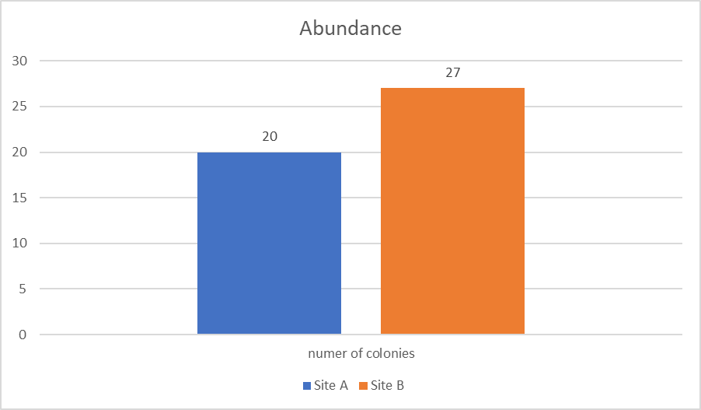

Fig. 2 Abundance of colonies in all the plates at both zones with no dilution factors. Number over bar indicates sample size.

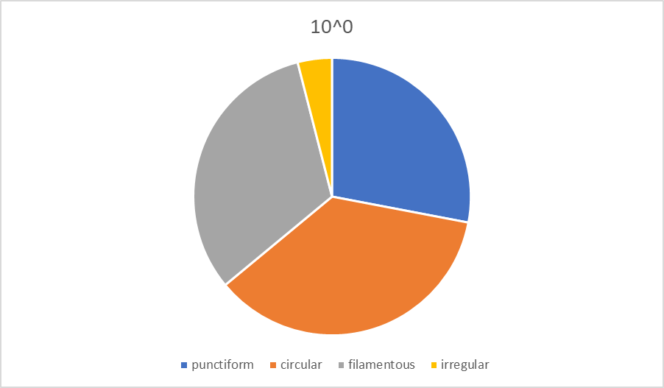

Fig 3. Pie chart representing the diversity of the bacteria present by discussing its shapes with a dilution factor of 10^0.

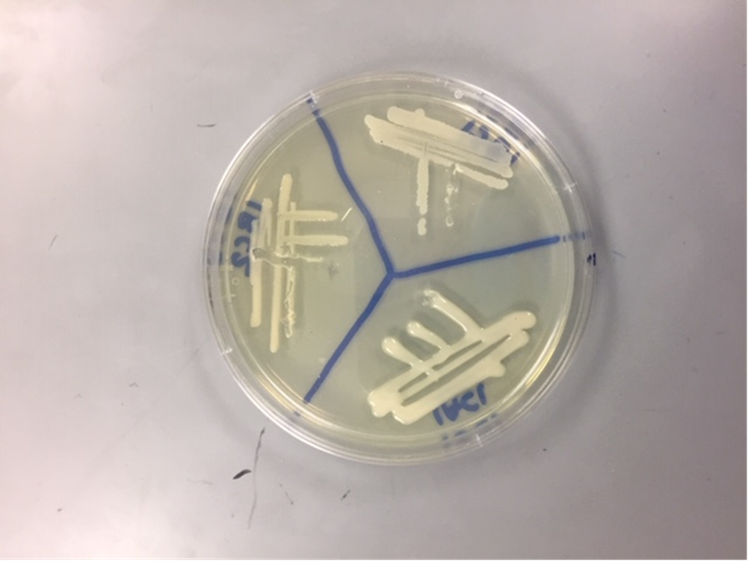

Fig. 4 is a picture of what the cultured bacteria looks like during testing and how each group was separated

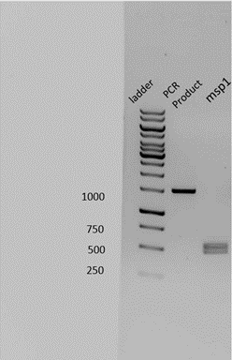

Fig. 5 Gel electrophoresis performed on the cultured bacteria to determine amount of base pairs and confirm its identity. From left to right: ladder, PRC product, and msp1. PCR product represents when the DNA was replicated. MSP1 shows after the enzyme cut it and made fragments.

|  |  |
| --- | --- |
| Species of Bacteria at site 1AC1 | % identity |
| *Pseudomonas helmanticensis* | 99.81 |
| *Pseudomonas baetica* | 99.62 |
| *Pseudomonas umsongensis* | 99.15 |
| *Pseudomonas jessenii* | 98.96 |
| *Pseudomonas koreensis* | 98.96 |

Fig. 6 Percent identity of the likeliness of the species of bacteria identified in 1AC1. The most likely being *Pseudomonas Helmanticensis and least likely being Pseudomonas Koreensis.*

|  |  |
| --- | --- |
| Species of Bacteria at site 1BC1 | % identity |
| *Bacillus wiedmanni* | 99.9 |
| *Bacillus proteolyticus* | 99.9 |
| *Bacillus cereus* | 99.9 |
| *Bacillus paramycoides* | 99.8 |
| *Bacillus albus* | 99.8 |

Fig. 7 Percent identity of the likeliness of the species of bacteria identified in 1AC1. The most likely being *Bacillus Wiedmanni* (99.9%) and least likely being *Bacillus Albus* (99.8%) .

|  |  |
| --- | --- |
| Species of Bacteria at site 1BC2 | % identity |
| *Pseudo agarici* | 99.17 |
| *Pseudo asplenii* | 98.97 |
| *Pseudo fuscovaginae* | 98.97 |
| *Pseudo helmanticensis* | 98.76 |
| *Pseudo baetica* | 98.76 |

Fig. 8 Percent identity of the likeliness of the species of bacteria identified in 1AC1. The most likely being *Pseudo Agarici* (99.17%) and least likely being *Pseudo Baetica* (98.76%) .

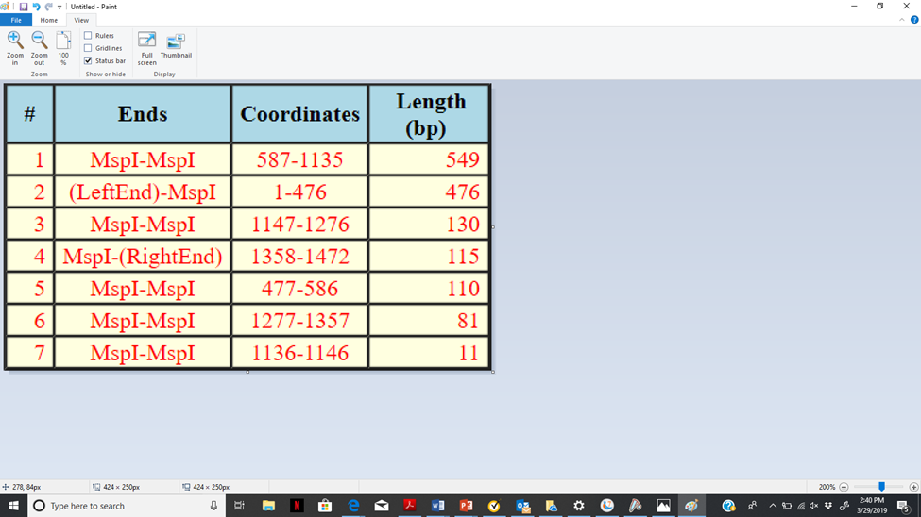

Fig. 9 this is an example of the results found using the BLAST software. The bacteria identified was *Pseudomonas helmanticensis* with the fragments being identical to those shown in figure 6.

References

Bhaskar N., E. S..Sudeepaa., H. N. Rashmi., and A.Tamil Selvi. 2007. Partial purification and characterization of protease of Bacillus proteolyticus CFR3001 isolated from fish processing waste and its antibacterial activities. BIORESOURCE TECHNOLOGY. 98: 2758-2764

Furhman J.A., J. Steele., I. Hewson., M.S. Schwalbach., M.V Brown., J.I. Green and Brown J.H. 2008. A latitudinal diversity gradient in planktonic marine bacteria. Environment Microbiology

HAGSTROM A.t., U. LARSSON, P. HORSTEDT, AND S. NORMARK. 1979. Frequency of Dividing Cells, A New Approach To The Determination Of Bacterial Growth Rates In Aquatic Environments. APPLIED AND ENVIRONMENTAL MICROBIOLOGY 37: 805-812

Hendricks C. 1972. Enteric bacterial growth. Environment Microbiology

Iwase T., A. Tajima., S. Sugimoto., K. Okuda., I. Hironaka., Y. Kamata., K. Takada., and Y. Mizunoe. 2013. A Simple Assay for Measuring Catalase Activity: A Visual Approach. BIOCHEM. CELL BIOL 3: 3081-3085

Lemke M. J and S. H. Bowen. 1998. The Nutritional Value Of Organic Detrital Aggregate In the Diet Of Fathead Minnows. Freshwater Biology 39: 447–453

Lopez J. R., A. L. Dieguez, A. Doce., E. De la Roca., R. De la Herran., J. I. Navas., A. E. Toranzo., and J. L. Romalde. 2012. Pseudomonas baetica sp. nov., a fish pathogen isolated from wedge sole, Dicologlossa cuneate. INTERNATIONAL JOURNAL OF SYSTEMATIC AND EVOLUTIONARY MICROBIOLOGY 62: 874–882 (Moreau)

Miller R. A., S. M. Beno., D. J. Kent., L. M. Carroll., N. H. Martin., K. J. Boor., and J. Kovac. 2016. Bacillus wiedmannii sp. nov., a psychrotolerant and cytotoxic Bacillus cereus group species isolated from dairy foods and dairy environments. International Journal of Systematic and Evolutionary Microbiology 66: 4744–4753

Ramirez-Bahena, M. H., M. J. Cuesta., J. D. Flores-Felix., R. Mulas, R. Rivas., J. Castro-Pinto., J. Branas., D. Mulas., F. Gonza lez-Andres., E. Velazquez., and I. Peix., 2014. Pseudomonas helmanticensis sp. nov., isolated from forest soil. INTERNATIONAL JOURNAL OF SYSTEMATIC AND EVOLUTIONARY MICROBIOLOGY 64: 2338–2345

Shade A., A. D. Kent,. S. E. Jones,. R. J. Newton., E. W. Triplett and McMahon K.D. 2007. Interannual dynamics and phenology of bacterial communities in a eutrophic lake