The compared longevity of both males and females before 1925 and after 1975
J. Hottinger
Longwood University, 201 High St, Farmville, VA 23909

Abstract
Human life expectancy has been increasing consistently for hundreds of years. A noticeable trend has been that females tend to have a higher survivorship than males. In this study, I collected data from Westview Cemetery in Farmville to compare the age of death of males and females that died either before 1925 (pre-1925) or after 1975 (post-1975) and separated the males and females. I then looked at this data to find if the data in Farmville would follow the trends of an increasing life expectancy for humans with females having the higher survivorship. I found that the age at death did increase over time and that females were increasing survivorship at a faster rate than males. I concluded that modern medicine and care is responsible for greater life expectancy and that women have faster increases in survivorship due to the reduction in reproduction costs and dangers.
Key Words: Longevity, Human demographic, Life expectancy, Sex difference, Survivorship
Introduction
Over the course of human history, the life expectancy of humans has slowly increased. However, a gap exists between males and females with females having a longer life expectancy over the last 200 years (Glei and Horiuchi 2007). This gap has continued to grow over time with the life expectancy of women growing by 71% compared to the 66% increase for men from 1900-1990 (Kinsilla 1992). There are many possible explanations for this difference in life expectancy due to sex, and it is still widely debated. Some suggest that it is due to behavior. This difference in behavior could have to do with competing for limited resources or males expending more energy competing for females (Moller and Fincher 2009). Another explanation is that the reduced cost of reproduction for women is a large factor as female survivorship climbs faster than the male survivorship (Bolund and Lummaa 2016). Whatever the cause, we wanted to find if this trend of improved life expectancy over time with a gap favoring females could be seen in demographic data from a small, rural town in Virginia. Our hypothesis was that females would have a higher proportion of survivorship than males and that overall life expectancy would have increased from the pre-1925 to the post-1975.

Methods
In September 2017, we traveled to Westview Cemetery in Farmville, Virginia. When there, the researchers divided into pairs in order to collect as much data as possible in a thirty-minute time frame. Each pair was assigned a specific section of the cemetery in which to record data. Unfortunately, due to time, not every section of the cemetery could be covered. One person searched for tombstones which stated the time of death to be pre-1925 while the other searched for tombstones with a time of death post-1975. For any tombstone that met the criteria, the age at death and gender was recorded. Data was not taken when gender could not be determined or when a tombstone was illegible. Once the data was collected, all the groups met and compiled all of the data together as pre-1925 or post-1975 for both males and females. Life tables and survivorship curves were used to portray any trends that may exist such as females surviving longer than males and post-1975 data showing higher survivorship than pre-1925.
Results
The collection of data for pre-1925 resulted in 192 people. Of these people, 104 were males and eighty-eight were females. Included in this data were sixteen infant deaths (0-6 years in age), twelve in males and four in females. For both men and women, survivorship dropped below 50% at the sixty-one-year-old age mark. Before this mark, males had lower survivorship than females. However, after sixty-one, males had a consistently higher survivorship than the females. At this point, survivorship plummets for both sexes and only three individuals survive past ninety (Figure 1). One man died at ninety-six, and two women die at ninety-one.
The collection of data for post-1975 resulted in 182 people. Ninety-six were male, and eighty-six were female. There were only three infant deaths, one male and two females. Male survivorship dropped below 50% at the eighty-one-year-old age mark and female survivorship dropped below 50% at eighty-six. At this point, survivorship dropped steadily for both sexes until the oldest age of 101 years for both sexes. However, the females had a higher survivorship at the age of 101 than the males as well as throughout the entire survivorship curve (Figure 2).
Discussion
The pre-1925 period in which data is collected shows a large number of infant deaths and lower survivorship than the post-1975 period. However, females did not have the expected higher survivorship than males. This is possibly due to the lack of proper medical care for women and the dangers of childbirth because of it (Moller and Fincher 2009). The post-1975 data has a much reduced number of infant deaths, a higher life expectancy, and a survivorship curve in which women tend to have higher survivorship. The improvement post-1975 is likely due to advances in medicine such as vaccines against disease and the wider availability of care (Moller and Fincher 2009). However, the decrease in infant death and increase in female survivorship is likely to be influenced by the reduction in reproduction cost and danger. Because of this, more mothers were able to survive pregnancy and there were less complications with the baby (Bolund and Lummaa 2016).
These findings support our hypothesis because both sexes show an increase in survivorship over time and females have a significantly higher survivorship than males in post-1975 data. However, further studies would need to be done in order to incorporate the entire population. This is because Westview Cemetery is generally used by wealthy, white families. It is likely that they could afford better care and medication, and they certainly do not represent the population as a whole. In order to improve this study, one should look at more widely used cemeteries to allow for more diversity and simply take more data. In further studies, one should look more specifically at the decrease in infant deaths, as it could provide an entire study of its own with important connections to the real world and current health care. I would suggest looking at how this and improvements in life expectancy in general will impact the human carrying capacity. This research is important because it can help show us if it is possible for humans to reach a carrying capacity and provides evidence of the increasing survivorship of humans.
Acknowledgements
I would like to thank Dr. Lehman for providing the transportation to Westview Cemetery and the rest of the class for aiding in collecting data. I would also like to thank my entire rugby team for providing me a time to relax and be among friends instead of working and being stressed. I would like to thank my aunt for sending me a lot of snacks which I enjoyed eating as I worked. Finally, I would also like to thank my English professor for making my eleven page paper due right before this one was.
Literature Cited
Bolund, E., V. Lummaa, K. R. Smith, H. A. Hanson, and A. A. Maklakov. 2016. Reduced costs
of reproduction in females mediate a shift from a male-biased to a female-biased lifespan
in humans. Scientific Reports 6: 1-9.
Glei, D. A. and S. Horiuchi. 2007. The narrowing sex differential in life expectancy in high-
income populations: Effects of differences in the age pattern of mortality. Population
Studies 61.2: 141-159.
Kinsella, K. G. 1992. Changes in life expectancy 1900-1990. American Journal of Clinical
Nutrition 1992.55: 1196-1202.
Moller, A. P., C. L. Fincher, and R. Thornhill. 2009. Why men have shorter lives than women:
Effects of resource availability, infectious disease, and senescence. American Journal of
Human Biology 21: 357-364.

Figure Legends
Figure 1. The survivorship curve of males and females that died before 1925. This figure shows the proportion of people that died before 1925 at certain ages for each sex. Survivorship is shown on a logarithmic scale.
Figure 2. The survivorship curve of males and females that died after 1975. This figure shows the proportion of people that died after 1975 at certain ages for each sex. Survivorship is shown on a logarithmic scale.

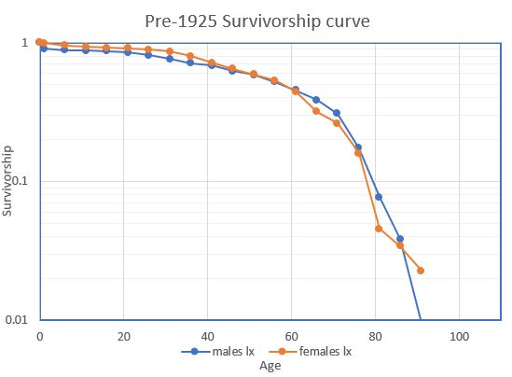
Figure 1

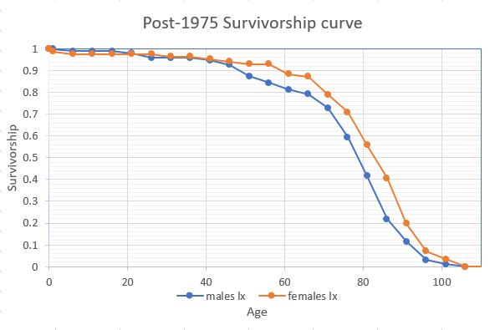
Figure 2

