Jonah Hottinger
Biol288
Advancements in neural regeneration provide promising treatments for neural injury
Introduction
One of the most common issues we have today in the medical field is nerve damage resulting from injuries or disease. Nerve damage is especially a problem in some diseases, such as Huntington’s, that attack the nerves in the body. Researchers in this field are currently working towards the ability to repair this nerve damage. This could be anywhere from peripheral nerve damage in extremities to the spinal cord and potentially paralysis. I personally have an invested interest in neural cell repair because I have peripheral nerve damage in my left wrist that results in a lack of feeling in my hand and occasional pain. There is currently no way to promote significant recovery from neural damage. Once nerves are damaged or “disconnected” it is very difficult to repair. However, contrary to popular belief, nerve cells do regenerate and thus heal, it just occurs at a very slow rate. Most researchers that study these neural injuries are attempting to find ways to speed and aid the process of regeneration. However, as researchers discover new potential treatments all the time, we need to ask which treatments are best and what the drawbacks of these studies are.
Background
Researchers are constantly looking at potential treatments to promote neural regeneration and testing their viability in studies. Some of the most promising treatments are cell transplantation, introducing engineered cells, targeting certain cells and inhibitors to enhance the body’s current abilities to regenerate, new medications, regeneration chambers, and providing conduits for cells in order to expedite repair. All of these studies are providing hope as scientists try to find a way to perform what was once thought impossible, repairing nerve cells.
Organic and synthetic cell transplantation
Cell transplantation is a promising treatment that shows the potential to aid in treating neural damage resulting from injury. Specifically, this treatment provides a lot of hope to those that suffer some form of paralysis due to an injury to the spinal cord. This is because we already have the ability to introduce new cells to protect a damaged area. One day, we may be able to transplant cells that can fully replace the damaged ones. This transplantation (Figure 1) can be done with both organic cells and synthetic, engineered cells.
Currently, organic cell transplantation is showing limited success in promoting neural regeneration. This is because researchers are currently having issues with cell necrosis after transplantation. This reduces efficiency drastically, and there can also be lesions and scarring from the injury preventing the new cells from establishing neural connections (Liu et. al 2017). In order to address these complications in treatment, researchers are also looking at engineering synthetic cells that could navigate the obstacles the organic cells face. The most promising form of synthetic cell transplantation is to target the injury itself by transplanting synthetic tissues. Researchers have found that introducing the synthetic tissue to injuries has directly promoted the outward growth of neurons (Lin et al 2018).
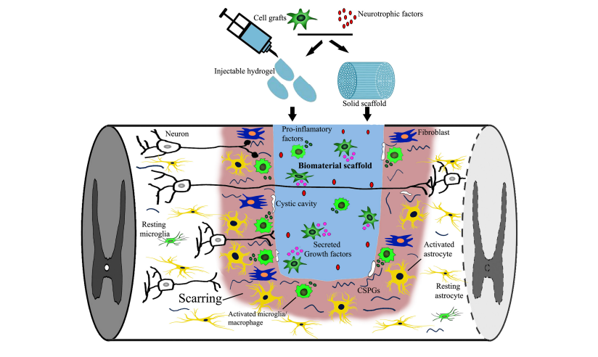
Figure 1. The transplantation of new cells to a damaged area and the obstacles it faces. The body’s natural attempt to heal can also be seen in the presence of astrocytes and microglia (Liu et. al 2017).
Medications
The most common and orthodox treatment for neural damage is the use of medications. Studies have been done in regard to hundreds of medications and how they can aid in neural regeneration. These studies have had mixed success, but they have resulted in finding new treatments that promote a significant increase in neural regeneration. One of the most successful medications is Topirimate (TPM). TPM has been used for years to treat patients with brain damage. However, it has recently been found to also be a protector against neural damage. Unlike many treatments, instead of repairing nerve damage it has been found to prevent it. If given to a patient after a serious injury, it has been found to significantly reduce the chance of neural damage occurring (Narin et al 2017). Unfortunately, it is difficult to apply TPM to patients in time to prevent nerve damage. Another medication, Quercetin, has been found to promote regeneration after acute spinal cord injuries. Quercetin targets signaling pathways and promotes astrocytes that are released by the body after spinal cord injuries. These astrocytes in turn activate and promote regeneration in the early stages of the body healing after injury. However, too many astrocytes in an area can cause disorders. Thus, Quercetin is currently as dangerous to patients as it is helpful (Wang et. al 2017). Along with these medications, the injection of growth hormones was found to both protect damaged areas and promote generation. The growth hormones were tested for assisting in regeneration of peripheral nerves, specifically the sciatic nerve. They interrupted the blocking of nerve regeneration by neurotrophic factors and were especially successful in assisting the regeneration of motor axons (Devesa et. al 2011). Similar to growth hormones, melatonin has also been found to be beneficial to neural regeneration. Melatonin also aided in the functional repairing of nerve damage in the sciatic nerve while providing protection. However, Melatonin has been unique in the fact that it has actually been found to reduce oxidative stress as well when injected (Kaya et. al 2015).
Genetic targeting
Researchers have found that one of the most promising forms of treatment is to target specific cells, pathways, promotors, and inhibitors. One of the studies to show significant neural regeneration combined two different treatments. They introduced TPEN, which is used for Zinc chelation, and an inhibitor for transcription factor Klf9 which shuts down neural regeneration. In the past, these two treatments had shown little success by themselves and were not thought of as a realistic treatment. However, when combined, they were found to significantly increase the survival time of damage cells and prevent necrosis as well as promoting regeneration. Together, they have become a viable treatment option for patients (Trakhtenburg et. al 2018). Another major focus of research has been Schwann Cells. Schwann Cells are the bodies natural way of repairing nerve damage. After a nerve injury, Schwann Cells transform to target and repair the damaged area. Unfortunately, Schwann Cells alone are very limited in their ability to heal and even more limited in promoting regeneration. However, researchers have found that Schwann Cells that express the ErbB2 signaling are far more successful in promoting regeneration. Scwann Cells move slowly through the spine, and research suggests that the activation of ErbB2 after injury will greatly increase regeneration and that promotion of intraspinal migration will increase the speed at which Schwann Cells heal injuries (Han et. al 2017). Other studies tend to target the nerves them cells. Researchers have been looking at how chambers placed around the nerves can aid in neural connections and aid in regeneration after a connection is broken. Researchers have found that the use of a H type nerve regeneration chamber enhances nerve regeneration without the need of nerve anastomosis. When the chamber was used as well as nerve anastomosis, regeneration was not improved. Because of this, researchers now believe that sutures are not a successful treatment, and chambers are more likely to promote nerve connections and regeneration (Hong 2017).
Research negatives
All of these studies are promising, but they are not yet near application. This is because none of these treatments have been successfully performed on a target that mimics the human nervous system. All neural connections have a gap between synapses as they send messages back and forth. When nerve damage occurs, these connections are broken, and the neural gap is an obstacle for any nerve regeneration. All of these studies have focused in the neural regeneration of mice. Although all the results are promising and show significant increases in nerve regeneration, mice have a much smaller neural gap than humans. Because of this, none of the treatments in their current state can be applied to clinicals, as they cannot overcome the neural gap in human cells.

Combining stem cells with conduits and amniotic fluid stem cells
Another study has been done that looks at combining nerve conduits with stem cells and growth factors to improve neural regeneration. However, this study was done using mini-pigs as the test subjects. This is significant because mini-pigs have a much larger neural gap than mice and are more applicable to humans. In this study researchers used amniotic fluid stem cells from humans and nerve conduits to promote and heal nerve damage in the sciatic nerve of the mini-pigs. Specifically, the researchers were looking at how the amniotic fluid stem cells impacted regeneration. The researchers found that nerve conduits alone significantly increased nerve regeneration. However, when the conduits were combined with amniotic fluid stem cells, the repair of the sciatic nerve of mini-pigs was even greater and neural regeneration of the nerve was highly successful. This amniotic fluid has all kinds of applications because it contains several cell populations, and the researchers believe that the use of amniotic fluid will become common for all types of cell therapy (Su et. al 2018).
Conclusion
All of these studies show great promise in our quest to find treatments that promote complete neuron regeneration. However, the use of nerve conduits and amniotic fluid has proven to be the best possible treatment we currently have due to its impressive success while being tested in mini-pig cells which provide much more difficulty than mice due to the comparative neural gaps. The other studies were all done on mice, and they still did not manage to replicate the same level of success in repair and regeneration. Cell transplantation simply has too many natural obstacles in dealing with necrosis of transplanted cells and scarring preventing them from establishing connections. The medications we use to treat nerve damage are quite effective, but they need to be used immediately after injury to protect the damaged area and best promote regeneration. Genetic targeting and focusing on specific cells and inhibitors is efficient, but it is limited by what the body can do. We are simply enhancing the body’s ability to heal in the same, limited ways it already does.
One day, we may be able to heal people with all kinds of injuries. People, such as myself, with loss of feeling and pain and even people suffering from paralysis may be able to have full functionality again. Certain types of treatment, such as new medications and the application of cell conduits, may also help people that suffer from diseases, such as Huntington’s, that attack the nerve cells and do so much damage.
Future Directions
In order for us to reach these goals and heal people with neural damage, we must continue to devote research to potential treatments and what exactly they can do. In order to do this, we need to continue testing in situations that would better simulate human nerve damage. We must target nerve regeneration that will be successful with the neural gap of humans. Doing so with mice provides us with information, but it does not give us any realistic idea of treatment. Testing treatments with subjects more closely related to humans, like primates, will provide us with much more knowledge and success when it comes to human application and clinical trials. It is also important for researchers to look at what exactly each treatment does and how it will help. For example, we need to know what treatments are better for those facing nerve damage and paralysis from injuries and what treatments will protect nerves and allow them to repair when someone suffers from a disease that attacks the nerves.

Literature Cited
Lin C., Liu C., Zhang C., Huang Z., Zhao P., Chen R., Pang M., Chen Z., He L., Rong L. and Li
B. 2018. Interaction of iPSC-derived neural stem cells on poly(L-lactic acid) nanofibrous
scaffolds for possible use in neural tissue engineering. International Journal of Molecular
Medicine 41: 697-708.
Su CF., Chang LH., Kao CY., Lee DC., Cho KH., Kuo LW., Chang H., Wang YH. And Chiu
IM. 2018. Application of amniotic fluid stem cells in repairing sciatic nerve injury in
minipigs. Brain Research 397-406.
Trakhtenberg EF., Lia Y., Fenga Q., Tsoa J., Rosenberg PA., Goldberge JL. and Benowitz LI.
2018. Zinc chelation and Klf9 knockdown cooperatively promote axon regeneration after
optic nerve injury. Experimental neurology 300: 22-29.
Han SB., Kim H., Lee H., Grove M., Smith GM. And Son YJ. 2017. Postinjury induction of
activated ErbB2 selectively hyperactivates denervated Schwann Cells and promotes
robust dorsal root axon regeneration. Journal of Neuroscience 45: 10955-10970.
Hong XY., Hong X., Gu WW., Lin J. and Yin WT. 2017. Femoral nerve repair using an H-type
nerve regeneration chamber in rats. Journal of Biological Regulators and Homeostatic
Agents 2: 335-341.

Liu S., Schackel T., Weidner N. and Puttagunta R. 2018. Biomaterial-supported cell
transplantation treatments for spinal cord injury: challenges and perspectives. Frontiers in
Cellular Neuroscience 11: 1-19.
Devesa P., Gelabert M., Gonz’lez-Mosquera T., Gallego R., Relova L. and Devesa J. 2012.
Growth hormone treatment enhances the functional recovery of sciatic nerves after
transection and repair. Muscle Nerve 45: 385-392.
Narin F., Hanalioglu S., Ustun H., Kilinc K. and Bilginer B. 2017. Topiramate as a
neuroprotective agent in a rat model of spinal cord injury. Neural Regeneration Research
12: 2071-2076.
Wang Y., Li W., Wang M., Lin C., Li G., Zhou X., Luo J. and Jin D. 2017. Quercetin reduces
neural tissue damage and promotes astrocyte activation after spinal cord injury in rats.
Journal of Cellular Biochemistry 119: 2298-2306.
Kaya Y., Savas K., Sarikcioglu L., Yaras N. and Angeloy DN. 2015. Melatonin leads to axonal
regeneration, reduction in oxidative stress, and improved functional recovery following
sciatic nerve injury. Current Neurovascular Research 1: 53-62.

