The comparison of microbial diversity of soil near asphalt and away from asphalt

Jonah Hottinger

Biol250

Spring 2017

Introduction
Urban expansion and the increased need for paved roads and sidewalks are having an impact on the Earth’s soil. These paved surfaces can prevent water from reaching the soil and can drastically change the microbial diversity therein. In previous studies, researchers have looked at the impacts of pavements on microbes by culturing their own samples and subjecting them to synthesized conditions. One study found that pavements can change the nutritional composition of soil and cause the soil to favor certain microbes (Xin Yu et al. 2012). Another study supported this in its findings that the microbes in soil near asphalt contained more asphaltene (Marczewski and Szymula 2002). This showed that certain microbes could survive the new environment and thrived.
However, certain pavements can have different impacts based off permeability. Studies have showed that a more permeable pavement, such as asphalt, will allow for more microbial diversity because it does not completely seal off the soil (Lan-Feng Fan et al. 2014). This was supported when it was found that many microbes will not grow at all in these sealed conditions (Coupe et al. 2003). This sealing of soil is also addressed when researchers found that soil under a pavement would degrade over time (Charzyński and Piotrowska-Długosz 2014).
The goal of the project was to continue such research and determine how the proximity to asphalt increases the diversity of the microbial colonies in soil. This has never been studied in Prince Edward County and will be carried out in Lancer Park. The goal was to further understand the microbial diversity in this county, and the hypothesis was that the soil located closer to the parking lot will have less diversity because it provides a more limited living environment.

Materials and Methods

Sample Collection
The samples for this experiment were collected from two different points. One was taken on the bank of Buffalo Creek, and the other was taken beside the sidewalk at the research center in Lancer Park. These samples needed to be plated as a direct count, 1:10, and 1:100. To plate them, 0.5 grams of each sample were measured and then placed into 50mL of water. The samples were shaken and then sat for five min. This was the direct count for both samples. Once the direct count was prepared, 10µL of each direct count sample were taken and added to a new tube (one for each sample respectively) containing 90µL nutrient broth. Both samples were then vortexed for 30 sec. These were the 1:10 samples. After this, 10µL of the 1:10 samples were taken and added into new tubes containing the nutrient broth. They were then vortexed for 30 sec. These were the 1:100 samples. Then, 100µL of the direct count, 1:10, and 1:100 of each sample were pipetted onto individual agar plates and spread over the agar. All six plates were then incubated at 30 degrees Celsius for 72 hours before they the number and types of colonies were measured.

Genomic DNA Extraction
After incubation, DNA extraction was done to isolate the DNA for PCR. One colony from each site was collected using a sterile toothpick and placed into its own microcentrifuge tube containing 300µL of microbead solution. Each of these samples were then transferred into a microbead tube and 50µL of solution MD1 were added to each tube. These tubes were then heated to 65 degrees Celsius in a heat block for ten minutes. After this, the tubes were vortexed horizontally for ten min at maximum speed. The tubes were then centrifuged at 10,000xg for 30 sec. The supernatant of the two samples were then placed into new 2mL tubes. Once done, 100µL of solution MD2 were added to the supernatant of each and then vortexed for five sec. The samples were then incubated at four degrees Celsius for five min. After being incubated, the tubes were again centrifuged at 10,000xg for one min. The supernatant of these two samples were then placed into new 2mL tubes. Then, 900µL of solution MD3 were added to each tube and vortexed for five sec. After this, 700µL of the samples were loaded into individual spin filters and centrifuged at 10,000xg for 30 sec. The flow through was discarded and the supernatant was centrifuged again at 10,000xg for 30 sec. After discarding the resulting flow through, 300µL of solution MD4 were added and the samples were centrifuged at 10,000xg for 30 sec. The flow through was discarded, and the tubes were centrifuged again at 10,000xg for one min. The spin filters were then placed into new 2mL tubes. Once done, 50µL of solution MD5 were added and they were centrifuged at 10,000xg for 30 sec. The DNA was then stored at -20 degrees Celsius.

PCR
PCR was then done to sequence the samples and identify their species. Two PCR tubes were prepared by adding 15µl of nuclease-free water, 25µL of OneTaq 2X Master Mix (New England Biolabs, Catalog #M0531), and 2.5µL of primer mix. The primers were Forward- 5’GAGTTTGATYMTGGCTC-3’ and Reverse- 5’-URGYTACCTTGTTACGACTT-3’. This was done in the order given. After these reactions were mixed, 7.5µL of the isolated genomic DNA were added, and the tubes were transferred to a PCR machine to begin thermocycling. The initial denaturation was set at ninety-four degrees Celsius for four minutes. It then went through a cycle of ninety-eight degrees Celsius for ten seconds, fifty degrees Celsius for fifteen seconds, and seventy-two degrees Celsius for twenty seconds. This cycle was done thirty times. It then went through a final extension of seventy-two degrees Celsius for five minutes. The PCR reaction was then held at four degrees Celsius.

PCR Purification and MspI digest
Once the PCR was complete, the reaction samples were added to two different 1.5mL tubes containing 250µL of binding buffer. These mixtures were then placed into spin filters and spun at 13,000 rpm for one min. The flow through was discarded, and 200µL of DNA Wash Buffer were added. The samples were then spun at 13,000 rpm for one min. Another 200µL of DNA Wash Buffer were added, and the samples were again spun at 13,000 rpm for one min. The spin filter columns were then transferred to a new tube and 20µL of sterile water were added. Once the PCR products were purified, 5µL of the products were mixed with 10µL of their respective MSPI enzyme mixed with tango buffer. Both samples were then incubated at 37 degrees Celsius for 45 min.

Gel Electrophosphoresis and DNA Sequencing
An agarose gel was then obtained from the instructor to perform electrophosphoresis. The samples were mixed with 5µL of 5X loading buffer. The gel in the chamber was then covered with 1X TAE buffer. Then, 10µL of the samples were loaded into separate wells in the chamber. The gel ran at 120 V for 30 min, and was analyzed using a UV camera. Once done, the rest of the DNA was prepared for sequencing. This was done by separately mixing 8µL of the PCR product with 4µL of sequencing primer for each. This primer sequence was 5’-GAGTTTGATCCTGGCTCAG-3’. The samples were then sent to EurofinsGenomics for sequencing.

Results

Diversity and Abundancy of Microbes
After the first seventy-two hours of incubation, numerous colonies had grown on the asphalt and creek plates. (Figure 1). The asphalt sample proved to be much more diverse than the creek sample in color, shape, and size of the colonies (Figure 2). The asphalt sample was much more diverse in color as it had more colors than the creek sample and a wider range of these colors (Figure2A and B). In both shape and size, the asphalt sample’s cells were more evenly distributed and did not suggest a dominant cell type and little diversity as the creek sample did (Figure 2C-F). Pictures of the plates can be found in supplemental figure one.

Identification of Microbes
After DNA extraction and PCR purification, the DNA concentration of the asphalt sample was 17.6 ng/μL. The concentration of the creek sample was 25.6 ng/μL. This asphalt sample was tested, and the results (Figure 3) showed that the sample was Bacillus toyonensis. Figure 3A shows the microbial colony that was taken and has now been identified as Bacillus toyonensis. Figure 3B is the 16s rRNA sequence that resulted from the PCR product of the asphalt sample. Figure 3C then shows that this sequence is a 100% match with Bacillus toyonensis because 794/794 of the base pairs matched. Figure 3D is a MspI digest of Bacillus toyonensis, and it matches the asphalt’s gel electrophoresis results in Figure 3E, further showing that they are a match.
The extracted microbial colony for the creek sample did not come back with any usable results after PCR. Two different colonies were extracted, and this corrupted the results. This is shown in the PCR product’s 16s rRNA chromatogram (Figure 4) where there are two different sequences running together. This makes it uninterpretable, and the colony could not be identified.

Discussion
The hypothesis of this study was that the sample taken near asphalt would have less microbial diversity. This is supported in the data from Figure 2. Bacillus toyonensis, identified from the asphalt sample, thrives off high levels of asphaltenes such as carbon and nitrogen (Mabinya et al. 2015). This finding corresponds with the findings of at least on previous study that suggested that different soil compositions would support different microbes (Xin Yu et al. 2012).
Because different soil compositions support different microbes, it is likely that the microbial composition by the creek would be completely different. This is supported by the findings that a soil environment near asphalt would have more asphaltenes, and the microbes present would be ones that can thrive off these conditions. (Marczewski and Szymula 2002). One possible cause for this microbial selectivity is permeability. The permeability of the soil changes the number of nutrients that can go through the pavement or soil (Lan-Feng Fan et al. 2014). This could be harming the environment, as soil can degrade after an extended amount of time under different pavements (Charzyński and Piotrowska-Długosz 2014). To further this experiment, one should test the microbes under and near different types of pavement to see if they are others that thrive off asphaltenes. These pavements could be harming our planet’s microbial diversity as people continue to urbanize.

Figures and Legends
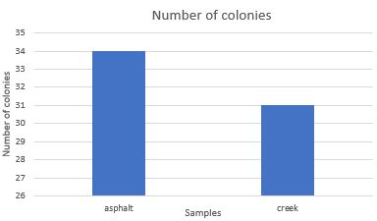

Figure 1. Number of colonies recorded from each sample. This figure shows the abundance of colonies from both sample sites on the 1:10 plates.

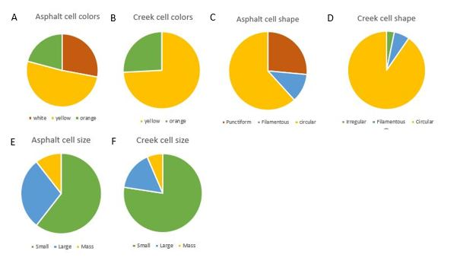

Figure 2. The microbial diversity of the asphalt and creek samples. This figure shows the diversity of both sample sites on the 1:10 plates. Figure 2A and figure 2B represent the diversity of the colors of the cells from their respective samples. White is represented as brown, yellow is represented as yellow, and orange is represented as green. Figure 2C and figure 2D show the diversity of the shapes of the cells. Punctiform is represented as brown, filamentous is represented as blue, circular is represented as yellow, and irregular is represented as green. Figure 2E and figure 2F show the diversity of the size of the cells. Small is represented as green, large is represented as blue, and mass is represented as yellow.

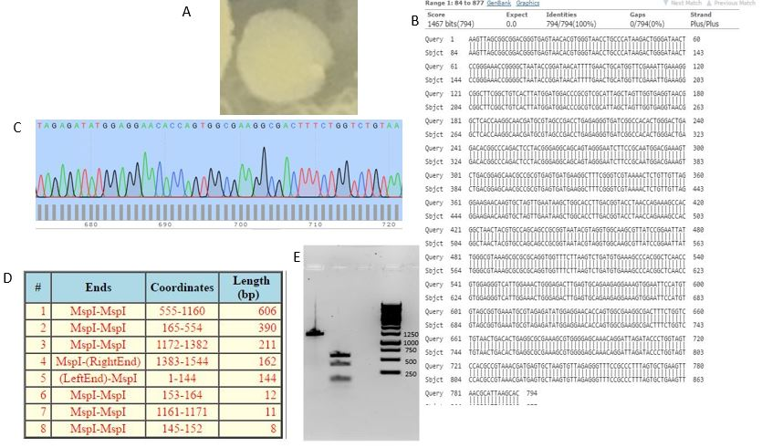

Figure 3. The identification of the asphalt sample colony. This figure shows all the results that help identify the asphalt sample cell as Bacillus toyonensis. Figure 3A is the microbial colony that is identified. Figure 3B is the sequence that resulted from the PCR product. Figure 3C is the sequence for Bacillus toyonensis. Figure 3D is the MspI digest of the Bacillus toyonensis. Figure 3E is the results of the gel electrophoresis.
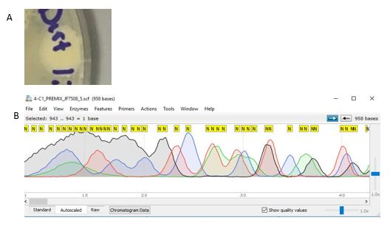
Figure 4. The identification of the creek sample colony. This figure shows the creek sample’s PCR product. Figure 4A shows the cell used as the sample. Figure 4B shows the PCR product obtained from the sample.

Cited References
Chang-Po Chen, Lan-Feng Fan, Hwey-Lian Hsieh, Sih-Fu Wang. 2014. Microbial community structure and activity under various pervious pavements. Journal of Environmental Engineering. 140.3.
Charzyński A, Piotrowska-Długosz. 2014. The impact of the soil sealing degree on microbial biomass, enzymatic activity, and physicochemical properties in the Ekranic Technosols of Torun. Journal of Soil and Sediments. 15.1.47-59.
Coupe SJ, Smith HG, Newman AP, Puehmeier T. 2003. Biodegradation and microbial diversity within permeable pavements. Journal of Protistology. 39.4.495-498.
Marczewski A, Szymula M. 2002. Absorption of asphaltenes from toluene on typical soils of Lublin region. Elsevier Science. 68.45.301-311.
Okaiyeto O, Uchechukwu UN, Leonard MV, Okoh AI. 2015. Bacillus toyonensis strain AEMREG6, a bacterium isolated from South African marine environment sediment samples produces a glycoprotein bioflocculant. Molecules. 20.3. 5239-5259.
Yu Xin, Wang YH, Wang Yu-hong, Wu, D. 2012. Effects of asphalt on the enzymatic activity and bacterial community in soil. African Journal of Microbiology Research. 6.34. 6399-6406.

