Allen Irby
Dr. Guler
ENG 400
10/1/2018

Persona 5 and Its Use of Rhetoric to Encourage Social Activism
Video games are a form of media that has grown drastically in popularity over the last few decades. Video games now stand shoulder to shoulder with the likes of Hollywood itself. Very few people have not played a video game at this point, and those who haven’t know what they are. Therefore, it is only natural that video games, like novels and movies before them, are now being used to influence the opinions of those who play them. This is seen throughout the medium, from games that offer commentary on mankind’s damage to earth’s ecosystem, to anger against about the damaging effects of certain economic systems. Still others, such as the subject of this paper, put the focus on more abstract issues. Persona 5 offers the player a glimpse into the lives of its characters. These characters face very real issues, ranging from abuse to corruption of the very government itself, and they must step up to make a change. This is the argument of Persona 5. It uses various forms of rhetoric in order to convince the player that they must be the change they want to see.

Plot Summary
Persona 5 follows a group of high school students in Japan. The main plot begins when they discover that they have the supernatural ability to enter people’s minds and destroy the negative emotions that are plaguing them. Once the person’s negative emotions are destroyed, they become aware of the evil they were causing and are apologetic. This drastic change in disposition is known within the game as a “change of heart.” The students decide that they can help society by targeting corrupt individuals with this power and so form team called the Phantom Thieves. The students first target for a “change of heart” is the high school gym coach. He uses is status as a former Olympic athlete (which has become a major badge of honor for the school) to get away with abusing and beating his students. The next major target the group faces is mob boss who is extorting citizens for money. They then focus on a corrupt CEO who is the father of one of the Phantom Thieves. He is willing to sacrifice his daughter’s happiness (not to mention the health and safety of his clientele) in order to grow his fast food empire. The final target is the soon to be Prime Minister of Japan himself, who used corrupt political practices and murder in order to rise to the top of the polls.

Method
Aristotle asserted that argumentative tactics can be separated into three different types. Logos, arguments based on logic, use factual evidence to back up their claims. Pathos, arguments based on emotion, use the speaker’s emotions or the audience’s emotions to make their argument persuasive. Ethos, arguments based on character, use the speakers ethics/standing to convince listeners that they are coming from a place of morality. Another tactic for rhetoric is using language as tool to convince an audience. One such tool is the use of metaphors, not just to spice up language but to make your statements less heavy handed. By combining these tactics, a rhetorician can sway his audience into adopting his point of view. These tactics aren’t limited to individual speakers but can also be applied to media that is attempting to sway its consumers opinion/outlook.

Analysis
The game’s insistent use of the phrase “change of heart” is key to understanding the game’s message. It is obvious that no one could spontaneously gain the ability to enter a person’s mind and change their outlook on things. Rather, the core message of the game is about the power of persuasion. At the heart of any movement or argument is a drive to change someone’s point of view. A “change of heart” is just a metaphor for persuasion. Heinrich’s describes a metaphor as “one thing stand[ing] for another,” (222). The game’s emphasis on this phrase, and the sheer number of times it’s used, indicates greater meaning (Figure 1). It seems likely that this is but one effort taken by the writers of Persona 5 to persuade the game’s players into stepping up and taking an active role in their schools, societies, or governments.

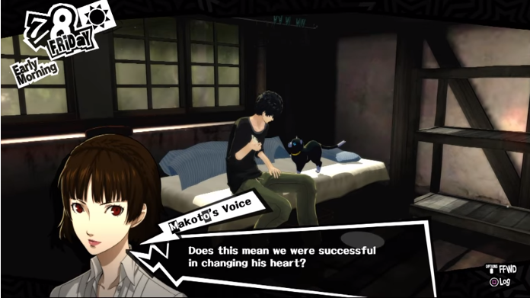
Figure 1

Throughout the course of the story, Persona 5 implements ethos in a unique way. Instead of using characters that have positions of respect, the writers decided to focus on high school age young adults. None of the characters have backgrounds that would make them particularly trustworthy (in fact the majority of the team are considered delinquents). In addition, the people who they are rebelling against tend to be people in positions of power. These people include a gym teacher (who has the principal wrapped around his finger), a mob boss, a district attorney (who happens to be the sister of one of the team), a famous CEO of a fast food chain (who is also the father of one of the group) and the soon to be Prime Minister of Japan. These people all use their positions to avoid criticism/punishment for their actions, and furthermore use it to threaten and even attack the protagonists (Figure 2). For instance Kamoshida, the gym teacher, threatens to expel the protagonist and his friends if they do not stop investigating his heinous actions. These decisions in the writing are significant because they mirror real life. Many people (especially those who are younger) feel as if they have very little power to affect the world around them. Furthermore, they feel like those who they may wish to criticize are above reproach and are untouchable (at least by them). This leads to a “wait and see” or “it’s someone else’s problem” mentality. These mentalities are the very things Persona 5 attempts to change. By pointing out this common problematic way of thinking and showing that it is in fact possible to make a change, the writers make an argument for the player to realize that they have power. They also urge the player to not blindly follow the words of someone in power, because that power does not make them a paragon of ethics.
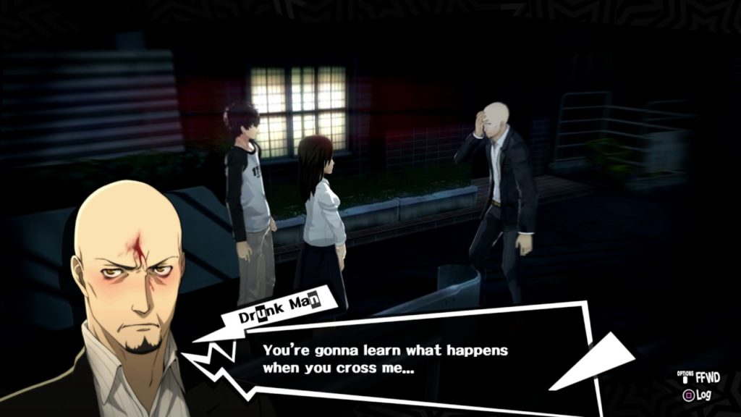
Figure 2

The second Aristotelian device used by the writers in Persona 5 is that of pathos. They partially do this by showing how the actions of those in power are negatively affecting the protagonist’s friends and family. For instance, a friend of the protagonist attempts suicide after she is sexually assaulted by Kamoshida. This immediately shows just how corrupt their school has become and galvanizes the Phantom Thieves to act. This reveal is shocking, and is meant to be so, and it makes the player think about the injustices going on around in the world around them. Just as the Phantom Thieves are given drive to move forward, the player is meant to feel sympathy for the characters affected by this man, and by extension people affected by criminals in real life. It’s an attempt to touch the emotions of the player. It’s used to give a face to the suffering in the world around them. In addition to showing the effects of the villains’ actions, Persona 5 also offers a glimpse into the minds of these villains. For instance, Okumura, the CEO that the group faces later, started down his road to cruelty because he was afraid of failing as his father and grandfather had done before him (Figure 3). This obviously doesn’t excuse his cruelty or make up for the people he had hurt along the way, but it gives the player the ability to understand where he is coming from. This ability to understand the people you disagree with is important when it comes to changing their minds (or in this case hearts). The game repeatedly shows both sides of the issue, both the effects of the cruelty and what caused the cruel behavior to begin with. It does this not only the eliminate the black and white trappings of many arguments, but also to spur the player into constructive action instead of simple anger.
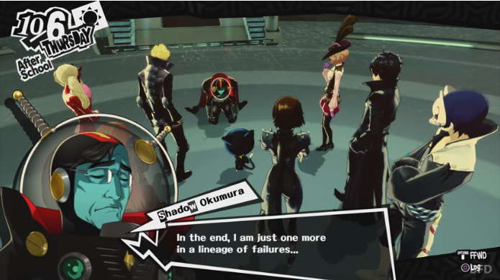
Figure 3
The final tool the writers use is that of logos. This is the simplest tool and benefits from open storytelling style of Persona 5. As mentioned in the previous paragraph, the game goes out of its way to show both sides of the issues it presents. This built upon by showing the resolutions of the players efforts. The corrupt gym teacher confesses his crimes in front of the entire student body. He is obviously arrested and the students soon benefit from this change. Safe from the teacher’s cruelty they can be happy. The mob boss surrenders himself to the authorities, and the streets immediately become safer. The soon to be Prime Minister drops out of the race and throws himself at the mercy of the courts, allowing a much more qualified candidate to take his place (Figure 4). In addition to these major changes, there are countless minor changes that the player can make. For instance, he can help his friend get back into running, which ultimately allows the track team to be reinstated. He can also help a doctor be cleared of false charges, allowing her business to grow and help more citizens. These results are all quantifiable and show that the players actions were not in vain. In fact, they had an extremely positive affect on the game world. This shows the player that activism can and will work. If you can convince those in power to see their own shortcomings (or the shortcomings of those around them) then they can change. A delinquent can expose the vile deeds of a teacher if they take the initiative. The average citizen can take a company to task for violating basic health and safety regulations. A high school student can convince a Prime Minister to do the right thing. But none of these changes can come about if someone doesn’t do something.
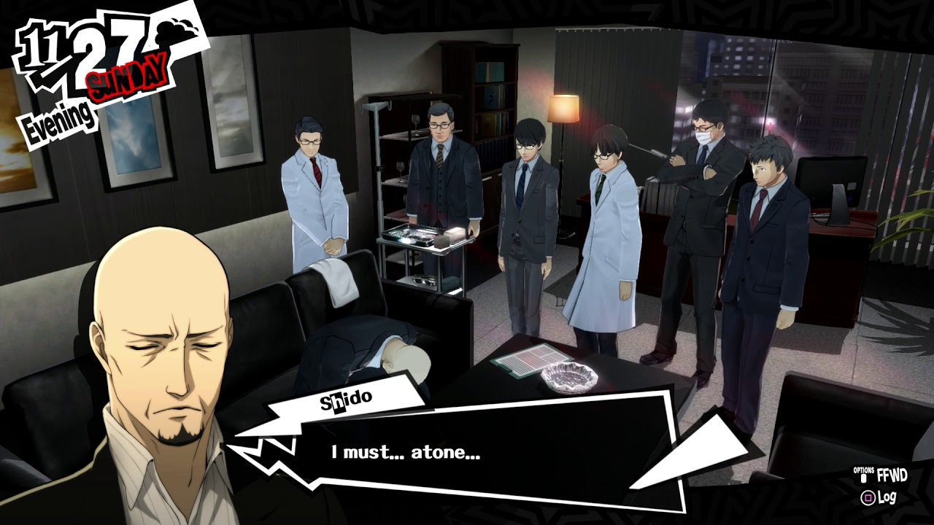
Figure 4

Persona 5 weaves a narrative around its characters that tells a story about the effects of abuse, crime, and corruption. Though storytelling and character interactions, the writers help the player to not only understand the protagonists and their struggles, but the antagonists as well. This creates a deep narrative that forces the reader to think about themselves and the world around them. What haven’t I noticed? Why haven’t I tried to make things change? Why didn’t I vote? How can I just ignore those who need help? These questions are hard to answer, and by forcing the player to think about them, the game hopes to spurn them into action. Part of wanting to make a change is understanding that you can, and Persona 5 shows the player this. Not only does it show the player that they can make a change, but it persuades them that they should make a change. It gives the player a responsibility, either sit back and let the world be cruel, or stand up and do something about it.

Works Cited
Yamamoto, Shinji. Persona 5. Atlus, 2017.

