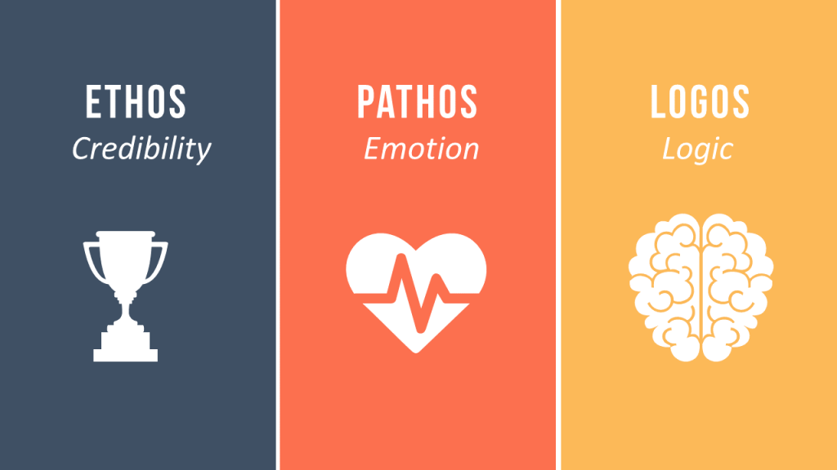In the three chapters covered this week, Heinrichs focuses mainly on Pathos, Logos, and Ethos.

- One take away comes from chapter four, where he points out the necessity of using arguments based on logic. His example relates a story of his attempting to change the cover for a magazine he worked at and failing said argument because he hadn’t done his research prior (Heinrichs 42). His failure was brought about by lack of convincing evidence. I experienced a similar issue with my boss several years ago. After I ignored my work phone, which had been ringing off the hook for several minutes, because I was helping a customer with a project, my boss pulled me aside and told me he would write me up if I didn’t answer my phone next time. I pointed out that he himself had reprimanded me a few months prior for ANSWERING the phone while helping a customer (after the customer complained I wasn’t giving her proper attention). I reasoned that I couldn’t possibly do both and we reached a compromise.
- In chapter 5 Heinrichs explains decorum. He describes it as dressing and behaving in a way that suits your audiences expectations. He references adults who dress as teenagers being the exact opposite of this practice (Heinrichs 48). Decorum was important for me when I was in JROTC in High School. Because it was militarily based, it was important that I adopt a different behavior around my friends once I was in a position of command. I could no longer stand around and goof off with friends (at least not all the time) because I had to be a leader.
- Chapter 6 once again focuses on the audience but it focuses more on your ethical appearance. The author describes Aticus’s court case in To Kill a Mockingbird (Heinrichs 60). In the scene, Aticus loses his ethical credibility precisely for not being racist. The Lowe’s I worked at in Danville was involved in a controversy in 2015 when a manager approved a woman’s request to not have any black employees sent to her house to deliver her appliance. The manager made the woman happy but angered quite a few others, leading to a news story and his own termination from the company.

2nd
Chapter 13 places an emphasis on the use of logos (using facts to back up your claims). The author uses an example of a Priapic ad to show logos on page 139. I used logos often as a sales associate at Lowe's Home Improvement. Whenever a customer struggled with a decision I would explain the pros/cons of the item they were considering.

Chapter 14 focuses on using logos with the specific goal of defending yourself. It also talks about logical fallacys such as arguments from ignorance. The author uses an example of a bad driver explaining why they don't need to slow down because they haven't crashed yet on page 155. I've had to defend myself from false accusations from a customer (who claimed I quoted him a ridiculously low price for a special item door). I reiterated to my boss how much training I'd received prior to this, as well as my excellent track record and the customers lack of receipt, to prove my innocence.

Chapter 16 emphasizes trust in an argument and maintaining your position despite well used ethos on your opponents part. The author uses examples of salesmen persuading people to buy things throughout the chapter. I've been on both sides of the equation so I can assert that he is, at least partially, correct as some salesmen just want the sale and will tell you anything to secure it.

3rd
Chapter 20 places emphasis on using tropes to spice up your language and make it more interesting/persuasive. He also speaks of the origins of curse words and how they were originally actually curses.
Chapter 22 is about seeing other sides of arguments as well as showing your own side. Heinrichs using an example of a mother-in-law thanksgiving visit and explains different answers to the issue. I faced a similar issue when dealing with unfair practices from my higher-ups when I was in JROTC. Several of my friends and I met with the leaders to explain our annoyances and got the situation resolved.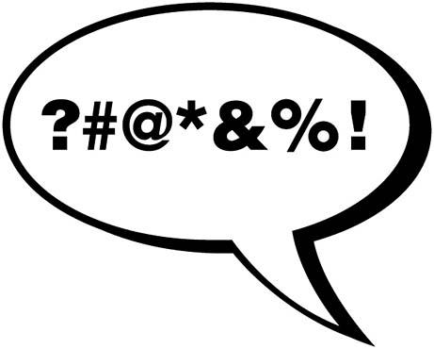

4th

Chapter 23 places heavy emphasis on dealing with errors on your part. The author focuses on his own experiences in making a journalistic error. Instead of allowing it to be a PR nightmare which ended with egg on his face, Heinrichs instead took the initiative and apologized while making a spectacle of it. This resulted in him receiving "a photograph signed by the governor [with] her smilingly holding up the volcano along with a copy of the offending magazine," (269).
I experienced this in community college when I bombed an exam. I spoke with the professor after class and apologized for my poor performance before explaining how I planned to study for the next one. He was so impressed (or so sorry for me) that he gave me bonus points on the exam that brought me up to a D-.

5th
Chapter 29 understanding the different situations you should use different strategies, and how to think quickly to determine the right course of action and adapt. On page 351, Heinrichs talks about George H. W. Bush's use of personal letters to ingratiate himself with both fans and rivals alike, making him a stronger candidate and potentially winning him the election. This is an example of using the right strategy at the right time. Once, while I was working at Lowe's, I saw the opposite. An employee was arguing with a manager who had reprimanded him for poor performance. The employee insisted it was because the manager didn't like him (despite the fact that it was a common sight on the sales floor to see this employee playing with his phone). This strategy didn't work for him and resulted in his termination.

"Civil Disobedience"

Thoreau focused on criticism of the US government, including slavery and an unwanted war. His argument was not to support a system you disagreed with, but also not just burn it down. He focuses on nonviolent resistance. We faced a similar issue when I was in JROTC. The student who led our battalion heavily favored her friends when it came to promotions and work duties. Myself and many other cadets resisted this and tried to get our teachers to stop the behavior.. After being unsuccessful for several attempts, we decided amongst ourselves to refuse to attend any JROTC events. Because JROTC relies on volunteer work (attending events is not technically mandatory) this swiftly brought the issue to our CO's attention and ended the imbalance.

