Thomas Hoke
ENSC 402
Final Project Write-Up

Population Dynamics of Common Waterfowl Wintering Species in Virginia, USA

Abstract
A recent study (Rosenberg et al. 2019) has shown that bird populations in North America are experiencing major declines except for a few groups including waterfowl. However, this research focused only on the summer breeding populations and did not focus on regional dynamics or wintering waterfowl populations. This study utilizes data from 48 Christmas Bird Count (CBC) count circles to evaluate population dynamics of common wintering waterfowl species in the Virginia 1970. Population trends for Mallard, American Black Duck, Wood Duck, and Canada Goose were analyzed and compared to historical trends from the mid-Atlantic region where applicable. Significant declines were observed in Mallard and American Black Duck populations over our study period while Canada Geese increased significantly, and Wood Ducks had no significant change. This work suggests that waterfowl habitat in the flyway or region is being lost or degraded as the continental trends for all species analyzed are significant increases over the study period.

Introduction

While many breeding populations of waterfowl in North America have reached new highs in the last decade, research by Rosenberg et al. (2019) has raised concerns about threats facing the avian community. This literature documented a loss of 3 billion North American birds over the last 70 years but highlighted the increases continental waterfowl populations have had during the same period (Ibid). However, continental and regional waterfowl dynamics often vary, and studies of wintering populations have reflected that regional issues are currently present for historically significant areas, such as the Chesapeake Bay, where Common Goldeneye and Redhead populations have declined despite relatively consistent breeding numbers (Perry et al. 2007). These trends are concerning since the mid-Atlantic region of the US is a major migration corridor for many waterfowl species due to its abundant coastal estuaries and more recently the prevalence of human created habitat plus the introduction of exotic aquatic plants (Perry & Deller, 1996). Due to human activity in and around this region though, many of the natural habitats that wintering waterfowl rely on have been degraded or altered, particularly submerged aquatic vegetation (SAV) beds. This has led to some species shifting their regional diets to new food sources to meet energetic demands, such as Canvasbacks making a switch from a SAV to an invertebrate heavy diet (Perry & Uhler, 1988). Many species have also shortened the amount of time they spend wintering in the region with later arrival and earlier departure dates (Reese & Weterings, 2018). As these shifts have occurred, both regional surveys and hunter harvest data have reflected a decreasing abundance of waterfowl in the region and shifts in the community composition.
In the last five years the changing regulations for waterfowl in the Atlantic flyway (AF) has reflected the declining abundance of common species. Mallards, which are the most prevalent duck on the continent, experienced a 38% decline in the AF over the last 20 years (Huesmann, 2017) and daily hunter bag limits for the species have halved from four to two as a result. Migratory Canada Goose have had recent declines in the AF with breeding failures and an ever-growing resident population causing concern and a shortening of the hunting season as a result. Other common species in the flyway are thought to under threat as well but the typical survey method, using aircraft, for wintering populations of waterfowl has drawn scrutiny for its small scope, differing sampling methods, and a lack of accuracy (Huesmann, 1999) and thus led to skepticism about the validity of the data being utilized. The Christmas Bird Count (CBC) has increasingly been utilized by waterfowl researchers as a substitute for aerial surveys as the scope of the CBC survey is large and growing while it still maintains a consistent sampling method (Rosenberg et al., 2019). However, since CBC data is not currently being utilized for regulatory changes, I felt it was pertinent to see if the data set for common species was complete enough to conduct population analysis that could be used for waterfowl conservation. To do this I compiled data from all Christmas Bird Count circles in Virginia for the last 50 years to examine trends in wintering waterfowl abundance as well as any differences between the community composition of waterfowl populations in the state versus the mid-Atlantic region. My objective was to assess these trends or shifts to determine the viability of the methods and to identify any species at risk so that I could inform conservation practitioners.

Methods
The methods utilized in this study were developed through previous research during which wintering waterfowl populations were analyzed for the coastal plain, the area east of the fall line, of mid-Atlantic region, which was defined as Delaware, Maryland, Virginia, and North Carolina. That analysis included 62 Christmas Bird Count circles, of which 18 were in the coastal plain of Virginia. For this project data was collected from the 48 current Christmas Bird Count circles in Virginia for the last 50 years, since data was inconsistent from 1950-1970. Data was collected and compiled for the four most waterfowl common species in the mid-Atlantic region with that being the Mallard, American Black Duck, Wood Duck, and Canada Goose (USFWS, 2019). Population data was collected in birds per party since this is the value utilized by CBC to standardize their data. The population trends for all species were analyzed using Linear Regression Models and comparisons between the waterfowl community composition in
Virginia and the mid-Atlantic.
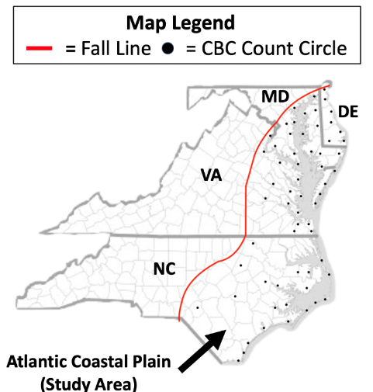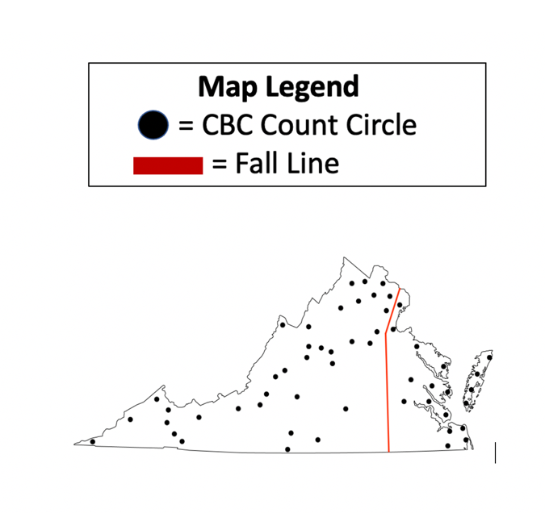

Results

Discussion
The signficant population decline observed in the Virginia Mallard population (p = 0.003) closely follows the population decline for the species across the Mid-Atlantic (p=0.001). These trends support the declines found by Huesman (2017) with the Atlantic Flyway mallard decreasing signficantly, most likely due to habitat loss but hybridization between farm ducks and wild mallards has also weakened the genetic makeup of the species in this region. American Black Duck in Virginia have also been declining signficantly (p < 0.001) during our study period which does follow the continental trend of the species since they primarily inhabit the eastern U.S. and have been declining in the Atlantic Flyway since the 1960s (Longcore & Clugston, 1998). The two main driving forces of the decline of this species through the flyway has been hybridization with mallards as well as a loss of habitat, with Virginia’s population being specifcally threatened by climate change as the state sits at the far southern end of their range and the drivers of migration to the region thought to be weakining (Ibid). The signficant decline (p = 0.003) of Wood Ducks in Virginia did come as a surprise since the population has been increasing across the state, flyway, and contient over our study period (USFWS, 2019). One potential explanation for the trend observed could be that Wood Ducks tend to be early migrants and thus the majority of the population has already passed through Virginia before the Christmas Bird Count take place in Decemeber. The signicant increase observed in Virginia’s Canada Goose population (p < 0.001) was also suprising since a signficant decline (p < 0.001) has taken place in the mid-Atlantic during our study period as well. The discrepancy between these trends in Virginia and the mid-Atlantic region is likely due to the increase of resident populations in the state since western Virginia tends to see little in the way of migratory Canada Geese but has ideal habitat for year-round survial due to human development and agricultural activity.
These results support the previous research work I have done looking at waterfowl abundance in the mid-Atlantic with duck populations expirencing declines in the majority of species studied while goose populations have mixed trends. These trends that have been uncovered supports my question for this study as well since the data for the last 50 years was more than adaquate to examine population trends in a manner that could be useful for conservation. However, at this time I would not recommend any regulatory action be taken on the species in this study since Mallards and Canada Geese are already in restrictive harvest and American Black ducks have just recently had their bag limit raised following years of unsuccessful restrictive regulation. What would certainly help all of these species though would be efforts to restore and protect wetland habitat along the east coast since all scientific literature on the topic tells us that the loss of habitat is the biggest driver of the declines in waterfowl abundance throughout the flyway. Unfortunately this becomes a political and economic issue since wetland restoration and protection is usually quite expensive, especially on the coast where development has had the biggest impact on the habitat available. Individuals can take steps to aid these populations as well though such as erecting nesting structures for Wood Ducks, which can be easily made from cheap lumber or plywood, or working with local conservation organizations to improve local habitat and advocate for effective conservation actions. The next step for this research would be to analyze species trends from other states in the mid-Atlantic region or Atlantic flyway as well as including Ring-necked Duck and Gadwall populations in this Virginia analysis.

Sources
Heusmann, H. W. 2017. Why are numbers of mallards (Anas platyrhynchos) declining in the Northeastern United States? The possible role of reduction in winter feeding sites. The Wilson Journal of Ornithology, 129(3), 528-534.

Heusmann, H. W. 1999. Let's get rid of the midwinter waterfowl inventory in the Atlantic Flyway. Wildlife Society Bulletin (1973-2006), 27(3), 559-565.

Longcore, J. R., & Clugston, D. A. 1998. American black duck (pp. 198-200).

Perry, M. C., Wells-Berlin, A. M., Kidwell, D. M., & Osenton, P. C. 2007. Temporal changes of populations and trophic relationships of wintering diving ducks in Chesapeake Bay. Waterbirds, 30(sp1), 4-16.

Perry, M. C., & Deller, A. S. 1996. Review of factors affecting the distribution and abundance of waterfowl in shallow-water habitats of Chesapeake Bay. Estuaries, 19(2), 272-278.

Perry, M. C., & Uhler, F. M. 1988. Food habits and distribution of wintering canvasbacks, Aythya valisineria, on Chesapeake Bay. Estuaries, 11(1), 57-67.
Reese, J. G., & Weterings, R. 2018. Waterfowl migration chronologies in central Chesapeake Bay during 2002–2013. The Wilson Journal of Ornithology, 130(1), 52-69.

Rosenberg, K.V., Dokter, A.M., Blancher, P.J., Sauer, J.R., Smith, A.C., Smith, P.A., Stanton, J.C., Panjabi, A., Helft, L., Parr, M, and Marra, P.P. 2019. Decline of the North American avifauna. Science, 366: 120-124.
United States, U.S. Fish & Wildlife Service. 2019. Waterfowl Population Status, 2019. Retrieved March 23, 2021, from https://www.fws.gov/migratorybirds/pdf/surveys-and-data/Population-status/Waterfowl/WaterfowlPopulationStatusReport19.pdf

