Cecily Hayek
Biology 288
Review Paper
The Necessity of Small Animal Procedures
Abstract
As pet health care starts to become more established, so do normal practices within it, like spaying, neutering, declawing, ear cropping and tail docking. Each procedure has positives and negatives for both the health of the animal and the owner. For spaying and neutering, these procedures increase the likelihood that the animals will be adopted and kept, as well as increase desirable behaviors and the health of the animal after the procedure. For declawing, ear cropping and tail docking, these procedures have little to no impact on the health of the animal and focus more on the wants of the owner, so they can be deemed unnecessary. By comparing the risks of each procedure, the benefits to the animal, owner, and the current legislation, the necessity of each procedure was determined.
Introduction
Small animal procedures have become commonplace and necessary in the eyes of many
pet owners around the world. The most common small animal procedures include spaying, neutering, declawing, and ear cropping and tail docking. The discussion of how necessary these procedures are having not clearly been addressed. There have been studies that indicate that pet health care is growing faster than human health care in terms of numbers of practicing veterinarians versus physicians (Einev et al, 2016). Since this field is growing so quickly, it is imperative to determine if these procedures are necessary to maintain the animal’s health and stability. To do this, it is important to examine each procedure and determine if its benefits outweigh its risks and downfalls.
Spaying and neutering are used worldwide in order to make animals more docile, and unable to reproduce. Many stray small animals are becoming part of overpopulated groups which are a danger to public health as well as the balance of our ecosystems. Having too many animals creates situations in which many do not lead good healthy lives, which is not adequate. Animal protection advocates want to increase animal welfare by controlling population growth through neutering and spaying (Jackman et al, 2007). Typically, animal shelters require that after adoption, the animal must be spayed or neutered as a policy to limit more animals in shelters. At the present time, in the U.S., there are approximately 7.6 million animals entering the shelter system each year (Kerrigan et al, 2018). Many shelters require owners to fix their animals in an attempt to lessen this number. Some studies have shown that these procedures also enable the animals to become more docile, like eliminating marking tendencies or aggression (Alexander et al, 1994). Animal shelters want to address this issue because when they are unable to take more animals, the excess animals are usually euthanized. This should not be the fate of any puppy or kitten, so it is important that this issue is addressed quickly.
For behavior issues in cats specifically, declawing has been a common procedure since the 1970’s. Recently there has been some push back from animal rights groups to discontinue this practice, but without it some cats may never find homes outside the shelter (Ha, 2016). Declawing is becoming increasingly unpopular, but it is still a commonly used practice around the world.
For many dog breeds, a common practice is ear cropping and tail docking. Once known as a way to decrease injuries during fights, now these elective procedures are used for a means to decrease ear infections, or just because the owner wants to change the appearance of the dog (Mills et al, 2016). Breeds like Doberman pinschers and boxers are often modified in this way to become more desirable and less aggressive-looking. Many find this practice to be unnecessary, and yet it is still practiced so widely.
In some areas around the world, many countries view all of the procedures differently and have passes different legislation either for or against them. It has taken many years for animal welfare to become important enough to be written into governments, but now that it is that popular it is important that each procedure is regulated. By comparing polices from across the world, it will be easy to determine if these procedures are necessary. So, the question still remains, are these procedures necessary to maintain the health and wellness of a small animal?
Spaying
Spaying females has been proven to be a necessary procedure because of the health benefits as well as keeping populations manageable. Spaying a female cat or dog simply means to sterilize the animal by removal of its ovaries. One main reason as to why spaying is necessary is because it increases the likelihood that the animal will be kept and or adopted. In one study conducted by Scarlett et al in 2002, females that were not spayed were more likely to be returned to shelters than those who were spayed. Shelters do not have facilities that are capable of handling and caring for the number of excess animals that need this service currently. For shelters, making a mandatory spaying policy is in order to preserve their own ability to care for animals. In a perfect world, there would be almost no need for animal shelters. In some of the older work from this same research team, it was determined that one stagnant reason for relinquishment of animals back to the shelter was not being spayed (Scarlett et al, 1999). If major changes are not made to increase the number of animals spayed, current populations of these animals will continue to surge (Di Nardo et al, 2007).
After an animal is spayed, she typically will act differently. Many owners find this change in behavior desirable. For example, one study showed that one behavior that is modified after spaying is a canine’s need to maternally guard toys and objects. After spaying the canines are less likely to guard and become aggressive. Additionally, the animal is at a higher risk of developing uterine or ovarian cancer if not spayed (O’Heare, 2003).
The different techniques that can be used to spay have only grown since its first use. One method of spaying is called an ovariectomy, which involves the removal of both ovaries. A second method, ovariohysterectomy, involves removing the ovaries as well as the uterus (Kooistra, 2003). Since both procedures are successful in making the animal unable to reproduce, both are used in clinics around the world. Having two techniques increases the likelihood that these procedures will take place, and that they will be successful (Goethem et al, 2006). Removing only the ovaries is typically only done in small dogs and cats, much like castration in male animals. Whereas the full removal of the ovaries and the uterus is done to help prevent uterine cancers and ovarian issues as well as sterilize the animal.
The major downfall of this procedure is that the animal is no longer able to produce a litter of puppies or kittens. Although this seems obvious, it is important to note that small animals like cats and dogs have made a significant impact on humans and as time continues the majority of the human population will continue to want to own and cherish these animals (Rand et al, 2018). Domestication of these animals is important to humans. Many animals are used as support animals, service animals and therapy animals. To meet the needs of individuals that need these services, there needs to be more and more animals trained for this process. Therefore, not every animal must be fixed, rather just a larger percentage of the population. There needs to be some kind of measure to ensure that as sterilization of female small animals continues, it is not too many so that the populations can still survive. A secondary downfall of this procedure is that it does require a lot of trauma to the animal because female’s reproductive organs are entirely internal. This just means that the incision needed for this procedure is larger that of one for male animals.
As mentioned before, many animals are spayed to help with overpopulation issues, especially in shelters. Some states, like California, have made it so that at 6 months of age, cats and dogs must be spayed. This applies to animals that are being adopted out of the shelter system. By addressing the overpopulation issue this way, families still get to adopt, and the animal is statistically more likely to be kept after being spayed. Legislation like this allows animals to live healthier lives and owners do not have to worry about litters of puppies or kittens appearing at their doorstep. This procedure provides many benefits for the animal and for the owner.
Spaying females allows for females to be adopted and kept, it is now safer than before, and allows us to be able to control populations of animals. Since there are so many benefits to the animal, this procedure should be considered necessary. If spaying is necessary and enforced, then there is a chance that overpopulation of small animals could be controlled. Not only does spaying increase retention rates of animals, it is shown to improve behaviors, decrease risk of cancers, and help control overgrown populations of animals.

Table 1. Retention Rate of Animal based on species, sex, and if the pet was altered. Animals that were altered had a 96% retention rate versus those that were not. Species and sex were not factoring for retention factors. There was a higher level of retention for the animals that were altered (American Veterinary, 2019).
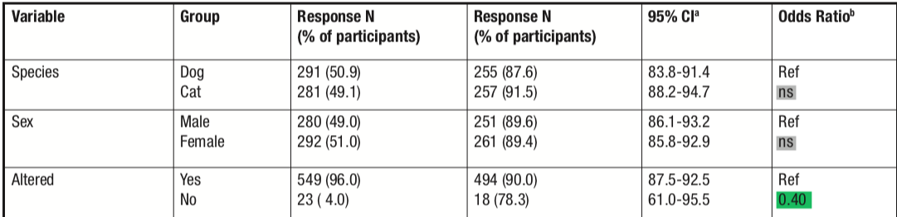

Neutering
Neutering, although it is a term that can be used for both females and males, for the purpose of this paper will be referring to fixing male animals. Neutering is the procedure in which the testicles are removed, or an orchiectomy. The major reasoning for neutering males is to deter bad behaviors. Male animals have the tendency to mark territory and can have the potential to become aggressive when they are still sexually intact. In male cats, after being neutered, the cats were more friendly and approachable compared to those that were not (Bonanni et al, 2019). Since owners want companions that are complacent and friendly, this option allows the choice of more animals to choose from.
As animals like cats and dogs continue to become more reliant on humans, their behavior starts to change, but as many are born feral, they do not have these same behavioral traits. One study showed that after being altered, males were 50% less likely to urine mark inside, and 60% less likely to mount people (O’Heare, 2003). For dog owners, it is easy to see that this is a fantastic choice in order to make their pet more obedient and less wild. Testosterone makes the animals react more intensely to stimuli, along the lines of another animal or new surroundings. When testosterone is removed, the pet is more docile and easier to control.
Shelters are, as already mentioned, trying to decrease the number of animals in them so they also implement policies where owners are required to neuter their pets after adoption. In one study, it was shown that animals are more likely to behave better based on whether they were intact or not, not whether they were male or female (Grigg et al, 2019). Additionally, in a study conducted in 2009 by Downes et al, one of the largest factors for pet-ownership in Ireland was whether the dog or cat was altered. This study also helped to establish the commonalty and necessity of neutering because of the extent of benefits that both the animal and the owner receive from it (Root, 2002).
Some downfalls for neutering include that it prevents the animal from reproducing as mentioned before, and that after puberty for males, this technique is obsolete in fixing behavioral issues. In multiple studies it has been supported that neutering after puberty does not help change behaviors like dog-dog aggression and marking tendencies (O’Heare, 2003; Grigg et al, 2019). Even so, this procedure allows the majority of animals to lead healthy and fulfilling lives afterwards.
Declawing
Declawing is an irreversible procedure that involves removing the front claws and sometimes back claws of a cat. Declawing is also known as an onychectomy, or the removal of claws surgically by means of amputation. That is correct, the amputation. Specifically, the amputation of either all of or part of the distal phalanges. This procedure was first used because it deters cats from being able to destroy furniture and other household items by scratching. However, scratching is instinct to cats and is completely natural, so there has been much debate as to whether this is humane.
Cats are usually declawed when their owners want to make sure the cat is not harming other humans, cats, or household objects (Ha , 2016). In some situations, declawing allows for a cat to keep its home and save the shelter some room. In extreme cases, like the owner has a compromised immune system, declawing a cat means that the cat gets to stay with its owner, rather than be isolated in a shelter, either waiting to be adopted or euthanized. In multiple surveys of cat owners, those that opted to have their cats declawed showed an increase in quality of their relationship with their cats, showing why this might be a positive choice (Ha, 2016).
Some studies have claimed that it is so cruel to the cat because if it was ever to be let out into the wild, it could never defend itself without its claws (Martell-Moran, 2019). This is completely true and why so many veterinarians are refusing to perform this procedure now. This same study has also concluded that in some cases, it is the only way that the cat will ever be adoptable, and so in few cases it is still carried out.
This procedure is included in this review because when it was first started in the 1970’s, almost every cat underwent this procedure. It was such a common procedure that it was taught in veterinary school and widely practiced across the world. Now, even though it is legal, many animal rights activists warn against it. Many veterinarians refuse to perform this procedure as well. It is entirely interesting that now, only about half a century after declawing began, it is now seen as taboo. Many countries view declawing as cruel, and it is actually banned. For example, Australia does not allow it, and neither does the majority of European countries. In the United States, it is heavily debated on the ethical side. New York and California have banned declawing for nonmedical reasons, and more states followed. However, it is still legal in 47 out of 50 states. Since so many countries around the world have banned it, it is important to understand why the majority of the states still allow it.
New studies have shown that unwanted cat behaviors can be changed with minimizing opportunities of anger and major change. For example, many indoor cats only act aggressive because it is in response to a large change in the environment, like a new couch (Curtis, 2008). Studies like this suggest that cats just need lots of areas to hide, scratch and multiple litter boxes are often recommended. According to one study, cats that are given environment enrichment are less likely to become aggressive or destructive. Additionally, owners can choose to improve a wide variety of categories, including physical, nutritional, social, and behavioral in order to make positive changes in their relationship with their cats (Herron, 2010). To go even further, a study conducted by Tanaka et al (2012) demonstrated that cats that are exposed to stressful situations had a high correlation with common health ailments like weight loss and even respiratory issues. Being in a stressful environment has tangible effects on cats, so one can understand that removing its claws would also increase its likelihood to act out and become more agitated.
In a novel study, declawing was seen to increase unwanted behaviors in cats, like damaging furniture, where about 10% of cats after the procedure still managed to cause mild damage to furniture (Moesta, 2012). This study also lists that a majority of these cats causing damage had no appropriate scratching areas available, which could explain the unwanted scratching.
Outdoor cats are not recommended to have this procedure because they would be exposed to more harm in the wild (Kogan, 2019). The current policy on free-roaming owned cats says that they are exposed to increased injury, death by means of vehicles, attacks from other animals, human cruelty, and extreme weather and thus should not be subjected to this procedure (American Veterinary, 2019).
This procedure therefore is not necessary and not justified and should not be commonplace in animal healthcare. It does not improve the wellbeing of the cat except for in extreme circumstances. Many sources point to an increase in desirable behavior after new stimuli are given to the cat, and scratching is natural so it should not be impeded on by this surgery. Declawing is a very antiquated procedure that is no longer recommended in almost all cases. Although it has been shown to increase cat’s desirable behavior, overall it takes away from their wellbeing.
Table 2. The Breakdown of owners that had both spay, neuter, and or declawing procedures. This table illustrates that the majority of pet owners opt for spaying and neutering, but declawing has significantly less percentage of completion. This table shows that along with spaying and neutering, declawing was once thought to be of equal importance (Moesta, 2012).
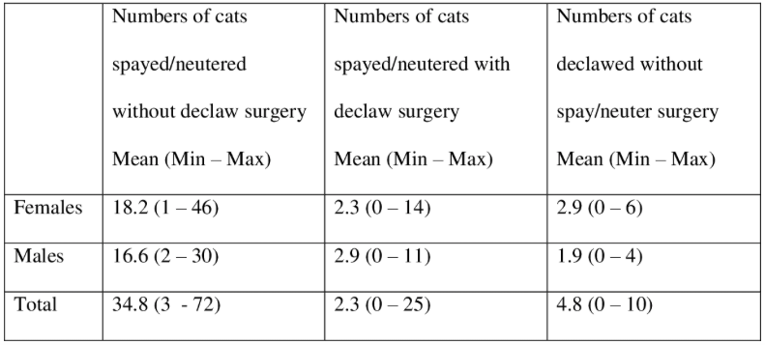
Ear Cropping
Ear cropping was first used in order to minimize injury from hunting and fighting, and as a way to decrease ear infection. Ear cropping is the process of removing part or the entire pinnae of an animal. The pinnae are the exterior flaps of skin on the ears of a dog. In the veterinary field, this procedure is referred to as cosmetic otoplasty. Afterwards, the flaps can be taped into place in order to shape the ears to the owner’s digression. Now it is seen as a way to customize your pet, and to make it more or less approachable. With many breeds, ear cropping has become commonplace that the dog’s ears will be cropped shortly after birth. It is known that it is widely practiced simply for the aesthetic. Ear shape often determines how humans perceive dog’s behavior and personality. In a study conducted on the perception of an animal based on ear shape, it was found that floppy ears were picked significantly more than pointy ears as more agreeable (Fratkin and Baker, 2015). This does not only extend to whether they are perky, but also if they are cropped or not. It is easy to see the difference between cropped and not cropped ears, especially when the norm for a breed is cropped (Mills et al, 2016).
Around the world, animal rights are being written into law slowly. In Europe, this practice is majorly illegal, and even areas in Canada are starting to accept new policies that ban it. In the United States however, it is very widely practiced and has no restrictions. It is important to note that some states in the United States have attempted to pass legislation that would make this procedure illegal, but they did not succeed (Fratkin and Baker, 2015). Since other countries consider this procedure to be cruel enough to ban, then the United States should follow suit. It is outrageous that someone would want to put their animal, especially a young puppy, through such a procedure.
Ear cropping has no benefit for the dog whatsoever. It does not decrease the likelihood for any disease, and it has not been proven that it increases hearing to a significant level. Therefore, this practice is harmful because the dog is being mutilated so that the ears are missing the external ear flap. It is considered cruel because performing unnecessary procedures on animals is seen as cruel, and since this is purely cosmetic it is seen as cruel. This procedure intentionally puts the dog under general anesthesia just to change a cosmetic feature, the epitome of unnecessary.
Tail Docking
Tail docking is the process in which a dog’s tail is chopped to be very short. It can be done in two different ways. The first one is when the tail is subjected to pressure, like a rubber band, that restricts blood flow to the tail. Eventually the tail will fall off. Comparing this to if someone were to remove a toe this way, it is obvious why this is cruel. The second method is when it is surgically cut to the desired length. This started as a way to distinguish working dogs from non-working dogs in the 1700’s as a means of collecting taxes and is already not needed in today's standards (Sinmez et al, 2017). It is purely cosmetic and is only done if the owner desires it. This is seen as a way to make the dog less destructive in homes, as tails wagging can cause some damage. It is also preferred for certain breeds, like Doberman pinschers, which can be docked in order to seem more aggressive or unapproachable.
At this point in time, there are no laws that prevent this from occurring to animals within the United States, but in Europe and Australia, it is banned with very few restrictions. This is important to note because some countries just have a restriction that the procedure must be performed by a veterinarian. The United States does not even require a veterinarian to perform this. Thinking in regard to the discrepancies in policies allows us to view this issue from a different standpoint. Still, it is shown that this practice is cruel (Fratkin and Baker, 2015).
In the study conducted to determine the public awareness and perceptions of tail docking, a Doberman with a docked tail was perceived as less playful and more aggressive, just based off of a photo (Mills et al, 2016). Since this procedure is purely for cosmetics, it does not provide any benefits for the dog. In addition, tail docking even has the potential to give the dog a negative connotation in the public’s minds, which is a major downfall. No procedure that owners pay for should affect the animal like this. Tail docking can also be a very painful process; the dog is literally losing more than half of its tail in most of the cases. For many puppies, general anesthesia is not used and can be very traumatic for the dog. By examining how painful it is, it is important to once again note that this procedure has absolutely no health benefit for the animal and is purely the choice of the owner in order to customize the animal. Because this procedure has more downfalls than benefits, it cannot be deemed necessary. This procedure is cruel and should no longer be practiced unless absolutely necessary.
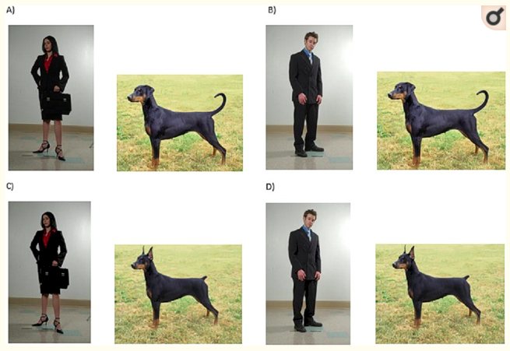
Figure One. Photos shown to test subjects to test perception and personality after only seeing these images. Individuals found that the dogs with the altered tail and ears were less playful and more aggressive. It is shown that animals that are altered cosmetically are perceived differently than those who are not (Fratkin and Baker, 2015).
Conclusion
The care for animals has only been improving and expanding as time continues on, and thus it is important to determine if small animal procedures are necessary. Animal care is such a fast-growing field, so much so that many different procedures are becoming more common and somewhat expected. Since these ideas of what should be done to keep up with animal health are spreading, it is very imperative that each practice is examined to determine if this is true. Spaying and neutering are both small animal procedures that are done routinely. These are both necessary procedures that veterinarians should recommend. Spaying decreases the chance of developing disease, increases desirable behaviors, controls populations and increases the likelihood of retention after adoption. Spaying is also cost effective, as new litters of puppies or kittens will not be born and have to be taken care of financially. Spaying also has two different forms of the procedure and by having two techniques it is safer to do so.
Neutering helps regulate male responses to stimuli, helps control populations and increase retention rates after adoption. Neutering deters unwanted behavior when the procedure is performed early enough and prevents excessive marking behavior. It makes sense to have this procedure because it eases the ownership of an animal.
However, after researching and combining information, it can clearly be seen that declawing, ear clipping, and tail docking are unnecessary for the health of the animal and the ecosystem as a whole. Procedures that are considered necessary have to have more benefits than Declawing is not the best option to get rid of unwanted behaviors for cats, and it therefore not necessary to put animals through. Declawing is a very antiquated procedure that is potentially putting the cat in danger and should not be a routine procedure anymore.
Ear clipping is purely cosmetic and is unnecessary to put small puppies through. Ear clipping has no benefits or health improvements for puppies and dogs. This means that it is unusually cruel to make an animal endure this process. Additionally, tail docking is also purely cosmetic, and thus is also unnecessary to put the animals through. There are absolutely no added health benefits for the animal thus it is cruel as well.
Banning procedures that are cruel towards animals should be a priority to animal advocates. Furthermore, law makers in the United States should research other countries and adapt policies that align with animal welfare goals. There are multiple countries around the world that have already taken this step to improve practices on animals. The United States policies surrounding animal welfare are far from acceptable and need to be addressed. This will allow for animals to be taken care of properly, and also addresses the issues of overpopulation and behavior training. Now that common small animal procedures have been examined, it is imperative to understand that only neutering and spaying are necessary, and cosmetic procedures like declawing, ear cropping and tail docking and unnecessary and therefore cruel.

References
Alexander S. A., Shane S. M.: Characteristics of animals adopted from an animal control center whose owners complied with a spaying/neutering program. J. Am. Vet. Med. Assoc. 1994, 205, 472-476.
American Humane Association. Keeping Pets (Dogs and Cats) in Homes: A Three-Phase Retention Study. Phase II: Descriptive Study of Post-Adoption Retention in Six Shelters in Three US Cities. 2017.
American Veterinary Medical Association (AVMA). Policy on Free-Roaming, Owned Cats. 2019.
Bonanni, Roberto; Natoli, Eugenia: Neutering Effects on Social Behaviour of Urban Unowned Free-Roaming Domestic Cats. Animals 9(12)
Curtis, T.M. Human-directed aggression in the cat. Vet. Clin. N. Am. Small 2008.
Di Nardo A., Candeloro L., Budke C. M., Slater M. R.: Modeling the effect of sterilization rate on owned dog population size in central Italy. Prev. Vet. Med. 2007.
Downes M., Canty M. J., More S. J.: Demography of the pet dog and cat population on the island of Ireland and human factors influencing pet owner- ship. Pre. Vet. Med. 2009.
Einev, L.; Finkelstein, A.; Gupta, A. Is American Pet Health Care (Also) Uniquely Inefficient? NBER Working Paper Series 22669. 2016.
Fratkin jamie and Baker Suzanne. The Role of Coat Color and Ear Shape on the Perception of Personality in Dogs. 2015
Goethem B. V., Schaefers-Okkens A., Kirpensteijn J.: Making a rational choice between ovariectomy and ovariohysterectomy in the dog: A discussion of the benefits of either technique. Vet. Surg. 2006, 35, 136-143.
Grigg, E.K.; Kogan, L.R. Owners’ Attitudes, Knowledge, and Care Practices: Exploring the Implications for Domestic Cat Behavior and Welfare in the Home. Animals 2019
Ha, James: Declawing has no effect on biting behavior but does affect adoption outcomes for domestic cats in an animal shelter. Applied Animal Behaviour Science, 2016.
Herron, M.E.; Buffington, C.A.T. Environmental enrichment for indoor cats. Compendium 2010.
Jackman J., Rowan A.: Free-roaming Dogs in Developing Countries: The Benefits of Capture, Neuter, and Return Programs, [in:] The State of the Animals. Salem DJ, Rowan AN, Eds.: Human Society Press. Washington D.C. 2007, p. 55-78.
Kerrigan, Josephine; Morris, Kevin: Factors Informing Outcomes for Older Cats and Dogs in Animal Shelters. Animals 8(3) MDPI Publishing 2018.
Kooistra, HS; Nickel, RF. Comparison of long-term effect of ovariectomy versus ovariohysterectomy in bitches. 2003. Magyar Allatorvosok Lapja.
Nicole K. Martell-Moran: Continued discussion on banning cat declawing. Journal of the American Veterinary Medical Association. 255(10):1111-1112. 2019.
Kogan, Lori R.: Owners' Attitudes, Knowledge, and Care Practices: Exploring the Implications for Domestic Cat Behavior and Welfare in the Home. Animals 9(11). MDPI Publishing. 2019.
Mills Katelyn E. , Robbins Jesse, and von Keyserlingk Marina A. G. Tail Docking and Ear Cropping Dogs: Public Awareness and Perceptions. PloS One. 2016.
Moesta, Alexandra. Feline scratching of furniture: impact, owner attempts to prevent it and attitudes towards declawing : a survey of cat owners and veterinarians. 2012
O’Heare James. The Effects of Spaying and Neutering on Canine Behavior. Applied Companion Animal Behavior Network. 2003.
Rand, Jacquie; Morton, John; Fleming, Sophie: Attitudes of Veterinary Teaching Staff and Exposure of Veterinary Students to Early-Age Desexing, with Review of Current Early-Age Desexing Literature. Animals 8(1). MDPI Publishing 2018.
Root, Margaret; Kustritz MV: Early spay-neuter: clinical considerations. Clinical Techniques in Small Animal Practice, 2002.
Scarlett, J.M.; Salman, M.; New, J.G.; Kass, P.H.: The role of veterinary practitioners in reducing dog and cat relinquishments and euthanasias. J. Am. Vet. Med. Assoc. 2002
Scarlett, J.M.; Salman, M.D.; New, J.G.; Kass, P.H. Reasons for relinquishment of companion animals in U.S. animal shelters: Selected health and personal issues. J. Appl. Anim. Welf. Sci. 1999.
Sinmez Cagri Caglar,Yigit Ali & Aslim Gokhan. Tail docking and ear cropping in dogs: a short review of laws and welfare aspects in Europe and Turkey, Italian Journal of Animal Science. 2017.
Tanaka, A.; Wagner, D.C.; Kass, P.H.; Hurley, K.F. Associations among weight loss, stress, and
upper respiratory tract infection in shelter cats. JAVMA 2012.

