DATA:
Countries Visited

Random Number generator of given data of foreign countries that Longwood students have visited (30)
2,1,0,1,1,0,10,8,1,1,1,0,1,0,0,0,0,1,0,0,5,1,0,0,1,5,2,2,2,0

Mean(1.53)
Median(1)
Q1(0)
Q3(2)
Five Number Summary (0, 0, 1, 2, 10)
IQR= 2-0=2
2(1.5)=3
0-3= 03
2+3= 5
Yes there are outliers(8 &10)
Standard Deviation
2.417

Box Plot
(made on website)
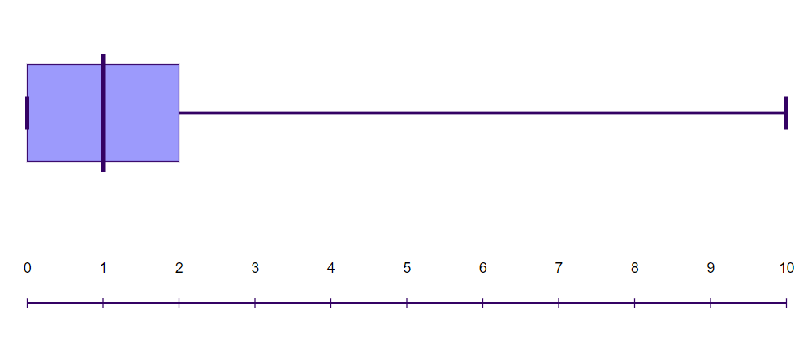
Frequency table

# of countries visited (x) | Frequency  f(x)
0 | 12
1 | 10
2 | 4
3 | 0
4 | 0
5 | 2
6 | 0
7 | 0
8 | 1
9 | 0
10 | 1

Histogram
(made on a website)

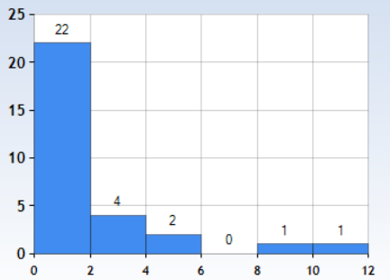

Faith Harris, Payton Davenport, Seneca Peklo
Statistics Paper
Our question was how many Longwood students have traveled outside of the country, and how many foreign countries they had visited. We created this question in order to understand the different levels of “worldliness” of Longwood students as well as to help the office of study abroad promote their program. The hypothesis is that students will have traveled to 0-2 foreign countries. This is our hypothesis because of the age range of college students and the affordability of Longwood in general. College students are generally between the age ranges of 18-22, so they have had less time to travel, and because of the affordability of Longwood, we are assuming that many lower-income families, that do not have the income to afford trips to foreign countries, attend.
We took 30 numbers from the data given and put it into a random number generator in order to find a random sample of the population, which is Longwood University students. With a minimum of 0 and maximum of 10, the mean of the sample comes out as 1.53 countries and the median was 1 country. There were two outliers (8 and 10) in the sample that were possibly caused by confounding variables. For example, ages of students, international students, or the financial status of the students. After looking at the data and making a frequency table, we came up with eleven classes. We decided on this number because it was easiest to separate our date because of the minimum and maximum numbers of countries visited. We picked our classes for the histogram based on the standard deviation(2.417). We used twos because the standard deviation rounded to the nearest whole number is two. After looking over all of our statistics, we concluded that our hypothesis was correct. Most of our data fell between zero and two foreign countries.
After looking over our statistics, our answer seems reasonable to us considering our question was based on college students and that our sample was random. This could be incorrect because our sample was not random enough or because we could have had a design flaw in our experiment.
Our experiment may be important for the study abroad office at Longwood University. The experiment focused on the number of countries Longwood students have traveled to, so the data we found would be helpful to them in determining the ways they promote their program and trips. The experiment found that students have traveled to 0-2 foreign countries so this would help give them insight into many things. For example, how comfortable their student body is with traveling to new places, and if they should implement education programs to help their participants prepare to go abroad.

