Name: Hannah Prem
Bi-Weekly Report Dates: 9/25-10/1 and 10/1-10/8
Steps Week 1: Total: 53,133 High: 9/27 (11,481) Low: 9/30 (3,614)
Steps Week 2: Total: 67,313 High: 10/2 (14,993) Low: 10/5 (5,379)
Week 1 graphs:
Weekly Outlook
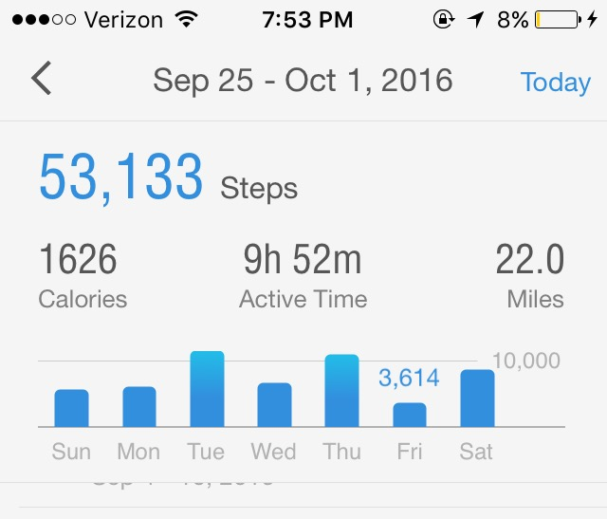

High Day:
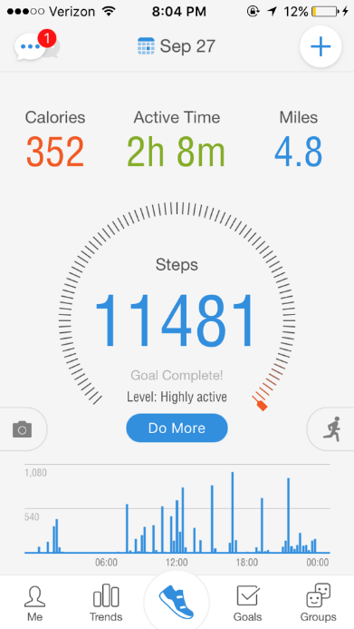

Low Day:
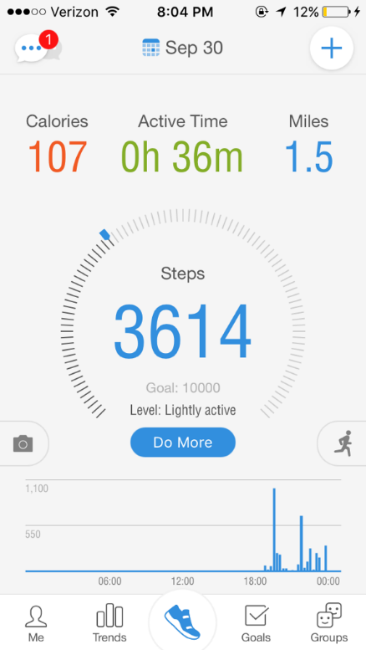

Reflection of Low Activity Day and High Activity Day (Week3):
- Friday had very low steps because I was working many hour
- Tuesday had steps spread throughout the day with high energy
- Friday I was very tired and rested more than usual
- My activity is mostly because my walks across campus

Week 2 Graphs:
Weekly Outlook:
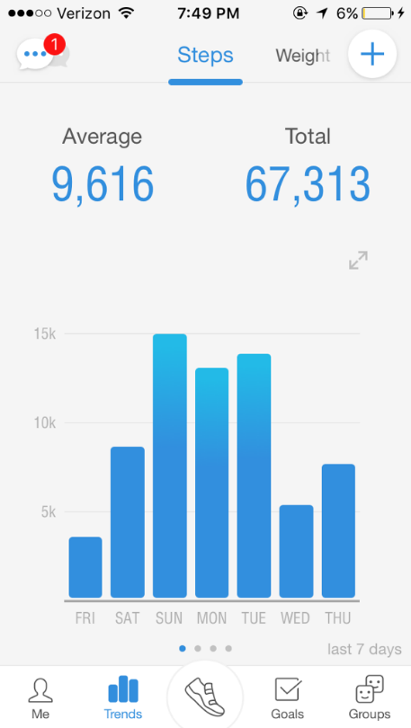

High Day:
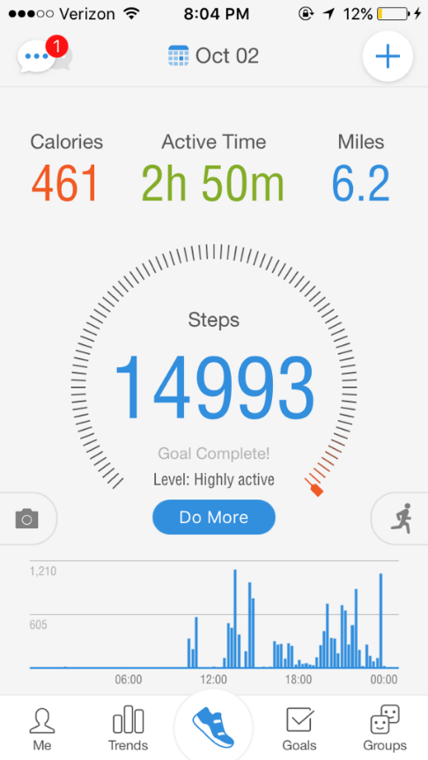

Low Day:
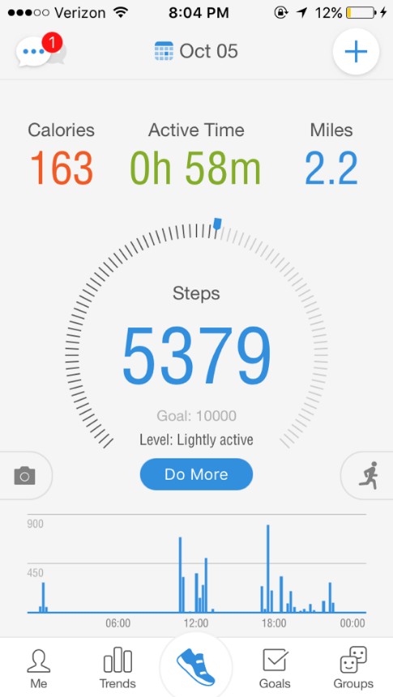

Reflection of Low Activity Day and High Activity Day (Week4):
- Wednesday was a very inactive day, however, when I went for my run the app didn’t track my steps
- Sunday was active in the later part of the day
- Sunday was spread evenly and very active
- Most of my steps are from walking to and from class and around campus
- Improving as the days progress

