Name:  Hannah Auerbach

Bi- Weekly Report Dates: 4/1-4/7 & 4/8-4/14

Steps Week 9 total: 55,278

High Day: Friday 4/1 (9,585 steps)

Low Day: Sunday 4/3 (4,608 steps)

Steps Week 10 total: 55,567

High Day: Thursday 1/14 (11,144 steps)

Low Day: Saturday 4/9 (5,337 steps)

**Week 1**

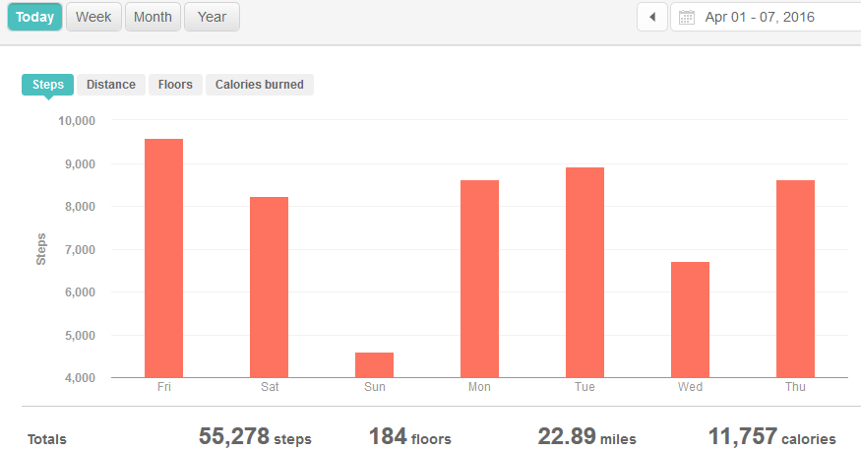

Reflection for Low Activity Day and High Activity Day (Week 9):

* On Friday, a friend came to visit me, so I walked back and forth to the visitor parking lot, which is on the opposite side of campus from my car. Those were the two main spikes in activity. Later in the day we also went on a picnic, which involved more walking.
* On Sunday, I spent a lot of the day sitting or in a car on the way back to Longwood.

Low day

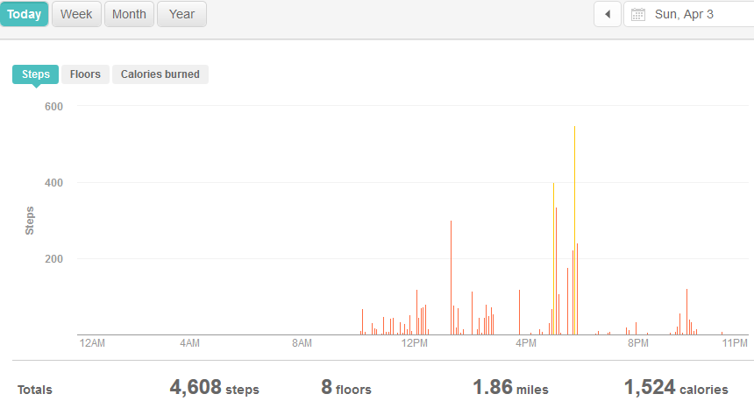

High day

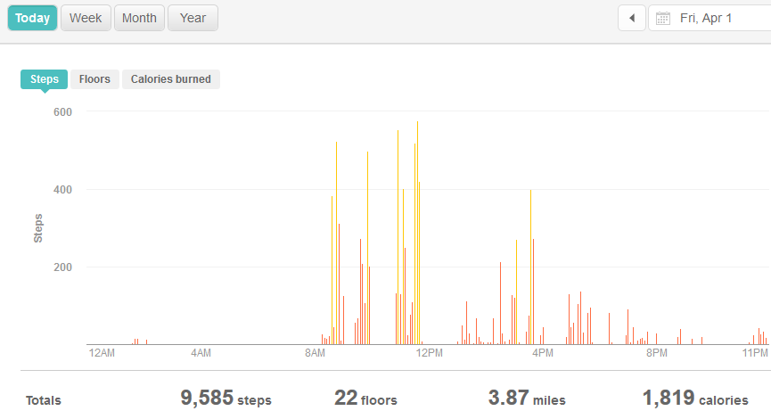

**Week 2**

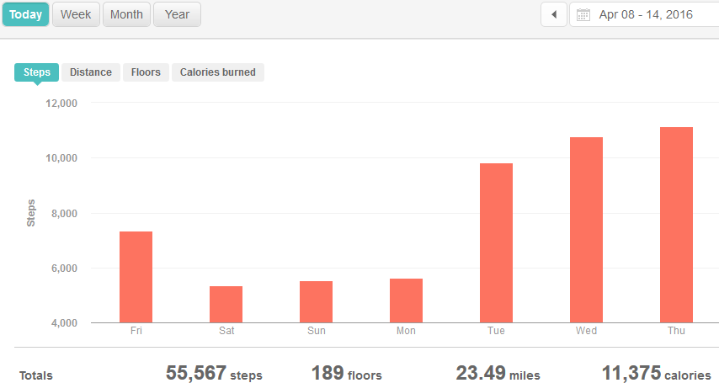

Reflection for Low Activity Day and High Activity Day (Week 10):

* On Saturday, I spent most of the day working in my dorm.
* On Thursday, I got a lot of steps in because I had a lot of meetings and errands to run throughout the day to various ends of campus.

Low day

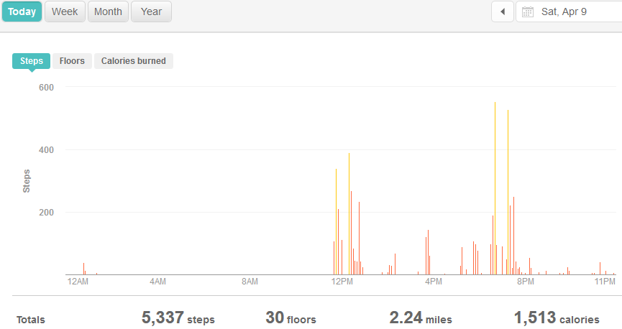

High day

