Name: Ann Smith
Bi- Weekly Report Dates: April 14-20 & April 21-27
Week 1 Total: 50,764 - high day was 11,788 steps, low day was 533 steps
Week 2 Total: 86,678- high day was 19,002 steps, low day was 7,701 steps
Week 1 Reflection and Graphs
Reflection: During the week of April 14-20 I slipped with my steps and only got 50,764. For my lowest day, I only got 533 steps and it is because I did not pay attention to the battery level on my fit bit and it died when I woke up. So undenounced to me, I walked around all day with an uncharged fitbit that was calculating no steps, on top of that I did not have my phone so that couldn’t even track my steps. That was a very stressful day for me and I should have slowed down to gather all my things instead of running around with my stress. On my high day, I had gone on a run during the day around the town of Farmville. I also went after dinner and worked out with a friend who goes to Hampden-Sydney College. I need to keep up my fitness because I was making better progress towards losing weight and being more fit.
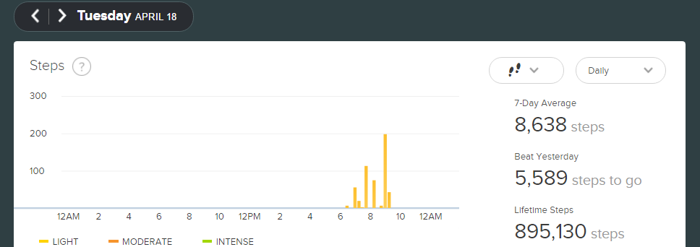
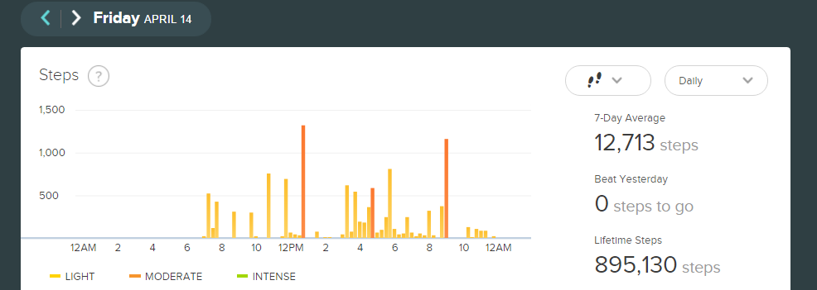
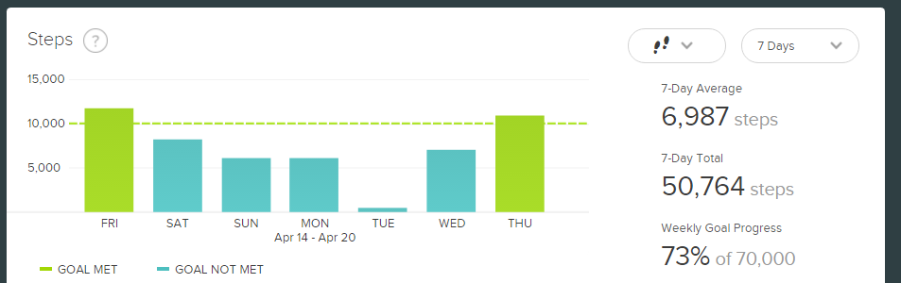

Week 2 Reflection and Graphs
During the week of April 21-27 I got 16,678 steps over my goal of 70,000 to make up for the fact that I had lacked in my steps in the previous week. On Saturday I had woken up with a lot of energy so I went to Hampden-Sydney to workout with my friend Trae. Then in the late afternoon I went on a run with my friend and her dog around Lancer Park. That night I walked around when I went from place to place instead of driving since the distances were not far and we had a large group. I was very sore on Sunday but I felt good and my body felt better than it did the previous week. On Thursday, I spent the majority of my day inside the library. I did get out and walk my friends to class to keep myself active but I didn’t do enough of that to keep myself fit. I should have gotten up more times in the day so I could have gotten more steps in instead of sitting for most of my day. I am proud of myself for getting back on track and I am challenging myself to hit at least 80,000 steps a week over summer in addition to changing my diet so that I can lose weight.

