I, Haleigh Pannell, having a clear understanding of the basis and spirit of the Honor Code created and accepted by the student body of Longwood University, shall at all times govern my university life according to its standards and actively work to support its principles, thereby thoughtfully accepting my responsibility for preserving the honor and integrity of all past, present and future members of the Longwood University community of scholars. I will not lie, cheat, or steal, nor tolerate those who do.
I, Molly Barkman, having a clear understanding of the basis and spirit of the Honor Code created and accepted by the student body of Longwood University, shall at all times govern my university life according to its standards and actively work to support its principles, thereby thoughtfully accepting my responsibility for preserving the honor and integrity of all past, present and future members of the Longwood University community of scholars. I will not lie, cheat, or steal, nor tolerate those who do.

To collect the quarters we pooled together our individual quarters stashed for our laundry and asked teammates for coins in their wallets. For the pennies we followed a similar method by asking our teammates for half, and the other half was provided by exchanging a quarter for 25 pennies from our school’s student union. I don’t think that there is much bias in this, but some can be seen in the fact that we are both from Maryland and it is possible that a certain age of quarters is more common in Maryland than in other states. Similarly, it can be seen that half the pennies came from one place and there could be a bias in that. The Population of the Quarters is the amount of quarters in total, and the sample includes the 50 of those quarters that we collected for this project. The individuals in this project, are each coin on their own, meaning there are 50 individual quarters.

Five Number Summary for Quarters:
Min | 3
Q1 | 12
Med | 17.5
Q3 | 20
Max | 50

Standard Deviation- 7.3725
Mean- 17.08

- To find the Confidence Interval I put in my calculator stat - tests- Z Interval and I put in standard deviation=7.3725 x=17.08 n=50 CI=.95 and I hit enter and got (15.036 ,19.124).To find the margin of error I subtracted the mean 17.08 by the smaller interval and divided that number by 2 and got 1.022
- There are 379.12 million quarters in circulation in the United States

To collect the pennies we pooled together our individual quarters stashed for our laundry and asked teammates for coins in their wallets. I don’t think that there is much bias in this, but some can be seen in the fact that we are both from Maryland and it is possible that a certain age of quarters is more common in Maryland than in other states. Similarly, it can be seen that half the pennies came from one place and there could be a bias in that.
The population of pennies is the amount of pennies in existence, the sample is the 50 we collected.The individuals are each individual penny so there are 50 individual pennies in this project.

Five Number Summary for Pennies:
Min | 3
Q1 | 7.5
Med | 15
Q3 | 26
Max | 75

Standard Deviation-17.82
Mean-20.1836

- To find the Confidence Interval I put in my calculator stat - tests- TInterval and I put in standard deviation=17.82 x=20.1836 n=50 CI=.95 and I hit enter and got (15.119 ,25.248).To find the margin of error I subtracted the mean 20.1836 by the smaller interval and got 4.9846
- There are 1.65 trillion pennies in circulation in the United States

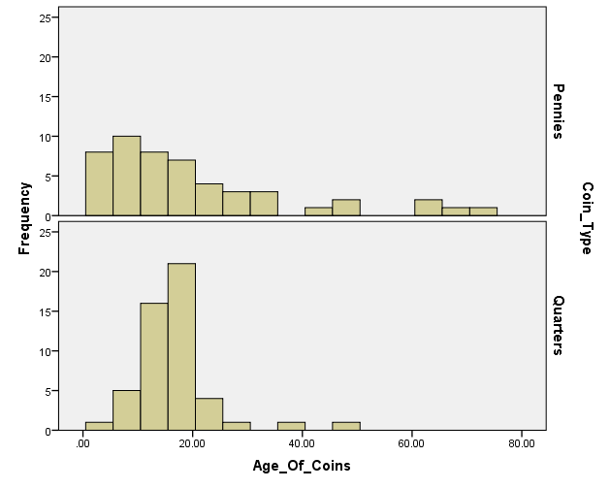
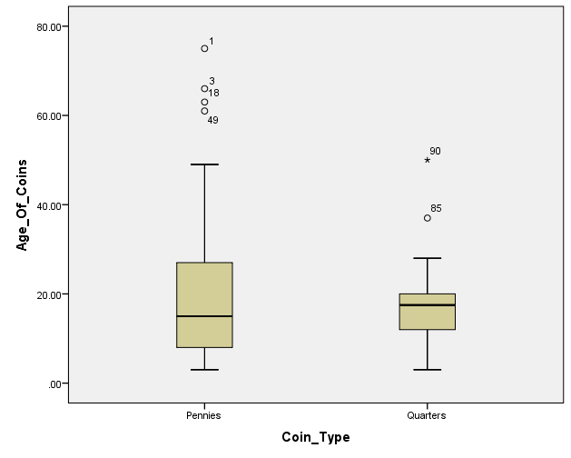

1. If you wanted to estimate the average age of pennies to within one year with 99% confidence, then how large of a sample size would you need to obtain? Use the standard deviation from your sample as your best estimate of the population standard deviation.
4.9846 = 2.5758 ∓ (17.82/ √n)
-2.5758 -2.5758
√n * 2.4088 = (17.82 / √n) * √n
1/2.4088 * (2.4088 * √n) = 17.82 * 1/2.4088
√n = 17.82 / 2.4088
(√n)² = 7.39787446
N = 54.729
N = 55 pennies

2. Suppose you want to estimate the proportion of pennies in circulation that are older than 20 years to within 2% with 98% confidence. Use your sample as a pilot study to determine the sample size necessary to achieve your goal.

N = (z*/m)²p’(1-p’)
N = (2.5758/.02)²(.26)(1-.26)
N = (16586.8641) * (.26) * (.74)
N = 3191.312653
N = 3192 pennies

3. Is the mean age of all quarters in circulation the same as the mean age of all pennies in circulation? You will need to use an appropriate inferential technique to the answer this question. Make sure that you show (and explain) all work that supports your conclusion. You should also produce a nice graphical representation of the distributions of the ages of your two coin types that makes it easy to compare the two distributions visually as well as discuss the assumptions necessary to run this inference test in your particular situation.

H₀: μ₁ = μ₂ H_{𝝰}: μ₁ ≠ μ₂
population | n | mean | Standard deviation
1 (pennies) | 50 | 20.1836 | 17.82
2 (quarters) | 50 | 17.08 | 7.3725

No the pennies mean is larger than the quarters mean. After putting this data into STAT → TESTS → 2-SampZTest we found a p value of .255, this is larger than an alpha of .05. Because of this we had to fail to reject the null hypothesis being that there is no significant evidence against it.

4. Working under the assumption that coins stay in circulation for thirty years and examining coin production figures from the last thirty years, I hypothesize that the proportion of quarters without an eagle on the “tails” side is 0.62. Use your data (all 50 quarters) to address the validity of my hypothesis using an appropriate inferential technique.

H₀: μ = 0.62 H_{𝝰}: μ ≠ 0.62
STAT → TESTS → 1-PropZTest
P₀ = 0.62
X = 25
N = 50
Prop: ≠ P₀
CALC
Z = -8.4494
P = .0000000000000000296 or 2.96 x 10⁻¹⁷

The p that we calculated is less than the alpha of .05. This means that there is significant evidence and we must reject the null hypothesis. In the case of this, the results mean that your assumption that the proportion of quarters without an eagle on the tails side is incorrect. The p’ we calculated was .04.

