Regression
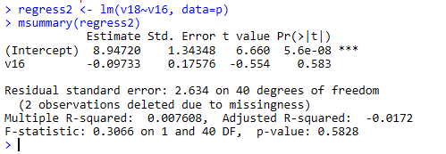
I hypothesized that the child/children who had assistance with the noodle necklace take home activity would improve their family relationships. In other words, if the child/children had assistance they would have improved relationships with their family.
Improved family relationships decrease .0973 for each unit of assistance had during the noodle necklace activity increases. Therefore, the relationship and assistance of the activities are inversely related. This finding was significant (p = .583). The R² statistic is .007608, this means that the model explains .7 percent of the variation of the dependent variable (improved family relationship). There is no discernable relationship between the assistance given and an improved family relationship.

