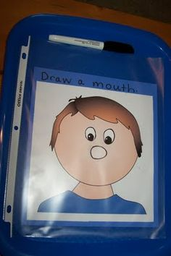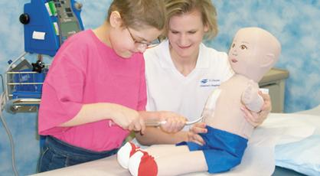

“A hospital can be a scary place. Helping kids cope with stress and uncertainty is what

Child Life Specialist

do bests. They asses needs and explain what s about to happen using age appropriate language and medical play. They calm fearful patients with relaxation and distraction techniques. Soon that scary place isn’t so scary.”

Visit:

[www.childlife.org](http://www.childlife.org)

for more information

“I want to

Inspire

People

I want someone to look at me and say

Because

of

You

I didn’t give up”

* Child Life Specialist

#### Grace Dalton

**Feeling loved**

**Feeling satisfied**

**Feeling confused**

**Feeling detached**

**Feeling secure**

**Feeling sad**

**Feeling connected**

**Feeling angry**

**Feeling joyful**

**Am I safe?**

**Do I belong?**

**Do I have power?**

**Are my thoughts valued?**

**Am I understood?**

**Do I matter?**

**(What’s really going on)**

**What you see:**

1. Normalization
   * While in the hospital the child will face many difficult procedures, physical changes, pain, or isolation. What people sometimes forget is the fact that these patients are still children.
2. Preparation
   * “Knowledge is power.” By preparing a child for an upcoming procedure, you can reduce the child’s anxiety as well as raise confidence level.
3. Emotional Expression
   * Children typically have trouble expressing emotion in these situations because they “can’t communicate, they fear what others will think, or they don’t know how to express emotions in words.” We try and promote emotional expression.
4. Play
   * A Child Life Specialist spends much of their time playing with patients. Through this we develop “trust, teach them about procedures, and help them express their emotions.”
5. End of life support
   * Although health care has come a long way, sometimes medicine is still unable to cure the illness ‘s the children are facing. When this is the case we are able to provide emotional support for the patient as well as the family.

5 Ways We Make A Difference