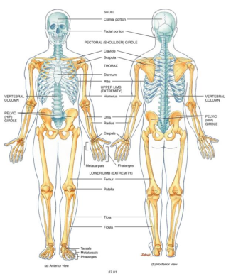Appendicular Skeleton

* 126 Bones
* Upper limbs, Lower limbs, Pelvic Girdle, Pectoral Girdle.

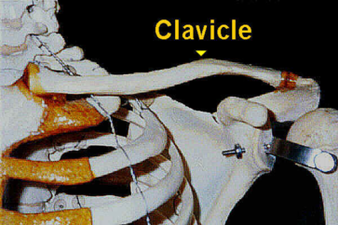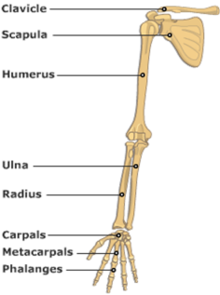**CLAVICLE**

* Sternal Extremity
  + Blunt, Medial End
* Acromial Extremity
  + Flat, Roughened
  + Lateral End

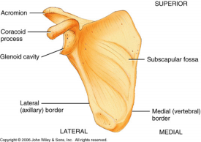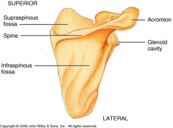**SCAPULA**

* Ventral Structures
  + Acromion
  + Glenoid Cavity (Fossa)
  + Coracoid Process
  + Subscapular Fossa
* Dorsal Structures
  + Spine
  + 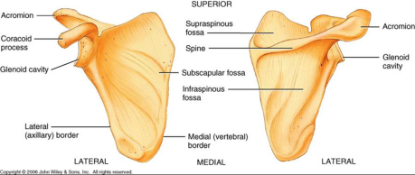Supraspinous Fossa
  + Infraspinous Fossa
  + Lateral Border
  + Medial Border

**30 Bones in each upper limb.**

* Arm (1) = Humerus
* 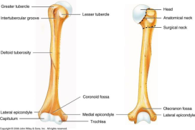Forearm (2) = Radius & Ulna
* Wrist (8) = Carpals
* Palm of Hand (5) = Metacarpals
* Fingers (14) = Phalanges

**HUMERUS**

* Head
* Anatomical Neck & Surgical Neck
* Lesser Tubercle & Greater Tubercle
* 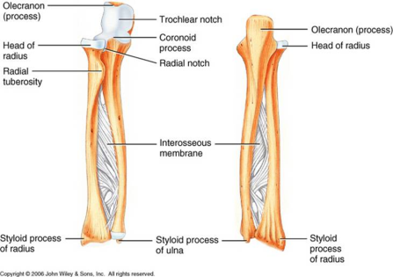Deltoid Tuberosity
* Trochlea
* Capitulum
* Medial & Lateral Epicondyle
* Coronoid & Olecranon Fossa

**ULNA**

* Medial Bone of forearm
* 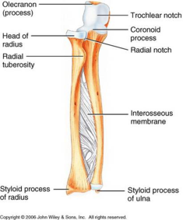Olecranon
* Coronoid Process
* Trochlear Notch
* Styloid Process

**RADIUS**

* Lateral bone of forearm
* Head
* Styloid Process

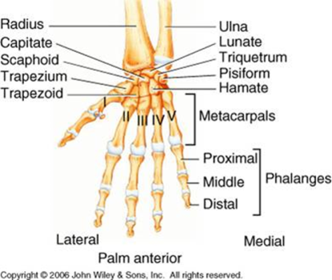**CARPUS (WRIST)**

* Lateral -> Medial
* Proximate
  + Scaphoid, Lunate, Triquetral, Pisiform
* Distal
  + Trapezium, Trapezoid, Capitate, Hamate
* **S**ally **L**eft **T**he **P**arty **T**o **T**ake **C**arol **H**ome

**METACARPALS**

* 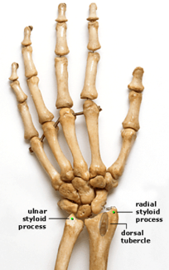I, II, III, IV, V

**PHALANGES**

* I
  + Proximal, Distal
* II, III ,IV, V
  + Proximal, Middle, Distal

**PELVIC GIRDLE**

* Hip (Coxal Bone)

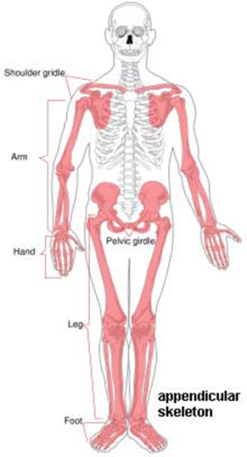**LOWER LIMBS**

* Femur
* Fibula
* Tibia
* Patella
* Tarsals
* 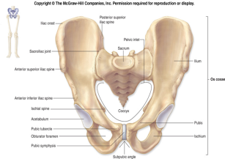Metatarsals
* Phalanges

**COXAL BONES (HIP)**

* Ilium
* Ischium
* Pubis

**ILIUM**

* Iliac Crest
* Anterior Superior Iliac Spine
* 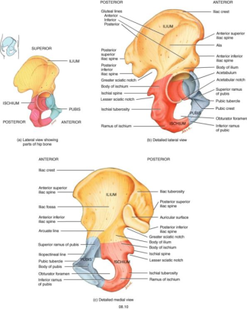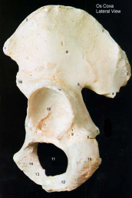Posterior Superior Iliac Spine
* Great Sciatic Notch

**ISCHIUM & PUBIS**

* Ischium
  + Ischial Tuberosity
  + Lesser Sciatic Notch
* Pubis
  + Pubic Symphysis

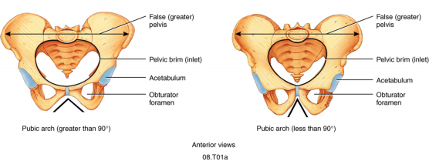**MARKINGS OF THE PELVIS**

* Acetabulum
* Obturator Foramen
* Pelvic Brim, Inlet, & Outlet
* True & False Pelvis

**FEMALE AND MALE PELVES**

* General Structure
  + Females light and thin; Males heavy and thick
* False Pelvis
  + Females shallow; Males deep
* Pelvic Brim
  + Females larger, more oval; Males large/lateral
* Obturator Foramen
  + Females Oval; Males Round
* Pubic Arch
  + Females > 90 degree angle; Males < 90 degree angle

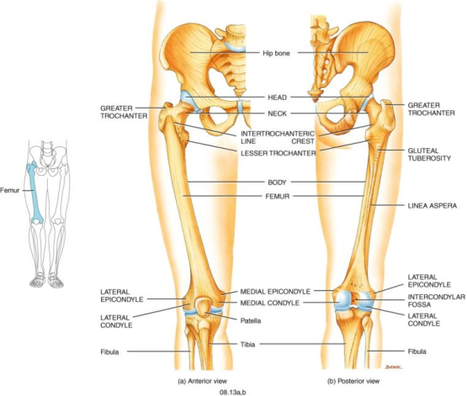**FEMUR**

* Head
* Neck
* Greater & Lesser Trochanter
* Medial & Lateral Condyle
* Intercondylar Fossa
* Medial & Lateral Epicondyle
* Gluteal Tuberosity
* Linea Aspera

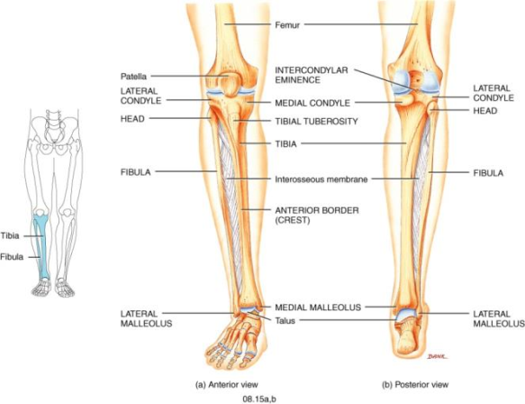**TIBIA**

* Medial & Lateral Condyles
* Tibial Tuberosity
* Medial Malleolus (Ankle)

**FIBULA**

* Head
* Lateral Malleoulus (Ankle)

**TARSALS**

* 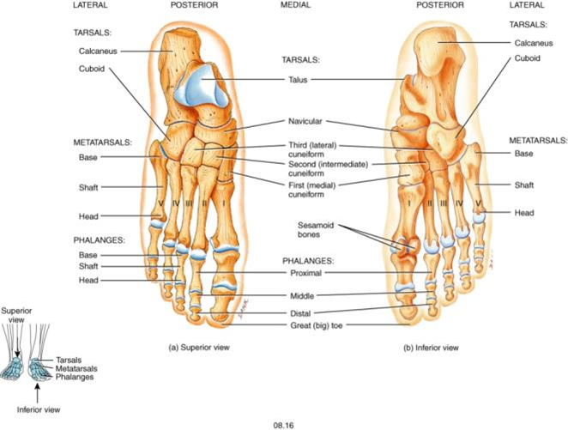Talus
* Calcaneous
* Navicular
* Cuboidal
* Cuneiforms
  + Medial
  + Intermediate
  + Lateral

**METATARSALS & PHALANGES (Same as Carpal)**