Regression

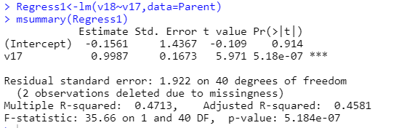

I hypothesized that families that enjoyed the Noodle Necklace activity improved the relationship between the child and parent. In other words, if the child/children enjoyed the Noodle Necklace activity, then it would improve the relationship with their family.

The relationship improvement between the child and the parent increases 0.9987 units for every one unit increase in how much the family enjoyed the Noodle Necklace activity. Therefore, it appears that enjoyment and relationship of the activity are directly related. The finding is significant (p=0.91). The R2 statistic is 0.4713, meaning that this model explains 47 percent of the variation in the dependent variable (improvement of child’s relationship with parent). There is a relationship that can be detected between the improvement between the parent and child and the level of enjoyment of the activity.