Climate Change Compounds Health Risks
for Disadvantaged Groups
Rose C. Gerena
Longwood University

Climate Change Compounds Health Risks
for Disadvantaged Groups

Earth’s climate system has undergone drastic changes as a direct effect of human influence. A few main anthropogenic drivers of climate change include aerosols, deforestation, the burning of fossil fuels and the rise of carbon dioxide emissions into the atmosphere (IPCC, 2014). As a result of these forces, there has been a measured increase in average temperature, precipitation levels, extreme weather events, droughts in the South and heavy downpours and flooding in the Midwest and Northeast (Balbus et al., 2016). While humans all over the nation and the world must face the issues that climate change presents, some populations are disproportionately affected by these conditions. There are multiple factors that contribute to the level of risk being faced. Low-income groups and communities of color are subject to impacts of climate change in addition to the socioeconomic stressors that they already encounter (Gamble et al., 2016). Thus, people of color and people that are economically disadvantaged are at a higher risk of detriment to their mental and physical health (Gamble et al., 2016).

Background
There are a few factors that contribute to the vulnerability that an individual or group has. In a report published by the U.S. Global Change Research Program, vulnerability is defined as “the tendency or predisposition to be adversely affected by climate-related health effects, and encompasses three elements: exposure, sensitivity or susceptibility to harm, and the capacity to adapt or to cope” (Balbus et al., 2016). Exposure refers to the interaction between an individual and the stressors they are confronted with. The second factor, sensitivity, is how much people or communities are affected by variability in the climate system. Finally, adaptive capacity is the ability to adjust and respond to events and is related to the amount of resilience a community has when recovering or adapting from adverse trends (Gamble et al., 2016). To add to the complexity, there are social health determinants that interact with these elements of vulnerability. These determinants of health include social, economic, and physical factors, as well as individual characteristics and behaviors. The various determinants of health are often out of any individual’s direct control and include income, education level, environment, gender, genetics, support systems and health services, among others (World Health Organization, 2010). As a result of these factors interacting, they can compound and adversely impact physical and mental wellbeing.
Climate-related stressors that communities of color and low-income communities are disproportionately affected by are extreme heat events, weather extremes, degraded air quality, waterborne and vector borne diseases, food safety and security, and psychological stress. (Gamble et al., 2016). Due to the ever-increasing amount of greenhouse gases being emitted into the atmosphere, Earth’s average and extreme temperatures are rising. In turn, the extremities in temperature weaken the body’s ability to maintain homeostasis, which can incite other health complications (Sarofim et al., 2016). Climate change has induced extreme weather events, which are projected to increase as temperatures continue to rise. Floods, possibly a result of heavy precipitation or hurricanes, droughts, wildfires, severe winter storms and thunderstorms are all examples of the extreme weather events that might occur and each poses an alarming threat to peoples physical and mental health.
Floods pose the risk of traumatic injury or death by drowning and impacted mental health issues. Infrastructure disruptions and the spread of diseases become an endangerment. Droughts cause a reduction in the quality and quantity of water supply as well as reduce air quality. It can impact respiratory health and increase the risk of water-related and foodborne illness. Droughts can cause economic insecurity, especially in rural areas, impacting agriculture (Bell et al., 2016). Wildfires can be menacing far beyond their immediate proximity. The smoke that wildfires produce can expose people to harmful chemicals and particles. It can be carried through the air for thousands of miles, causing an uptick in respiratory issues being brought to health services (Bell et al., 2016). Thunderstorms can leave damaged infrastructures and fallen trees and other debris in their wake. Winter storms threaten extreme cold and freezing wind, which may lead to frostbite and hypothermia. Both thunderstorms and winter storms create treacherous driving conditions, putting people at further risk (Bell, et al., 2016). All of these climate related stressors do not impact humans equally. Due to a combination of increased exposure and sensitivity and a lower adaptive capacity, in addition to possible pre-existing health problems, these stressors can take a large toll on communities of color and impoverished groups.
According to the Fifth Assessment Report (AR5) of the Intergovernmental Panel on Climate Change (IPCC), it is evident that the climate system has been drastically altered by human influence (IPCC, 2014). The increasing concentration of greenhouse gases (GHG) is responsible for more than fifty percent of the recorded increase in average global temperature. There has also been an observed rise in surface temperature since the mid-20th century. In addition to these alarming changes, the global water cycle has also been affected. Anthropogenic drivers have contributed to the melting of glaciers and the loss of Arctic sea-ice. Increases in ocean temperature and the rise of sea levels have been tracked globally over the last fifty years (IPCC, 2014).
Along with changes to the global climate system, there have been changes in the duration, frequency, and intensity of extreme weather events (Bell et al., 2016). Hurricanes, floods, droughts, wildfires and severe winter storms are different types of extreme events that could potentially cause great harm to certain areas and the populations that inhabit them. Just as certain populations are more vulnerable to exposure from extreme climate events, the infrastructure of different places can also be more vulnerable to damage (Bell et al., 2016). Disruption of infrastructure caused by an extreme weather event creates an uptick in health risks and lowers the adaptive capacity of the place being impacted.
A scientific assessment of the impacts of climate change on human health states “serious health risks can arise from infrastructure and housing damage and disruption or loss of access to electricity, sanitation, safe food and water supplies, health care, communication and transportation” (Bell et al., 2016). The nation’s infrastructure is built to function based on preceding weather patterns and is unlikely to hold up well in the face of future climate stressors (Bell et al., 2016). Damage to roads interferes with ability to employ emergency response teams and disaster relief organizations. Deterioration to sewage and drainage systems can compromise water quality and increase the risk of water-related illnesses. The loss of power increases likelihood of food-borne illnesses because perishable items cannot be kept at the proper temperature. Carbon monoxide poisoning threatens spaces that are not well ventilated enough to handle the “increased use of gasoline-powered generators, charcoal grills, and kerosene and propane heaters or stoves” if electricity is lost (Bell et al., 2016). Treatments and access to medication might be stalled at the detriment of the person in need. Extreme weather events are dangerous and threaten physical and mental health. In addition, the destruction of infrastructure and its loss of functionality elevates the threat of harm to individuals. Together, these things reduce the adaptive capacity that an area has, meaning it does not have the necessary means to adapt or cope with the adversity being faced.
Certain areas are more vulnerable to threat than others, due to their level of resilience in response to climate-related stressors. Vulnerability refers specifically to groups of the population that face a disproportionately higher risk to climate change stressors, while resilience refers to the systemwide ability to safeguard those groups against endangerments through infrastructure (Revi et al., 2014). Low income groups are often more vulnerable because of a lapse of quality in housing coupled with insufficient infrastructure. There is also often a deficiency in health care, emergency response services, and disaster risk reduction (Revi et al., 2014).
Urban areas are largely affected by environmental stressors because they are already strained by overpopulation, a continuous rise in pollution, a need for resources and concentrated poverty (Revi et al, 2014). Damage to housing is often a result of disasters and it can weigh heavily on the lower class, whose dependence on housing is a central part of their livelihood (Revi et al., 2014). Due to the ever-increasing threat of climate risk, it is becoming more important to increase the adaptivity of urban areas and enable them to protect their inhabitants. People of color, low income groups and people with limited English proficiency (LEP) are more vulnerable to exposure and are more likely to live in risk prone areas that shoulder most of the burden of air pollution (Gamble et al., 2016). Among these groups, there are higher rates of chronic medical conditions like cardiovascular and kidney disease, diabetes, asthma, and COPD, all of which can be amplified by climate-related health impacts (Gamble et al., 2016). Social, economic and educational factors that interfere with adaptive capacity include “limited transportation, limited access to health education, and social isolation related to language deficiencies (Gamble et al., 2016).” Minority groups are projected to become the majority by 2042, meaning that the amount of people of color affected by climate vulnerability will escalate over time (Gamble et al., 2016).
Climate change is a global issue that will affect all people. Low income groups and people of color specifically are at a higher risk of mental and physical detriment as a result of climate change because of socioeconomic factors. It is important to understand these issues because measures can be taken in order to reduce vulnerability and protect these populations. Upon analysis, it becomes evident that there is a need to fortify infrastructure, especially in densely populated, low income areas. Enforcing change that will strengthen areas that are more exposed and less capable of adapting or coping with the adverse impacts of climate change will reduce stressors on these populations and the strain on these areas. Further, it would reduce the risks to the mental and physical health of large portions of the population.
In order to protect vulnerable populations from the exposure and risk that climate change presents, mitigation and adaptation strategies must be employed. Mitigation in this context is best defined as the “structural and nonstructural measures undertaken to limit the adverse impact of natural hazards, environmental degradation, and technological hazards” (Keim, 2008). Mitigation strategies are measures that are taken preceding the damage of climate-related impacts that focus on reducing GHG emissions rather than adaptative strategies that would help with recovery and resilience of a vulnerable population after enduring the endangerment (Keim, 2008).
The Center for Disease Control and Prevention (CDC) used data collected from the census to estimate the level of social vulnerability of different regions based on socioeconomic status, household composition, race or ethnicity, native language and infrastructure conditions (Gamble et al., 2016). The data is mapped and shows the overall vulnerability of an area as well as the individual ratings of the elements the overall score is comprised of and is known as the Social Vulnerability Index, as illustrated in Figure 1. Geographic Information System (GIS) technology is similar and can be used to “quantify and visualize factors that contribute to climate-related health risks” (Gamble et al., 2016). By using a combination of census data, climate data, and data of health determinants, GIS mapping can locate vulnerable populations in order to improve the adaptive capacity of those populations (Gamble et al., 2016). It is a necessary and important tool for improving emergency preparedness and resilience in the at-risk communities (Gamble et al., 2016). It is needed because while a disaster may strike and do similar physical damage to an area across racial or ethnic and class distinctions, the pre-impact responses and post event recovery make a world of difference (Gamble et al., 2016). One problem with this strategy is the limitation on the data concerning these factors that is necessary for mapping. People have concerns about their right to privacy, making the collection of available data on socioeconomic and health factors more difficult (Gamble et al., 2016).
Vulnerability reduction programs are one way of increasing the resilience of a population. Resilience can be increased by practicing preparedness, response and recovery (Keim, 2008). Responsibility for adaptative strategies for reducing vulnerability and increasing resilience is placed on individual communities. Through the promotion of health and safety by public health and medical institutions, vulnerability can be reduced (Keim, 2008). A home that is considered healthy is a disaster resilient one. A healthy community is one that can limit the exposure of its population and is a sustainable community (Keim, 2008). In order to prepare and respond to climate-related events appropriately, it is important to recognize that different climate events incite different needs from the communities affected.
In the event of a drought, risk should be assessed by examining food security, water, sanitation, and shelter (Keim, 2008). There will be a need for emergency operations for an extended period of time as well as a plan for populations that are displaced due to the drought. Educating the public about water use and risks to their health and what they can do to protect themselves would make a significant impact in improving preparedness (Keim, 2008). Response to a drought by individual communities is guided by state and national procedure to address the impacts to safe food and water supply, hygiene and shelter (Keim, 2008).
In the event of a wildfire, again there must be an assessment of the hazard at the local level. Emergency evacuation and shelter procedures should be developed and drills should be practiced. There is a responsibility to educate the members of the community about the risk of this event and what the procedures are for withstanding the wildfire (Keim, 2008). In response to this type of emergency, the first step is to find lapses in health and medical needs and resources in order to adjust distribution of care (Kiem, 2008). Decisions regarding shelter from displacement and safe food, water and air quality will be instrumental in ensuring public health and safety (Keim, 2008).
Another example of a climate-related emergency event that adaptation strategies can help decrease health risks for is flooding. As a direct result of using meteorological forecasting to warn people of flash floods, mortality rates decreased by more than fifty percent (Keim, 2008). It is important to push education and communication to the public about being prepared at home, school or work and to be aware of flood zones and evacuation routes (Keim, 2008). Power generators and water pumps can be useful in upholding infrastructure needed to provide medical care (Keim, 2008). The aftermath of a flooding event presents the risk of transmission of vector-borne disease which creates a need for surveillance, although in the U.S., the chance of an outbreak occurring is relatively low (Keim, 2008).
There needs to be guidelines in place at the state and national level in order to provide a framework to ensure peoples safety at the local level. The adaptative strategies presented are good, but to reduce the impact of climate change on human health, mitigative strategies that limit and eventually reduce the amount of carbon emissions are also necessary. Carbon Dioxide Removal (CDR) technology is one way to reduce carbon emissions. CDR methods include capture and storage and afforestation (IPCC, 2014). Solar Radiation Management (SRM) is another geoengineering technology that might be able to considerably reduce carbon emissions, however it is still uncertain and further testing is required (IPCC, 2014). If these strategies are employed and successful, the significant cuts in GHG emissions over the next few decades can dramatically decrease the risks of climate change because it will limit global surface warming (IPCC, 2014).
In order to systematically reduce the overall dangers to human health that climate change presents, a combination of adaptative and mitigative strategies must be employed effectively. Any one method will not be sufficient in itself; there must be multiple steps in place to proactively limit and reduce GHG emissions and to enhance infrastructure to be resilient when adaptation measures become necessary. To implement these strategies will demand cooperation from all levels of government and above to an international scale (IPCC, 2014). Climate change is an issue that effects all countries and all people and it requires collaboration on a massive scale to decrease the associated risks.

References
Balbus, J., Crimmins, A., Gamble, J. L., Easterling, D.R., Kunkel, K.E., Saha, S., & Sarofim, M.C., 2016: Ch. 1: Introduction: Climate Change and Human Health. The Impacts of Climate Change on Human Health in the United States: A Scientific Assessment. U.S. Global Change Research Program, Washington, DC, 25-42. http://dx.doi.org/10.7930/J0VX0DFW
Bell, J.E., Herring, S.C., Jantarasami, L., Adrianopoli, C., Benedict, K., Conlon, K., Escobar, V., Hess, J., Luvall, J., Garcia-Pando, C.P., Quattrochi, D., Runkle, J., & Schreck., C.J., III, 2016: Ch. 4: Impacts of Extreme Events on Human Health. The Impacts of Climate Change on Human Health in the United States: A Scientific Assessment. U.S. Global Change Research Program, Washington, DC, 99-128. http://dx.doi.org/10.7930/J0BZ63ZV
Gamble, J.L., Balbus, J., Berger, M., Bouye, K., Campbell, V., Chief, K. Conlon, K., Crimmins, A., Flanagan, B., Gonzalez-Maddux, C., Hallisey, E., Hutchins, S., Jantarasami, L., Khoury, S., Kiefer, M., Kolling, J., Lynn, K., Manangan, A., McDonald, M., Morello-Frosch, R., …Wolkin, A.F., 2016: Ch. 9: Populations of concern. The Impacts of Climate Change on Human Health in the United States: A Scientific Assessment. U.S. Global Change Research Program, Washington, DC, 247-286. http://dx.doi.org/10.7930/J0Q81B0T
IPCC, 2014: Climate Change 2014: Synthesis Report. Contribution of Working Groups I, II and III to the Fifth Assessment Report of the Intergovernmental Panel on Climate Change [Core Writing Team, R.K. Pachauri and L.A. Meyer (eds.)]. IPCC, Geneva, Switzerland, 151 pp.
Keim, M.E., 2008: Building human resilience: The role of public health preparedness and response as an adaptation to climate change. American Journal of Preventive Medicine, 35, 508-516. http://dx.doi.org/10.1016/j.amepre.2008.08.022
Revi, A., D.E. Satterthwaite, F. Aragón-Durand, J. Corfee-Morlot, R.B.R. Kiunsi, M. Pelling, D.C. Roberts, and W. Solecki, 2014: Urban areas. In: Climate Change 2014: Impacts, Adaptation, and Vulnerability. Part A: Global and Sectoral Aspects. Contribution of Working Group II to the Fifth Assessment Report of the Intergovernmental Panel on Climate Change [Field, C.B., V.R. Barros, D.J. Dokken, K.J. Mach, M.D. Mastrandrea, T.E. Bilir, M. Chatterjee, K.L. Ebi, Y.O. Estrada, R.C. Genova, B. Girma, E.S. Kissel, A.N. Levy, S. MacCracken, P.R. Mastrandrea, and L.L.White (eds.)]. Cambridge University Press, Cambridge, United Kingdom and New York, NY, USA, pp. 535-612.
Sarofim, M.C., Saha, S., Hawkins, M.D., Mills, D.M., Hess, J., Horton, R., Kinney, P., Schwartz, J., & Juliana A. St., 2016: Ch. 2: Temperature-Related Death and Illness. The Impacts of Climate Change on Human Health in the United States: A Scientific Assessment. U.S. Global Change Research Program, Washington, DC, 43-68. http://dx.doi.org/10.7930/J0MG7MDX
World Health Organization. (2010, December 1). The determinants of health. Retrieved from https://www.who.int/hia/evidence/doh/en/

Figure 1: Mapping Social Vulnerability
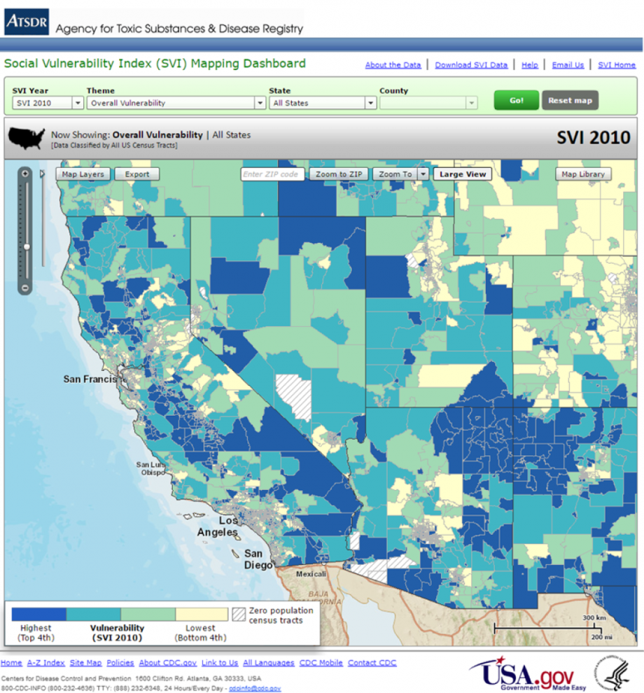

Figure 1. This map depicts the social vulnerability of the Southwest region of the United States based on a measurement of socioeconomic status; household composition; race, ethnicity and language; and housing/transportation. The areas with the highest overall vulnerability are represented in dark blue and areas with the lowest vulnerability represented in yellow (Gamble et al., 2016).

