Cover Letter:
04/10/17
Dear, Betty Newman
Assignments Manager for Residential and Commuter Life
Lancaster G13
201 High Street
Farmville, VA 23909
We are three Longwood residential students who have been delighted by the conveniences of these facilities. However we do believe that student residential life could be improved with the adoption of a new pet policy to make Longwood housing even more delightful. The majority of students do have at least one animal that they leave behind at home. If Longwood were to offer a new pet policy allowing students to bring their pets, not only will the students benefit but Longwood will as well. The pets will decrease the students stress levels and Longwood will be given the opportunity to collect extra revenue through a pet fee.
The purpose of this proposal is to decrease student stress and anxiety, while at the same time producing a new source of revenue for the school. We believe that this proposal covers the possible issues that could be raised about a change or alteration in the University’s Pet Policy. We hope that you will be pleased with our research and conclusions. However if you have any questions or concerns about this possible change of policy, do not hesitate to do so.
Sincerely,
Virginia Colvin, Brittney Alvarez and Maggie Galleher

Title Page:
The Helping Paw! Improving Student Life
For All Residential Students

Submitted to: Longwood Housing
Date: 04/10/17

Betty Newman
Assignments Manager for Residential and Commuter Life
Lancaster G13
201 High Street
Farmville, VA 23909

Summary: In this proposal we are addressing the Longwood University Pet Policy. Many students have been recently discussing their displeasure with the policy and how difficult it is to obtain the necessary paperwork for the emotional support pets. In this proposal we discuss the benefits of students being allowed to bring these animals with them to college, of these benefits are reduction of stress which results in lower levels of anxiety and depression. This proposed change to the policy would allow “normal” students to have an animal with them at college without having to go through the process of obtaining the necessary paperwork for an emotional support pet. While there would be costs associated with the changing of the pet policy, the costs would be for the students as the college could charge a pet fee. In the proposal we have also included other potential solutions or ideas for changing the pet policy. We have also collected data from students here at Longwood University to get their opinions and receive some sufficient data.
Background:
Any residential Longwood student may easily gain access to the University’s pet policy, through Longwood University’s website. The school’s pet policy states:
“Students are permitted to have non-carnivorous, non-poisonous fish in their rooms in tanks no larger than 10 gallons. Frogs, turtles, hermit crabs, amphibians, and reptiles are not fish and are therefore not permitted. No other type of animal is permitted in residence hall rooms or Longwood managed apartments. Persons possessing pets in violation of this regulation will be required to remove the animal within 24 hours. There may be instances where the animal must be removed immediately. Students will face disciplinary action, including a University fine, and will also be responsible for any damages that have occurred. All damages will be assessed by RCL staff members”
Although there are fish allowed in the residential student’s housing assignments, these pets lack a quality that may benefit student life. Animals such as cats, dogs and rodents encourage human interaction and usually develop a close tie with the individual. When the individual leaves for college they must leave their furry friend at home. Longwood does support the exercising of service animals for students with disabilities. However if all students were able to bring these animals with them to school this would not only make the students feel more welcomed but help create a more positive college experience. This will create a easier transition into a new life away from the comforts of home. These relationships help to strengthen a child’s social skills, giving them the potential to do better in a school setting. There are many students who live on campus or within Longwood managed apartments who would benefit from having a service animal.
According to the American Psychological Association, “About one-third of U.S. college students had difficulty functioning in the last 12 months due to depression, and almost half said they felt overwhelming anxiety in the last year.” College students are becoming more and more stressed and their stress is triggering depression and in some cases even becoming comorbid with anxiety. Now there is something that, while it cannot cure anxiety and/or depression, it can help relieve stress by releasing a certain chemical in the brain that has been shown to relieve stress relieve stress, oxytocin. According to Forbes staff member Jill Castellano, “Pet Therapy Is A Nearly Cost-Free Anxiety Reducer On College Campuses.” In this article Jill talks about the pet therapy program at Tufts University and how successful it has been and how the biggest cost to the University is time. In her article Jill quotes the assistant professor from Tufts University, Megan Mueller, “As we learn more about how human-animal interaction can reduce stress and anxiety, we think this might be a really interesting cost-effective method of helping students’ mental health.”

Project Narrative:
Longwood’s goal is to welcome their students and encourage them to exercise the resources that are provided by the school. Therefor certain students exercise their rights to bring to school with them, a service dog. There are higher levels of stress being reported from college students. The National College Health Assessment found from the statistics of 125,000 students from more than 150 colleges and universities. The results showed that one third of these students had suffered from depression and anxiety. While there are some fantastic programs here at Longwood that are designed to handle students who suffer from these types of mental disorders, the counseling center being the main one, programs like these are not designed to handle the increasing number of students who require or could benefit from psychological attention. It can take weeks to get an appointment and even once you have one scheduling them is not consistent therefore the students are not receiving the attention they need on a constant schedule, and when dealing with psychological issues consistency is extremely important. This brings us to our idea of completely changing Longwood’s Pet Policy to simply allowing pets such as dogs and cats in certain dorms. We conducted a survey and below are some of the statistics and responses to the survey:
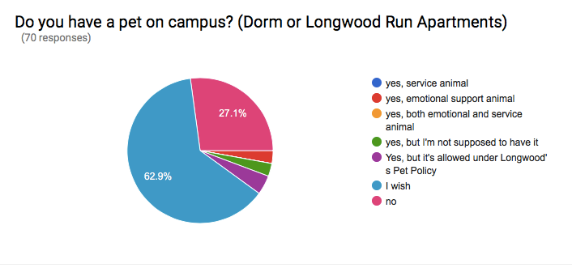
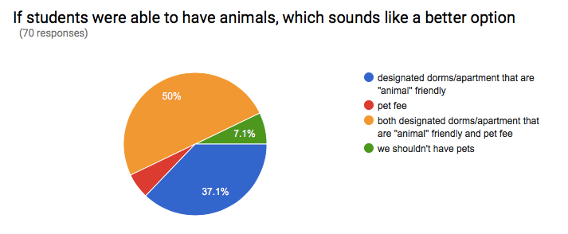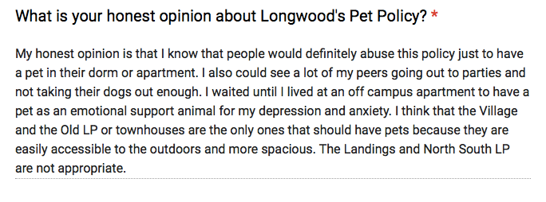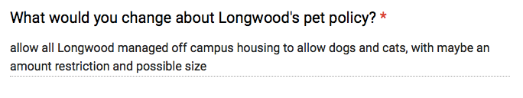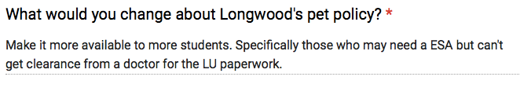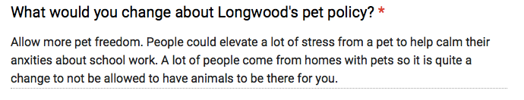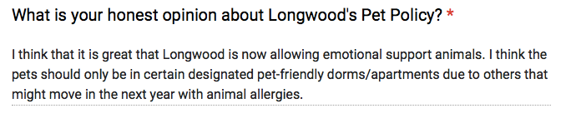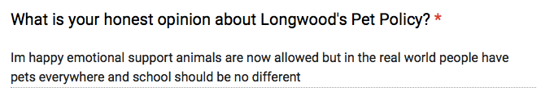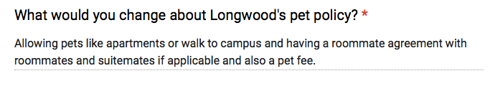

Proposal solution: The biggest argument against our proposal is the dreaded pet allergies and the safety of the other students. We propose a change to the buildings such as we can keep some buildings pet free and that way we have a place to house the students with severe pet allergies and/or phobias. Also, this would mean that it would be no cost to the school, in fact it could bring in additional revenue if the school decided to charge a little extra money to students who wanted to keep a pet. We know that we mentioned above that Tuft university was doing a pet therapy program, while we agree this is a great idea and absolutely love the fact that schools are doing more to help students with their mental health. According to bestcolleges.com The 10 Colleges with Successful Pet Therapy Programs are the following colleges; Yale Law, yes one of the top law schools has even started taking programs like this more seriously to lower the stress, depression, and anxiety levels in their students. UConn, Occidental College, Fordham University, Rochester Institute of Technology, Tufts, UC Riverside, Caldwell College, Oberlin College, and Mercy College. However what we are proposing is not a Pet Therapy Program, the reason we are not proposing a Longwood managed Pet Therapy Program is because we would run into the same problems that we run into with our counseling programs lack of resources for all the students, and we can’t get them into a program right then and there when they may feel they need it most because they have to sign up for time slots. If we changed the pet policy however, the students would have access to their oxytocin releasing friends whenever they needed it. They would could have their friend cuddling up to them while they are doing homework, or studying for a test. This could also potentially help the students sleep better which not only would help them lower their stress levels, it could help stop students who are taking things to sleep unnecessarily. Isn’t it at least worth the thought that such a small change to a policy could help the students of Longwood’s mental health so much? That it could help with the students struggling with anxiety and/or depression without causing them to go through so much trouble of the paperwork and the appointments to get a diagnosis then waiting while the paperwork goes through. It’s ultimately a timesaver for the university too, they will not have to take time to process the paperwork. So in the end changing Longwood’s pet policy to allowing the students to have pets such as dogs and cats benefits not only the students, but the staff of Longwood University and those at the counseling center.
Schedule:
If this change/ alteration to the Longwood University's pet policy:
* To experiment with the Helping Paw Program, only one Longwood Apartment complex will be pet friendly.
* The Helping Paw Program will be announced to the students at the end of the concluding semester, that only Longwood Village apartments will be eligible for pet housing. For example, If the Helping paw were to become active fall 2020, the announcement will be at the end of semester spring 2020.
* RA's will take surveys at the end of every semester, about how the students overall stress levels are currently
* The RA's throughout the semester will also take record of any incidents of the animals throughout each semester.
Based on the data the RA's collect, Longwood will choose on wither to expand the Helping Paw program.
* As the Helping Paw is found as a success Longwood Housing will announce expansion of the program to other residential apartment buildings.
Benefits:
If a change such as this is added to Longwood's pet policy, there will be great benefits ahead for their students. Longwood Residential students will gain stress relief from classes having their furry companion around. Longwood will produce excess revenue to put towards future growth of the Longwood facilities. If there is a new adoption of this pet policy, this will give students the power of choice. Many students move to off campus housing to be able to have a pet, which Longwood currently doesn't offer. If that were to become obsolete, there will be a gain of residential students.

Conclusion:
Currently Longwood has only the option of service animals in their pet policy. This makes it difficult for students to obtain the necessary paperwork for the emotional support pets. In this proposal we discuss the benefits of students being allowed to have the option to bring these animals with them to college. The benefits of allowing pets are the reduction of stress which results in lower levels of anxiety and depression. This proposed change to the Longwood Pet Policy would allow most students a choice to bring an animal with them to college. This new policy would be an easier process than the current process for an emotional support animal.
While there would be costs associated with the changing of the pet policy, the costs would be for the students as the college could charge a pet fee. This proposal includes other potential solutions or ideas for changing the pet policy. There has also been efficient data collected from Longwood University's own students, to support an adjustment/ change of the current pet policy. Put this proposal to the test!

Work Cited:
"Students Under Pressure." Pardon Our Interruption. N.p., Sept. 2014. Web. 10 Apr. 2017. http://www.apa.org/monitor/2014/09/cover-pressure.aspx
Log in to NewsBank. N.p., n.d. Web. 16 Apr. 2017.
http://infoweb.newsbank.com/resources/search/nb?p=AMNEWS&b=results&action=search&t=product%3ANewsBank%21America%2527s%2BNews%2Fcountry%3AUSA%21USA%2Fstp%3ACollege%252FUniversity%2BNewspaper%21College%252FUniversity%2BNewspaper&fld0=alltext&val0=%22pet+policy%22+and+stress&bln1=AND&fld1=YMD_date&val1=&sort=_rank_%3AD
BestCollegesOnline.com. "10 Colleges With Successful Pet Therapy Programs - Best Colleges Online." BestCollegesOnline.com. N.p., 19 Jan. 2017. Web. 16 Apr. 2017.
http://www.bestcollegesonline.com/10-colleges-with-successful-pet-therapy-programs

Castellano, Jill. "Pet Therapy Is A Nearly Cost-Free Anxiety Reducer On College Campuses." Forbes. Forbes Magazine, 06 July 2015. Web. 16 Apr. 2017.
https://www.forbes.com/sites/jillcastellano/2015/07/06/pet-therapy-is-a-nearly-cost-free-anxiety-reducer-on-college-campuses/3/#7ffbb087134f
Monitor on Psychology. American Psychological Association, n.d. Web. 16 Apr. 2017.
http://www.apa.org/monitor/2014/09/cover-pressure.aspx

