Hannah Auerbach, Jordan Berkompas, Mary Zell Galen
Math 171 Project: The Age of Coins
5/2/17
In the spring of 2017, the Norwood University Coin Collectors Club held elections for its executive board. The race for the position of vice president was heated, and the most highly contested issue during the debate between the two candidates was thus: whether the mean age of quarters in circulation was the same as or different from the mean age of pennies. Michael Sixpence was sure that there was no difference in ages, but his opponent Timothy Coin stood firm that there was.
To resolve this conflict, the collectors gathered coins from Norwood University Honors freshmen and sophomores. Twenty-four of the quarters came from a roll that was obtained from a bank in the summer of 2016, which meant that the year 2017 was not represented in that portion of the sample. Thus, both samples were fairly random, though the sample of quarters could not be considered fully representative of all quarters currently in circulation.
The collectors wanted a visual image of their sample data to show to the electorate, so they created histograms of the quarters and pennies. See figures 1 and 2 for histograms of the sample data. The coin collectors found no outliers in the data set.
The distribution of quarter ages was slightly skewed to the right, where the majority of coins were produced within the past five years. This could be because older coins have been taken out of circulation, meanwhile newer coins have been most recently distributed to banks to enter into circulation. The students from whom the sample coins were collected likely obtained their coins as change after spending money at establishments throughout Virginia and New Jersey.
With 14 buckets in a histogram, the pennies have a slight skew right, likely for similar reasons to the quarters’ distribution. As new coins are made, they are distributed more and more to banks and passed out to consumers while older pennies are damaged and taken out of circulation.
The collectors compiled all sample data. For sample quarters, the mean was 19.8, the standard deviation was 14.351, and the five-number summary was 1, 9, 18, 30, 52. For sample pennies, the mean was 20.68, the standard deviation was 14.986, and the five-number summary was 0, 7, 19, 32, 53.
In support of the skews shown on the histograms, there was a slight discrepancy between the measures of center for both samples. The mean age of the sample of quarters was 1.8 years higher than the median, and the mean for pennies was 1.68 years higher than the median. This demonstrates that a few particularly old coins inflated the mean in each sample.
By taking their sample data and running it through a confidence interval test, the collectors determined on a 95% confidence interval that the true mean age of all quarters in circulation would be between 15.72 years and 23.88 years old. Likewise with the same amount of confidence, they concluded that the true mean age of pennies in circulation would be between 16.42 years and 24.94 years old.

When looking at the confidence intervals of their samples, the collectors found that the margin of error for the mean circulation age of quarters was ± 4.079, while the mean circulation age of pennies was ± 4.259.
The collectors then wanted to know how large of a sample size they would need in order to estimate the mean with a 1 year margin of error and 99% confidence, just for fun. To estimate the average age of quarters in circulation to within one year with 99% confidence, the collectors would need a sample size of 339 or more coins. To achieve the same estimation for pennies, the collectors would need a sample size of at least 369.
These avid collectors also determined that a coin would be more rare (“rarer,” in some circles) the older it was. Though their sample was void of many 2017 coins, they felt these coins would be much more easily collected than older coins. As their sample was large enough and contained no outliers, they felt that their sample would be an accurate representation of the population at large. With that in mind, they used the inverse norm function to estimate the age of rare (2% of population or less) coins in their sample, and found that coins aged 49 or older made up 2% or less of their population. With pennies, they have to be about 52 years or older in order to be considered rare.
Finally, the collectors set out to settle their big debate. Because they wanted to compare the means of two populations based on two samples but did not know the population standard deviations, they decided to use a two-sample t-test for the difference between population means. The intrepid crew carried out this hypothesis test using the PHANTOMS method (see figure 3 for full test) with the null hypothesis that the mean ages were equal and a two-sided and different alternative hypothesis. They found that, assuming there was no difference in the true mean ages of quarters and pennies, there was a 76.49% chance of obtaining a larger difference in ages than they found in their samples. With this in mind, they concluded that there was no significant difference between the means of each coin’s age in circulation. With the debate settled, the club members moved onto elections, where Timothy Coin reigned triumphant.

Appendix
Figure 1: Distribution of Sample Quarters
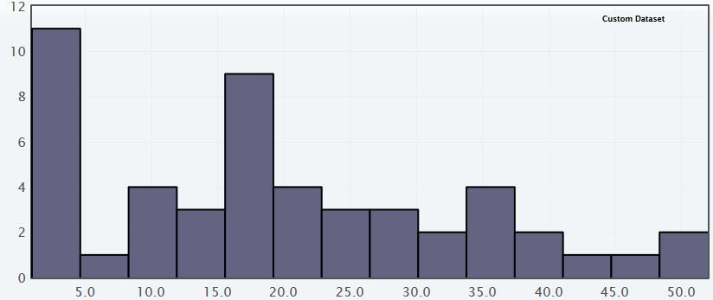
Figure 2: Distribution of Sample Pennies
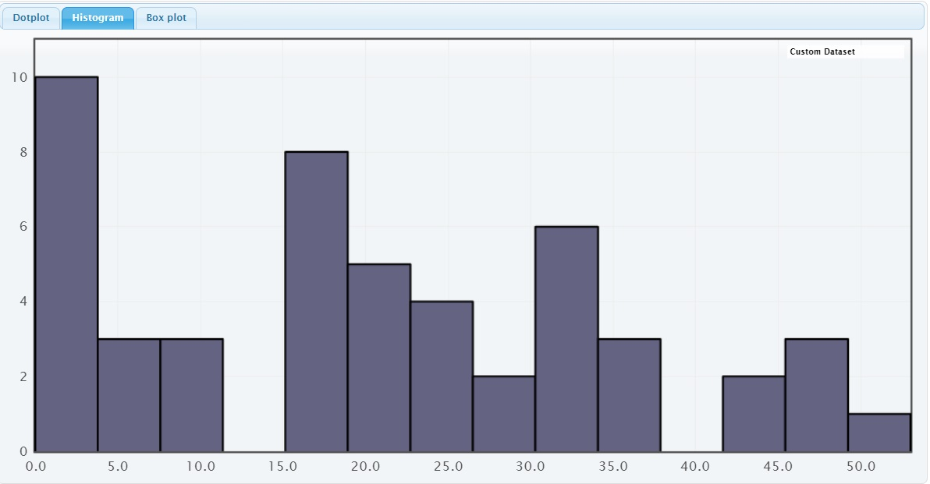
Figure 3: PHANTOMS analysis
P- Population 1: All quarters in circulation in 2017
· μ1: Average number of years quarters have been in circulation
Sample 1:
· n1 = 50
· x̅1 = 19.8 years
· s1 = 14.351 years
Population 2: All pennies in circulation in 2017
· μ2: Average number of years pennies have been in circulation
Sample 2:
· n2 = 50
· x̅2 = 20.68 years
· s2 = 14.986 years
H- Ho: μ1 = μ2
Ha: μ1 ≠ μ2
A- i) Samples are random and independent of each other and defined by the same
categorical variable
ii) Mean and standard deviation is unknown for both populations
iii) Distribution of each coin is slightly skewed right, though the mean and median are very
close to each other.
iv) Sample sizes from each population are > 20, and the combined sample size is
therefore > 40.
N- Two-Sample T-Test for Difference Between Population Means
T- t ≈ -0.2999
O- P-value: p ≈ 0.7649
M- We will fail to reject the null hypothesis (P-value is not statistically significant at an α = 0.5 level.)
S- There is not statistically significant evidence that the true mean ages of quarters and pennies currently in circulation are different from one another.

