|  |  |  |
| --- | --- | --- |
| **Teacher**: Ms. Winters  **Topic**: RAFT/prewriting for PSAs  **Lesson:** 4  **Grade**: **11** | | |
| **Essential Question**: Are there things happening in America today that are unfair or hurtful? What is my responsibility with these issues? | | |
| **NCTE/ILA Standard for ELA**: | | |
| **SOL & Essential Skills from Curriculum Framework**:  11.8.b) Narrow a topic and develop a plan for research.  CF: define a position and select evidence to support that position through reading, writing, and discussion. | | |
|  |  | |
| **Anticipatory Set-Slide 1 of PowerPoint**  **-What 2 topics has your group narrowed down for your PSAs?**  **-What is a PSA?**  **-What is one reading strategy and one vocabulary strategy you can use in your research for PSAs?** | | |
| ***Students will be able to. . .*** | | ***The teacher will. . .*** |
| 1. Define PSA 2. Describe 1 reading strategy & 1 vocabulary strategy | | 1. Show slide one and take up answer papers |
| **Mini-Lesson Activities**  *Introduce RAFTs and explain what it is and how students can use them for writing their PSA. Explain that students can use it as a reading strategy and to write anything. Show RAFT template, then fill in to model for students using any random PSA topic (a few listed below). Fill out another template to practice filling out the template as a class. Students will use class time to work in their PSA groups to fill out RAFTs. If groups finish early, they can begin writing and research for PSAs.* | | |
| ***Students will be able to. . .*** | | ***The teacher will. . .*** |
| 1. Identify the parts of a Raft 2. Apply RAFT to prewriting for PSAs and as reading/writing strategy and demonstrate ability to work as group to begin PSA projects  * choosing topic (must be social justice issue) * role of students * audience for PSA   -format (known: PSA) | | 1. Explain that students can use a RAFT for PSAs 2. Show slide 2:  * **Role:** Who are you as the writer? A concerned citizen? A student? An actor/actress? * **Audience:** Who are you writing to? * **Format**: In what way do you plan to write? A diary? A newspaper article? A letter? A PSA? * **Topic:** What are you writing about? A cause? A natural disaster? An important issue?  1. Demonstrate how to fill out practice RAFT with students on a random PSA topic (students can suggest topic or default to Bullying or texting and driving) 2. Practice with students filling out a RAFT 3. Handout RAFT Writing Template 4. Students go to PSA groups to fill out RAFTS for PSAs 5. Allow students to begin writing/research for PSAs with time left after filling out RAFTs. |
| **Closure** | | |
| ***Students will be able to. . .*** | | ***The teacher will. . .*** |
| 1. Define parts of RAFT 2. Define Tone | | 1. Review parts of RAFT 2. Review Checklist for Unit/Projects 3. Slide 3- EXIT Question: What are the parts of a RAFT? What is tone? |

***Instructional Materials***:

Ideas from Erika Miller’s Mini lesson

-Raft definition

RAFT Template (below)

PSA Checklist (below)

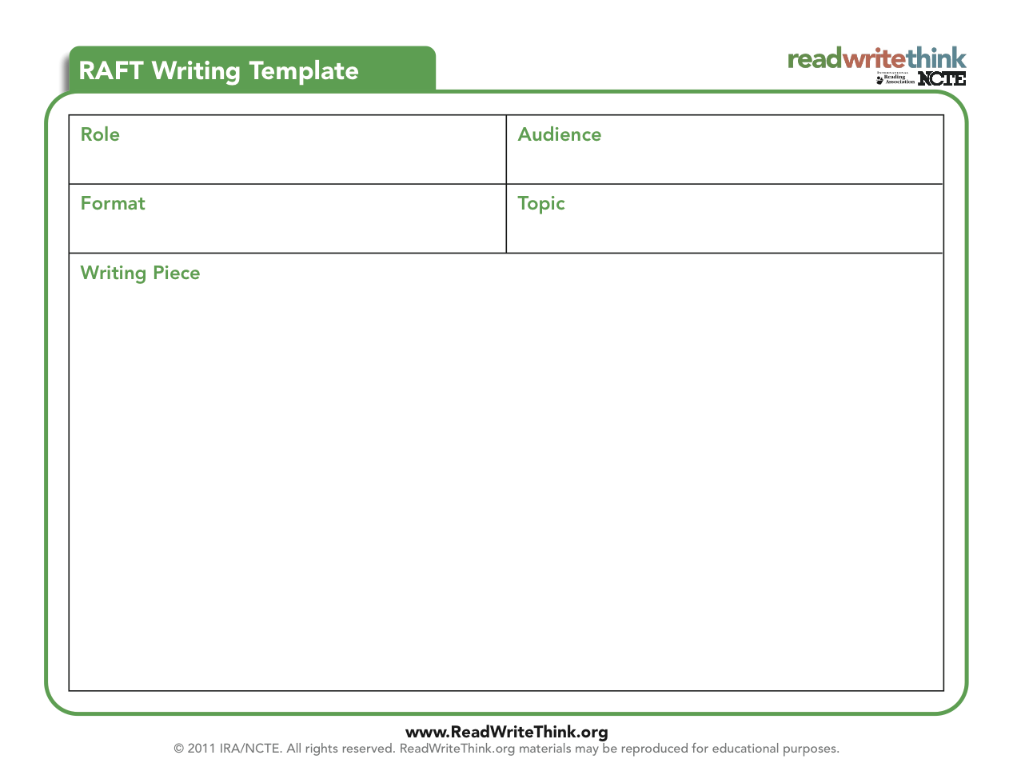

**Sources:**

RAFT Template http://www.readwritethink.org/files/resources/printouts/RAFTWriting.pdf