Social Media and Justice Short Paper
David Carr (2012) noted, “Hashtags come and go… but they are not only better than nothing, they probably make the world, the one beyond the keyboard, a better place.” The #LikeAGirl activism movement hashtag was seen over multiple social media platforms during 2014 and advocated for women rights. Always, the feminine hygiene product, launched a new leg of an epic battle to give the reassurance to women and help increase girl’s confidence around the world. Also, this hashtag tackles the societal limitations that stands in girls’ way. When the phrase “like a girl,” is added at the end of a phrase, it is a hard knock against any adolescent girl. It has a huge tool on a girls’ confidence, due to the fact that, in society, the phrase is used as an insult. For example, “you throw like a girl,” is said to display that an individual throw is very weak and not very good. The brand, Always, wanted to show that doing things, “like a girl,” is amazing. They launched a commercial to broadcast this movement and it was seen during the Super Bowl.
Many questions arose from this hashtag that society needed to ask itself. Do we limit girls and tell them what they should or shouldn’t be? Do we box them into expected roles? Always asked a group of girls, and shockingly 72% of the girls do feel society limits them. According to Sam Killerman (2017), social justice is “removing barriers so that all individuals, regardless of their identities or social group memberships, will have equitable access to social resources” (p. 12-13). Always pointed out on a huge gender social injustice by being a female in today’s society. In the commercial, a group of males and females were given an action to do with the first thing that popped into their head. For example, the question, ‘run like a girl,’ was said and the older males and females immediately began to frail their arms and run slow and unathletically. This stereotype is well known along society as women are seen less athletic and weaker than men. Killerman (2017), states that a societal norm are “informal rules that a society reinforces and that members of that society live by” (p. 55-56). To add on, social norms plus gender creates gender norms. Gender norms tell us what types of things we should wear, buy, be interested in, and want to be when we grow up. This is why this phrase, ‘like a girl,’ is so prevalent in today’s society, due to the pressure of gender norms. In fact, Always states, “7 out of 10 girls feel they don’t belong in sports. With the pressure to conform to societal expectations, many girls will not go forth in participating in sports or they will quit while in a sport. This hashtag wants to keep all girls to play #LikeAGirl and is getting society to join together to rewrite these informal rules individuals follow by. Girls should feel comfortable in doing whatever they want to do even if the rules say that it’s what men are supposed to do. Furthermore, females should be encouraged to follow their path and feel confident along the way. There should not be rules that restrict individuals based off of what gender they are in, and this commercial and hashtags advocates for that.
What does it mean to do things #LikeAGirl? To the young girls in this commercial, it means to fight and to be determined but to the males and older females, it means the exact opposite. Men have had privilege in the ‘athletic’ aspect by which they don’t get accused of not being able to perform in a certain way or judged for doing it. Men have an unearned advantage in society as a result of their gender. Women have not been given their chance to prove themselves because they are held back by these gender norms and stereotypes. With this privileged, the oppression circle starts. In the cycle of oppression, stereotypes serve as the basis for the formation of prejudice. Killerman (2017) states, “prejudice is a conscious or subconscious negative or otherwise limiting belief about a group” (p. 19). In this case, #LikeAGirl displays the perceived prejudice against females. The prejudice might not be fully recognized by others, but it has a great effect on females. Always was interested in looking into how girls deal with the confidence crisis that happens around puberty. As previously stated, everyone knows ‘crying like a girl’ or ‘running like a girl’ is not a compliment, but no one notices the seriousness and damage due to the conformity of individuals to these societal norms. “Like a girl,” should be advocated to not be an insult because it means to be strong, talented and amazing. Always encouraged and invited girls around the globe to share what they do #LikeAGirl.
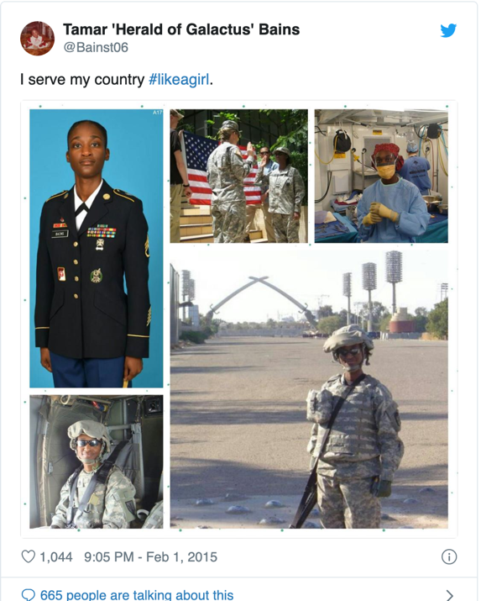
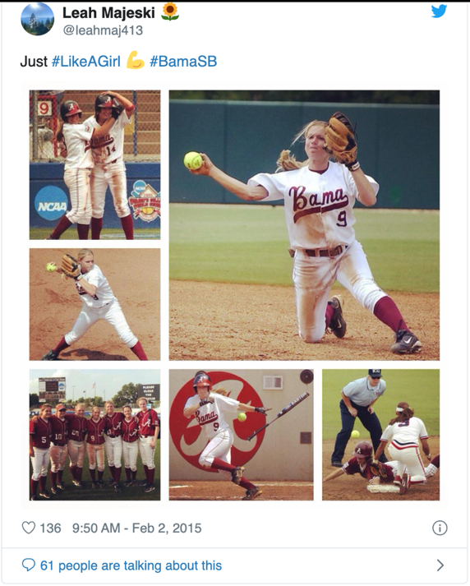

This hashtag movement was meant to give girls an increase in confidence, and it was not made to target males and bring them down. This is a common misconception associated with forms of feminism. Killerman (2017) explains that there are many different forms of feminism, and it means different things to many different people. “Feminism has been working to lessen the severity of male privilege since a long time ago” (188). The #LikeAGirl movement is not working to knock down boys, it is about better equality between genders, and in no way of promoting females being superior. Due to the many societal norms and stereotypes, females feel an increase of fear and discomfort doing activities outside the ‘norm,’ and this hashtag is to show that females aren’t alone and to try and advocate for these societal pressures to be minimalized.
This hashtag arose in 2014, yet it still shows up in posts and topics of interest today. Different forms of feminist movements have been and are happening throughout the years. For example, in 2017, country artist Keith Urban created a song called Female, and this is a different example of advocating for women social justice just as #LikeAGirl advocates for. In this song, Keith Urban sings, “When you hear somebody say somebody hits like a girl, how does that hit you? Is that such a bad thing?” This statement runs alongside the #LikeAGirl hashtag movement and was made 3 years later. He then sings, “Sister, shoulder, daughter, lover, healer, broken halo, mother nature, fire, suit of armor, soul survivor, holy water, secret keeper, fortune teller, Virgin Mary, scarlet letter, technicolor river wild, baby girl, women shine, Female.” This advocates to show the importance of women, and that they are capable of many different things and should not be held back of what they can achieve solely based off of their gender. Both men and women are highly capable of many successes and can both do whatever they are comfortable with and have the will to do, without rules to follow by society. This hashtag promotes social justice for genders within society, and it hopes to open up individuals’ eyes and give females the opportunity to follow their own path without rules to follow or judgement behind them.

References
Carr, D. (2012, March 25). Hashtag activism, and its limit. The New York Times. https://www.nytimes.com/2012/03/26/business/media/hashtag-activism-and-its-limits.html

Kahn, M. (2014, July 1). Retrieved from https://abcnews.go.com/Lifestyle/redefines-means-run-girl/story?id=24377039

Keith Urban. (2017). Female
Killermann, S. (2017). A guide to gender: The social justice advocate's handbook. Austin, TX: Impetus Books.
Our Epic Battle #LikeAGirl. (2014). Retrieved from https://always.com/en-us/about-us/our-epic-battle-like-a-girl

Vagianos, A. (2016, May 3). The Reaction To #LikeAGirl Is Exactly Why It's So Important. Retrieved from https://www.huffpost.com/entry/why-like-a-girl-is-so-important_n_6598970

