Kendra Fetty
CHEM 101-05
Dr. Stegall
23 October 2017
Using the Scientific Method
- Can the amount the balloon fills up be controlled by the amount of vinegar?
- If the amount of vinegar added into bottle is increased, then the amount the balloon fills up will be increased as well.
- To test this hypothesis, I first gathered my materials of an empty water bottle, vinegar, baking soda, a funnel, a two-foot length string, a stopwatch, a ruler, and five balloons. I decided to use five increments of vinegar to see if increasing the amount of vinegar led to an increase in balloon size, so I went with 50mL, 75mL, 100mL, 125mL, and 150mL. First, I would pour the amount of vinegar into a graduated cylinder to measure out the liquid before pouring it into the bottle. Next, I measured out 30g of baking soda and placed the funnel into the balloon. After the funnel was carefully inserted into the balloon, I poured the baking soda into it. Then, I wrapped the bottom of the balloon around the top of the bottle and got my partner to hold it in place. After checking to make sure it was secure, my partner turned the balloon over so the baking soda would fall into the vinegar while I used the stopwatch to measure how long the balloon took to fully inflate and measure the circumference with the piece of string. Once the balloon started to deflate, I quickly recorded the results onto a separate piece of paper. This procedure was then repeated four more times to gather more data to either prove or disprove my hypothesis.
The independent variable was the amount of vinegar while the dependent variable was the amount the balloon filled up. The controls of the experiment were the water bottle and the amount of baking soda added to the balloon and the degree of replication was one.
- Graph:
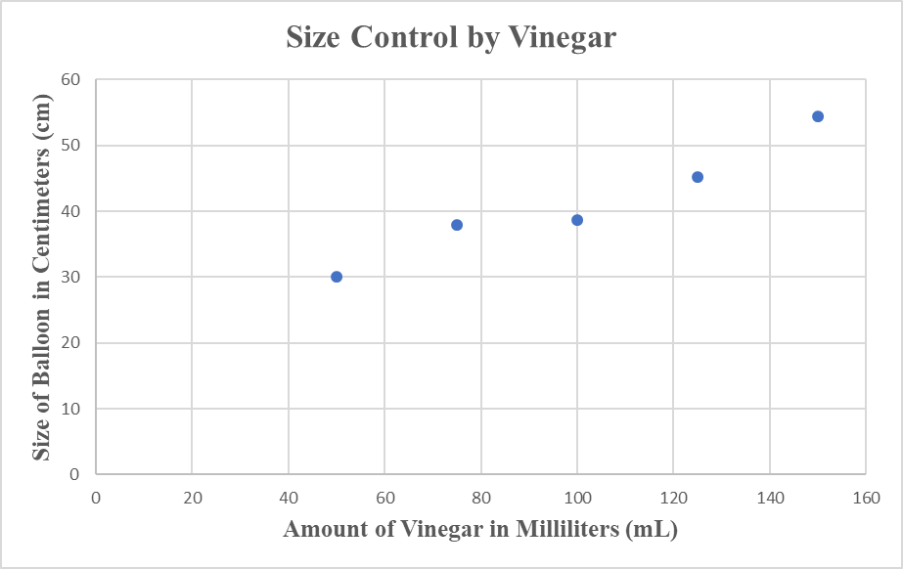
The data clearly depicts a positive relationship between the two variables of the amount of vinegar and the size of the balloon as each time the amount of vinegar increases so does the size of the balloon. This confirms my hypothesis as I said that as the amount of vinegar increased so would the size of the balloon.
- To modify the experiment to better test the hypothesis I would test more measurements of vinegar as five is a relatively small number of trials, so I would try eight to ten different measurements in order to see if there is a certain measurement that goes against the trend of an increase in vinegar leads to an increase in the size of the balloon.
Word Count: 448

