24 Hours in Farmville, Virginia
By: Kendra Fetty
October 6-7, 2017
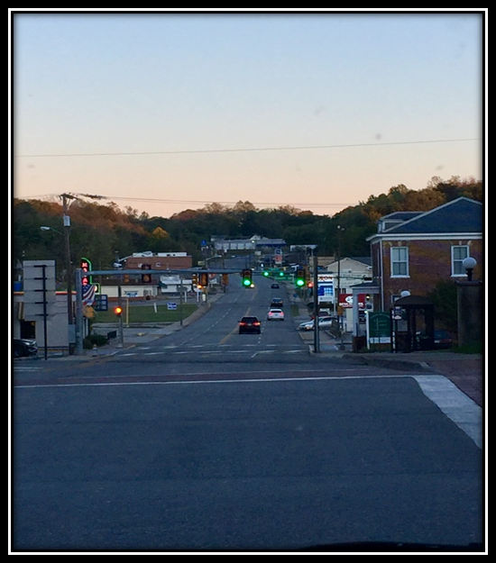
Farmville, Virginia is considered to be a small and sleepy town, but this is a common misconception. The town is usually bustling with activity with two colleges located within the borders, Longwood University and Hampton Sydney, and plenty of local businesses that are always promoting the community and its residents. One weekend where Farmville really comes to life is Oktoberfest weekend as there are plenty of activities going on between the colleges and community itself.
Friday, October 6th
4:00pm-5:15pm: Color Wars on Iler Field
Oktoberfest really starts on Longwood’s campus when Color Wars begins as all the classes join together on Iler Field for an epic clash between the classes, “where red and green make blue.” The odd numbered graduating classes are green while the even numbered graduating classes are red, which is how the paint is chosen. It is an exciting event to participate in, or watch, as all students clash to see who can get the most paint of their graduating class on the other. Do not forget to where white so you will have your very own souvenir from the classic Longwood tradition!
6:00pm-7:00pm: Enjoy Dinner Around Farmville
After showering to get rid of excess paint from Color Wars, head on downtown for a bite to eat. There are a variety of options from Cook-Out, El Patron, Subway, and many more, but I personally recommend Macado’s as the one in Farmville is very quaint and gives off a stylish vibe. The inside of the restaurant is on the small side, but it feels very antique and is a short walk from Longwood’s main campus. Also, there are so many sandwich combinations it is enough to make your head spin from all the delicious options! Personally, I recommend an appetizer of chicken tenders and a Peanut Butter Cup milkshake for dessert. Once you finish feel free to browse through nearby shops or turn in early to prepare for a fun and exciting day tomorrow.
Saturday, October 7th
11:45am-12:15pm: Head Over to Stubbs Mall
After resting from the previous day’s activities, get ready and head over to Stubbs Mall to prepare for some entertainment to begin the Oktoberfest festivities for Saturday. Right at noon are the Spirit Leaders and Klownz Performance, both of which are traditions held by Longwood to begin the celebration of Oktoberfest as they are silly performances that unite the campus through laughter and Lancer pride. These two performances are definitely not ones to be missed as they are sure to make you laugh from the ridiculous outfits and funny dancing.
12:15pm-1:15pm: Browse Through the Oktoberfest Booths
Next, take a break from the entertainment to walk around Stubbs Mall to the booths set up by various clubs from Longwood University. Each booth is unique to that club as clubs are allowed to sell whatever they want, within the school’s rules and regulations, which makes visiting each booth exciting and enticing. Take time to browse through merchandise or find a quick snack to munch on to tide you over until lunch.
1:30pm-2:00pm: Picnic Lunch Outside Lankford
For lunch you can enjoy Dorill Dining Hall’s outdoor picnic located just outside of the Lankford Student Union. The food options will satisfy even the pickiest of eaters as there are healthy options, like fruits and vegetables, and some sweets, like cookies, soft pretzels, and brownies. It is free for Longwood students and costs $8 dollars for anyone else outside of Longwood’s students. While you eat you can still hear performances that are happening on Stubbs Mall as the food is located only a short distance away and you can enjoy seeing the festivities happening at the different booths.
2:15pm-3:30pm: Live Music Performances
Head back over to Stubbs Mall after a filling lunch to hear some amazing music from bands that traveled to Longwood just for the Oktoberfest festivities. Starting off the numerous live performances at 2:15 is a group called Night Years. In between sets feel free to sit on the lawn and talk with friends about your experiences so far or go grab a quick snack from one of the booths located just a few feet from the stage.
4:00pm-5:15pm: Dinner Around Farmville
After enjoying some music from She’s a Legend, embark around Farmville once again for something to eat. I recommend going to Cook-Out in order to enjoy some cheap, but delicious, food after a long day of walking around in the hot sun. Do not forget to grab one of Cook-Out’s signature shakes that you can customize to your liking with anything from fruits to candy, not to mention you can always ask for a double helping of that certain candy for no extra cost, which is something kids would enjoy after a fun day in the sun.
5:30pm-6:00pm: Afternoon Entertainment
Before turning in for the night, head back over to Stubbs Mall to enjoy one last show of entertainment. At 5:30 you can catch the infamous DJ JD jamming out with Longwood students after a fun day at Oktoberfest. This is the perfect way to end Oktoberfest weekend at Farmville as it shows that the town is not so sleepy as it first may appear to outsiders when entering the close-knit community.
Word Count: 880

