Introduction
Microbes are one of the most fundamentally occurring microorganisms in nature. Dissolved nutrients and organic materials allow for the growth and development of Microbes within water sources (Stelzer). This research study is based upon two bodies of water found around the EEC (Environmental Education Center) in Lancer Park at Longwood University. The first area examined is the pond located directly behind Lancer Park apartments; which is a very still body of water. The second area examined is Buffalo Creek, located behind the EEC; which is a running body of water. Both water sources are riparian areas. Riparian areas are hotspots of interactions between plants, soil, water, microbes, and people (Groffman). The waterways within riparian areas are highly important to the ecosystem due to the fact everything within a riparian area requires safe water to grow and develop.
These two water sources are very different in microbial concentration since one is running and one is still. Ponds are still bodies of water that sit and may collect waste materials over time, thus contaminating the water. “Extraction of surroundings resulted in millions of cubic meters of waste stored on-site in ponds. Unique microbial ecology is expected in these ponds, which may be key to their bioremediation potential” (Golby). This is the exact opposite in moving water which filters out any waste products as it goes along its way. A study done on rivers showed that not only does it filter out certain wastes, but microbes are essential parts to the ecosystem within these bodies of water. “In both systems, microbes and fauna consume plant litter and release products, such as nitrogenous wastes, that can then be used by other organisms” (Wagener).

While these two bodies of water are quite different in many ways, one similarity is the collection of runoff agricultural water from the farm located near. A wide range of plant pathogens have been identified in irrigation water sources. Algae and equipment-clogging biofilms also result from high microbial levels in irrigation water (Radulae’s).
The question asked before research began was: Would we find a higher concentration of microbes within a running stream of water or a still pond? Through further research on the topic, we believe that there will be a higher concentration of microbes within the still water than compared to the running water. We believe this because the running water is constantly filtering the water supply while the still water remains immobile.
Materials and Methods
Sampling
Sampling occurred in two areas; Buffalo Creek and a pond behind Lancer Park. Sampling was done by hand with two conical tubes. The conical tubes were labeled as “Pond” and “Creek”. These two tubes were kept closed, placed six inches below the surface of the water, and then opened to collect a sample in each of their respective locations.
Bacterial Plating and Dilution
Bacterial Plating required 3 LB agar plates per location; one undiluted, one 1:10 diluted, and one 1:100 diluted. To dilute the sample, sterile water had to be used. Ninety microliters of sterile water were then placed into two microtubes, thus allowing for two sites of dilution. Ten microliters from the original sample was placed into the tube labeled “1:10 dilution” and ten microliters from the 1:10 dilution were placed into the tube labeled “1:100 dilution”. This process was done for both the Pond and Creek samples. 100 microliters of each sample (undiluted and diluted) were then moved from the tubes to the plates using a micropipette. These samples were streaked around the agar plates using a spreading tool. Following the plating and dilution, the three samples were placed in a room temperature (37C) area for 48 hours to allow for growth and observation.
DNA Extraction
To extract proper DNA, only one site of bacteria could be collected and used. One colony was selected from two of the six sample plates (Creek and Pond). The selected bacteria were moved from the agar plate to a microfuge tube using a toothpick. 300 microliters of microbead solution were added to each of the tubes and then vortexed shortly to allow for proper mixing. 50 microliters of MD1 solution was added to the original 300 microliters. This new solution was placed in a 65C heat bath for ten minutes and then vortexed for ten minutes to allow for proper mixing. The solution was placed into the centrifuge to allow for all the beads to separate from the supernatant. This supernatant was then moved to a fresh microfuge tube and added into 100 microliters of MD2. This new solution was incubated for five minutes at 4C. The supernatant was again moved to a new tube, and added into 900 microliters of MD3. This solution was then centrifuged for thirty seconds, and then supernatant was moved to a new sterile microfuge tube. The supernatant was added into 300 microliters of MD4 and centrifuged again to allow for proper mixture and separation. Fifty microliters of MD5 was added to the mixture, allowing for the release of the bound DNA. This DNA was cooled and kept in a -20C area, waiting for PCR.
PCR
PCR required two set up PCR tubes with 0.5 microliters of Forward Primer, 0.5 microliters of Reverse Primer, 12.5 microliters of Master Mix, and 8.5 microliters of Nuclease-Free water. These two reaction tubes were mixed by consistently pipetting up and down. Three microliters of the previously separated genomic DNA were added to each PCR tube. PCR tubes were then transferred to a PCR machine where they began thermocycling.
Results
Throughout all our testing, we found that the creek generally tended to have a higher concentration of bacteria than the retention pond. There were quite a few different aspects that played a role in the different characteristics between the microbes found in the pond and the creek. The first aspect was the quantity of bacteria growth on the plate following collection. The growth on the plate was extensively higher in the creek sample, 40 colonies, than on the pond sample, 27 colonies. Another characteristic that represented a difference in bacteria was size. Figure 1 shows the different sizes of bacteria found between each collection site. The Creek had a larger number of small colonies and medium colonies. Both samples produced an even number of large colonies, at 4 apiece. A third aspect measured between the two sites was the color of the bacteria. Figure 2 represents the colors produced between the two sites were white and yellow. The pond solely produced orange colonies, and neither site produced purple colonies.

Figure 1 – Size of Bacteria. This figure represents the size of each colony of bacteria on our agar plates.

Figure 2 – Percentage of Bacteria by Color. This figure represents the percentage of colors found on the agar plates.
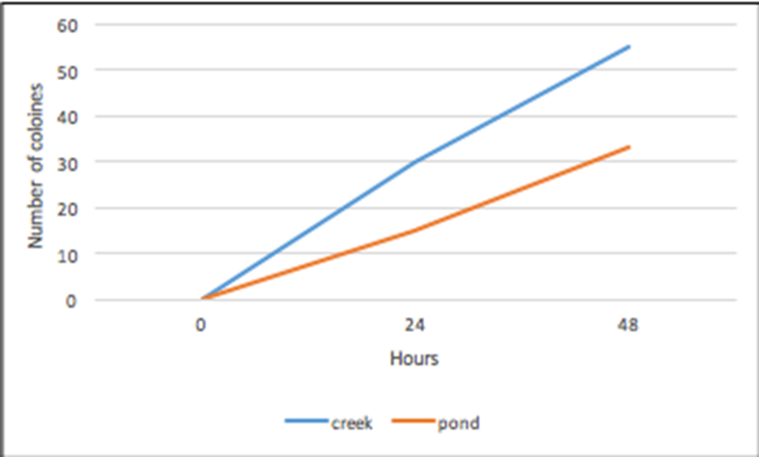
Figure 3 – Incubated Bacteria Growth Over Time. The figure shows the bacteria growth over a period of 48 hours while being incubated.
Discussion
The hypothesis for this experiment was that there would be a higher concentration of microbes within the pond than within the creek. We believed this to be true since the pond is a stagnant body of water, while the creek is constantly in motion. The data collected throughout the experiment did not support our hypothesis. The creek had a higher concentration of microbes than the pond. These conclusions could have resulted from when we disturbed the water around us while taking samples or the fact that there is runoff from a nearby farm into the creek. If we were to repeat this experiment, one thing I would change is the conduction of the DNA testing from the collected samples. Due to human error, the creek samples were unable to be properly interpreted by their DNA sequence.
Our research lead to us finding that the bacteria we tested was most similarly related to Aquaspirillum arcticum. This research has the purpose of attempting to see just how large the concentration of bacteria is within the water around us on a daily basis. Buffalo Creek eventually feeds into the Appomattox River, which is a main source of water for most of Virginia. This research, if done on a larger scale, could eventually lead to show if the water we intake into our bodies, in particular well water, is contaminated with the same bacteria we found in the retention pond and buffalo creek.
References
Golby, S., Ceri, H., Gieg, L. M., Chatterjee, I., Marques, L. L. R., & Turner, R. J. (2012). Evaluation of Microbial Biofilm Communities from an Alberta Oil Sands Tailings Pond. FEMS Microbiology Ecology, 79(1), 240-250.
Groffman, P. M., Bain, D. J., Band, L. E., Belt, K. T., Brush, G. S., Grove, J. M, Zipperer, W. C. (2003). Down by the Riverside: Urban Riparian Ecology. Frontiers in Ecology and the Environment, 1(6), 315-321.
Raudales, R. E., Parke, J. L., Guy, C. L., & Fisher, P. R. (2014). Control of Waterborne Microbes in Irrigation: A Review. Agricultural Water Management., 9-28.
Stelzer, R. S., Heffernan, J., & Likens, G. E. (2003). The influence of dissolved nutrients and particulate organic matter quality on microbial respiration and biomass in a forest stream. Freshwater Biology, 48(11), 1925-1937.
Wagener, S. M., Oswood, M. W., & Schimel, J. P. (1998). Rivers and soils: Parallels in Carbon and Nutrient Processing. Bioscience, 48(2), 104-108.

