Samuel Kane
Bio 324 – Genetics
Dr. Barber
November 19, 2017
Mixing Gene Expression with Resveratrol
Introduction
Cancer is a very scary and relevant topic for many, if not all people today. Cancer is one of the leading causes of death in the entire world. Many people used to think that cancer was only an environmental disease, but further studies and research have shown that some cancers may / can be genetic. One prominent aspect of destroying cancer cells is apoptosis. Apoptosis is defined as the death of cells that occurs as a natural and controlled part of an organism’s growth or development. While apoptosis is a natural occurrence for organisms, it can be sped up or slowed down by many different factors. One of these factors (or in this case a substance) is resveratrol. Resveratrol is a substance found in plants and red wine that have antioxidant properties allowing for potential anti-carcinogenic effects.
Resveratrol and apoptosis have a very interesting relationship. Due to that relationship; we could develop our scientific question: “How does the gene expression of cancer cells change after treatment with a natural inhibitor, resveratrol?” Resveratrol has been shown to inhibit the transformation and proliferation of cancer cells. We had to choose three separate proteins to conduct this experiment on, and we chose Bax, Bcl2, and p53. Our main focus was on apoptosis within the cells, considering these genes are closely related. “Resveratrol reduced cell viability, altered the expression of the apoptotic markers Bax and Bcl2” (Kumar).

Methods
RNA Isolation
RNA was isolated from b16 melanoma cells. There were two different sets of b16 melanoma cells; one that was media treated and the other that was resveratrol treated. 175μL of RNA Lysis Buffer was added to both samples and inverted. 350μL of RDA was then added to the solution inverted 4 times, centrifuged for 10 minutes, and the clear lysate were taken. 200μL 95% ethanol was added to the lysate, mixed, and samples were transferred to a spin basket to be centrifuged for one minute. 600uL of RNA wash solution was added centrifuged and eluate discarded. 50μL DNase mix was applied to the membrane and incubated at room temperature for 15 minutes then 200μL of DNase stop solution was added and centrifuged for one minute. 600μL of RWA was added, centrifuged for 1 minute. The samples were then washed again with 250μL of RWA, centrifuged for 2 minutes, and the spin basket was then transferred to an elution tube where they were washed once more with 100μL of nuclease-free water, centrifuged for 1 minute, and the eluted RNA was stored at -70⁰C until further needed.
cDNA Synthesis through RT-PCR
The isolated RNA was then synthesized into cDNA containing the genetic sequences of p53, BCL2, and BAX through RT-PCR. Both the resveratrol and media samples were combined with the RT primers of the genes. 10μL of Reaction Mix was then added to the solution. The RNA solution was then sent through a heat cycle (25⁰C for 5 minutes, 42⁰C for 1 hour, 70⁰C for 15 minutes) to synthesize the cDNA which was immediately stored on at -20⁰C until further needed.
20μL of both the resveratrol and the media sample were diluted with 100μL of water and then the cDNA samples were loaded into a 3x8 well plate. 2μL of the media-sample was loaded in the top four well and the resveratrol-sample were loaded into the bottom. 23μL of SYBR master mix with the β-actin primer (control) was added to the first rows of both sections and then the mixes containing our gene primers were added into their separate rows. The reaction plate was placed into the PCR-instrument and gene expression was measured for the 2-fold difference.
Results
Data Analysis
Data was analyzed through the use of a delta-delta ct test, and a ttest to show any significance in notable gene expression. The genes treated with the basic media showed no significant change in expression. However, the genes treated with resveratrol showed a very significant change in gene expression. Both the Bax and p53 gene showed positive change or increase in expression, while Bcl2 showed a negative change or decrease in expression (figure 1a,b,c).
Discussion
Throughout testing, the Bcl2 protein was found to be quite different from Bax and p53. Shown in Figure 1, a b and c, all three of the analysis graphs are quite different from one another. The main difference shown is that Bcl2 resulted in a negative change comparison between media and resveratrol. The best explanation for this is that Bcl2 inhibits apoptosis, thus resulting in resveratrol reducing its gene expression, as shown in Figure 1b. Therefore, within cells where Bcl2 is found in high levels, Bax and p53 are low, and vice versa, thus showing that these genes are inversely proportionate to one another.
Our scientific question was “How does the gene expression of cancer cells change after treatment with a natural inhibitor, resveratrol?”. Resveratrol proved that it could, under the correct conditions within cells, speed up the process of apoptosis and be a significant help in defending an organism against potential harmful cellular growth, such as cancer. There is still much to learn, and many tests to be done, before there will ever be a definite way to ultimately defeat cancerous cells from forming, but this is definitely a step in right direction.

a.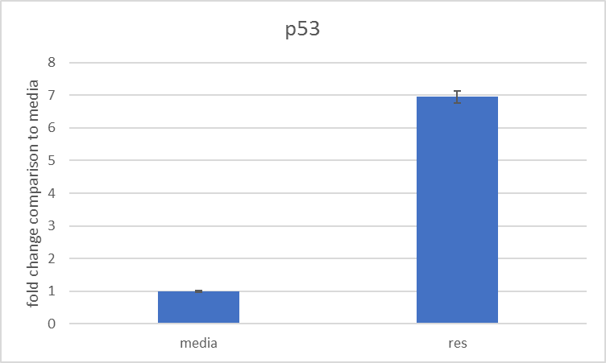 b.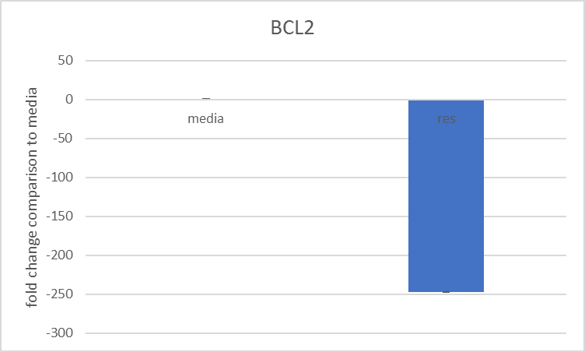 c.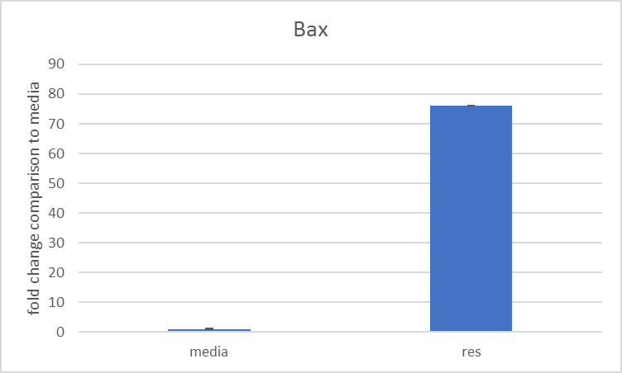
Figure 1. RTPCR data analysis; fold change comparison between media treated and resveratrol treated genes; p53, bcl2, and bax. The graphs show nearly no significance amongst the media treated data, but very significant amongst the resveratrol treated data.

References
Csuka, O., RemenÁr, É., Koronczay, K., Doleschall, Z., & NÉmeth, G. (1997). Predictive value of p53, Bcl2 and Bax in the radiotherapy of head and neck cancer. Pathology Oncology Research: POR, 3(3), 204-210.
Goraczniak, R., Wall, B. A., Behlke, M. A., Lennox, K. A., Ho, E. S., Zaphiros, N. H., . . . Gunderson, S. I. (2013). U1 adaptor oligonucleotides targeting BCL2 and GRM1 suppress growth of human melanoma xenografts in vivo. Molecular Therapy.Nucleic Acids, 2, 13.
Johnson, G. E., Ivanov, V. N., & Hei, T. K. (2008). Radiosensitization of melanoma cells through combined inhibition of protein regulators of cell survival. Apoptosis: An International Journal on Programmed Cell Death, 13(6), 790-802.
Kumar, S., Stokes,James, I.,II, Singh, U. P., Scissum-Gunn, K., Singh, R., Manne, U., & Mishra, M. K. (2017). Prolonged exposure of resveratrol induces reactive superoxide species-independent apoptosis in murine prostate cells. Tumor Biology, 39(10)
Lahiry, L., Saha, B., Chakraborty, J., Bhattacharyya, S., Chattopadhyay, S., Banerjee, S., . . . Das, T. (2008). Contribution of p53-mediated bax transactivation in theaflavin-induced mammary epithelial carcinoma cell apoptosis. Apoptosis : An International Journal on Programmed Cell Death, 13(6), 771-81.
Lee, W., & Chang, C. (2010). Bax is upregulated by p53 signal pathway in the SPE B-induced apoptosis. Molecular and Cellular Biochemistry, 343(1-2), 271-9.
Maxwell, S. A., Acosta, S. A., & Davis, G. E. (1999). Induction and alternative splicing of the bax gene mediated by p53 in a transformed endothelial cell line.Apoptosis : An International Journal on Programmed Cell Death, 4(2), 109-14.
Wiech, T., Stein, S., Lachenmaier, V., Schmitt, E., Schwarz-finsterle, J., Wiech, E., . . . Hausmann, M. (2009). Spatial allelic imbalance of BCL2 genes and chromosome 18 territories in nonneoplastic and neoplastic cervical squamous epithelium. European Biophysics Journal : EBJ, 38(6), 793-806.

