Samuel Kane
Dr. Barber
Biology 324 – Genetics
September 18, 2017
Synthetic Biology - MicroboCop
Synthetic biology is the design and construction of new biological entities such as enzymes, genetic circuits, and cells or the redesign of existing biological systems (Biology). Synthetic biology has been used in many ways, such as: Biofuel alternatives, medications, and even surgical practices. According to Valda Vinson in her article The Allure of Synthetic Biology, “it’s stated that the emerging field brings together biologists, physicists, chemists and engineers…to build new biological functions”. This is further proven in our experiment because we are only doing a single part of the entire project. The other sections of the experiment have been completed by a mixture of biology and chemistry students. The fact that we and the other biology and chemistry students are working together on this project exemplifies and promotes the creation of something innovative by bringing together people from separate disciplines.
The main purpose to this experiment is to create a more viable and on-the-spot way to test for GSR (Gun-shot residue). As of right now, testing for GSR is very impractical and not time efficient. Testing for GSR at the moment requires particles to be analyzed by SEM (Scanning Electron Microscopy) and X-ray fluorescence, which can be very time consuming. “With time, particles are rapidly lost” (Brozek-Mucha). These particles being rapidly lost means that the current tests taking so long allows for crucial data to be lost, thus leaving an open space for something to come and replace the current methods. A new procedure that could be instantly done would improve forensic match making capabilities and decrease the loss of information.
This experiment is much larger than one group could handle, so it was split into multiple sections, allowing for it to be done more efficiently and effectively. Our class’s part of the experiment focuses specifically on building the promoter for lead binding protein (PpbrA). The reason for the building of this is because lead is the most prevalent element found within GSR. The way we are building this promoter is by expressing it through the plasmids from E.coli DNA. E.coli has been one of the most used bacterium in Synthetic Biology due to its ease of access and modification. This should allow for a GSR test that anyone can carry around with them, in a sterile container, and pull out to get their results nearly instantly.
Plasmid DNA Isolation
In order to isolate the Plasmid DNA, we had to first acquire a sample. The sample we used were bacteria cells which allowed us to harvest the DNA from them. This DNA was continuously mixed with various buffers and then centrifuged which allowed for binding of the DNA. Contaminants were then removed by adding wash buffer. The plasmid DNA was purified and then eluted.
Restriction Enzyme Digestion
Restriction Enzyme Digestion required us to take our purified plasmid DNA and cut specific sequences out of them. In order to do this, we had to set up two separate microfuge tubes; one was for the PpbrA promoter and one for the Plasmid DNA. Both mixtures required the use of restriction enzymes: EcoRI and NheI. Once pipetted together in a microfuge tube, both samples were incubated at 37C for thirty minutes and then heated at 80C for five minutes.

Colony PCR
PCR required .5 microliters of both a 10micrometer forward and reverse primer, as well as 12.5 microliters of a OneTaq 2x Master Mix, and 11 microliters of Nuclease-free water. These components were mixed into four PCR reaction tubes. We chose four colonies of bacteria from our DNA isolation, and put one colony into each of the four tubes. The PCR tubes were then transferred to a PCR machine to begin the process of thermocycling.
Gel Electrophoresis
We added 5 microliters of loading buffer into each of our PCR tubes and slowly pipetted up and down to assure mixture. We also added a purple marking dye to the gel, to show us how far the sample would run down the gel. We loaded one chamber in the gel per PCR tube. The gel was then run at 120 V for thirty minutes.
Our main data from the project came from the gel electrophorsesis. When analyzing this gel as shown in Figure 1, our chamber 1 shows a very thick and bright section of bands. Our chamber 2 shows a smaller yet bright section of bands, and our chamber 4 show a very smaller yet bright singular band. These bands represent size and groups of base pairs. Based on how far they moved down, it represents a lesser number of base pairs. Following the analysis of the gel electrophoresis and the test plates, we had to perform a function check. The function check showed how well we isolated and amplified the plasmids from the original DNA in order to express the lead when mixed with the PpbrA and RFP.

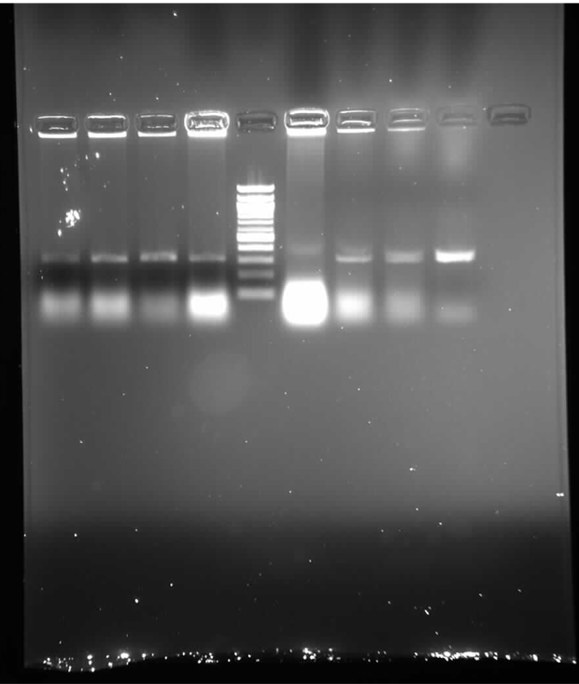
Figure 1. Gel electrophoresis. This gel shows two group’s sets of data, with our specific data being the 4 columns to the right.
Discussion
The objective of this experiment was to use synthetic biology in order to imbed a PpbrA promoter onto E. coli. We have not entirely finished the experiment yet, but so far everything has come out so good. The only chance of error for this experiment would be human error, considering we’re doing mostly everything by hand. This section or lab is only a single part of the entire Robocop experiment, so future directions would be to complete every section and have a complete functional synthetic biology creation. Once complete, this should allow for an easier and more efficient, both in cost and time, way to test for GSR.

References
Biology, S. f. S. (2009). Special focus: Synthetic biology. Biotechnology Journal, 4(10), 1371.
Borremans, B., Hobman, J. L., Provoost, A., Brown, N. L., & van der Lelie, D. (2001). Cloning and Functional Analysis of the pbr Lead Resistance Determinant of Ralstonia metallidurans CH34. Journal of Bacteriology, 183(19), 5651–5658.
Brown, N., Hobman, J., Julian, D. (2012). Cysteine Coordination of Pb(II) is involved in the PbrR-dependent Activation of the Lead-Resistance Promoter, PpbrA, from Cupriavidus metallidurans CH34. BMC Microbiology. 1471- 2180. 12:109.
Brozek-Mucha, Z. (2011). Chemical and Morphological Study of Gunshot Residue Persisting on the shooter by means of scanning Electron Microscopy and Energy Dispersive X-ray spectrometry. Microscopy and Microanalysis, 17(6), 972-82.
C., & G. (2010). Biofuel Production in Escherichia coli: The Role of Metabolic Engineering and Synthetic Biology. Applied Microbiology and Biotechnology, 86(2), 419-34.
Dellomonaco, C., Fava, F., & Gonzalez, R. (2010). The path to next generation biofuels: Successes and challenges in the era of synthetic biology. Microbial Cell Factories, 9, 3.
Shapira, P., Kwon, S., & Youtie, J. (2017). Tracking the Emergence of Synthetic Biology. Scientometrics, 112(3), 1439-1469. 1379.
Vinson, V., & Pennisi, E. (2011). Synthetic biology. The Allure of Synthetic Biology. Science (New York, N.Y.), 333, 1235.

