Samuel Kane
Dr. Lehman
Bio 288 – Sophomore Seminar
November 28, 2017
Synthetic Biology 101
Introduction
Have you ever watched any kind of science fiction movie where a scientist created robots such as iRobot or Terminator? If so, then welcome to the world of Synthetic Biology! However, synthetic biology isn’t only creating robots, but anything that has to do with the design and construction of new or replicated biological entities.
Synthetic biology’s ranges of scientific implications is insanely broad. This field can go from something as simple as synthesizing a chemical to something as complex as synthesizing an entire genome. One of the coolest facts about the field of Synthetic Biology is that it most likely will never reach a stopping point; there will always be room for it to improve upon itself and continue to grow and thrive.
Rise of Synthetic Biology
Synthetic Biology can be dated back to the early 20th century. One of the earliest known synthetic biologists is Stephane Leduc. Stephane Leduc is a French biologist who began his journey into synthetic biology around 1910. He coined the term “synthetic biology” in one of the many books he wrote on the subject, La Biologie Synthetique. While Stephane may not have been the first person to ever dive into the field of synthetic biology, he definitely will not be the last.
Current Fields and Applications
Currently in the world, there are many practical applications for the use of synthetic biology. Behind these applications are many scientists who belong to many different scientific fields. Some of the most prominent fields associated with synthetic biology include: Molecular Biology, Computer Science, Engineering, and Chemistry.
All of the fields list above generally must come together to create what the world calls synthetic biology. Some of the things we use every day comes from synthetic biology such as biofuels, therapeutics (medicine and vaccines), chemicals, and even food ingredients. The fields can do plenty on their own, but it’s almost unimaginable what they can do as a combined entity.

Sophia – First “Human” robot 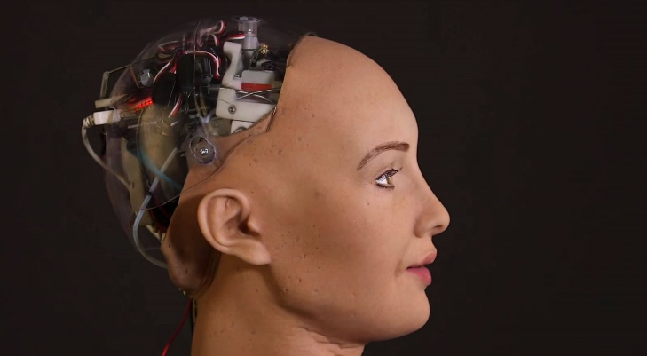
Sophia: The first “computer generated human robot”
Is iRobot or Terminator an actual possibility? Well, we got one step closer in October 2017 when a robot gained citizenship. Sophia is a robot, with very humanistic features, that earned / achieved citizenship in Saudi Arabia very recently. Although she was just granted citizenship, Sophia has been around for quite some time. She has made appearances on TV shows such as the Jimmy Fallon show and appeared on the cover of magazines such as Elle. She almost seems as if she is some kind of “robot ambassador” yet she currently exists as just a means of assisting mankind, as she is a caregiver for elderly people. Sophia is a strong talking point of just how far a robot can go in the midst of humanity. However, Sophia is only just the beginning of what these scientists plan to create. As of now, her team of scientists plan on creating a family of robots, each of which more prominent and able than the last.
Discussion
Ethical Implications
As stated previously in the section “Current Fields and Applications”, there are many uses for Synthetic Biology. However, some of these uses may not be seen as very ethical practices. The reasons for these practices being known as unethical stems from the fact that they are generally an unnatural or inorganic process.
One huge controversy currently is GMOs in food. GMO stands for genetically modified organisms. These GMOs can come from pesticides used or even injected growth serums. Currently, especially in America, there’s a huge movement for Organic foods. There is currently billions of dollars being put into scientific research to find alternatives to food that possess any kind of GMOs or anything that’s presumably unnatural. People are under the impression that ingesting these GMOs can be harmful to almost every part of the human body. Would you want to eat a food that sprayed with a substance that purposely kills and infects various other organisms?
One huge ethical implication comes in the form of surpassing human life and playing “God”. This has previously been seen in things such as stem cell research and robots, in particular Sophia. As previously stated in the section “Sophia – First “Human” Robot”, a robot was recently given citizenship in the country of Saudi Arabia. However, since its occurrence, there has been a fine line drawn between citizenship and personhood. This means that just because she is a citizen, doesn’t mean she has all the rights and links to humanity that a normal human would.
Another form of playing “God” can come from stem cell research. Some stem cell research includes the use of dead fetuses (from abortions or other methods) to provide medical help to sickly individuals. There are currently many institutions, with billions of dollars in research money, searching for a possible alternatives to anything unethical in relation to stem cell research, thus bypassing the issues currently faced.
Future Directions
The field of synthetic biology has a greater purpose and will further amplify knowledge compared to anything we’ve seen before. As stated previously, there are current billions of dollars in research money being invested into the field annually. Even with an already large amount of investment, it is only on the rise for the future. Currently, the field is in a period of nonstop growth and development. Synthetic biology is a field that will forever grow larger and never end expansion. As long as someone can think it, synthetic biology will attempt to find a way to do it. Synthetic biology, while taking every step one at a time, is very much so a field of long term goals.

References
Frow, E. K. (2013). Making big promises come true. Articulating and realizing value in synthetic biology. BioSocieties, 8(4), 432-448.
Galdzicki, M., Clancy, K. P., Oberortner, E., Pocock, M., Quinn, J. Y., Rodriguez, C. A., . . . Sauro, H. M. (2014). The synthetic biology open language (SBOL) provides a community standard for communicating designs in synthetic biology. Nature Biotechnology, 32(6), 545-50.
Jain, A., Bhatia, P., & Chugh, A. (2012). Microbial synthetic biology for human therapeutics. Systems and Synthetic Biology, 6(1-2), 9-22.
Longstaff, H., Schuppli, C. A., Preto, N., Lafrenière, D., & Mcdonald, M. (2009). Scientists' perspectives on the ethical issues of stem cell research. Stem Cell Reviews, 5(2), 89-95.
Mackenzie, A. (2010). Design in synthetic biology. BioSocieties, 5(2), 180-198.
Molyneux-Hodgson, S., & Meyer, M. (2009). Tales of emergence--synthetic biology as a scientific community in the making. BioSocieties, 4(2-3), 129-145.
Myhr, A. I., & Traavik, T. (2003). Sustainable development and norwegian genetic engineering regulations: Applications, impacts, and challenges. Journal of Agricultural and Environmental Ethics, 16(4), 317-335.
Pleiss, J. (2006). The promise of synthetic biology. Applied Microbiology and Biotechnology, 73(4), 735-9.
Schmidt, M., Ganguli-mitra, A., Torgersen, H., Kelle, A., Deplazes, A., & Biller-andorno, N. (2009). A priority paper for the societal and ethical aspects of synthetic biology. Systems and Synthetic Biology, 3(1-4), 3-7.
van Doren, D., Koenigstein, S., & Reiss, T. (2013). The development of synthetic biology: A patent analysis. Systems and Synthetic Biology, 7(4), 209-220.
Vogel, K. M. (2014). Revolution versus evolution?: Understanding scientific and technological diffusion in synthetic biology and their implications for biosecurity policies. BioSocieties, 9(4), 365-392.

