Bacteria are single celled organisms that can have many uses. Some bacteria are helpful to our ecosystem, and some are harmful. Bacteria spread easily if the desired conditions are met in that environment. A study was conducted at University of Nis by the faculty of medicine and it concluded that the telephones of health care personnel may be the cause of some infections in the hospitals (Nikolic et al, 2011). A study was done on bacteria on covered and covered cell phones by Women’s Christian College, and they also discovered that the bacteria on cell phones can multiply and cause infections to humans since phones are not regularly cleaned (Suganya & Sumanthy, 2012). The objective of this experiment is to compare the amount of bacteria on two separate surfaces. The two surfaces tested in this experiment were the palm of our hands, and cell phones. The hypothesis is that if we collect bacteria from cell phones and hands and compare it, there will be more bacteria on the cell phones.

Materials and Methods Used in the Finding of Bacteria upon our Hands and Cellphones
Materials:
1 – Sharpie (create quadrants within petri dish)
2 - (2) Petri Dish (hold the bacteria)
3 - (6) Sterile Cotton Swabs (collect potential bacteria from test subjects)
4 - (2) Cell Phones (test subject)
5 - (2) Hands (test subject)
6 - Distilled Water (sterilize the cotton swabs)

Method / Procedure:
First, we took the two petri dishes and a sharpie marker and separated each petri dish into three quadrants and labeled them as: Hand, Phone, and Control.
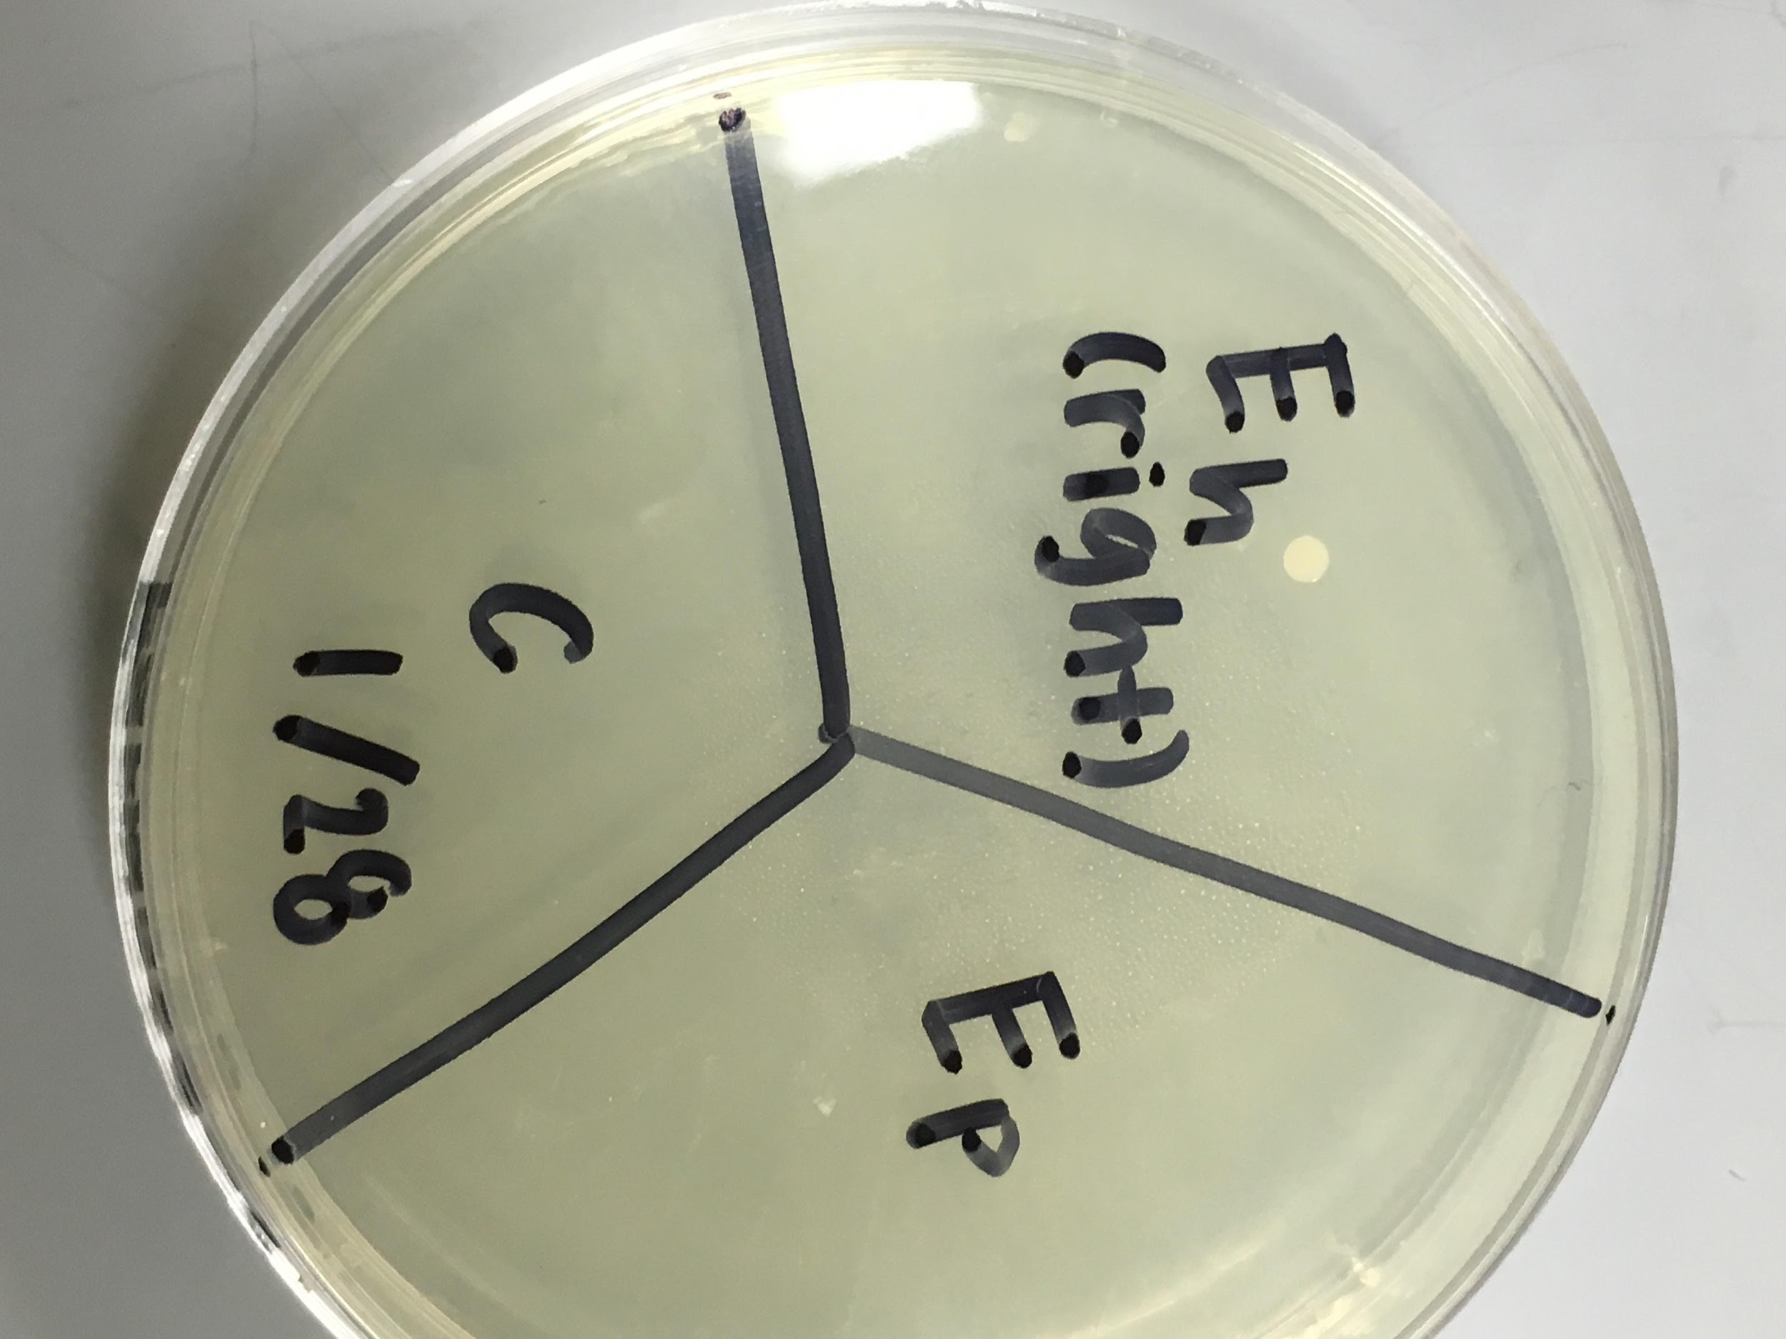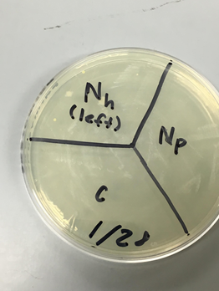
Next, we dipped the cotton swabs into distilled water and slid them lightly across the surface we were testing for bacteria (palm of the hand & back of the phone) and for the control we used distilled water.
After collecting the sample from our hands and phones, we slid the cotton swabs in a winding/serpentine motion across the correctly labeled section of the petri dish. (Hand to Eh / Nh, Phone to Ep / Np and Control (clean cotton swab) to c).
Finally, we taped our two petri dishes together and placed them in a room temperature area (to prevent dangerous bacteria from forming) upside down as to allow the condensation to collect on the top as to not mess with the potential bacteria. Then waited a week to measure our bacterial growth.

Results
After a week of letting the bacteria grow in our petri dishes, we examined them under a microscope to get a close look at exactly what was contracted. On the petri dish labeled Nicole (N) we saw no growth in the control or from the phone, although we found four brown, circular bacteria growing from the swab from Nicole’s hand. In the other petri dish labeled Emoni (E) there was once again no bacteria growth in the control or from the phone, but there was bacteria growth visible in the hand section shown below.
Figure 1. 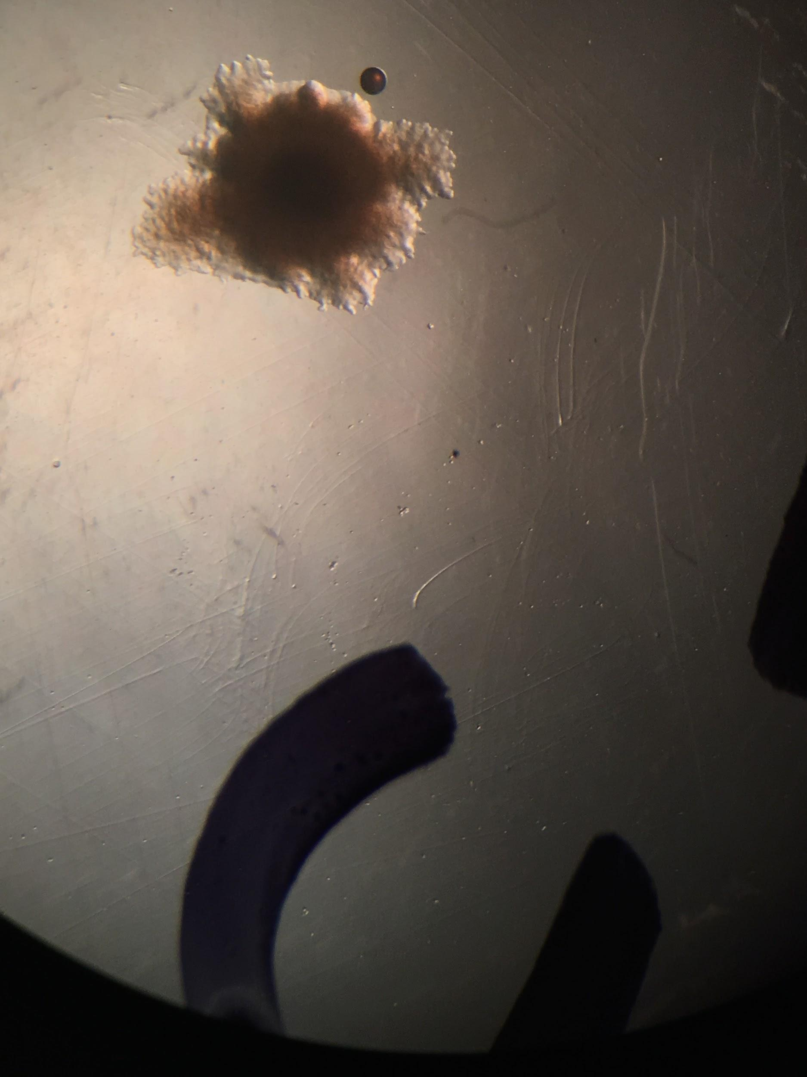Figure 2. 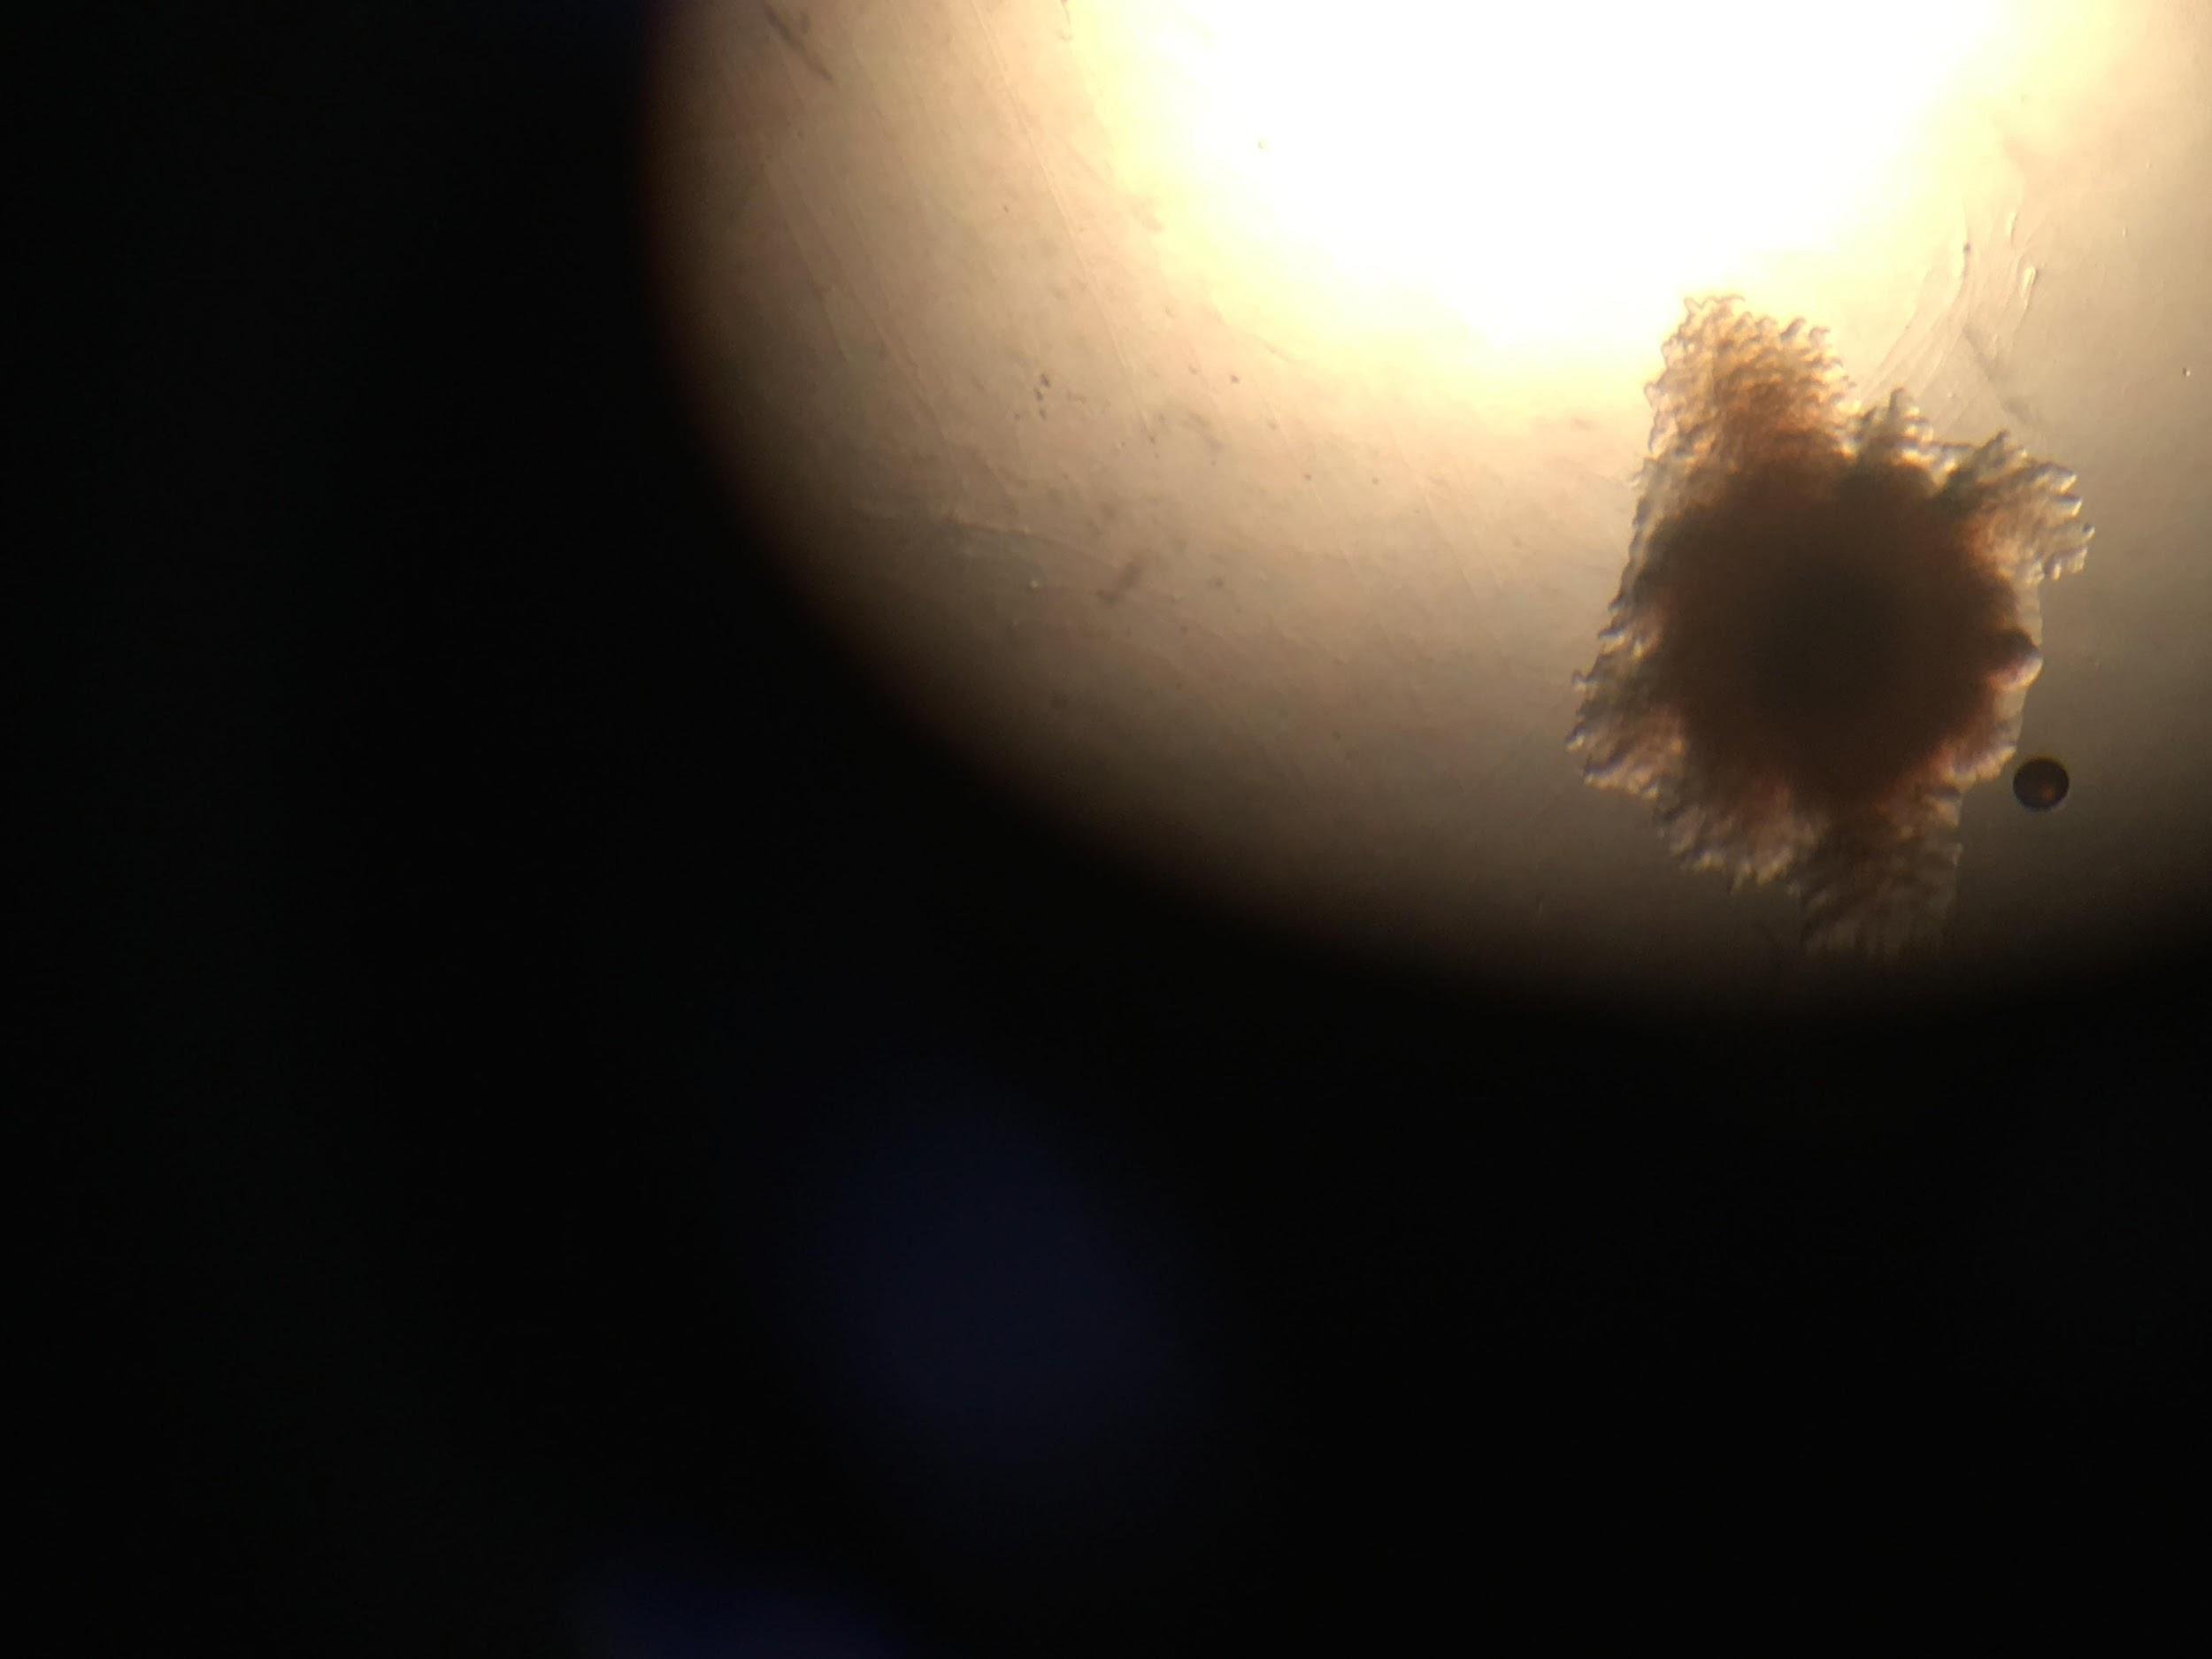
Figures 1 and 2 are images taken under the microscope from Emoni’s dish, these bacteria are similar to the two large bacteria found in Nicole’s petri dish pictured in Figure 3.

 | Nicole dish | Emoni dish
Control | 0 | 0
Hand | 4 | 1
Phone | none | none

Discussion

At the conclusion of our experiment, the bacteria we collected from our hands/phones was significantly lower than what we expected. The data we collected for this experiment did not support the hypotheses that we determined before we began. Unfortunately, with the low amount of data we were able to collect we could not make an extensive conclusion as to which surface cultivated more bacteria growth. If we had swabbed more surface area and transferred it onto the petri dish, or had a longer period of time for growth, we believe we would have had more bacteria visible on our dishes. Our data did not support our hypotheses because we assumed that our phones would contract more bacteria growth than our hands because of the constant touching of our phones by our hands and other surfaces throughout the day without ever being washed unlike our hands. It would be optimal if we were able to repeat this experiment for several trials to receive conclusive data in which surface contracts more bacteria. The procedures listed would have to be repeated in every trial to accurately obtain data that correctly reflects or incorrectly solidifies our hypothesis. In conclusion, it is difficult to say how important our findings are in relevance to our experiment/hypothesis because of how little we still know about the direction our experiment could potentially go.

Literature Cited

Nikolic, M, Arandjelovic, M, Stankovic, A & Kirvokapic, L J 2011, ‘Bacterial contamination of mobile phones used in hospitals’, Journal of Society for development in new environment in B&H, vol.5, no. 5, pp. 1254-1259

Suganya, S & Judia Harriet Sumanthy, V 2012, ‘Isolation and identification of bacteria from covered and uncovered mobile phones’, International Journal of Environmental Sciences, vol. 3, no. 1, pp. 44- 54

