Hannah Elmore
Findings
A number of statistical data tests were run to try and answer my research question: “How much assistance did most children who completed the Noodle Necklace Activity need?” The research question was tested using three different tests: an independent sample t-test, a pearson's correlation, and a regression. The variables that were used to run the test, all had one common variable; and that was the assistance needed by children during the activity.
The first test completed was an independent samples t-test. The goal of this test was to try and figure out if there was a connection between the parent assistance needed for the noodle necklace activity and household participants besides the parents during the activity. Below is a table summarizing my results of the independent samples t-test.

Table 1
Independent Samples T-test between Parent Assistance Needed for Noodle Necklace Activity and Household Participants Besides Parents During Activities
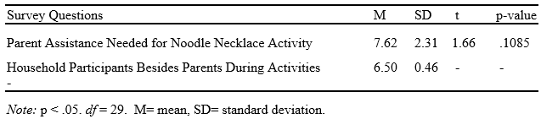
In the table above an independent sample t-test has been calculated between two variables. The variables are two separate questions from the Family Fun Time Activities survey that was sent home to the head start parents. The dependent variable is a question that asks on a scale from 0-10 about how much assistance their child required during the noodle necklace activity. Zero being no assistance, and ten being a lot of assistance. The independent variable is a question from the survey that asks if anyone else besides the child/children and parents participated in any of the activities. It is a yes or no question. The correlation between the variables is that other people in the household besides the parent and child/children may have participated in the noodle necklace activity due to the child/children requiring extra assistance with this activity. The mean, standard deviation, t-value, p-value, and df were calculated through RStudio. The p-value is greater than the significance level so the null hypothesis would be retained.
.1085<.05, not true, no significant difference between means
The second test that was run was a pearson’s correlation. “The amount of families who enjoyed the noodle necklace activity was determined by how much assistance the child needed while trying to complete the activity.” This test provided results that proved whether there was a strong or negative correlation between that statement. Both of the variables used to run this test were asked on a 0-10 scale. The results indicate that there is a weak positive correlation (r=.1103) between how many families enjoyed this activity and how much help a child needed to complete the Noodle Necklace Activity. Therefore, when families were more engaged in the activity, they enjoyed it more. The researcher does not know if this would be true in a larger population.
The third and final test done was a Regression. For this test I hypothesized that children whose parents interact with them for several hours in a day will need less assistance while completing the Noodle Necklace activity. This would be due to the child being possibly more advanced due to their parents interacting with them more.
The coefficient between the two variables I used in my model was 0.06696. Since it is positive we know there is a direct relationship, meaning as the value of the independent variable increases the mean of the dependent variable will also increase. Although, it seems like parent interaction and the child’s amount of assistance needed are directly related. This is not true because the finding of the model is not significant when compared to the alpha values, therefore (p=0.654). The R^2 statistic is 0.005204, furthermore this model gives us .05 percent of the variation in the dependent variable (child’s need of assistance during activity). There is no relationship between the amount of parent interaction a child receives a day and a child’s need for assistance in the Noodle Necklace activity.

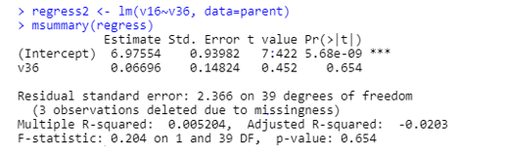
In conclusion, the main thing I was trying to obtain results for through my research question was how much assistance most children needed to complete the Noodle Necklace Activity. However, most of the tests I ran included variables that expanded to other factors. For example, in the pearson's correlation test that I ran I had said that the amount of assistance that a child needed to complete the activity determined how much the parents enjoyed the activity. The results indicated that there was a weak positive correlation between the variables. This test was not only testing the assistance that was needed by the child during the activity, but also how their need for assistance affected the parent’s enjoyment of the activity. Overall, through the three tests I ran I was able to obtain results for an estimated amount of assistance most children needed to complete the Noodle Necklace Activity and also how their need for assistance affected other variables of the study such as parent enjoyment. The independent samples t-test and regression provided results that indicate parent interaction and the number of household participants that participated in the activity besides the parents had an affect on how much assistance a child needed to complete the Noodle Necklace Activity.

