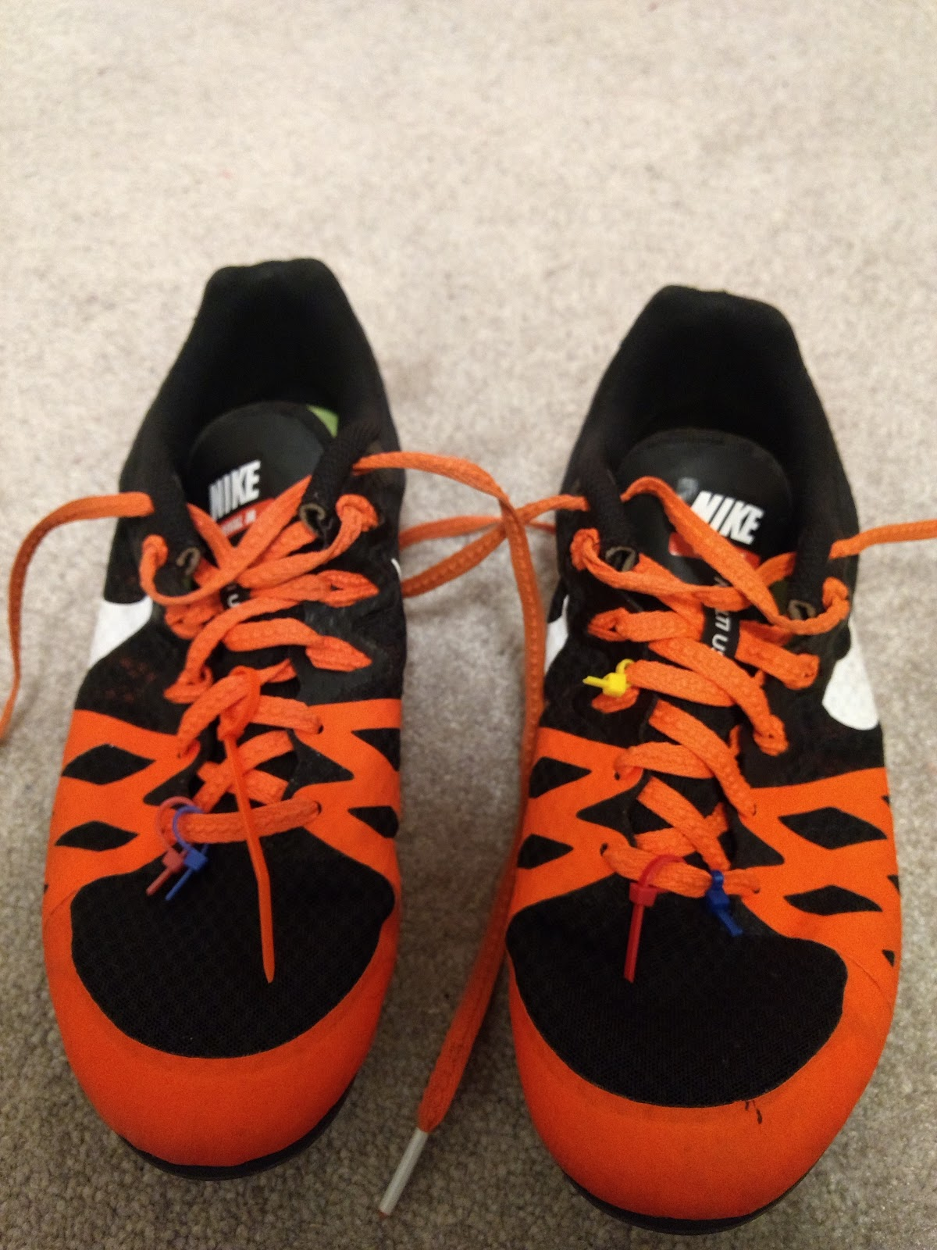

These are my “spikes”. They are shoes specifically made for sprinting events at track meets. I wore these shoes at every track meet for six years. The zip-ties I obtained at elite track meets. Elite track meets are meets where you have to achieve a certain time in your event to gain invitation. At these meets, they check the length of the spikes on the bottom of the shoe for regulation height. If approved, you are given a zip-tie to signify your clearance to other coaches. The zip-ties become a thing of pride as, the more you have, the better of an athlete you are. Athletes would often compare the number of zip-ties on their shoes. I was very proud to have gained as many zip-ties as I did.

