Name: Erin Dwinell
Bi-Weekly Report Dates: February 1-8 & February 8-15
Week 1 Total= 49,542 steps: high = 11,650 steps, low = 3,161 steps
Week 2 Total= 84,579 steps : high = 18,783, low= 2,634

Week 1 Reflection and Graphs
Reflection: On the week of February 1-8 I completed a total of 49,542 steps. I believe that this is a very low number for me because of my usual level of high intensity training every Monday through Friday because I am on the soccer team here at Longwood. I would accredit this low number due to my forgetfulness to charge my Fitbit and to put it on after I would shower after practice. My graphs for my high day, February 6th, and my low day, February 5th, would not show me my daily graphs for this week. On February 6th, I believe I got the most steps because I had lift in the morning, with four classes a good distance from each other, and also conditioning later in the afternoon. My low day February 5th, was a day that I consider a rest day to do homework and tend to not do much to rest up for my training during the week. I noticed that on the weekends my steps seem to be much lower than that of the week because I tend to keep those days as my resting days. Also, this was the week that I was recovery from my concussion.

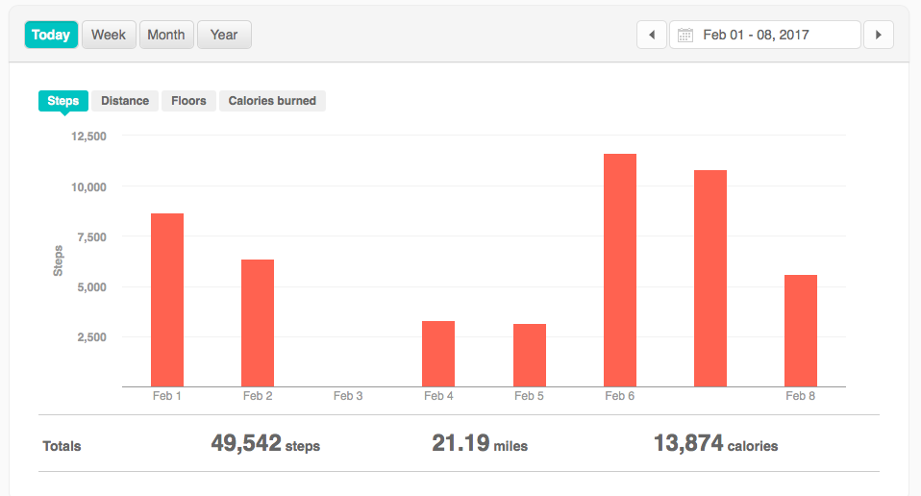
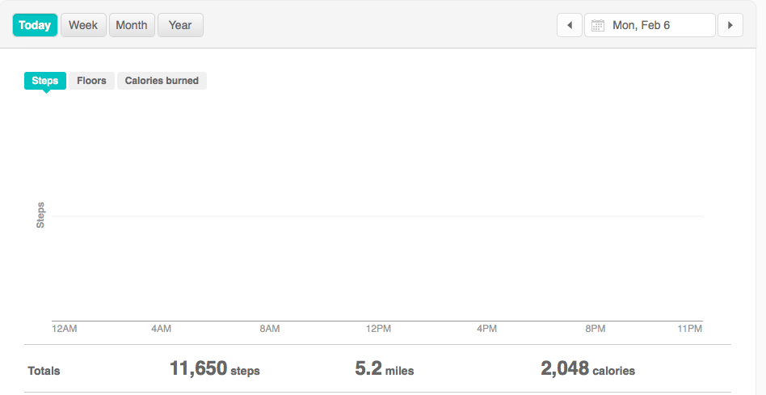

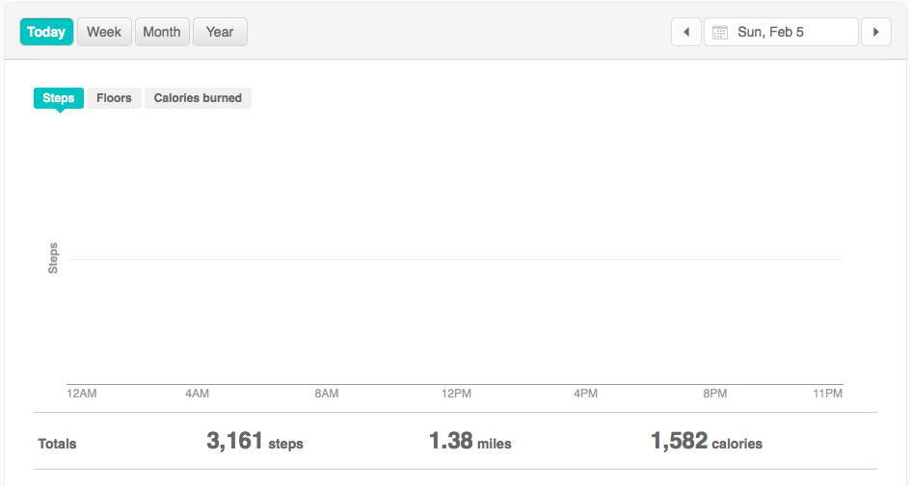

Week 2 Reflection and Graphs
Reflection: During the week of February 8-15 I completed a total of 84,579 steps. My highest day was Tuesday, February 14th. My highest bouts occurred mostly very early in the morning between 6 and 8 AM. This is due to futsal training. I tend to be constantly moving during the three ten minute games and get in a lot of steps. But, our coach added in speed ladder training as our “rest” in-between games which created more steps. My lowest amount of steps occurred on Saturday, February 11th. My highest bout occurred around 11 AM because I took a walk from my dorm to Uptown Coffee for a good breakfast. This day was not completely recorded because I took a ride to Richmond to drop someone off at the airport. My Fitbit died during this time and by the time I got back the day was over. These next weeks I am going to be more conscientious about getting more steps in on my rest days and also making sure my Fitbit is always charged enough.

